%P53
clc
clear all
h=0.01;
tao=0.005;
lamda=0.5;
%Lax-Friedrichs
x=-1:h:1;
u(1:101,1)=ones(101,1);
u(102:201,1)=zeros(100,1);
for k=1:100
u(2:200,2)=0.5*(u(3:201,1)+u(1:199,1))-0.5*lamda*(u(3:201,1)-u(1:199,1));
u(2:200,1)=u(2:200,2);
end
subplot(2,2,1);
plot(x,u(1:201,1)','LineWidth',2);
xlabel('x');ylabel('y');
title('Lax-Friedrichs');
%迎风格式
x=-1:h:1;
u(1:101,1)=ones(101,1);
u(102:201,1)=zeros(100,1);
for k=1:100
u(2:201,2)=u(2:201,1)-lamda*(u(2:201,1)-u(1:200,1));
u(2:201,1)=u(2:201,2);
end
subplot(2,2,2);
plot(x,u(1:201,1)','LineWidth',2);
xlabel('x');ylabel('y');
title('迎风');
%Lax-Wendroff
x=-1:h:1;
u(1:101,1)=ones(101,1);
u(102:201,1)=zeros(100,1);
for k=1:100
u(2:200,2)=u(2:200,1)-0.5*lamda*(u(3:201,1)-u(1:199,1))+0.5*lamda*lamda*(u(3:201,1)-2*u(2:200,1)+u(1:199,1));
u(2:200,1)=u(2:200,2);
end
subplot(2,2,3);
plot(x,u(1:201,1)','LineWidth',2);
xlabel('x');ylabel('y');
title('Lax-Wendroff');
%Beam-Warming
x=-1:h:1;
u(1:101,1)=ones(101,1);
u(102:201,1)=zeros(100,1);
for k=1:100
u(3:201,2)=u(3:201,1)-lamda*(u(3:201,1)-u(2:200,1))-0.5*lamda*(1-0.5*lamda)*(u(3:201,1)-2*u(2:200,1)+u(1:199,1));
u(3:201,1)=u(3:201,2);
end
subplot(2,2,4);
plot(x,u(1:201,1)','LineWidth',2);
xlabel('x');ylabel('y');
title('Beam-Warming');
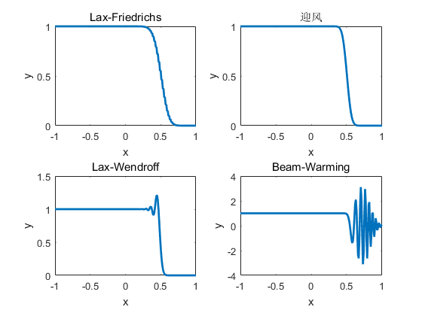
Published with MATLAB? R2016a

