English
中文

Dossier_Management SOP 使用手册/CN

Installation
1. 下载并解压.zip 文件夹
2. 点击 ‘Dosssier_Management.bat’ 一键安装
（脚本会自行探查可执行python，若没有则去K盘下载）
（首次安装耗时较长）

注：
在使用之前，建议您将常用的 SharePoint 路径 同步到本机 OneDrive路径上。
1. 访问常用 SharePoint 站点（Dossiers 储存的位置）。
2. 点击 “Add a shortcut to OneDrive”。
3. 选择同步的路径。
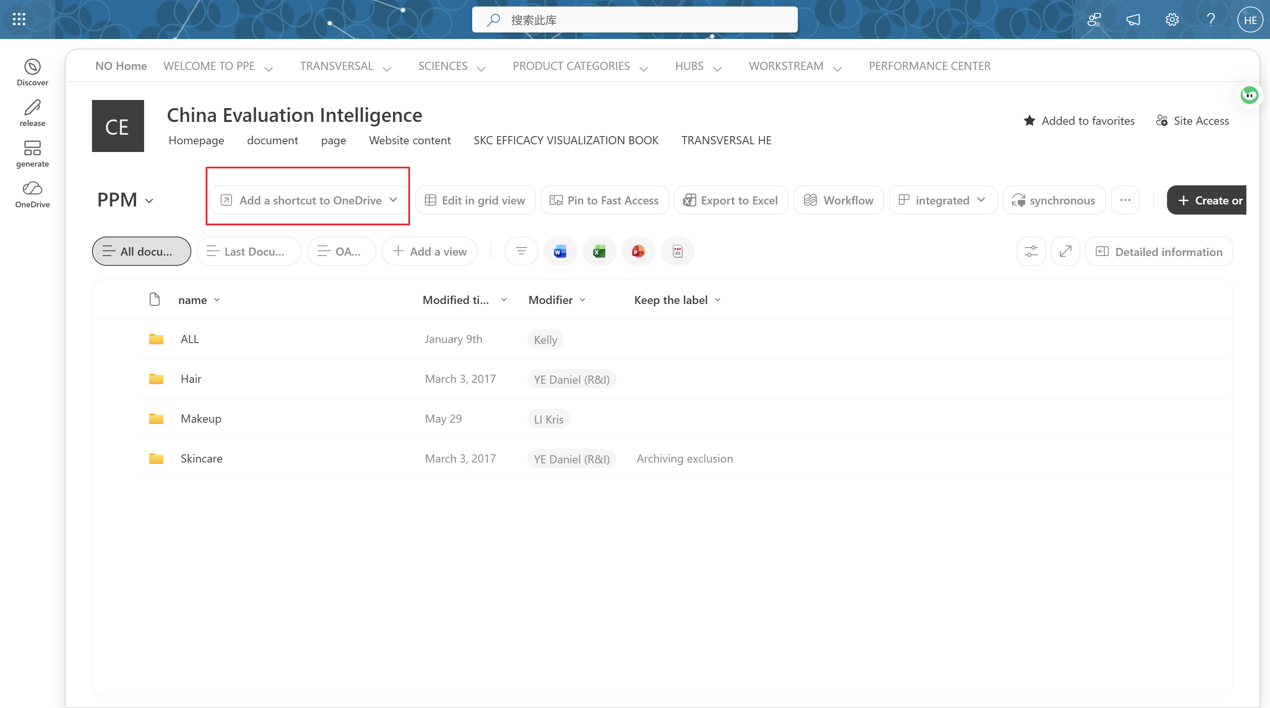

Tool Use
- 首先在Search Target Path 栏里输出刚才同步的路径
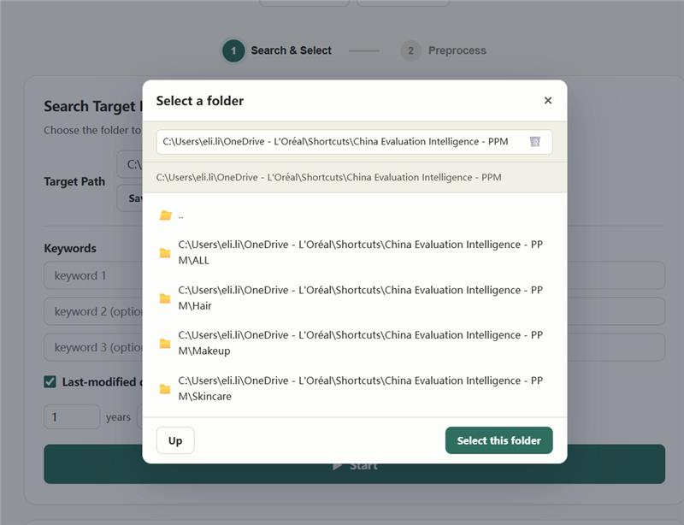

- 输入Keyword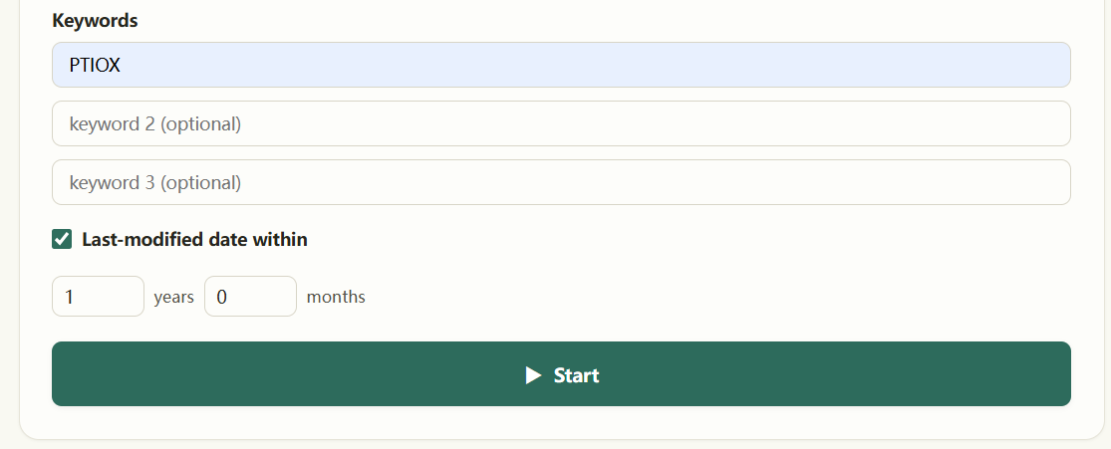

- 选择相关报告并点击Next > Proceed
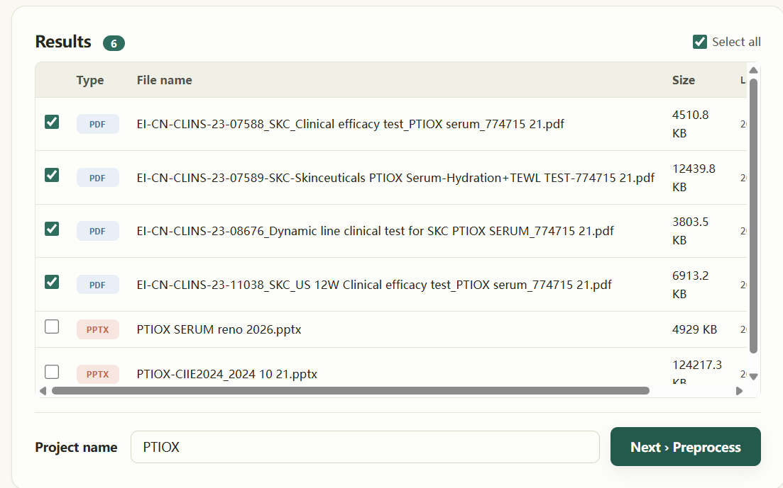

- 等待预处理完成后，打包合集窗口将会弹出。这时点击 L’Oréal GPT，并将合集文件夹拖入Companion聊天窗口，配合快捷指令 ‘@extract’. 等待文件上传完成后再发送。
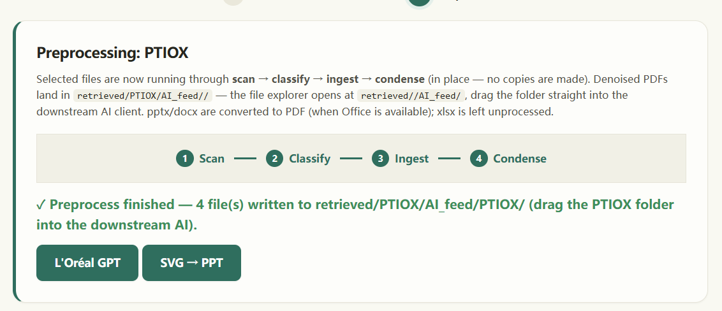
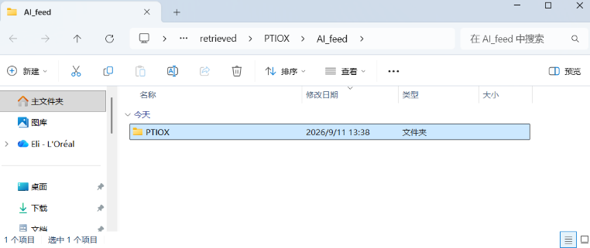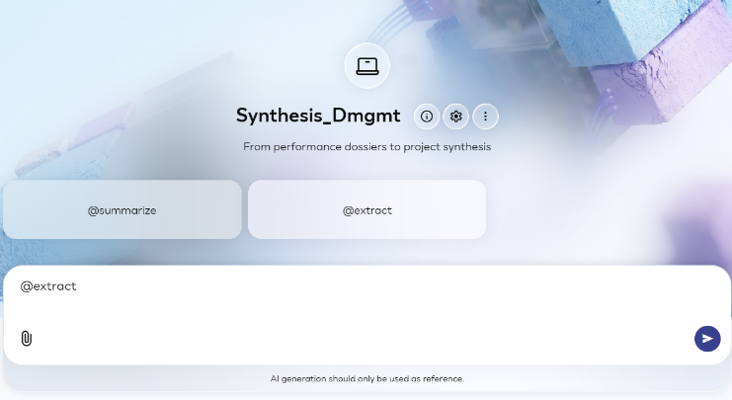

- 若输出因指标数量过多而截断，AI会提示输入 ‘continue’ 或 ‘继续’ 来提取剩余指标。
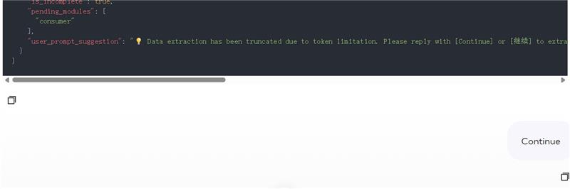

- 全部指标提取完成后，输入 ‘@summarize’ 指令，令AI输出xml 代码。

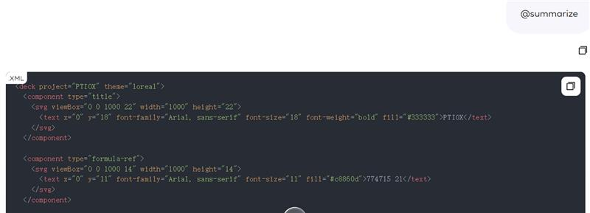

- 将整段复制并回到工具页面上，点击 ‘SVG → PPTX‘，并将代码粘贴至输入框。
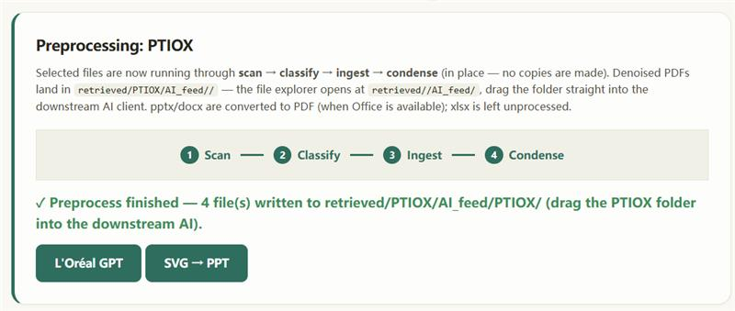
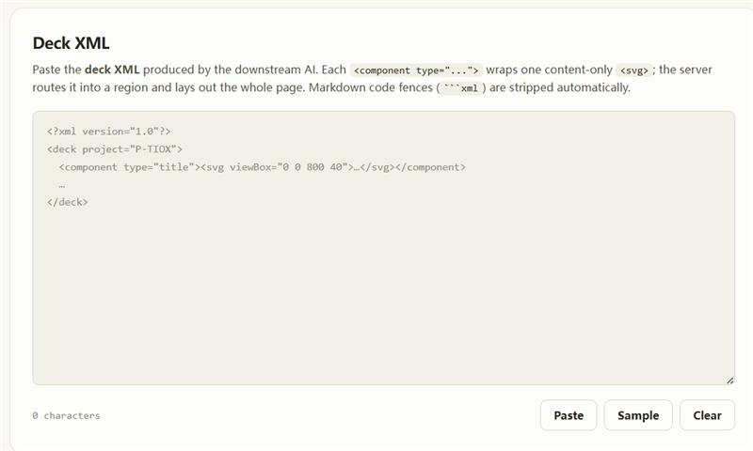

- 最后点击 Build Deck 即可生成 Synthesis Deck. Preview支持调整字号、颜色、组件紧凑度。调整完成后点击 Save to Folder 即可保存PPT文件至本地路径。

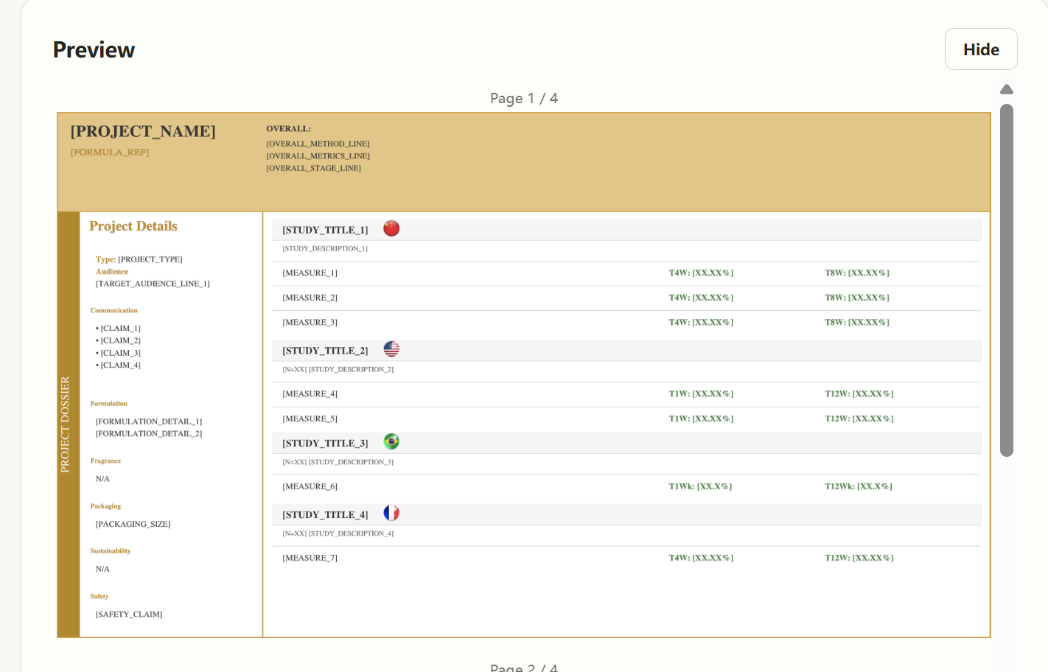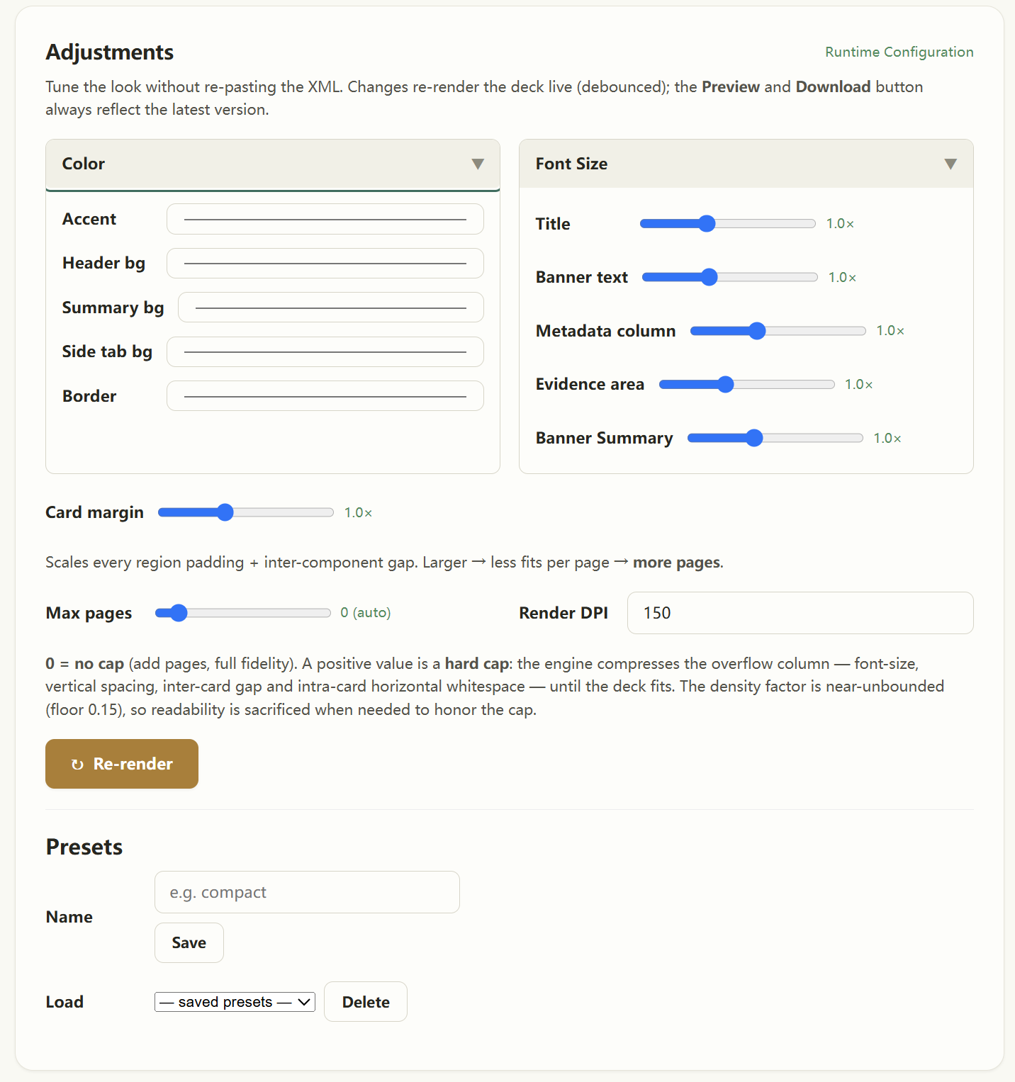
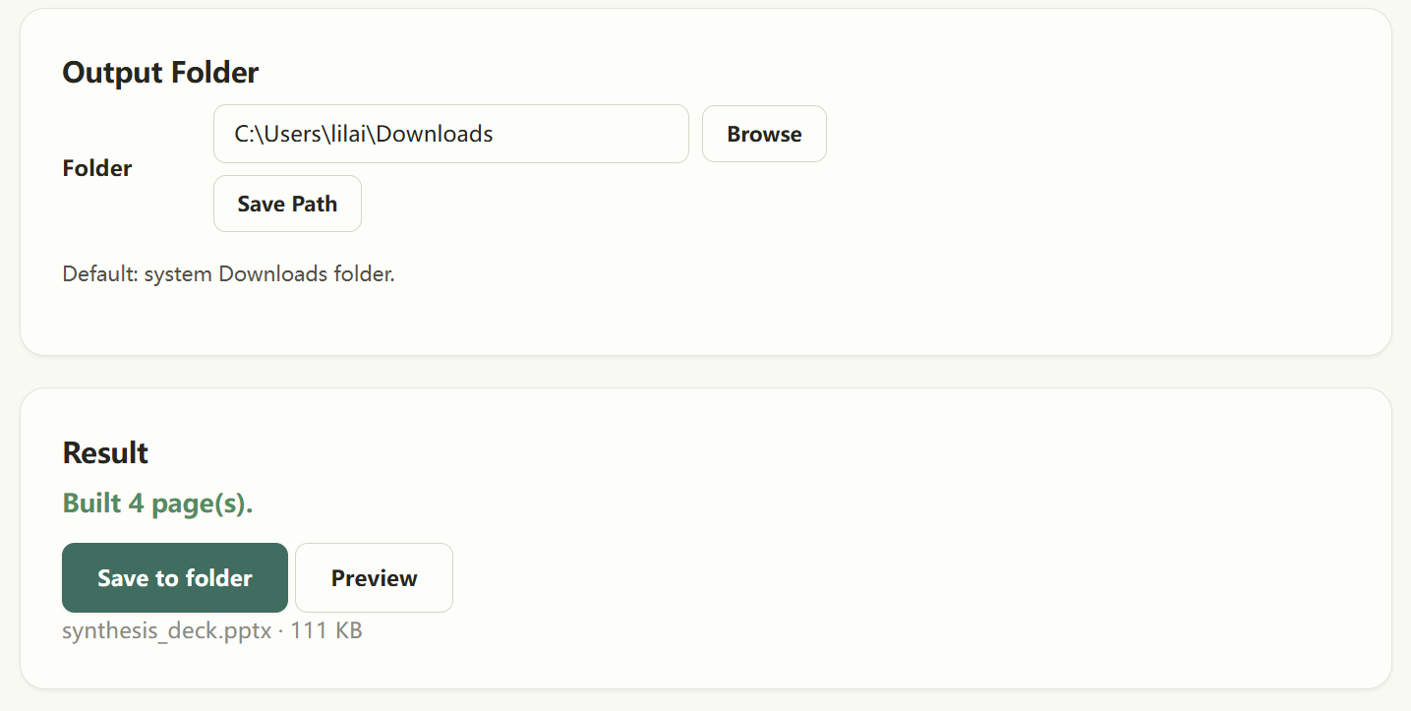

Dossier_Management SOP Guidance/EN

- Download and extract the zip folder;
- Click ‘Dosssier_Management.bat’ for installation
  - The script will automatically detect python availability; if python is not found, it will install from K:\ shared drive
- The initial installation will take a while to install the dependency requirements – Once and for all.

Note:
This tool runs on your local machine and can only have access to your local file paths.
Therefore, before using this tool, it is recommended to sync your commonly used SharePoint path onto your local OneDrive path.
Here is how to proceed:
- Navigate to your commonly used SharePoint site.
- Sync this site by clicking “Add a shortcut to OneDrive”.
- Choose your preferred path to be linked with.

Tool Use
- First, enter the path you just synchronized in the 'Search Target Path' field.

- Enter Dossier Keyword

- Select relevant dossiers and clit ‘Next > Proceed’

- Once the preprocessing is complete, the collection packaging window will pop up. At this point, click on Loreal GPT and drag the collection folder into the Companion chat window, using the shortcut command “@extract.” Wait until the file has finished uploading before sending it.

- If the output is truncated due to an excessive number of metrics, the AI will prompt you to enter “continue” or “继续” to retrieve the remaining metrics

- Once all metrics have been extracted, enter the ‘@summarize’ command to have the AI generate XML code

- Copy the entire section, return to the Tools page, click “SVG → PPTX,” and paste the code into the input field.

- Finally, click “Build Deck” to generate the Synthesis Deck. The ‘Preview’ feature allows you to adjust font size, color, and component spacing. Once you've made your adjustments, click “Save to Folder” to save the PowerPoint file to local.

