Dossier_Management SOP Guidance/EN

- Download and extract the zip folder;
- Click ‘Dosssier_Management.bat’ for installation
  - The script will automatically detect python availability; if python is not found, it will install from K:\ shared drive
- The initial installation will take a while to install the dependency requirements – Once and for all.

Note:
This tool runs on your local machine and can only have access to your local file paths.
Therefore, before using this tool, it is recommended to sync your commonly used SharePoint path onto your local OneDrive path.
Here is how to proceed:
- Navigate to your commonly used SharePoint site.
- Sync this site by clicking “Add a shortcut to OneDrive”.
- Choose your preferred path to be linked with.
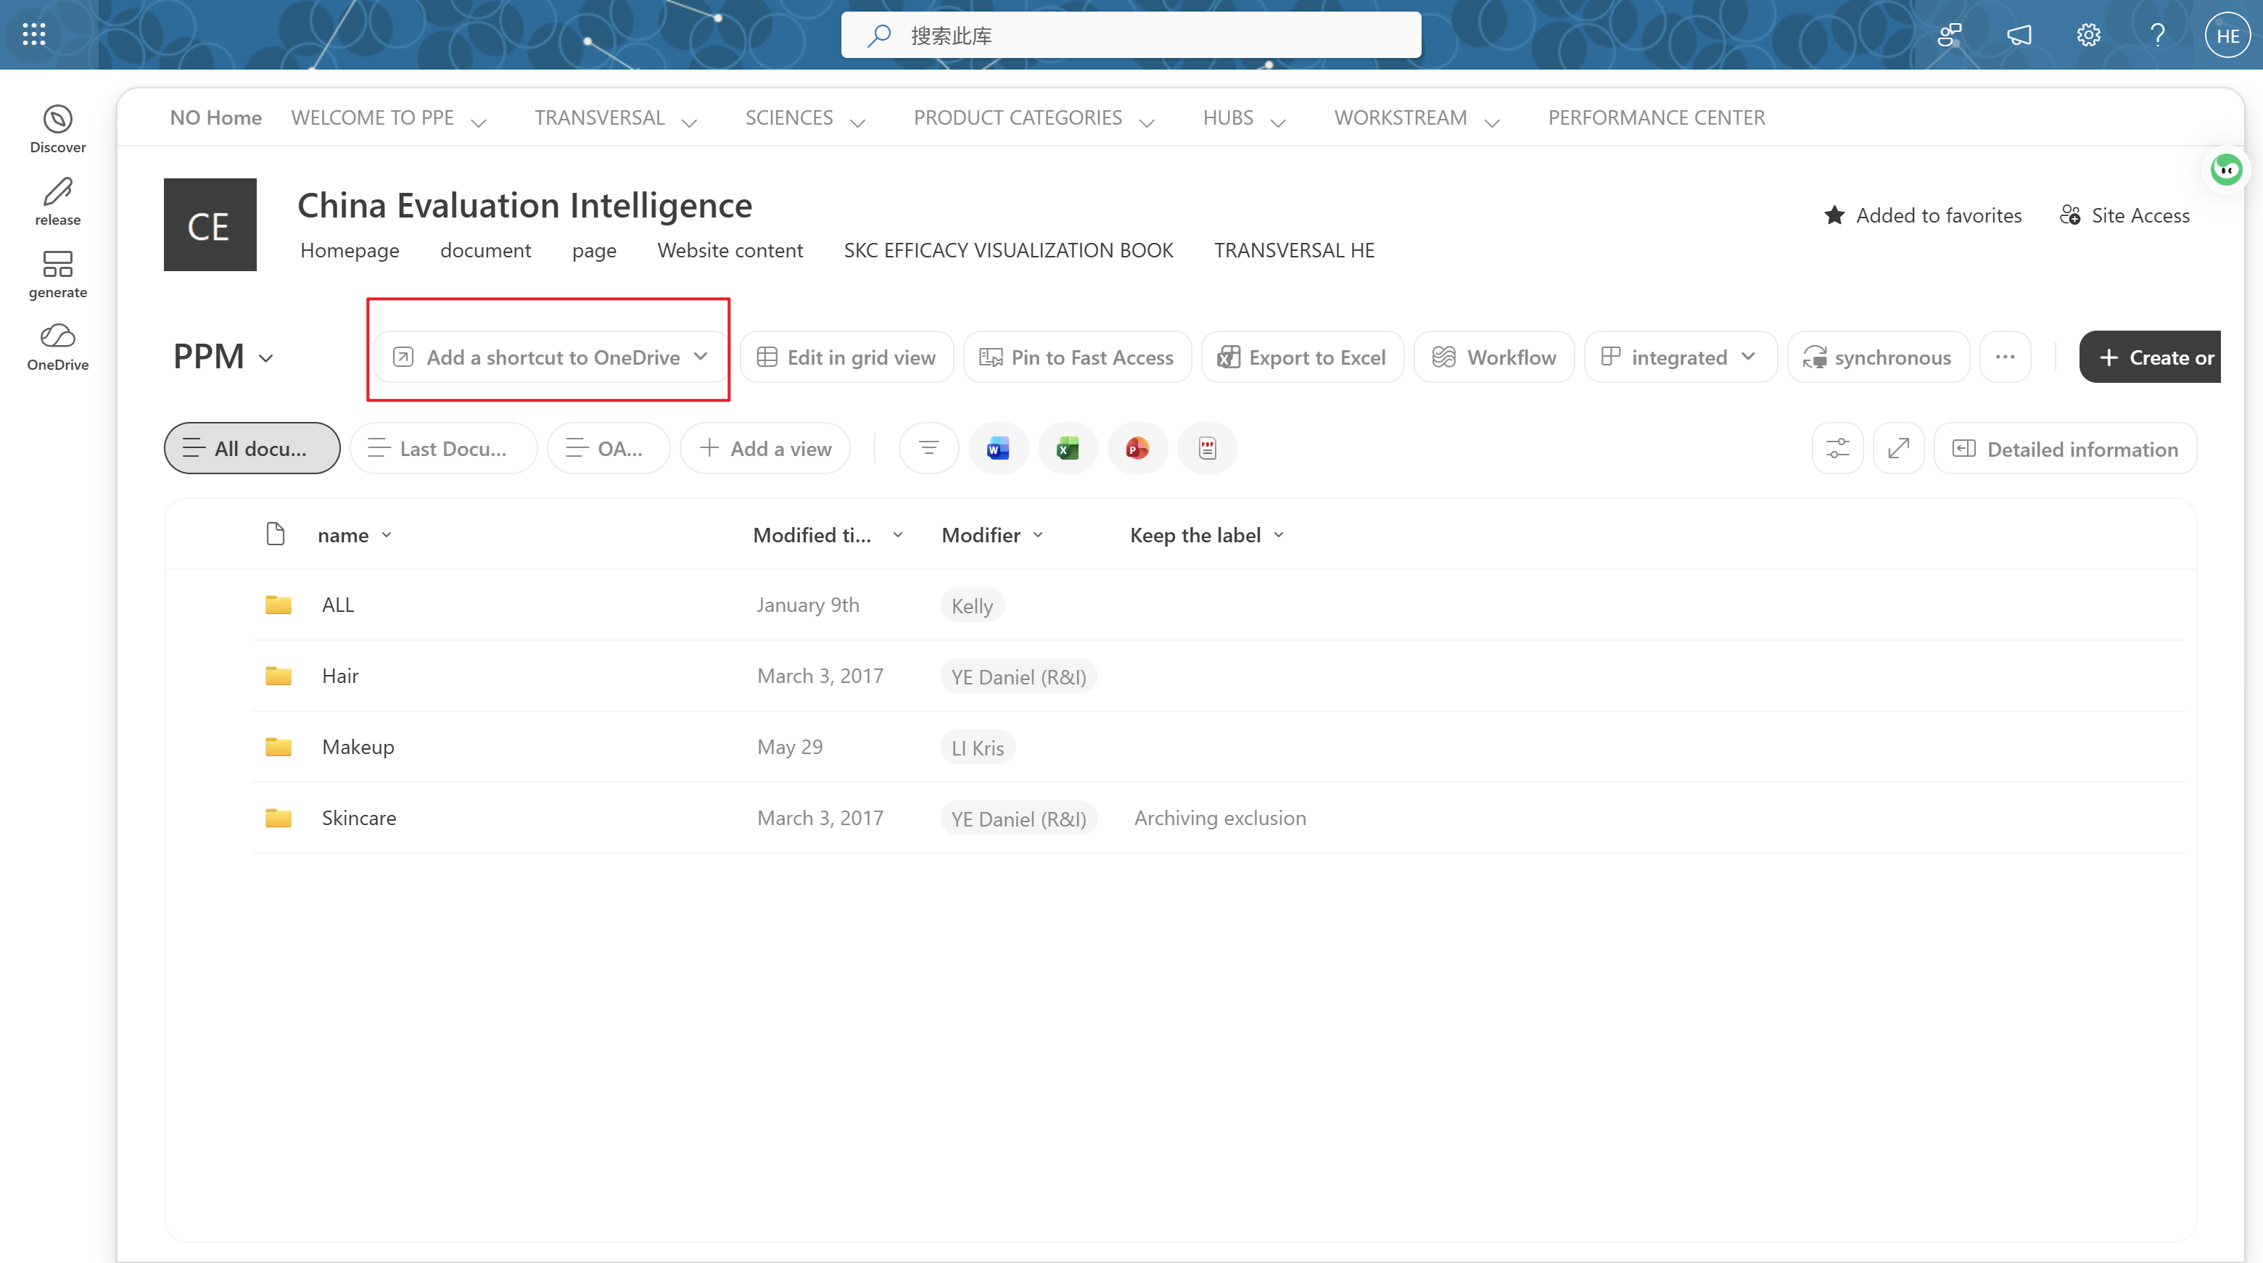

Dossier_Management SOP 使用手册/CN

1. 下载并解压.zip 文件夹
2. 点击 ‘Dosssier_Management.bat’ 一键安装
（脚本会自行探查可执行python，若没有则去K盘下载）
（首次安装耗时较长）

注：
该工具仅运行于本地，且只能浏览本地文件路径；
因此，在使用之前，建议您将常用的 SharePoint 路径 同步到本机 OneDrive路径上。
可以通过以下方式实现：
1. 访问常用 SharePoint 站点。
2. 点击 “Add a shortcut to OneDrive”。
3. 选择同步的路径。

