Precision First Verification for Selecting Reliable LLM Reasoning
DASE7506 Advanced Machine Learning Methods MP2
Student ID 3036779621 | 31 October 2026

Abstract
This report studies whether a verifier should separate irreversible rejection from reversible scoring when selecting one of four LLM-generated solutions to a maths problem. I developed Model Z, a precision-first cascade that groups candidates by parsed final answer, short-circuits unanimous groups, removes only answer groups with high-precision error evidence, and ranks the survivors with learned embedding and character-text scores plus bounded reasoning features. Five question-level out-of-fold schemes governed feature promotion. The four hard gates improved the same downstream selector by 18-21 correct training selections across the five OOF schemes and by 7 of 798 validation questions. Model Z reached 768/798 (96.24%) on validation and 384/467 (82.23%) in one frozen test run. The test gap remained after removing validation's easy unanimous rows, indicating a harder disagreement distribution. The evidence supports conservative filtering, but the remaining errors show that complete semantic composition still requires explicit entity, state and relation modelling.
Keywords LLM verifier, candidate selection, answer groups, out-of-fold evaluation, arithmetic consistency

1 Research Question
The course bank provides four plausible reasoning traces for each GSM8K-style question. The scorer awards a point when the selected candidate has a correct final numeric answer; it does not require every intermediate step to be valid. This creates two distinct tasks: identify answer groups that are almost certainly impossible, then compare the remaining explanations without over-trusting fluent text or majority agreement.
My research question was whether selection accuracy improves when these tasks are separated. I expected high-precision negative gates to remove convincing but demonstrably bad answer groups, while weaker semantic and arithmetic evidence would work better as small score adjustments. I therefore tested a two-stage verifier rather than one unrestricted classifier or a collection of hard rules.

2 Data and Evaluation Protocol
Each row contains a question, four candidate texts and fixed candidate embeddings of shape 4 by 1024. The supplied protocol contains 4,755 training, 798 validation and 467 test questions with no split overlap. Training references were used for fitting and question-level OOF analysis; validation supported development and selection. The frozen Model Z was then evaluated on test once. Multiple candidates may share the correct parsed answer, so answer-group selection is the appropriate unit of analysis.
Table 1 Data splits and their permitted roles
Split | Questions | Role | Reference use
Train | 4,755 | Fit models and five-scheme OOF analysis | Training supervision
Validation | 798 | Development, ablation and error analysis | Method selection
Test | 467 | One frozen final evaluation | Scoring and reproduction only

I used accuracy as the primary metric and tracked fixes, harms and answer-group changes for every proposed component. Baseline A always selected candidate 0. Baseline B selected the earliest candidate in the largest parsed-answer group. These achieved 78.20% and 86.22% validation accuracy, respectively, showing that consensus is useful but leaves substantial room for reasoning-sensitive selection.

3 Model Z
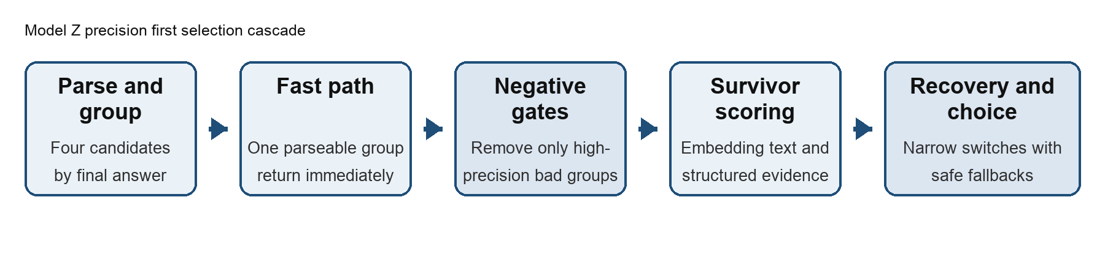
Figure 1 Model Z separates high-precision rejection from survivor scoring and recovery

3.1 Answer groups and fast path
The official parser converts each candidate's visible final answer to a canonical numeric value. Candidates with the same value form an answer group. If only one parseable group exists, Model Z immediately returns its earliest candidate because every candidate in that group receives the same official score. This fast path covered 2,641/4,755 training questions and 443/798 validation questions with 100% accuracy. The remaining 2,114 training and 355 validation rows entered the full verifier.

3.2 Learned base scorer
The base scorer combines a relative-embedding ridge model with answer-structure-specific character TF-IDF and LinearSVC heads. Relative embeddings subtract the within-question candidate mean, so the model learns how a candidate differs from its three alternatives rather than memorising absolute embedding offsets. Character n-grams of length 3-5 capture local reasoning and formatting patterns. Separate heads are used for 3-1, 2-2, 2-1-1 and all-distinct answer structures; unanimous rows need no text head. The learned Model M baseline reached 749/798 (93.86%) validation accuracy.

3.3 Precision first negative gates
Four gates operate on complete answer groups before final ranking: a shared unrepaired broad-arithmetic mismatch, a fractional final answer, a safe nonpositive answer when the question contains no explicit negative input, and an explicit Final Answer declaration that conflicts with the protocol-visible answer. A group is removed only when its supporting candidates satisfy the gate. If every parseable group would be removed, all groups are restored. This fallback makes a gate conservative even when its empirical precision does not transfer perfectly.

3.4 Survivor scoring and recovery
Surviving candidates retain the learned score and receive bounded evidence for calculation coverage, repeated quantity coverage, retention of the question target near the reasoning tail, stable implicit factors, remainder or difference structure, and terminal dependency for cumulative targets. An answer group's score is the maximum candidate score plus 0.3 times the group mean. The maximum preserves the strongest explanation while the mean gives limited credit to independent agreement.
Two narrow recovery mechanisms run after scoring. An omitted-factor switch requires a matching numeric ratio, an explicit factor in the question, evidence that one trace used the factor, and a bounded score gap. Boxed-answer recovery applies only when the target is consistent, visible and maps to a protocol-parseable answer group. Missing, conflicting or invisible targets leave the scored choice unchanged.

4 Experimental Design
Feature promotion followed a fixed order. I first required a mechanism that did not depend on question IDs or references at inference. An irreversible gate needed answer-group precision evidence and an all-groups-removed fallback. Weights were selected on a deterministic five-fold OOF split using question index modulo five, then checked on four balanced five-fold schemes with seeds 11, 29, 47 and 83. A component had to be non-negative across the robustness schemes, show acceptable fix-harm churn, avoid validation regression and pass the production implementation checks.
This procedure deliberately rejected rules that repaired one validation example without training support. It also rejected positive net results when fixes and harms cancelled within folds. After model selection, I audited arbitrary input length, candidate-order invariance, one- versus four-thread determinism, checkpoint reconstruction, source hashes, fallbacks and resource use. The pre-test freeze audit recorded 128 passing checks.

5 Results
Table 2 Selected validation progression
Method | Main change | Correct | Accuracy
Baseline A | Always candidate 0 | 624 | 78.20%
Baseline B | Largest parsed-answer group | 688 | 86.22%
Model C | Raw embedding classifier | 715 | 89.60%
Model D | Relative embedding scorer | 727 | 91.10%
Model M | Structure-specific embedding and text | 749 | 93.86%
Model T | Initial complete precision-first cascade | 766 | 95.99%
Model X | Declaration filter and safe recovery | 767 | 96.12%
Model Z | Two OOF-stable semantic adjustments | 768 | 96.24%

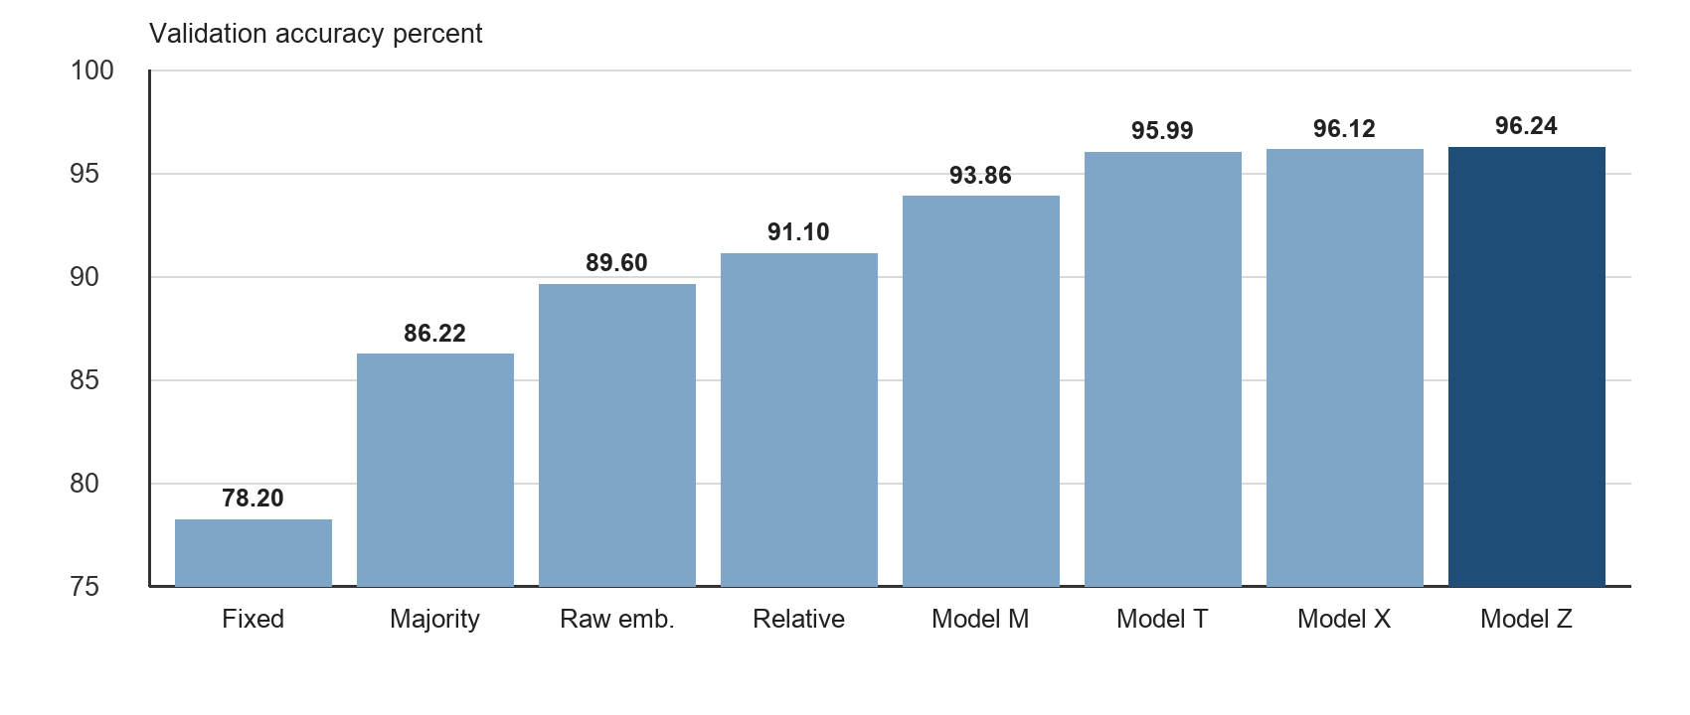
Figure 2 Validation accuracy increased from simple selection to the frozen Model Z
Relative to Model M, Model Z fixed 20 validation selections and harmed 1, a net gain of 19. The final two semantic adjustments changed only one validation answer group relative to Model X, but their five OOF deltas were consistently positive. This matters because a single validation fix is weak evidence on its own.
Table 3 Model Z versus Model X across five train OOF schemes
Scheme | 7506 | 11 | 29 | 47 | 83
Net correct | +10 | +7 | +8 | +8 | +5
Fixes | 12 | 12 | 14 | 10 | 10
Harms | 2 | 5 | 6 | 2 | 5

5.1 Frozen test result
After the source and checkpoint were frozen, one prediction and one independent scoring run produced 384/467 (82.23%) on test. Prediction took 1.83 seconds internally and 1.94 seconds wall time on the development Mac. The lower result cannot be explained only by the absence of easy rows: validation contains 443 unique-answer fast-path questions, but its disagreement subset still scores 325/355 (91.55%), 9.32 percentage points above test. The test disagreement bank is therefore harder or shifted relative to validation.

6 Ablation and Error Analysis

6.1 What the hard gates contribute
Keeping the final scorer, switches and recovery path fixed, removing all four hard gates reduced validation from 768 to 761. Restoring the gates added 18-21 correct OOF selections across the five schemes and 7 validation selections, with no correct-to-wrong gate harm in any answer structure. The largest contribution came from fractional answers, followed by safe nonpositive answers.
Table 4 Empirical precision and marginal contribution of the hard gates
Gate | Train wrong | Val wrong | Train lower | Val lower | Val gain
Fractional answer | 279/279 | 56/56 | 98.93% | 94.79% | +4
Safe nonpositive | 122/122 | 25/25 | 97.57% | 88.71% | +2
Final declaration conflict | 25/25 | 5/5 | 88.71% | 54.93% | 0
Shared broad arithmetic | 6/6 | 3/3 | 60.70% | 36.84% | +1

All observed gate flags were wrong groups, but the one-sided 95% exact lower bounds show why 279/279 is much stronger evidence than 6/6. The broad-arithmetic gate was retained because its definition is narrow, every OOF scheme gained one selection, validation gained one, and the fallback prevents total deletion. A grid of soft penalties did not find a smaller, consistently better alternative; large penalties were required to match the hard-gate contribution.

6.2 Accuracy by disagreement structure
Table 5 Model Z validation accuracy by parsed-answer structure
Structure | Interpretation | Correct | Total | Accuracy
4 | All candidates share one answer | 379 | 379 | 100.00%
3-1 | Three candidates agree | 197 | 204 | 96.57%
2-2 | Two pairs disagree | 41 | 45 | 91.11%
2-1-1 | One pair and two singletons | 117 | 130 | 90.00%
1-1-1-1 | All answers differ | 34 | 40 | 85.00%

Difficulty rises with disagreement. The 30 remaining validation errors were manually assigned to exclusive diagnostic categories: 11 multiplicity, time or participant-accounting errors; 9 state-transition or baseline-ledger errors; 8 relational-algebra or comparison errors; 1 discrete-remainder error; and 1 geometry error. Typical failures included omitting a repeated event, computing only the change rather than the requested total, and subtracting one paired student instead of two.
The rejected experiments reinforce this diagnosis. Individual arithmetic penalties, unit rules, answer magnitude priors, majority-to-minority switching, lexical overlap, PCA or k-nearest-neighbour embeddings and nonlinear static meta-rankers were unstable or validation-negative. Arithmetic consistency was useful only as narrow negative evidence. The remaining problems require explicit entity roles, state transitions and relational composition rather than more isolated keywords.

7 Efficiency and Reproducibility
Table 6 Frozen Model Z resource and reproducibility record
Item | Measured result
Checkpoint assets | 1,575,004 bytes uncompressed (about 1.50 MiB)
Validation prediction | 1.48 s internal; 1.57 s wall; four threads
Test prediction | 1.83 s internal; 1.94 s wall; four threads
Train-input stress run | 4,755 rows; prediction plus scoring about 6.49 s wall
Development machine | Apple M5 Pro, 48 GiB RAM, macOS arm64, Python 3.12.10
Rebuild | Both assets and all 798 selections reproduced byte-for-byte
Source closure | 27 local inference modules and two assets hashed

The environment used NumPy 2.5.3, scikit-learn 1.9.1, joblib 1.6.0, SciPy 1.18.1 and threadpoolctl 3.7.0. LinearSVC used random_state 7506; the robustness schemes used seeds 11, 29, 47 and 83. The two checkpoint SHA-256 values are 4d9e50...99cb6 for model.npz and 9cd782...11586 for structure_text_model.joblib. Full hashes are distributed with the checkpoint metadata and source manifest.
The frozen validation result can be reproduced with the following commands:
OMP_NUM_THREADS=4 OPENBLAS_NUM_THREADS=4 MKL_NUM_THREADS=4 \
python predict.py --method submission.py --checkpoint runs/model_z_robust_semantic \
--split validation --output runs/model_z_robust_semantic/validation-predictions.json
python score_predictions.py --split validation \
--predictions runs/model_z_robust_semantic/validation-predictions.json \
--output runs/model_z_robust_semantic/validation-score.json

8 Limitations and Conclusion
The method has three main limitations. First, gate precision is empirical on this course bank and is not a universal guarantee. Second, Model Z verifies traces through parsed quantities, text patterns and bounded structural features; it does not build a complete symbolic solution or prove every reasoning step. Third, validation was used repeatedly during development, and its 96.24% accuracy did not predict the harder test disagreement distribution.
The strongest conclusion concerns model design rather than the last validation point. High-confidence contradictions are suitable for irreversible filtering when a safe fallback exists. Weaker evidence should remain reversible through scoring or narrow recovery. This division produced stable OOF gains, a seven-question validation contribution from the hard gates and a compact CPU-only model. Future work should represent entities, baselines, state changes and relations explicitly, then route only uncertain disagreement rows to that more expensive analysis.
After the frozen test score was observed, I ran isolated train/validation-only router experiments to study whether additional experts could override Model Z. They did not access test inputs or references, were not substituted into submission.py and are not used to claim a better test score. The final submitted method and checkpoint remain the pre-test-frozen Model Z.

9 AI and Reuse Disclosure
I used OpenAI Codex for substantive assistance with project interpretation, local environment checks, verifier brainstorming, Python code and test drafting, experiment orchestration, debugging, result summarisation and report structure and language. I proposed the main two-stage research direction, evaluated whether experiments should continue, and made the final decision to submit Model Z. AI suggestions were accepted only after local execution, OOF analysis, validation checks, regression tests and resource verification.
The frozen verifier does not call Codex, ChatGPT or any external LLM/API during inference. AI assistance did not introduce external data, answer lookups or unapproved pretrained weights. All reported scores, timings and hashes came from local runs, and I retain responsibility for the implementation, interpretation and submission. The questions and references derive from GSM8K under its retained MIT licence; candidate solutions and fixed representations were supplied by the course and generated with Qwen3-0.6B.

References
[1] DASE7506, MP2 Selecting Reliable LLM Reasoning, course guide, 2026. https://github.com/xudongwu-0/DASE7506-MP2/blob/main/guide/GUIDE.md
[2] K. Cobbe et al., Training Verifiers to Solve Math Word Problems, arXiv:2110.14168, 2021.
[3] Qwen Team, Qwen3 Technical Report, arXiv:2505.09388, 2025.
[4] scikit-learn developers, scikit-learn 1.9.1 documentation, 2026. https://scikit-learn.org/

