# Start trial

* 1. To activate trial license, go to License -> Start Trial

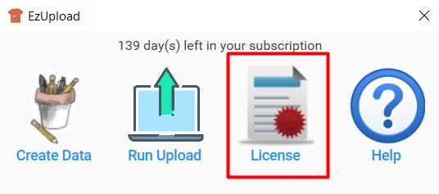 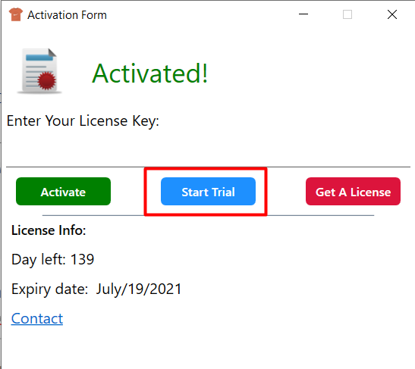

# Create content to upload (JSON file)

* 1. At main menu choose “Create Data”

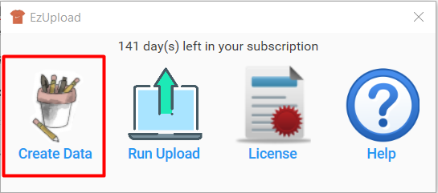

* 1. Go to tab Merch Upload, click Browse Image to select image file (.PNG) or choose “Browse JSON” to edit content file

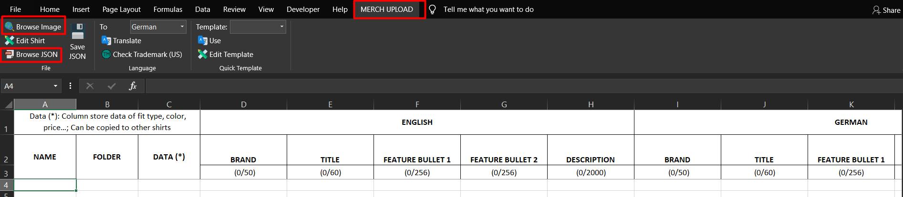

* 1. To edit price, fit type, color…, choose row to edit and click “Edit Shirt”

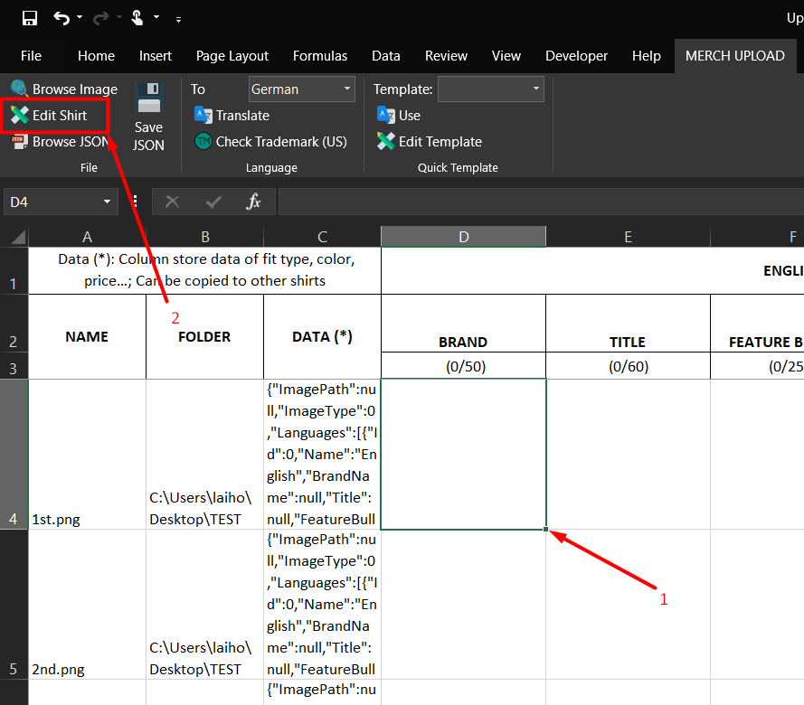 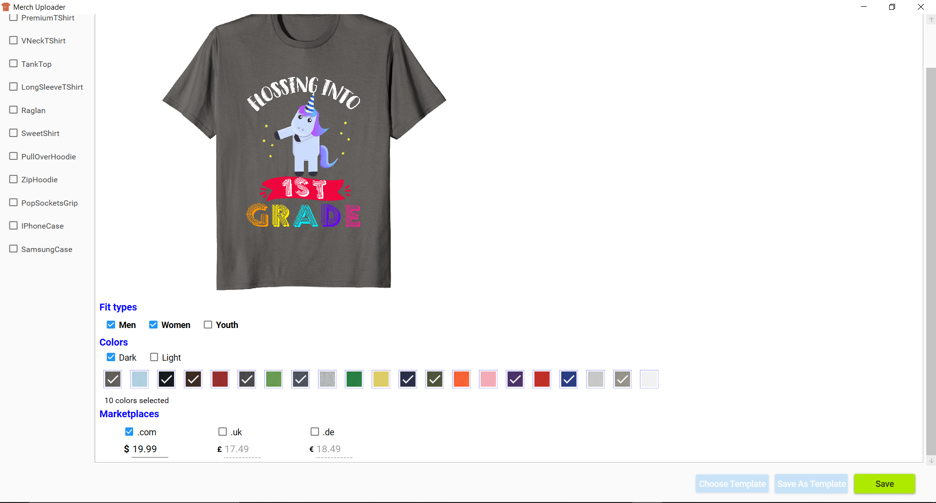 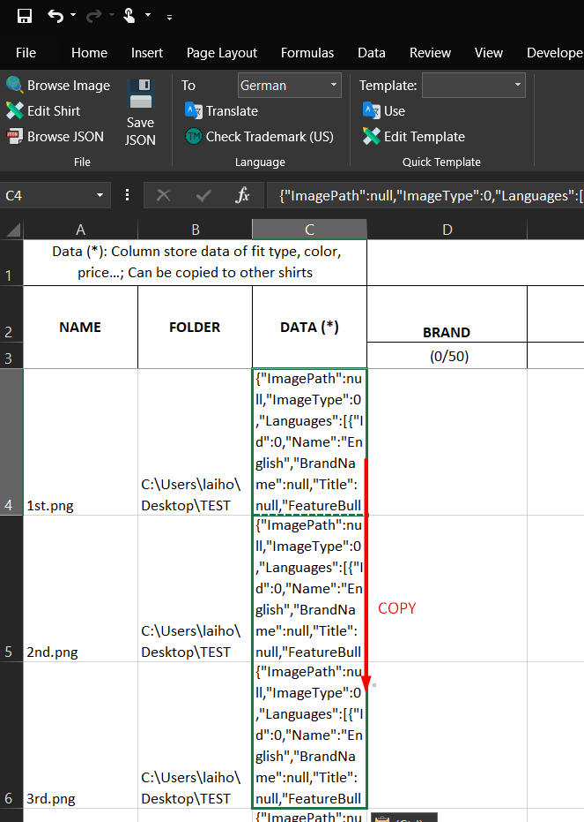

* After editing, click “Save” text data will be stored in “C”
* Copy text in “C” column to other rows to apply this style to other shirts.
  1. Write Brand, Title, Bullet, Description respectively.
  2. Other utility function:
* “Translate”: using Google translate to translate to other language
* “Check Trademark”: check Trademark for active cell (US only)
* “Template”: Save and use frequently used text
  + Click “Edit Template” and add frequently use text (include data in C column) and save

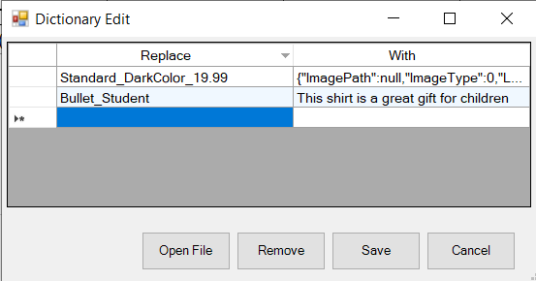

* + Back to excel file, select cell, select template and click “Use”

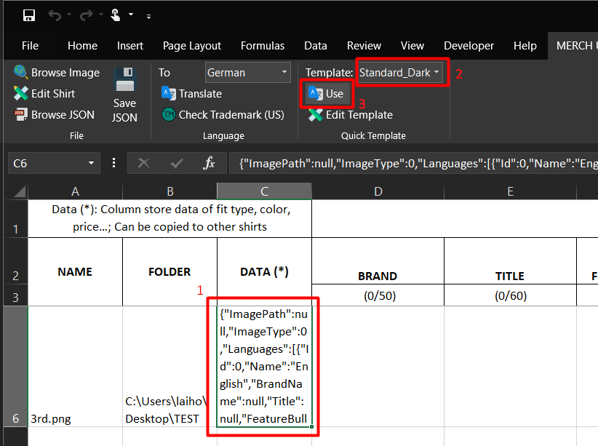 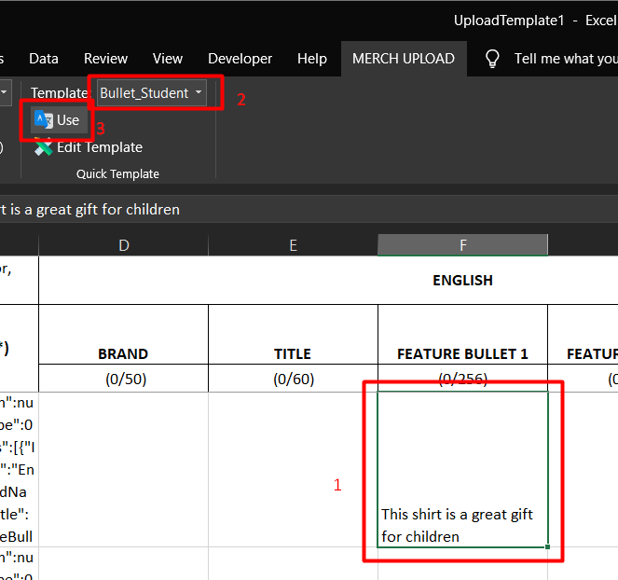

* 1. After complete click “Save JSON”
* *JSON file which store upload data will be stored at same folder with image file (.PNG)*

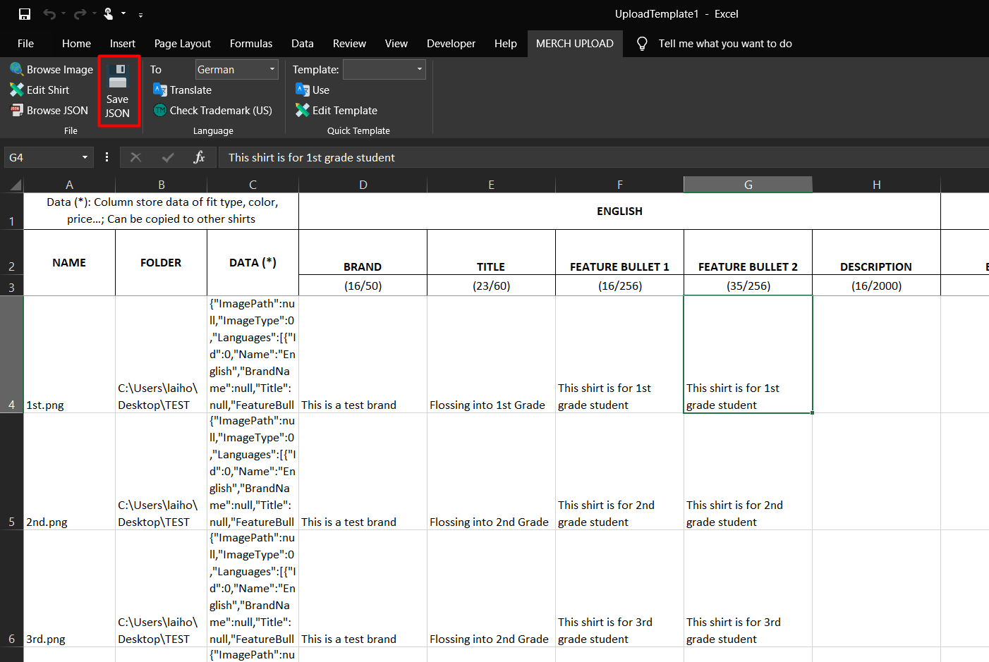

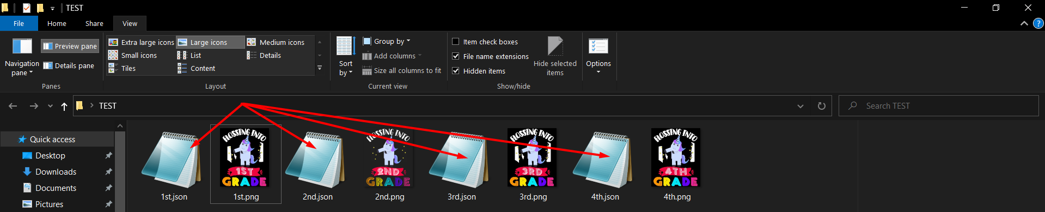

# Account configurations

*You just have to do these configurations for first time upload, next time tool will auto login for you*

* 1. Click Run Upload, expand tab Account Configurations

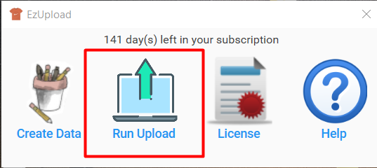

* 1. Click “+” to add folder (1 folder for each account)
* This folder will store cookies for next log in session

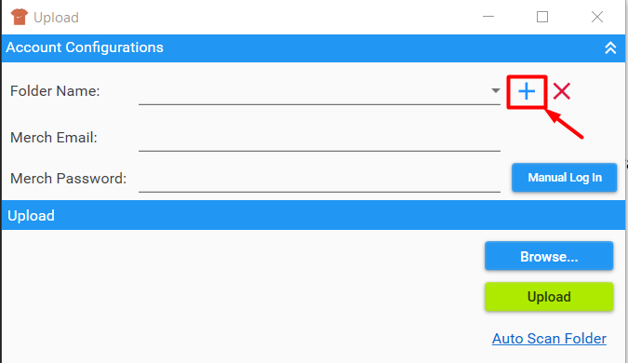 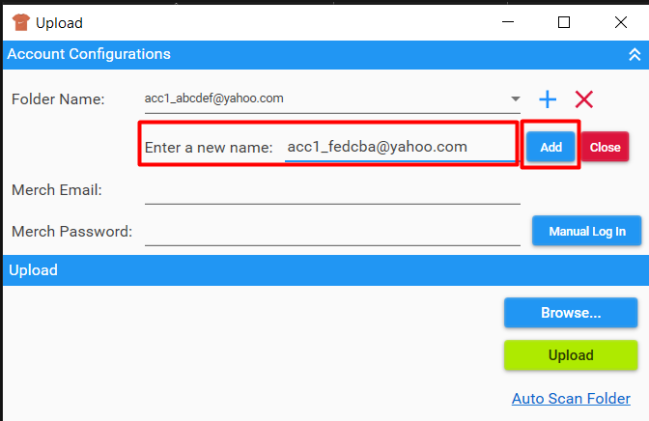

* 1. Click “Manual Log In” and manually log in for first time
* Check don’t require OTP in this browser

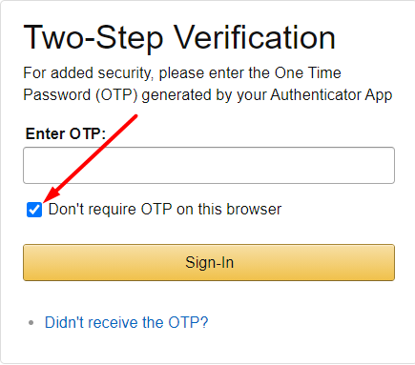

* 1. You can store email & password to auto log in next time, email & password will be encrypted and only store on your computer

# Run Upload

* 1. Choose Browse… and browse to created JSON files and click “UPLOAD”
* *Note: PNG file must be in the same folder with JSON file*

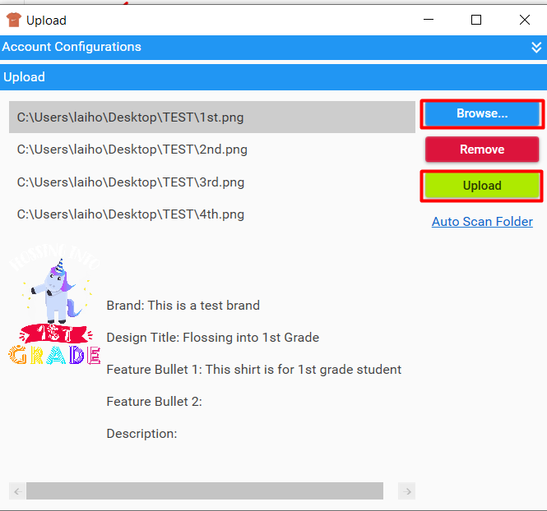

# Auto Scan Folder mode

*In this mode, every time JSON files copied into chosen folder, tool will automatically trigger an upload session*

* 1. Click Browse… and choose folder to watch
  2. Input daily upload limit (depend on your tier)

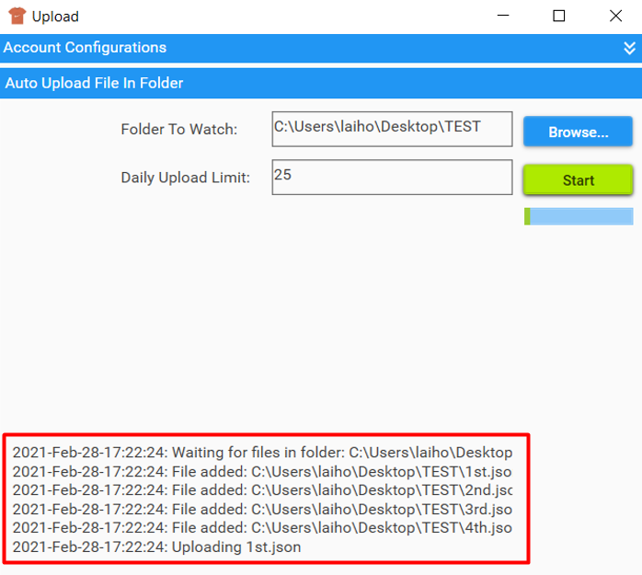

* 1. Click “Start” and the tool will start watching the folder

*Success/Fail upload will be copied to Success/Fail sub folder inside the folder*