选取2019年4月的会员销售分析

1. 分析购买A专柜同时购买B专柜的会员，统计专柜之间的关联度，获得主要关联多的专柜组合：

| **nuu** | **BRANDNAME** | **BRANDNAME** |
| --- | --- | --- |
| 106 | ADIDAS* | NIKE |
| 64 | PEPCO BABY* | 迷你铅笔* |
| 58 | 江博士* | 米奇/牧童等 |
| 56 | 爱乐游** | 江博士* |
| 54 | 江博士* | 迷你铅笔* |
| 51 | 安奈儿* | 米奇/牧童等 |
| 51 | 爱乐游** | 米奇/牧童等 |
| 51 | 米奇/牧童等 | 小猪班纳pepco |
| 51 | 安奈儿* | 小猪班纳pepco |

1. 通过购买ADIDAS* 的单数或额度与是否购买NIKE的回归分析

与单数：

| **最大似然估计分析** | | | | | |
| --- | --- | --- | --- | --- | --- |
| **参数** | **自由度** | **估计** | **标准 误差** | **Wald 卡方** | **Pr > 卡方** |
| Intercept | 1 | -2.4866 | 0.2658 | 87.5125 | <.0001 |
| bills | 1 | 0.5528 | 0.2037 | 7.3659 | 0.0066 |

| **优比估计** | | | |
| --- | --- | --- | --- |
| **效应** | **点估计** | **95% Wald 置信限** | |
| bills | 1.738 | 1.166 | 2.591 |

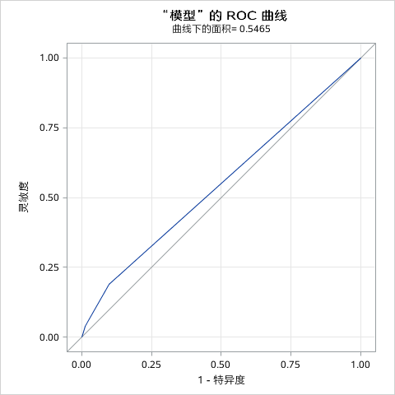

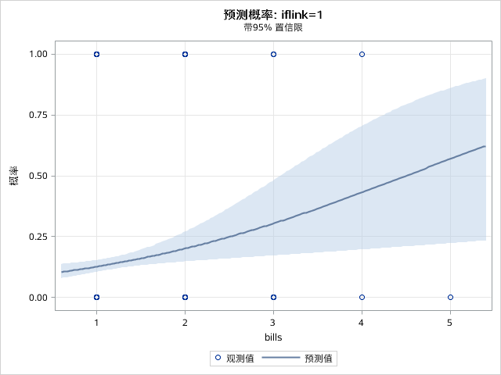

与额度：

| **最大似然估计分析** | | | | | |
| --- | --- | --- | --- | --- | --- |
| **参数** | **自由度** | **估计** | **标准 误差** | **Wald 卡方** | **Pr > 卡方** |
| Intercept | 1 | -1.8306 | 0.1800 | 103.3998 | <.0001 |
| amount | 1 | -0.00002 | 0.000211 | 0.0064 | 0.9363 |

| **优比估计** | | | |
| --- | --- | --- | --- |
| **效应** | **点估计** | **95% Wald 置信限** | |
| amount | 1.000 | 1.000 | 1.000 |

