Design Document Notes

* Goals of a design doc
  + Document the software design
  + Clarify the problem being solved
  + Act as discussion platform to further refine the design
  + Explain the reasoning behind those decisions and tradeoffs made in that decision
  + List alternatives and why they weren’t chosen
  + Support future workers by documenting design process
* Software design
  + Accounts for expertise presented
  + Flexible to changing requirements
  + Produces guideline for implementation
  + Accounts for time constraints
  + Minimal Viable Product
    - Emphasizes simplicity
* Relationship to other systems
  + 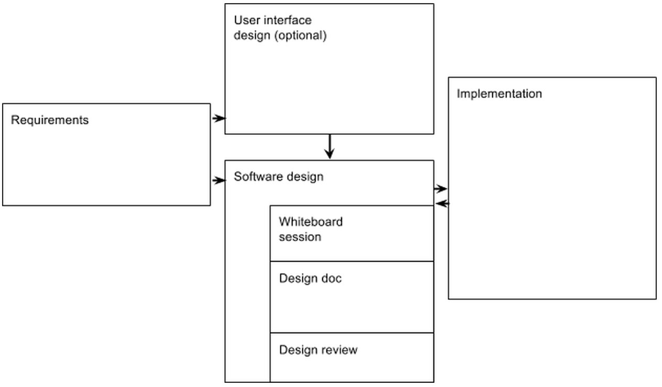
* Context, scope, and goals
  + Quickly shows what is trying to be accomplished, how to assess effectiveness, and forces decisions to be made within the scope of the project
* Consider big picture
  + Cross cutting
  + Security and privacy
  + Ethical implications
  + Alternatives considered

Reference: “Design docs – A design doc” by Malte Ubl. https://medium.com/@cramforce/design-docs-a-design-doc-a152f4484c6b