Laikh Tewari

Ms. Chen

Senior Project

May 22, 2018

Evidence of Modes

Primary: This week, I focused on implementing a shell iOS app to simulate the full functionality. The general flow of the app proceeds as follows:

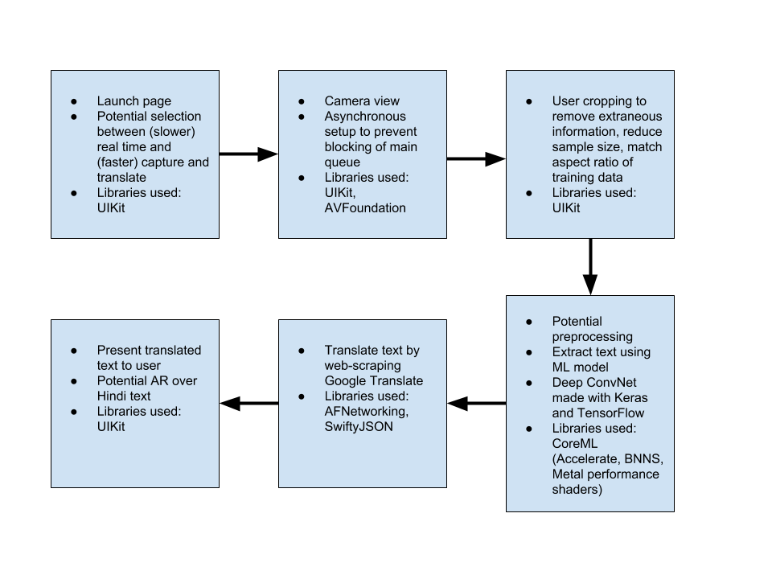

As shown in the diagram, the UI work was done natively in iOS using UIKit. In order to develop the camera module, I used the AVFoundation library. I decided to set up the camera asynchronously, since, while I was testing the app, it would stall briefly trying to call the hardware. Apple also has implemented safeguards to prevent developers from accessing the camera without a user’s knowledge, so I also implemented a permissions manager. My next steps are to develop the machine learning model using Keras with a TensorFlow backend and implement the translation module by web-scraping Google Translate.

Secondary: In researching the construction of a design document, I came across the idea of the Minimal Viable Product (MVP). This philosophy is often used to guide software projects, stating that all additional features should be cut in the short run so that the core of the project is finished quickly. The motivation for working on the MVP comes from a desire to go to market as soon as possible, or even to present to investors, who care more about the potential growth and presentation than the technical details driving the software. I began developing a design doc to record my design decisions toward the MVP. Moreover, I also included “big picture” concepts, such as a problem statement, overview of the solution, the impact it would have, and differentiation from preexisting products.