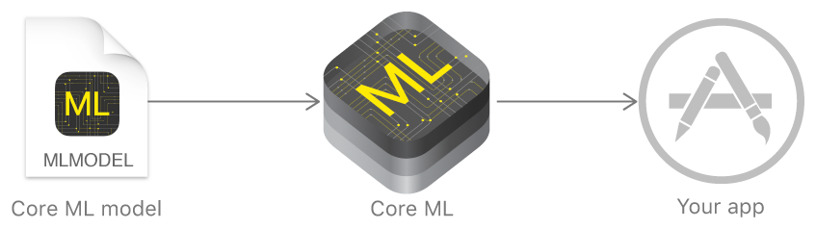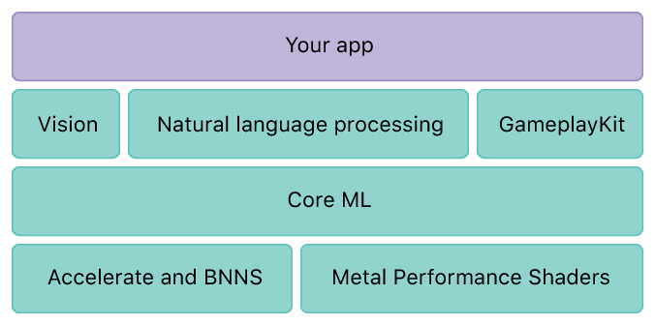

* Accelerate
  + large-scale mathematical computations and image calculations, optimized for high performance
    - Vector/matrix math
    - Digital signal processing
    - Large number handling
    - Image processing
* Basic Neural Network Subroutines (BNNS)
  + Collection of functions that you use to implement and run neural networks, using previously obtained training data
* Metal Performance Shaders
  + Optimization of computational performance with kernels tuned to hardware GPUs