Create a Bank Application with the following requirements:

1. Customer can login to bank application with already provided customer Id and password
2. Customer can update the password
3. Customer can edit his/her profile
4. Customer can check his/her account balance.
5. Customer can do the fund transfer.

Sample GUI:

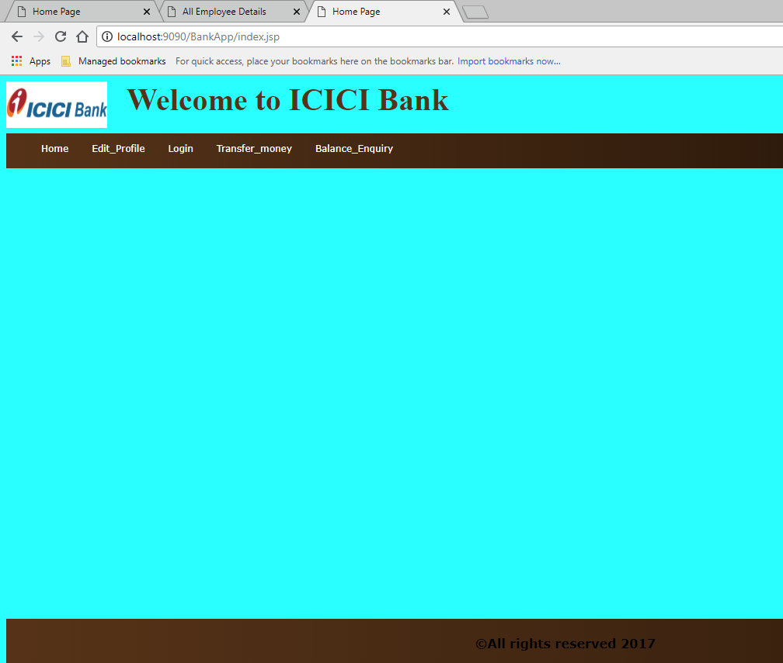

Home page should provide the following links

(Display necessary links whenever required)

1. Link to home page
2. Fund Transfer
3. Edit profile
4. Login
5. Change password
6. Logout
7. Check balance

If cookie is disabled, force the client to enable the cookie. (Check whether cookie is enabled or disabled at client browser.

Check the performance of bank application by logging request processing time.

Instructions:

1. Create appropriate layers of application (controller, service, dao and model)
2. Create 2 entities one is Customer and second is BankAccuount
   1. Customer entity has following attributes: customer id, customer name, password, email, address, date of birth and account
   2. BankAccount has following attributes: account id, account type and balance
3. Proper Naming conventions (Meaningful names)
4. Proper Package structures