EL SEWEDY UNIVERSITY OF TECHNOLOGY
Faculty of Engineering Technology · Industry White Paper

WHITE PAPER
PetPulse
Egypt’s all-in-one pet care ecosystem connecting owners, vets, trainers, and shops on a single trusted platform.
A white paper is a short, persuasive business document that introduces your project to people outside the university — industry partners, potential funders, and research collaborators. Unlike your proposal (which proves your project to academic examiners), a white paper proves your project to the real world.
In 4 short paragraphs, deliver: (1) the problem, (2) the solution, (3) the proof it works, (4) the call to action. Target length: 150–200 words. Use plain language — no jargon. Lead with a striking statistic or scenario if possible.
The Problem
Egypt’s pet care sector is fragmented and largely offline — pet owners struggle to find verified veterinarians, certified trainers, or trusted pet sitters, while pet businesses lack a unified digital channel to reach customers, resulting in poor service discovery, unverified providers, and zero community infrastructure for Egypt’s rapidly growing pet-owning population.

Our Solution
PetPulse is a full-stack web platform and marketplace that connects Egyptian pet owners with verified veterinarians, certified dog trainers, premium pet shops, adoption hubs, mating match services, monthly subscription boxes, and secure pet hosting — all in one place, with profile verification and community-driven trust signals.

Proof It Works
PetPulse’s MVP launched on Vercel and successfully integrated 7 distinct service verticals — veterinary consultations, training academies, pet shops, adoption, mating, subscription boxes, and pet hosting — into a single responsive platform serving Cairo’s pet community.

What We're Looking For

Partner with PetPulse to onboard your veterinary clinic, pet shop, or training academy onto Egypt’s first unified pet care marketplace — reach thousands of verified pet owners from day one.

How It Compares
A quick visual comparison helps decision-makers. Add 3–5 rows comparing your solution to the leading
alternatives.
Feature | Our Solution | Facebook Groups | Generic Classifieds (OLX)
Provider Verification | ✓ Verified Profiles | Unverified | Unverified
Service Verticals | ✓ 7 (Vet, Train, Shop, Adopt, Mate, Box, Host) | 1 (Community only) | 1 (Listings only)
Pet-Specific UX | Yes — Purpose-built | No — Generic UI
Egypt-Focused | ✓ Yes | No | Partial
Example values shown — replace with your real comparison.

2. How It Works
Build credibility without losing readers
Industry readers want to know if there is real substance behind the pitch — but they will close the document if it becomes a textbook. Aim for: one diagram + 4 short steps + a list of key technologies. Save deep technical details for the thesis.
System at a Glance
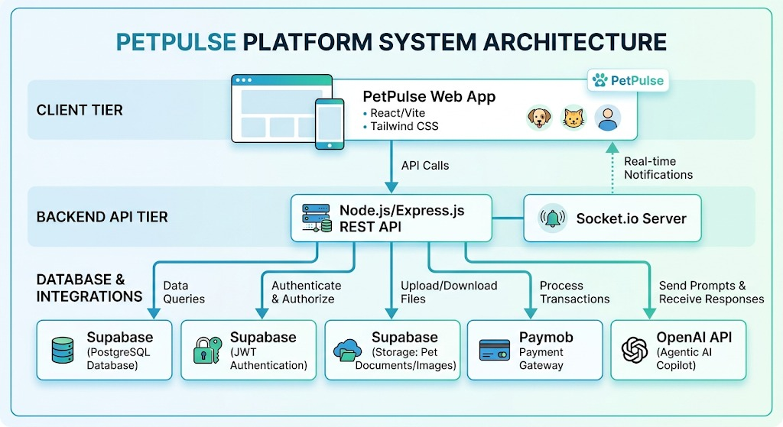
Insert a clean system diagram or architecture sketch below. Caption it clearly
1 | Sign Up & Build Your Profile | Pet owners, vets, trainers, and shop owners create verified profiles — specifying their pets, services, and availability. Businesses upload credentials for trust-badge verification.
2 | Browse & Connect | Owners search by service type, location, and pet breed. PetPulse surfaces verified vets, trainers, shops, adoption listings, and hosting providers near them in Cairo.
3 | Book & Transact | Users schedule appointments, place product orders, submit hosting requests, or contact providers directly through the platform — eliminating the need for scattered WhatsApp conversations and unreliable service discovery.
4 | Review & Grow | After every interaction, users can leave verified reviews and ratings. These reviews help providers build credibility while helping other pet owners make informed decisions.

The 4-Step Process

3.Results & Validation
Hard numbers build trust. Three KPIs at the top — then a 2-paragraph narrative of how you tested and what you found.
7  SERVICE VERTICALS | Cairo  LAUNCH CITY | 1 Platform  ALL-IN-ONE SOLUTION
Example KPI values shown — replace numerator, denominator, and labels with your real metrics.
4. Get Involved
Let's talk.
We are looking for industry partners, investors, and collaborators to take this solution from prototype to deployment.
FOR INDUSTRY  Partner With Us  List your clinic, shop, or academy on PetPulse and gain instant access to CairoRun a real-world pilot at your facility with full support from our teams verified pet owner community. | FOR FUNDERS  Invest in PetPulse  Help us scale from prototype to commercial deployment — detailed financials available on request. | FOR RESEARCHERS  Research & Expand  Partner with us on pet health data research, AI-driven vet triage, or regional expansion across MENA.

CONTACT THE TEAM
Team members | Salma Mohamed – 230105870, Laila Mohamed – 250103991, Fatma Mohamed – 230106003, Sara Salah – 230105798, Ahmed Sherif – 230104417, Essam Osama – 230104858, Gaber Hosny – 230101439, Mohamed Ebrahim – 230101269, Mahmoud Mustafa Mahmoud – 230105193, Abdelrahman Essam Ali – 230102357
Supervisor | Dr. Hend Adel · Email hend.ahmed@sut.edu.eg
Project Page / Repo  Qr Code for QMS | https://petpulse-pi.vercel.app/

PetPulse was built by a team of engineering technology students at El Sewedy University of Technology, combining full-stack web development, UX design, and market research to address a real gap in Egypt’s pet care industry.
Name | Role | Contribution & Background
Salma Mohamed | frontend | Co-led the development of the PetPulse user interface using React.js and Vite. Salma focused on building out the core user flows, including the provider search interfaces and the adoption hub module. She ensured that the platform's UI components were highly responsive across all devices and implemented state management to handle complex user interactions seamlessly.
Laila Mohamed | backend | Contribution & Background: Architected and deployed the core backend infrastructure using Node.js and Express.js. Laila was responsible for designing the complex relational database schema in Supabase (PostgreSQL) to support heterogeneous data models for vets, trainers, and shops. She also developed the primary RESTful API endpoints and managed the seamless integration of Cloudinary for media storage.
Fatma Mohamed | backend | Contribution & Background: Focused on the backend logic and third-party integrations critical to the platform's functionality. Fatma engineered the booking logic, appointment scheduling systems, and the integration of the Paymob payment gateway. She also implemented database connection pooling and cron jobs to eliminate serverless cold-start latencies and maintain high availability.
Sara Salah | frontend | Co-led the frontend engineering effort with a strong focus on UI/UX design and styling using Tailwind CSS. Sara developed the reusable component library (cards, modals, form controls) used across the five main service modules. She was responsible for optimizing the frontend performance, ensuring the application met its target of sub-2-second page load times.
Ahmed Sherif | Agentic Ai | Spearheaded the research and integration of the OpenAI API to power PetPulse's intelligent features. Ahmed designed the system architecture required to support the Agentic AI Copilot, ensuring that user prompts were efficiently processed and contextually relevant responses were generated to assist pet owners with health and training queries.
Essam Osama | Agentic Ai | Focused on AI workflow automation and system integration. Essam developed the backend logic necessary to connect the AI models with the platform's live database, allowing the AI to fetch real-time data about provider availability and pet records. He optimized the API calls to reduce latency and manage token costs.
Gaber Hosny | security | Led the implementation of the platform's authentication and authorization architecture. Gaber integrated robust JWT (JSON Web Token) middleware to secure all write endpoints across the 19 Express routers, ensuring that stateless, horizontally scalable sessions were both reliable and highly secure against hijacking attempts.
Mohamed Ebrahim | Agentic Ai | Led the prompt engineering and AI model fine-tuning efforts. Mohamed established the strict safety guardrails and system instructions that prevent the AI from giving unverified medical advice, ensuring it properly redirects critical cases to human veterinarians within the PetPulse ecosystem.
Mahmoud Mustafa Mahmoud | security | Focused on data privacy and strict Role-Based Access Control (RBAC). Mahmoud engineered the logic that firmly separates the privileges of standard pet owners, verified service providers (vets/trainers), and platform administrators, ensuring that sensitive user data and financial records are strictly isolated
Abdelrahman Essam Ali | security | Directed the platform’s vulnerability management and secure data transmission protocols. Abdelrahman ensured all database queries were sanitized to prevent SQL injection, managed the secure environment variables for production deployments, and validated the security compliance of the Paymob transaction processing flows.

This project was developed at El Sewedy University of Technology (SUT) — Egypt's polytechnic university dedicated to applied engineering and industry collaboration. SUT students work on projects connected to real industrial partners across the energy, manufacturing, and technology sectors.

© El Sewedy University of Technology · Polytechnic of Egypt

