**ليلي عصام بدوي محمود Name**:

**B.N**:620

**Topic**: Big Data

GitHub Link: https://github.com/lailaessam975/ece001

GitHub Pages: https://lailaessam975.github.io/ece001/

Big Data and its Applications:

The world today produces an enormous amount of data every day. Experts have predicted that this scenario may also result in a great wave of data or dramatically, even a data tsunami. This huge amount of data is nowadays known as Big Data. More or less of the data tsunami being true, we now feel it a necessity to have a tool to have this data in a systematic manner for applications in various fields including government, scientific research, industry, etc. This will help in a proper study, storage, and processing of the same.

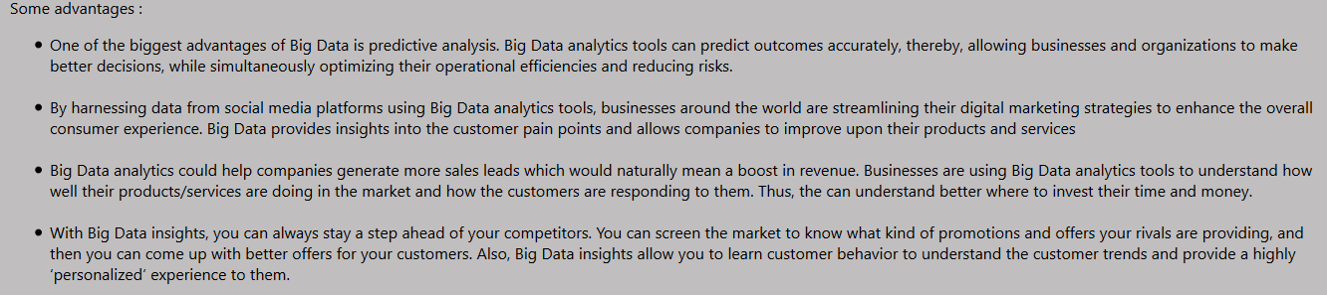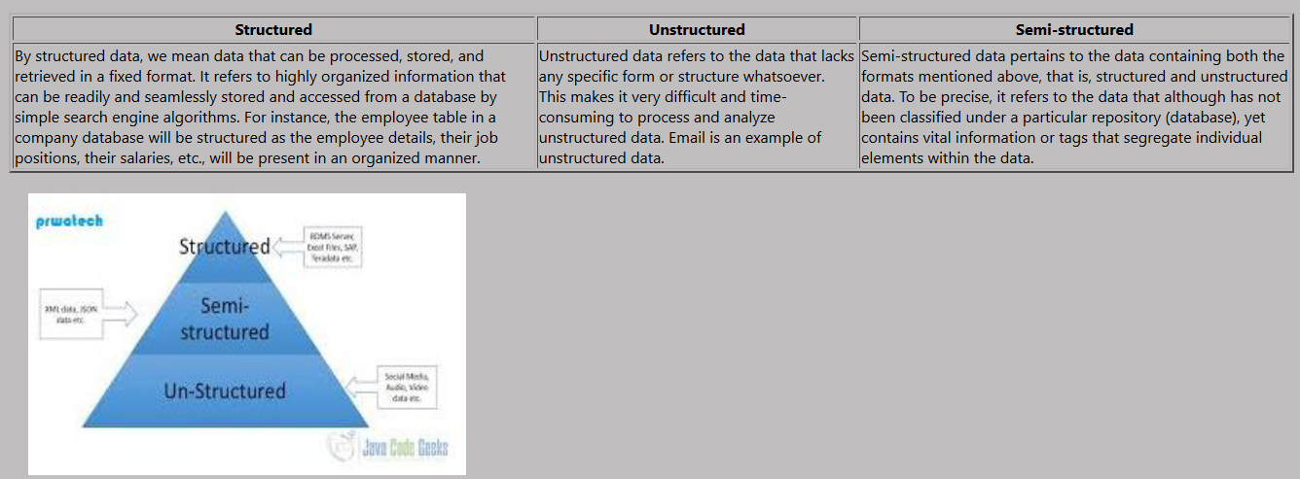Screenshots:

*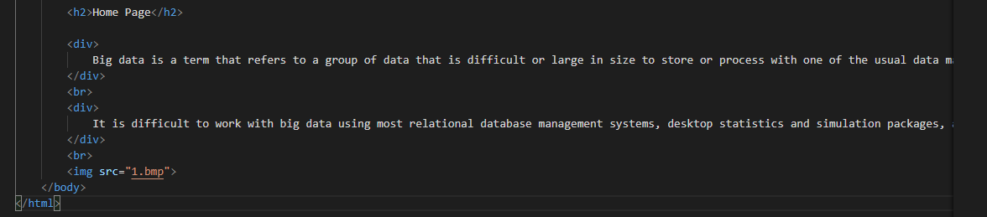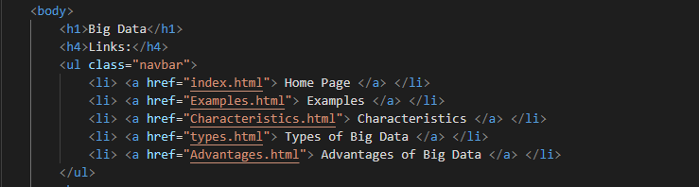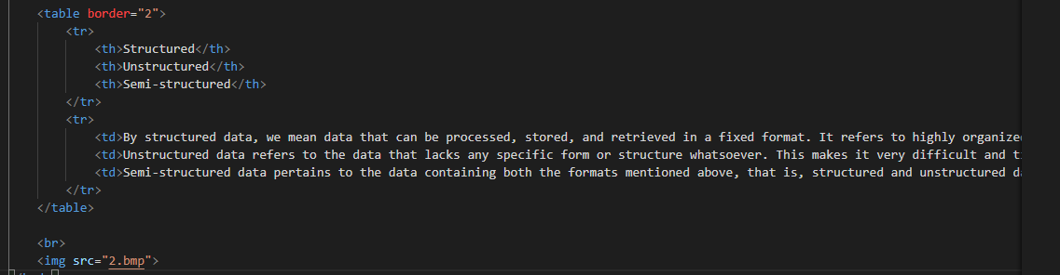Source Code:*