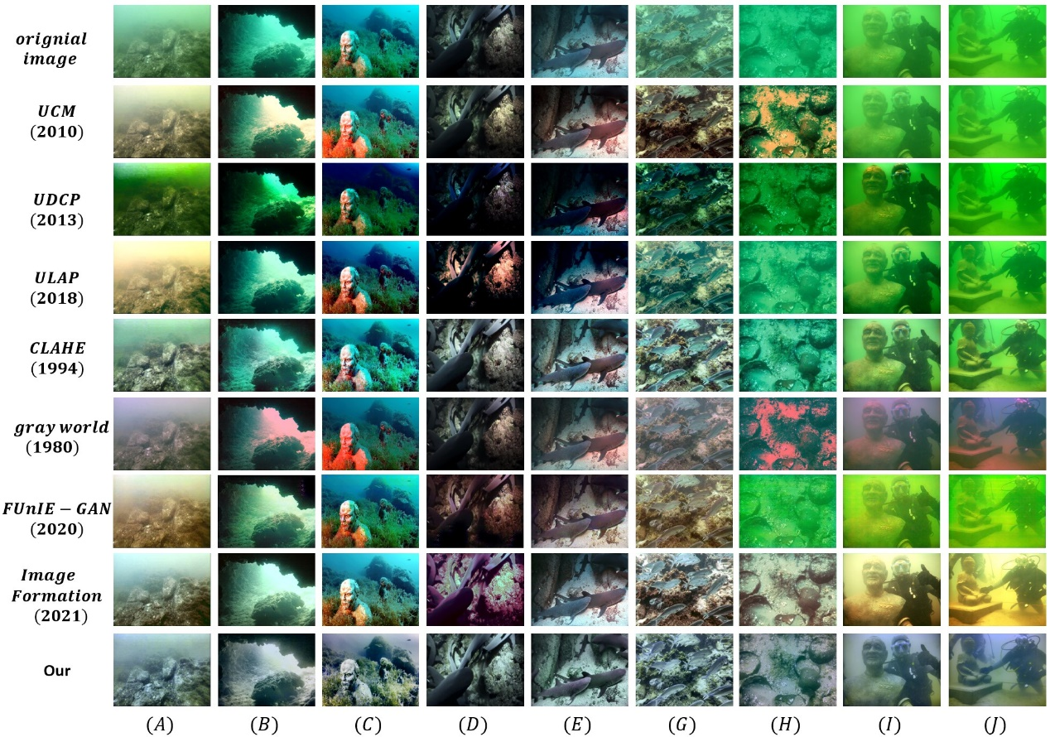

Please evaluate the quality of the images according to the subjective visual experience, and rate each image out of five points, and each column of images is a group as a comparison.

|  |  |  |  |  |  |  |  |  |  |
| --- | --- | --- | --- | --- | --- | --- | --- | --- | --- |
|  | **(A)** | **(B)** | **(C)** | **(D)** | **(E)** | **(G)** | **(H)** | **(I)** | **(J)** |
| **1** | 3 | 2 | 1 | 3 | 3 | 1 | 2 | 1 | 2 |
| **2** | 2 | 3 | 2 | 3 | 2 | 1 | 3 | 2 | 3 |
| **3** | 3 | 3 | 4 | 3 | 3 | 1 | 4 | 1 | 3 |
| **4** | 4 | 2 | 2 | 1 | 3 | 3 | 4 | 4 | 1 |
| **5** | 2 | 2 | 1 | 2 | 2 | 1 | 1 | 2 | 3 |
| **6** | 1 | 3 | 3 | 2 | 1 | 1 | 2 | 1 | 2 |
| **7** | 1 | 1 | 2 | 2 | 3 | 3 | 4 | 4 | 3 |
| **8** | 4 | 3 | 4 | 4 | 4 | 3 | 3 | 3 | 4 |

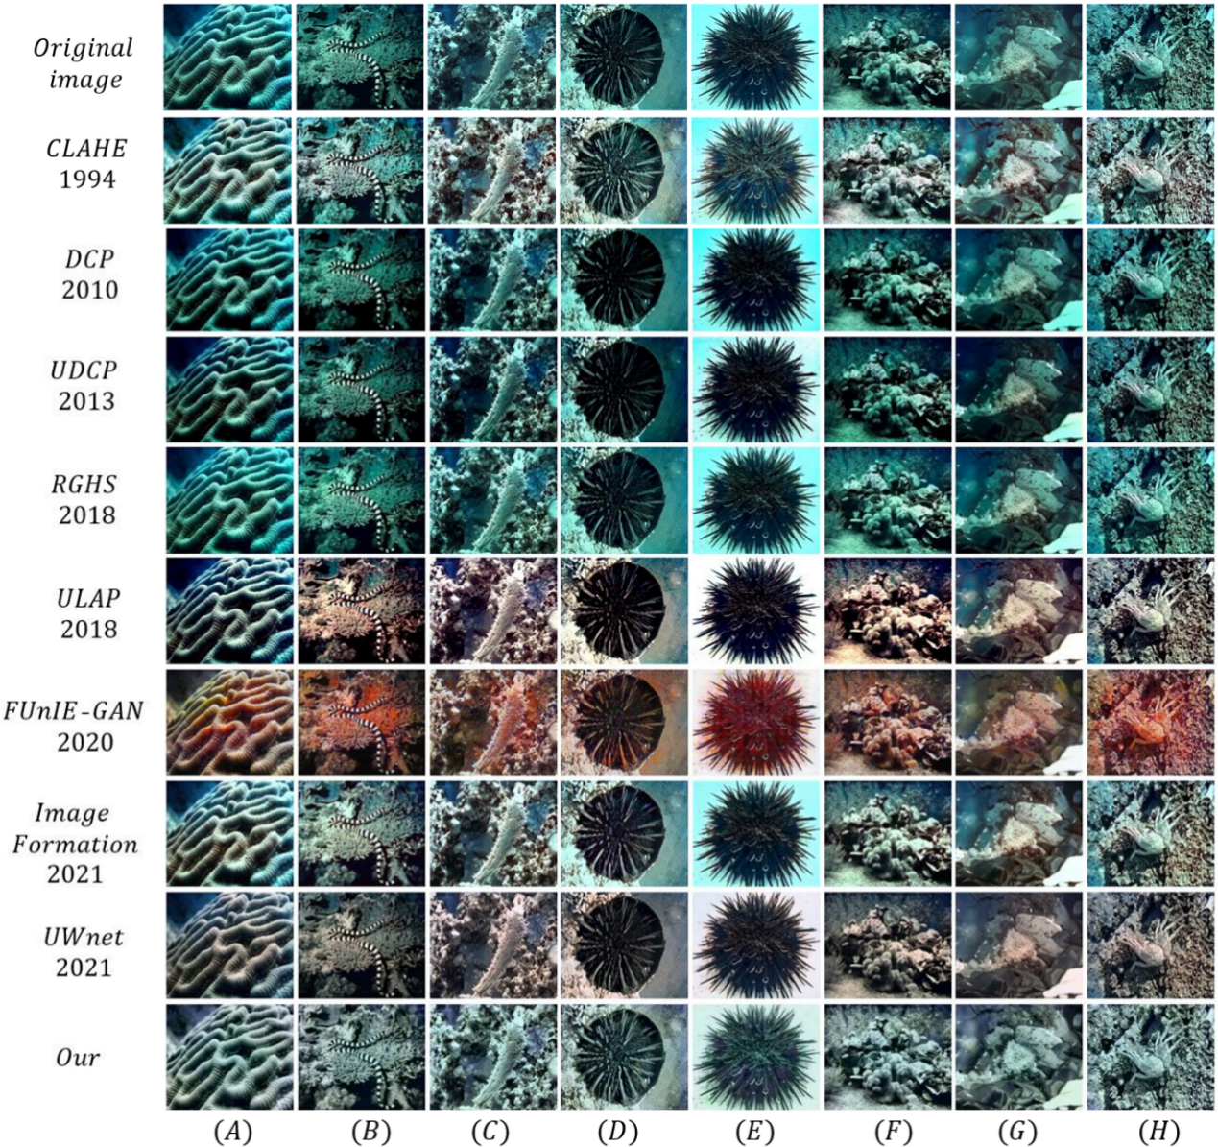

Please evaluate the quality of the images according to the subjective visual experience, and rate each image out of five points, and each column of images is a group as a comparison.

|  |  |  |  |  |  |  |  |  |
| --- | --- | --- | --- | --- | --- | --- | --- | --- |
|  | **(A)** | **(B)** | **(C)** | **(D)** | **(E)** | **(F)** | **(G)** | **(H)** |
| **1** | 3 | 2 | 3 | 1 | 2 | 1 | 3 | 2 |
| **2** | 1 | 2 | 3 | 4 | 2 | 2 | 3 | 1 |
| **3** | 2 | 2 | 2 | 3 | 1 | 2 | 2 | 4 |
| **4** | 1 | 3 | 1 | 3 | 2 | 2 | 1 | 4 |
| **5** | 3 | 4 | 3 | 2 | 3 | 4 | 3 | 2 |
| **6** | 2 | 1 | 2 | 3 | 2 | 1 | 2 | 1 |
| **7** | 2 | 2 | 3 | 2 | 3 | 3 | 2 | 3 |
| **8** | 2 | 3 | 2 | 2 | 3 | 3 | 3 | 2 |
| **9** | 3 | 4 | 2 | 4 | 4 | 4 | 3 | 3 |

participator

|  |  |  |
| --- | --- | --- |
| Gender | Age | Occupation |
| female | 23 | student |