**Soal Studi Kasus (TODO LIST)**

1. Buatlah sebuah form input yang memungkinkan karyawan untuk memasukkan tugas baru.



<form name="myForm" id="todoForm">

    <input placeholder="masukkan tugas" id="todo" name="fname" required>

    <button type="button" onclick="AddTodo()">Tambah</button>

  </form>

1. Tampilkan daftar tugas yang sudah ditambahkan dengan menggunakan elemen HTML yang sesuai.

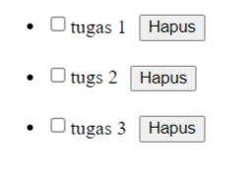

function AddTodo() {

  var item = document.getElementById("todo").value

  if (item === "") {

    alert("input text tidak boleh kosong!");

  } else {

    var text = document.createTextNode(item);

    var newItem = document.createElement("li");

    wrap = document.getElementById("todoList");

    wrap.appendChild(newItem);

    var checkBox = document.createElement("input");

    checkBox.type = "checkbox";

    checkBox.onclick = checkedTodo.bind(checkBox);

    var btn = document.createElement("button");

    btn.style.margin = "10px"

    btn.textContent = "Hapus"

    btn.addEventListener('click', () => newItem.remove());

    newItem.appendChild(checkBox);

    newItem.appendChild(text);

    newItem.appendChild(btn);

    document.getElementById("todo").value = "";

  }

}

1. Berikan opsi untuk menandai tugas sebagai selesai atau belum selesai.

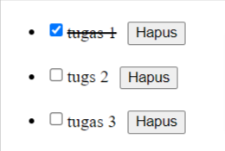

function checkedTodo() {

    console.log("unchecked", unchecked())

    if (this.checked) {

      this.parentNode.style.textDecoration = "line-through";

    } else {

      this.parentNode.style.textDecoration = "none";

    }

  }

1. Tambahkan fitur penghapusan tugas dari daftar.

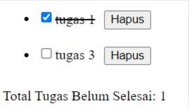

var btn = document.createElement("button");

    btn.style.margin = "10px"

    btn.textContent = "Hapus"

    btn.addEventListener('click', () => newItem.remove());

1. Tampilkan jumlah total tugas yang belum selesai.

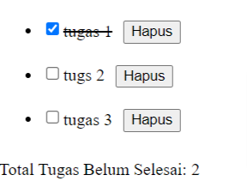

 function unchecked() {

    var checkboxes = document.querySelectorAll('#todoList input[type="checkbox"]');

    var uncheckedTodo = 0;

    checkboxes.forEach(function (checkbox) {

      if (!checkbox.checked) {

        uncheckedTodo++;

      }

    });

    document.getElementById("total-uncheced").innerHTML = `<p>

        Total Tugas Belum Selesai: ${uncheckedTodo}

      </p>`

  }

1. Tampilkan pesan atau notifikasi jika karyawan telah menyelesaikan semua tugas.

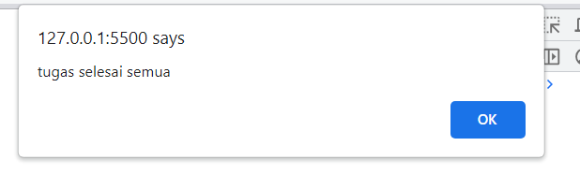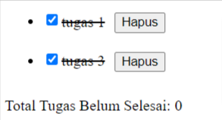

 document.getElementById("total-uncheced").innerHTML = `<p>

        Total Tugas Belum Selesai: ${uncheckedTodo}

      </p>`

  if (uncheckedTodo === 0) alert("tugas selesai semua")

1. Buatlah tombol untuk menghapus semua tugas sekaligus.



var btnremove = document.getElementById("remove-all")

var todoList = document.getElementById("todoList")

btnremove.addEventListener('click', function () {

  while (todoList.firstChild) {

    todoList.removeChild(todoList.firstChild);

  }

})

1. 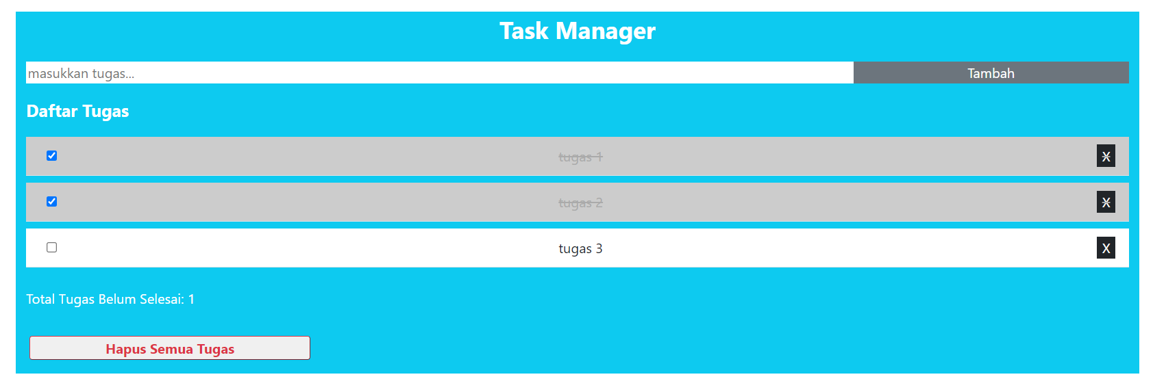Tambahkan Design dengan Boostrap 5. Desing Bebas.
2. <!DOCTYPE html>
3. <html lang="en">
4. <head>
5. <meta charset="utf-8">
6. <meta name="viewport" content="width=device-width, initial-scale=1">
7. <!-- Bootstrap CSS -->
8. <link href="https://cdn.jsdelivr.net/npm/bootstrap@5.0.2/dist/css/bootstrap.min.css" rel="stylesheet" integrity="sha384-EVSTQN3/azprG1Anm3QDgpJLIm9Nao0Yz1ztcQTwFspd3yD65VohhpuuCOmLASjC" crossorigin="anonymous">
9. <script src="script.js"></script>
11. <title>Document</title>
12. </head>
13. <style>
14. html, body {
15. height: 100%;
16. }
17. </style>
18. <body>
19. <div class="container p-3">
20. <div class="row bg-info">
21. <p class="text-center fw-bold fs-3 text-white">Task Manager</p>
22. <div class="d-flex w-100 mb-3">
23. <input id="todo" class="w-75  border-0" placeholder="masukkan tugas..." type="text" required>
24. <button onclick="AddTodo()" class="w-25 bg-secondary text-white border-0 btnadd">Tambah</button>
25. </div>
26. <p class="fw-bold fs-5 text-white">Daftar Tugas</p>
27. <ul id="todoList"></ul>
28. <div class="text-white" id="total-uncheced"></div>
29. <button onclick="removeAll()" class="fs-6 w-25 rounded-1 m-3 text-danger border-1 border-danger fw-bold">Hapus Semua Tugas</button>
30. </div>
31. </div>
33. <!-- Option 1: Bootstrap Bundle with Popper -->
34. <script src="https://cdn.jsdelivr.net/npm/bootstrap@5.0.2/dist/js/bootstrap.bundle.min.js" integrity="sha384-MrcW6ZMFYlzcLA8Nl+NtUVF0sA7MsXsP1UyJoMp4YLEuNSfAP+JcXn/tWtIaxVXM" crossorigin="anonymous"></script>
35. <!-- Option 2: Separate Popper and Bootstrap JS -->
36. <script src="https://cdn.jsdelivr.net/npm/@popperjs/core@2.9.2/dist/umd/popper.min.js" integrity="sha384-IQsoLXl5PILFhosVNubq5LC7Qb9DXgDA9i+tQ8Zj3iwWAwPtgFTxbJ8NT4GN1R8p" crossorigin="anonymous"></script>
37. <script src="https://cdn.jsdelivr.net/npm/bootstrap@5.0.2/dist/js/bootstrap.min.js" integrity="sha384-cVKIPhGWiC2Al4u+LWgxfKTRIcfu0JTxR+EQDz/bgldoEyl4H0zUF0QKbrJ0EcQF" crossorigin="anonymous"></script>
38. </body>
39. </html>