**errchecker**

Here is errchecker and fake_logs_generator executed. It prints exactly the same output as it is in /tmp/errchecker-log.txt . “Exception:” is detected during Tomcat startup and count is printed.

Centos

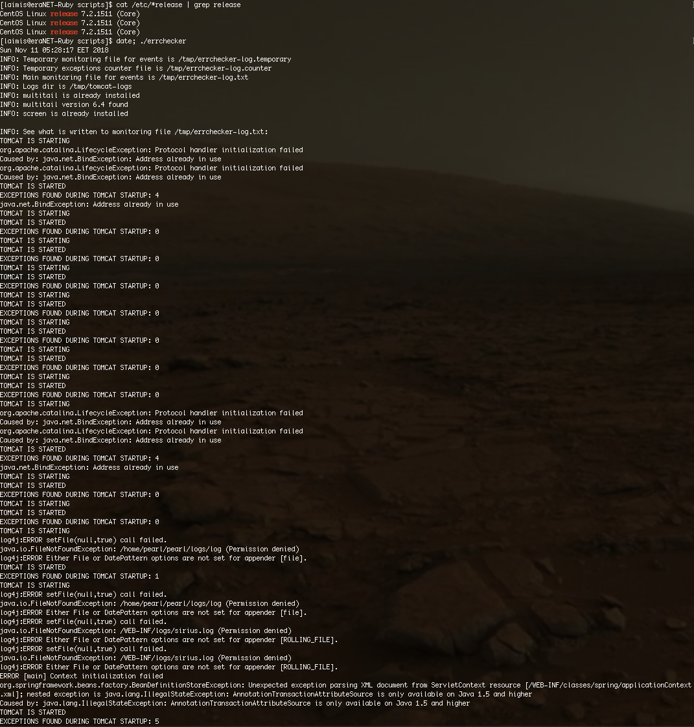

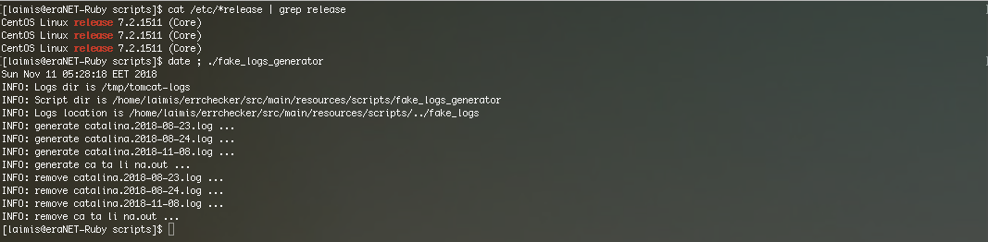

Ubuntu

