DDA (Discontinuous Deformation Analysis) Software User Guide

1. Introduction

This software is intended to provide services for DDA users and several costumed functions were implemented to ease their work. All calculation use DDA’s author Dr. Shi’s code.

This is open source software; users could do [secondary](app:ds:secondary) [development](app:ds:development) under LGPL license according to their needs.

The architecture of the software is designed for DDA. Currently, it is simple implementation, and will get further development next. If you have any suggestion, please mail to [ddasoftware@163.com](mailto:ddasoftware@163.com).

For DDA study, read Dr. Shi, G.H.‘s “Discontinuous deformation analysis: a new numerical model for the statics, dynamics of block system”. Doctoral Thesis, Berkeley, University of California, USA.

1. How to Install?
2. Download required files.

For rapid development, the DDA software use FreeCAD as base CAD software. So the first step is to download FreeCAD0.13 at

<http://sourceforge.net/projects/free-cad/files/FreeCAD%20Windows/FreeCAD%200.13/FreeCAD_0.13.1828_x86_setup.msi/download>

(And FreeCAD’s home page: [www.freecadweb.org](http://www.freecadweb.org))

Then download the DDA software “DDA0.1.7z” at [www.ddamm.org](http://www.ddamm.org).

1. Install software

Install “FreeCAD\_0.13.1828\_x86\_setup.msi” downloaded before at a path only with English alphabet, for example “D:/Program Files(x86)/FreeCAD0.13”. Then unzip “DDA0.1.7z” to the ${FreeCADRoot}/Mod, for the path given, it is “D:/Program Files(x86)/FreeCAD0.13/Mod”

Now installation is done.

1. Overview of software

The software is designed of 4 parts: DL(DDA Line), DC(DDA Cutting), DF(DDA Forward), DG(DDA Graph). The 4 parts correspond to those of DDA’s author Dr. Shi’s programs respectively. DL program mainly generates joint lines and tunnel lines according to parameters; users can also add other objects (like additional line etc.) in DL. DC program cuts blocks out according to the result by DL, and sets parameters (like block material number, whether block is fixed etc.) to blocks; users can also add bolt elements in DC. Then in DF, users set physical parameters (like how many steps user wants to analyses, the specific material parameters for the material number of blocks) first; then DF program does the core DDA analysis. DG program replay the analysis result by DF.

1. How to use?

4.1 Interface Instruction.

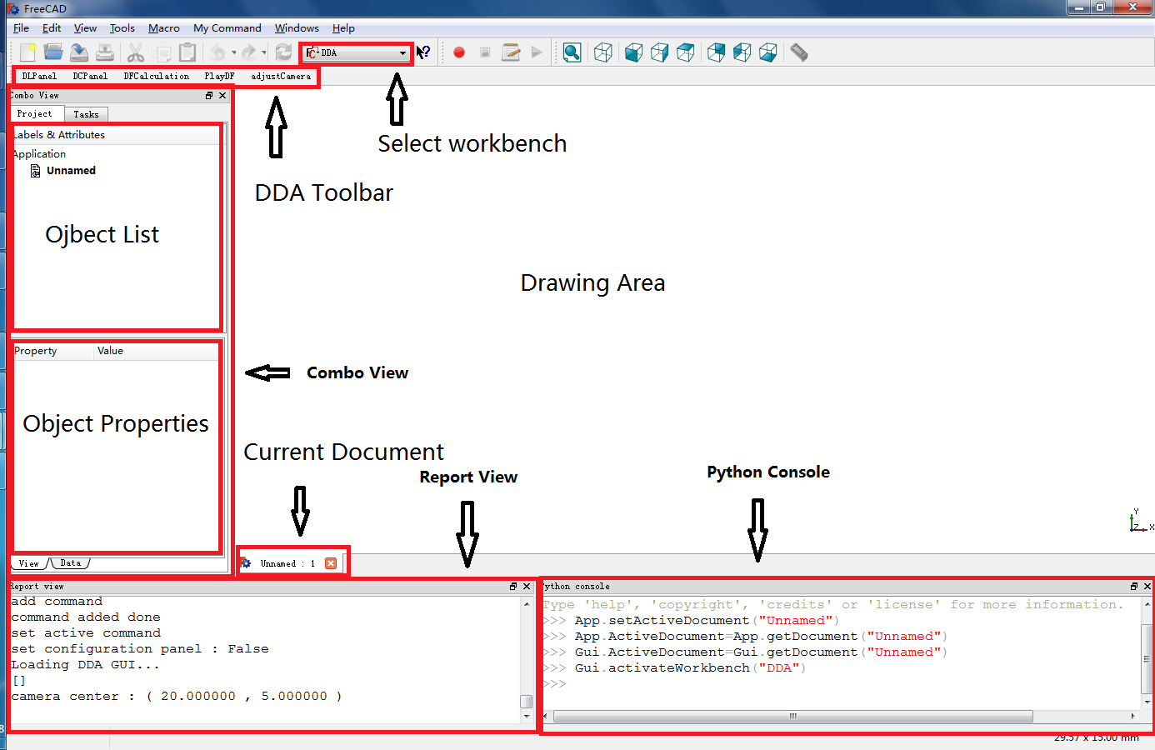

**Document**：In FreeCAD，all contents are in documents, and it is good to keep one documents active every time.

**Drawing Area**：Every document created with a drawing area, all objects are drawn in this area.

**Toolbar**：FreeCAD has many toolbars for different workbench. For DDA, we select DDA workbench to use DDA toolbar.

**DDA Toolbar**：All functions needed by DDA is in this toolbar, and the DDA software is under developed and not completed yet, so it is better to only use DDA workbench.

**Object List**：All objects drawn could be find in the object list.

**Object properties**：When one object is clicked, its properties will be displayed in the area.

**Combo View**: Shows the contents of object list and object properties. It could be found in “View->Views”。

**Report View**：Report program’s output message. It could be found in “View->Views”。

**Python Console** : python command line，developers may need it. It could be found in “View->Views”。

4.2 DL part Instruction

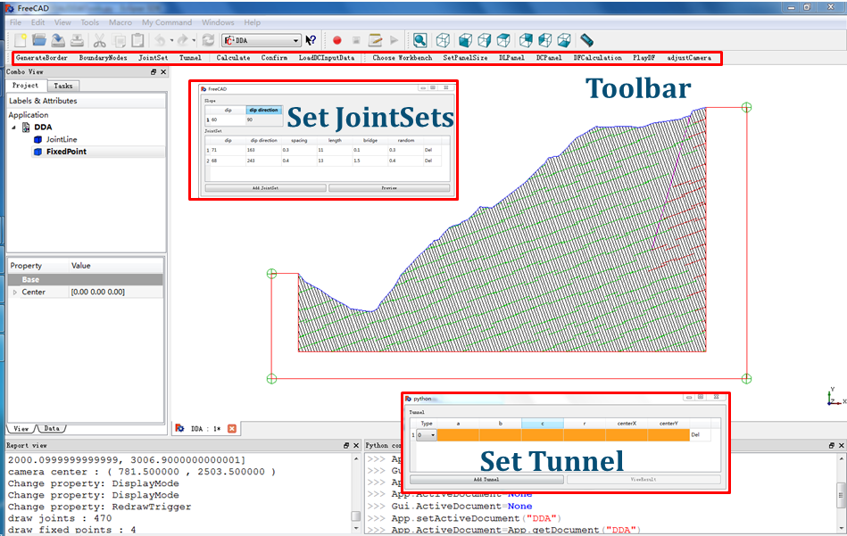

DL part only provides functions of manipulating joint lines. Users could generate joint lines or just load existing joint lines from files。Joint lines on screen could be modified after left click。DL toolbar is as follows：

C:\Users\laine\Pictures\dl_toolbar.png

BoundaryNodes : input boundary nodes. User could click on drawing area to confirm point location, and then press ‘Esc’ to close the boundary. ( Lines cannot be intersected)

GenerateBorder : This is a function to let user add border easily. While adding border, the fixed point to fix border is added at the same time.

JointSet ： Input parameters, and joint lines will be calculated. The sheet is as follows:

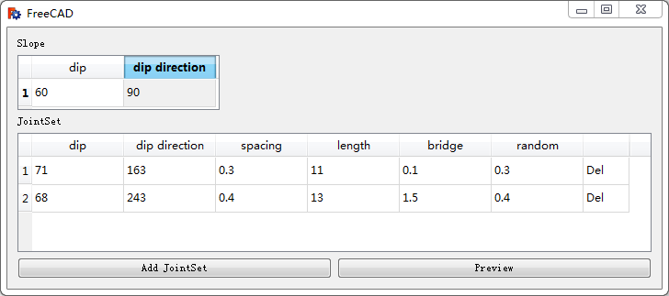

Tunnel ：Input parameters, and tunnel will be generated.

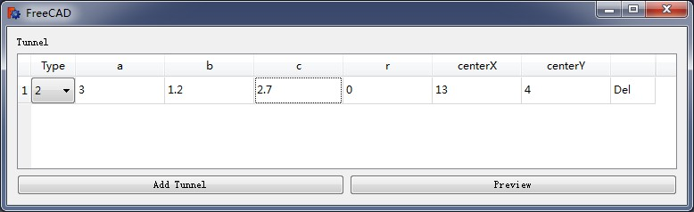

Calculate : Calculate DL result.

Confirm ： Save result for DL. (If any Joint lines are modified manually, users must click “Confirm” before change to DC part)

LoadDCInputData : Load existing DL joint lines data.

* 1. DC Instruction

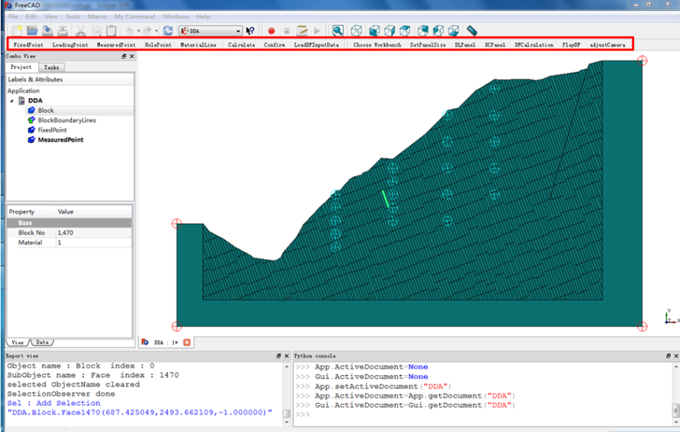

The main function of DC is to add bolt element and 4 kinds of points.

DC Toolbar is as follows:  
C:\Users\laine\Pictures\dc_toolbar.png

FixedPoint ： Adding fixed points. Just click at drawing area to confirm position. The color for Fixed Point is Red.

LoadingPoint ：Adding loading points. Just click at drawing area to confirm position. The color for Loading Point is Amaranth。

MeasuredPoint ：Adding measured points. Just click at drawing area to confirm position. The color for Measured Point is Sapphirine。

HolePoint ：Adding Hole points. Just click at drawing area to confirm position. The color for Hole Point is [Dark](app:ds:dark) Yellow

MaterialLine ：Click at drawing area, blocks intersected with the line will get the same material. The material line will disappear after that.

Calculate ：Calculate DC’s result. In DL part, we already get joint lines, so in this part, this command need to be called first to generate blocks, then we could set materials for blocks.

Confirm ：Save DC data. If DC data is changed, users must click “confirm” to save result.

* 1. DF Instruction

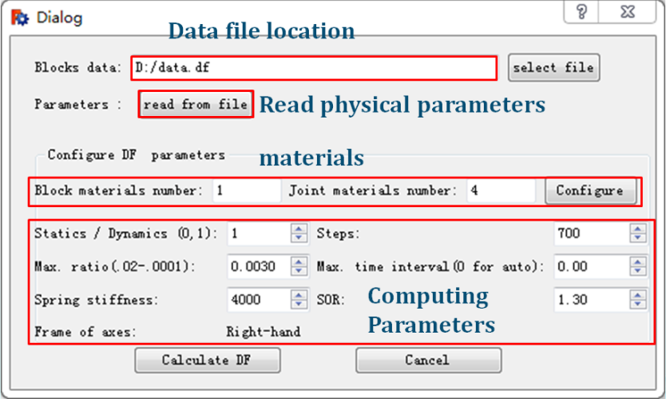

All operations of DF is in this dialog. Steps：

1. Click ”select file” to select block data file. If you have physical parameters file, go to step2, else step 3.

2. Click “read from file” to read physical parameters(the file “parameters.df” under project path). (Including computing parameters, materials and so on)

3. Input all computing parameters. Dialog to set block parameters, joint parameters, loading point parameters will show if “Configure” clicked.

4. Click “Calculate DF” to start DDA analysis. The time of calculation depends on the amount of calculation.

4.4 DG Instruction

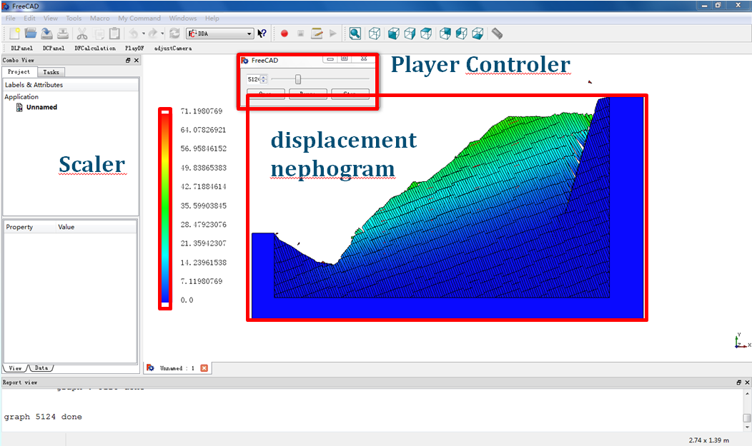

DG part only has few operations. Its control panel is as follows:

1. Click “open”, file “data.dg” under “${projectPath}” will be loaded.

2. Just use the DG Player as a normal player to replay DDA analysis result.