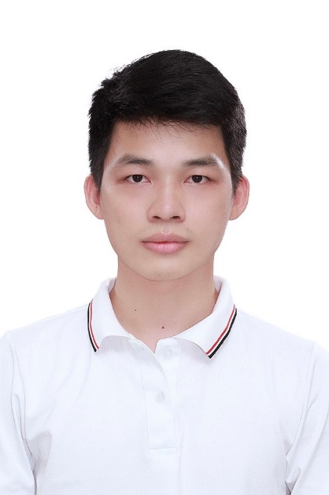

My objective:  
- To practice at place where have a complete automation system.   
- Working in a professional environment  
- Improving and learning my skill to knowledge

**LAI VAN OANH**

***Phone:0968772684***

***Email:laioanh961@gmail.com***

***Adress:*** ***Quang Binh - Kien Xuong - Thai Binh***

***Gender : Male***

***Date of birth : September 22, 1996***

**SOFTWARE**

* Altium, Proteus,…
* Keil C, EB tresos, S32DS, Iar
* Office

**EDUCATION**

* ***HIGH SCHOOL*** *Sep 2011 – Jun 2014*

Chu Van An highschool.

* ***UNIVERSITY*** *Sep 2014 – Dec 2019*

Ha Noi university of Science and Technology.  
Field: Control and Automation Engineering



**SKILLS**

* *Progamming:* C/C++, Makefile,…
* *Embedded programming:* ARM, NXP
* *Designer hardware*

**EXPERIENCES**

* ***PROJECT***  // *Oct 2017 – Dec 2017*

***Control Voltage Mode***

* ***PROJECT*** //  *Jan 2018 – Mar 2018*

***Wireless Device Control***

* ***PROJECT*** //  *Apr 2018 – May 2018*
* ***Solor Bettery Chager***

**LANGUAGE**

* VIETNAMESE
* ENGLISH

# REFERENCES

# 

Ths. Dao Duc Thinh

Lecturer Hanoi University of Science and Technology

Email:thinh.daoduc@gmail.com

Mobile:+ 84 843 481 420

# EXPERIENCES

# 

**10/2020 – Present:** Embedded developer

FPT SOFTWARE VIET NAM CO,. LTD

***Works****:*

- Implement and use with microcontroller: NXP, STM32… programming with driver for UART, LIN,...

- Implement programming driver in middleware layer following AUTOSAR

- Implement test with debugging and test equipment

- Good experience about git, make file and knowledge some problems

- Design cover code test by test case and test suite following AUTOSAR

My project:

|  |  |
| --- | --- |
| Project | ARTD |
| Description | Dev test for module LIN and UART protocol on AUTOSAR standard |
| Team size | 2 |
| My position | Dev - test |
| My responsibilities | * Use ARM chip to communicate with Lin driver * Write test code to cover all requirements in AUTSAR standard * Discuss directly with developer when found any bugs in driver code * Generate quality documents * Hardware and software testing |
| Technologies used | * C/C++, makefile, LIN, UART, EB, S32DS, MAF, AUTOSAR architecture |

**09/2019 – 10-2020:** Service Engineer

NIHON DENKEI VIET NAM CO,. LTD

***Works***:

- Customer care, consulting on products, maintenance services for equipment for research and production.

- Work, talk directly with Maker about technical problems, ask for price quotes for services and products.

- Planning maintenance, maintenance, making service and product quotes for

customers.

|  |
| --- |
| FAMILY  **Full Name** : Lai Van Oanh  **Date of birth : September 22,1996**  **Permanent Address** : 663 Truong Dinh Street, District Hoang Mai, Ha Noi City.  **Current Address :** Quang Binh-Kien Xuong-Thai Binh  **Phone number :** 0968772684    FAMILY RELATIONSHIPS  **Mother’s full Name** : Dang Thi Hao  **Date of birth : 1968**  **Address :** Quang Binh - Kien Xuong -Thai Binh  **Occupation :** Businessman  **Father’s full Name** : Lai Van Thuy  **Date of birth : 1967**  **Address :** Quang Binh - Kien Xuong-Thai Binh  **Occupation :** Businessman |

MY GOAL IN THE NEXT 10 YEARS

Hello! My name is Lai Van Oanh. Applying for the position of the company. With my own knowledge, I am confident that I can complete all the tasks in the good way.

+Short – term goals:

* Always willing to learn and gain the practical experiences for the well – done working
* Good communication in English

+Long – term goals:

+ Career: Willingness to take on any responsibility and leadership skill is one of goals I aim for.

+ Life: Have a happy life, make money for house, car and get married

PLAN FOR THE 10-YEAR GOALS

+ The first 2 years: Accumulating practical experiences at work, perform all the assignment required

+ The next 3 years: Striving for the position of production department manager

+ The next 5 years:

- Continuing to work in the company for a long time

- Trying myself in other relating areas

- Buy a house and have a wealthy life, get married at the age of 30