# Change Password Simple Program

|  |  |
| --- | --- |
| Main | <http://localhost:8990/change_password> |
| Password changed event logs | *http://localhost:8990/logs* |
| List of Users – to show password was updated | *http://localhost:8990/users* |
| In Memory DB | http://localhost:8990/h2 |
| JDBC Url (n Memory DB Console Setup) | jdbc:h2:mem:testdb |
| Dummy Preloaded data for testing: | johnsmith@yahoo.com/test123 |
|  | janesmith@yahoo.com/test123 |

**To run:**

Java –jar demo2-0.0.1-SNAPSHOT.jar

Source Code:

## Screenshots:

**Main Page**

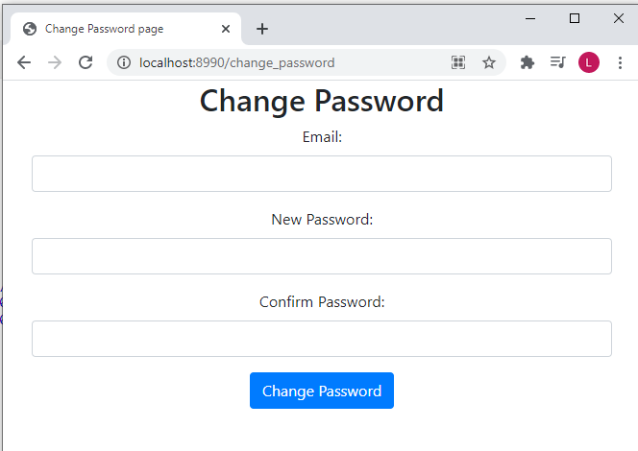

**Invalid Credentials**

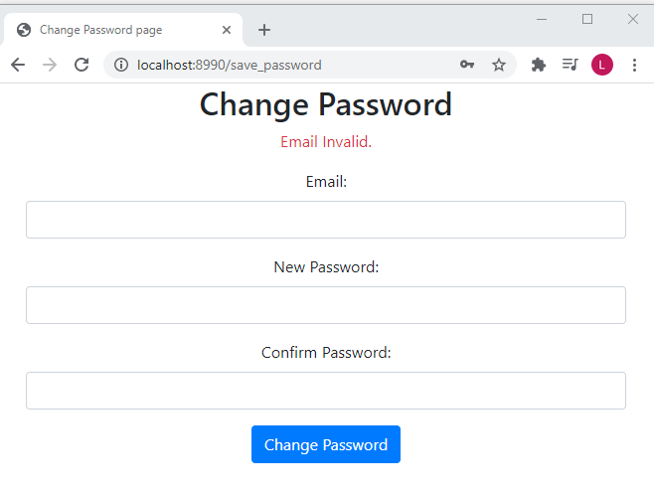

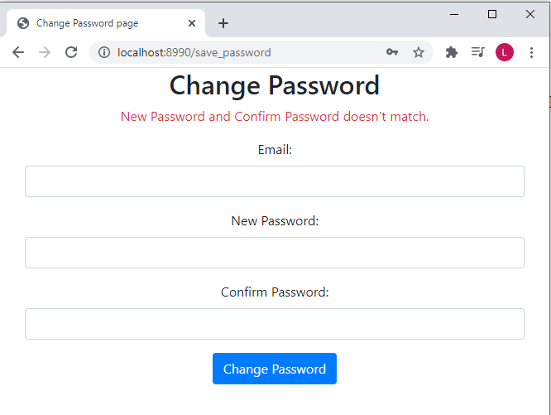

**Successfully Changed Password**

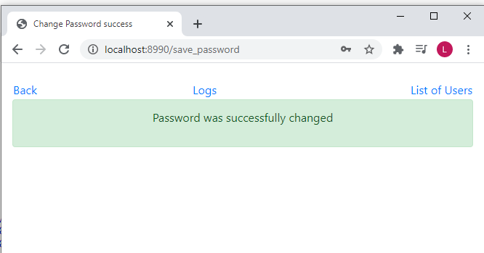

**List of log event once successfully changed Password**

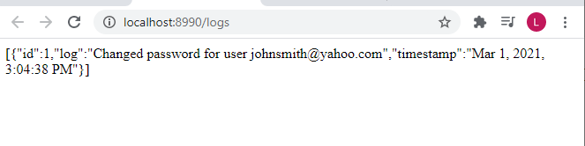

**List of User to show that password was successfully updated**

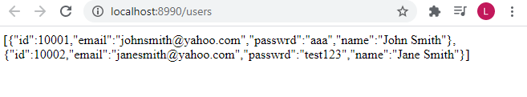

**Database:**

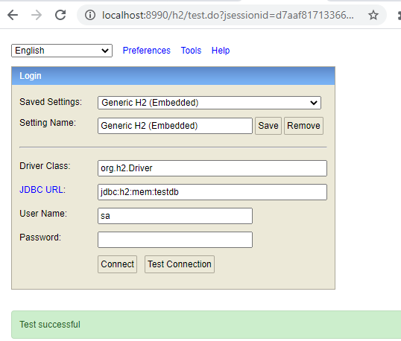

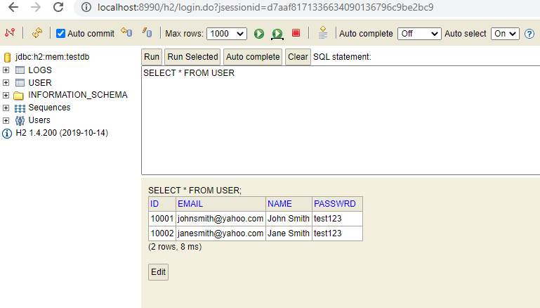

**Notes:**

* For changing password, user should be able to input old password too to verify that they are the correct user.
  + Created function to verify email and current password, but from the program, I’m just currently using findByEmail
  + User findUserByEmailAndPasswrd(String email, String passwrd) //UserRepository