Data preview 的数据:
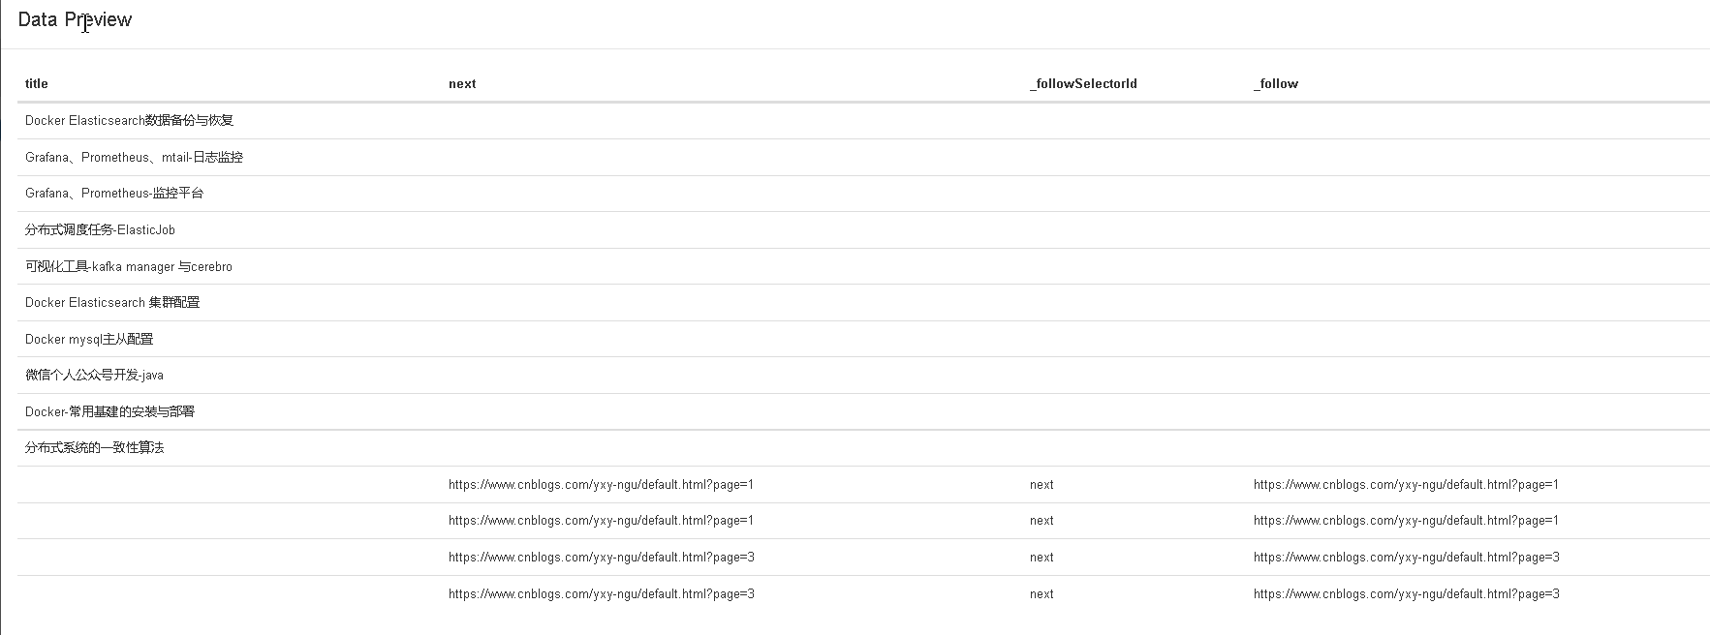

实际抓取的数据：
会把不带title数据的记录给删掉； 做法是：
- 和分页器Selector不同ID的会将这个数据的_deduplicateFirstPage设置为hash值； 有一个setFirstPageDeduplicatorDataHash的调用
- 和分页器相同的ID，会将_deduplicateFirstPage设置为undefined//没有setFirstPageDeduplicatorDataHash的调用，hash为undefined，这也就导致了_deduplicateFirstPage为undefined； 数据处理时，会将_deduplicateFirstPage为undefined的数据给删掉

web-scraper-order | web-scraper-start-url | next | title
1640510423-44 | https://www.cnblogs.com/yxy-ngu/default.html?page=2 | https://www.cnblogs.com/yxy-ngu/default.html?page=3 | Spring Security简介与基础原理
1640510423-47 | https://www.cnblogs.com/yxy-ngu/default.html?page=2 | https://www.cnblogs.com/yxy-ngu/default.html?page=3 | mysql事务隔离级别
1640510420-34 | https://www.cnblogs.com/yxy-ngu/default.html?page=2 |  | 分布式调度任务-ElasticJob
1640510420-32 | https://www.cnblogs.com/yxy-ngu/default.html?page=2 |  | Grafana、Prometheus、mtail-日志监控
1640510420-38 | https://www.cnblogs.com/yxy-ngu/default.html?page=2 |  | 微信个人公众号开发-java
1640510420-35 | https://www.cnblogs.com/yxy-ngu/default.html?page=2 |  | 可视化工具-kafka manager 与cerebro
1640510420-39 | https://www.cnblogs.com/yxy-ngu/default.html?page=2 |  | Docker-常用基建的安装与部署
1640510425-52 | https://www.cnblogs.com/yxy-ngu/default.html?page=2 | https://www.cnblogs.com/yxy-ngu/default.html?page=1 | java多线程9：线程池
1640510423-45 | https://www.cnblogs.com/yxy-ngu/default.html?page=2 | https://www.cnblogs.com/yxy-ngu/default.html?page=3 | RabbitMQ-Spring AMQP
1640510425-56 | https://www.cnblogs.com/yxy-ngu/default.html?page=2 | https://www.cnblogs.com/yxy-ngu/default.html?page=1 | java多线程5：线程间的通信
1640510425-53 | https://www.cnblogs.com/yxy-ngu/default.html?page=2 | https://www.cnblogs.com/yxy-ngu/default.html?page=1 | java多线程8：阻塞队列与Fork/Join框架
1640510425-51 | https://www.cnblogs.com/yxy-ngu/default.html?page=2 | https://www.cnblogs.com/yxy-ngu/default.html?page=1 | java多线程10：并发工具类CountDownLatch、CyclicBarrier和Semaphore
1640510423-49 | https://www.cnblogs.com/yxy-ngu/default.html?page=2 | https://www.cnblogs.com/yxy-ngu/default.html?page=3 | 【java】doc转pdf
1640510425-58 | https://www.cnblogs.com/yxy-ngu/default.html?page=2 | https://www.cnblogs.com/yxy-ngu/default.html?page=1 | java多线程3：synchronized
1640510425-59 | https://www.cnblogs.com/yxy-ngu/default.html?page=2 | https://www.cnblogs.com/yxy-ngu/default.html?page=1 | java多线程2：Thread中的方法
1640510420-31 | https://www.cnblogs.com/yxy-ngu/default.html?page=2 |  | Docker Elasticsearch数据备份与恢复
1640510423-42 | https://www.cnblogs.com/yxy-ngu/default.html?page=2 | https://www.cnblogs.com/yxy-ngu/default.html?page=3 | Kafka简介与基础原理
1640510420-37 | https://www.cnblogs.com/yxy-ngu/default.html?page=2 |  | Docker mysql主从配置
1640510420-36 | https://www.cnblogs.com/yxy-ngu/default.html?page=2 |  | Docker Elasticsearch 集群配置
1640510423-48 | https://www.cnblogs.com/yxy-ngu/default.html?page=2 | https://www.cnblogs.com/yxy-ngu/default.html?page=3 | 【JAVA】pdf转图片
1640510420-40 | https://www.cnblogs.com/yxy-ngu/default.html?page=2 |  | 分布式系统的一致性算法
1640510423-50 | https://www.cnblogs.com/yxy-ngu/default.html?page=2 | https://www.cnblogs.com/yxy-ngu/default.html?page=3 | mysql数据库索引
1640510425-54 | https://www.cnblogs.com/yxy-ngu/default.html?page=2 | https://www.cnblogs.com/yxy-ngu/default.html?page=1 | java多线程7：ReentrantReadWriteLock
1640510423-41 | https://www.cnblogs.com/yxy-ngu/default.html?page=2 | https://www.cnblogs.com/yxy-ngu/default.html?page=3 | Redis简介与基础原理
1640510425-57 | https://www.cnblogs.com/yxy-ngu/default.html?page=2 | https://www.cnblogs.com/yxy-ngu/default.html?page=1 | java多线程4：volatile关键字
1640510425-55 | https://www.cnblogs.com/yxy-ngu/default.html?page=2 | https://www.cnblogs.com/yxy-ngu/default.html?page=1 | java多线程6：ReentrantLock
1640510420-33 | https://www.cnblogs.com/yxy-ngu/default.html?page=2 |  | Grafana、Prometheus-监控平台
1640510423-46 | https://www.cnblogs.com/yxy-ngu/default.html?page=2 | https://www.cnblogs.com/yxy-ngu/default.html?page=3 | RabbitMQ
1640510425-60 | https://www.cnblogs.com/yxy-ngu/default.html?page=2 | https://www.cnblogs.com/yxy-ngu/default.html?page=1 | java多线程1：进程和线程的概念
1640510423-43 | https://www.cnblogs.com/yxy-ngu/default.html?page=2 | https://www.cnblogs.com/yxy-ngu/default.html?page=3 | JAVA性能优化工具小记

