I did 2 repeated tests for each voltage range, and measured the variation in the signal over a long time period.

Channel 2:

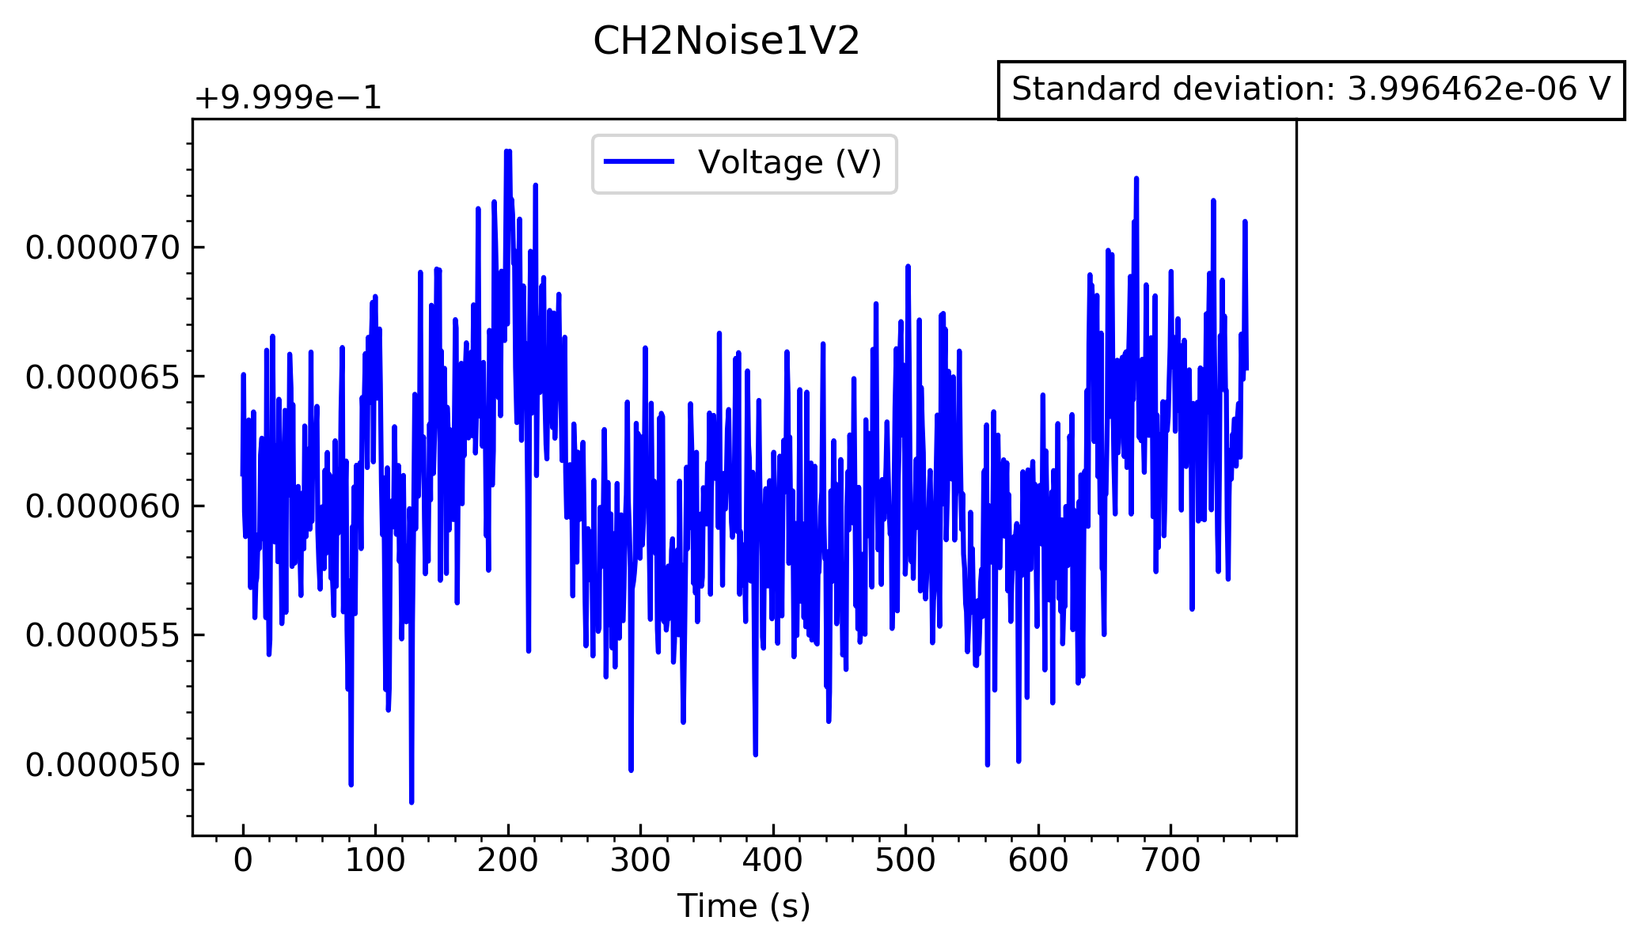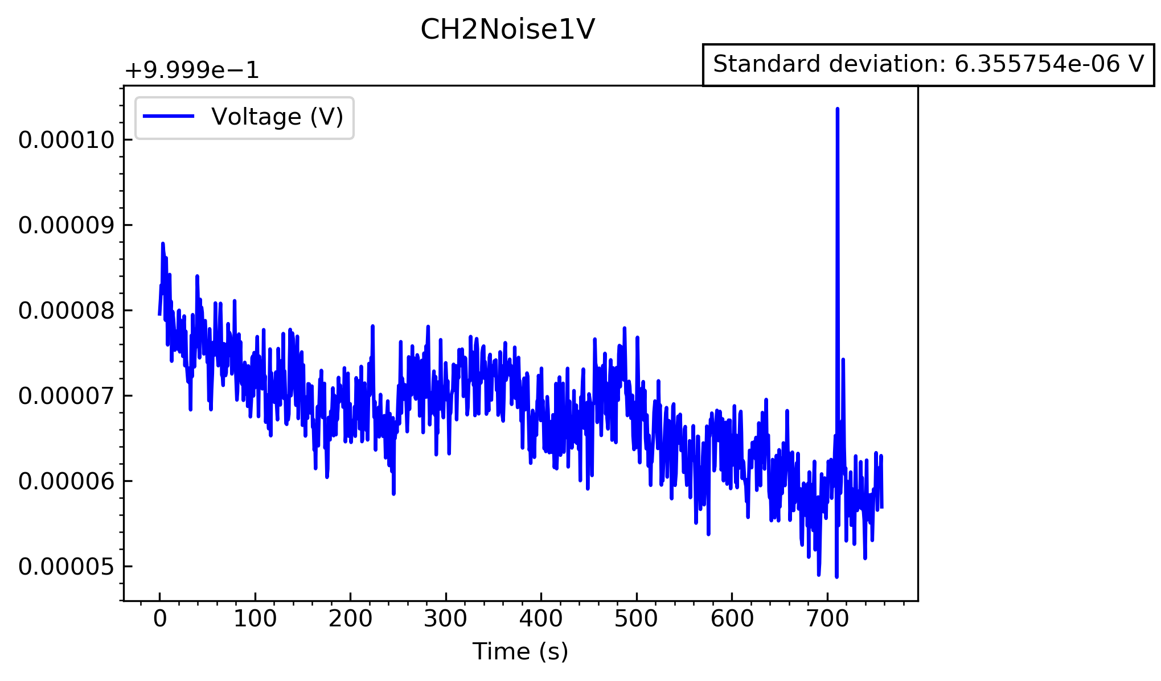Look at the 1V range first

In the first test there is a clear decrease at the beginning, which may be due to the circuit just being switched to that range. I would consider the second test to be more accurate, which gives a standard deviation of 3.996x10-6V

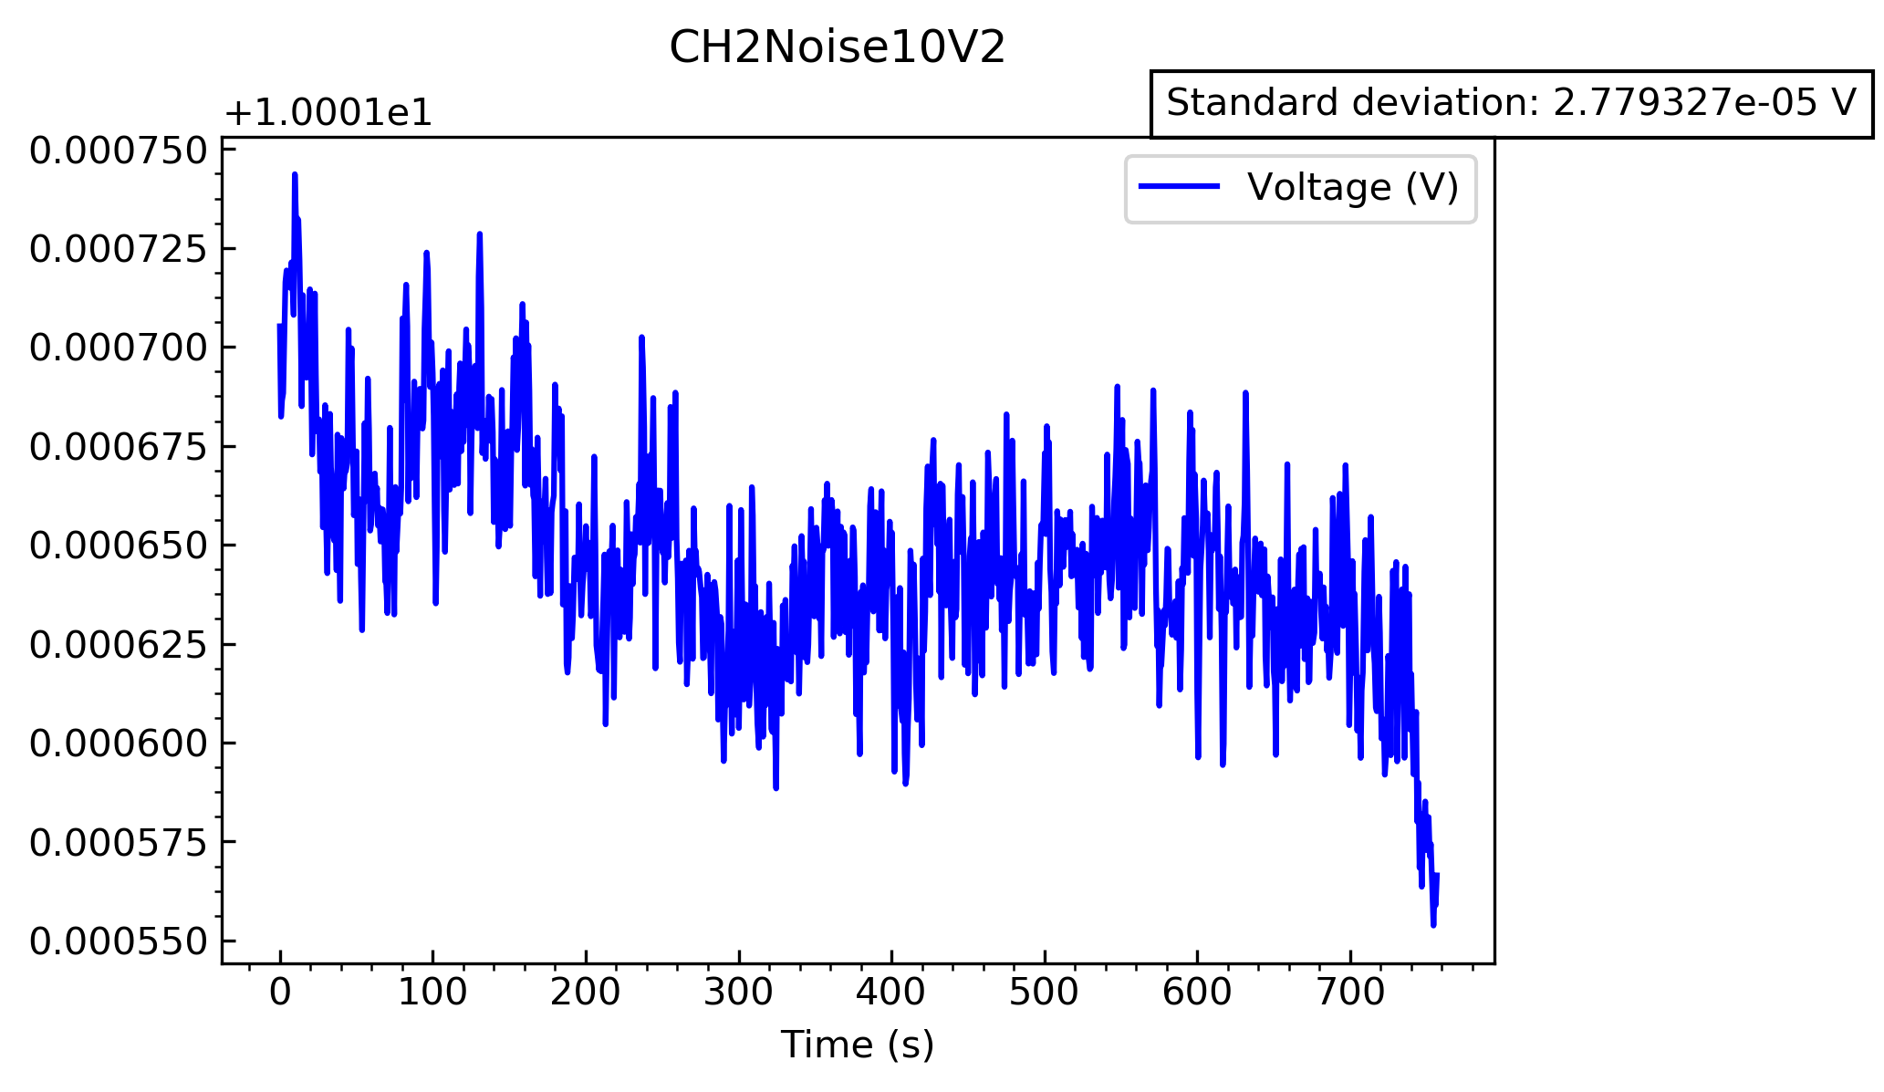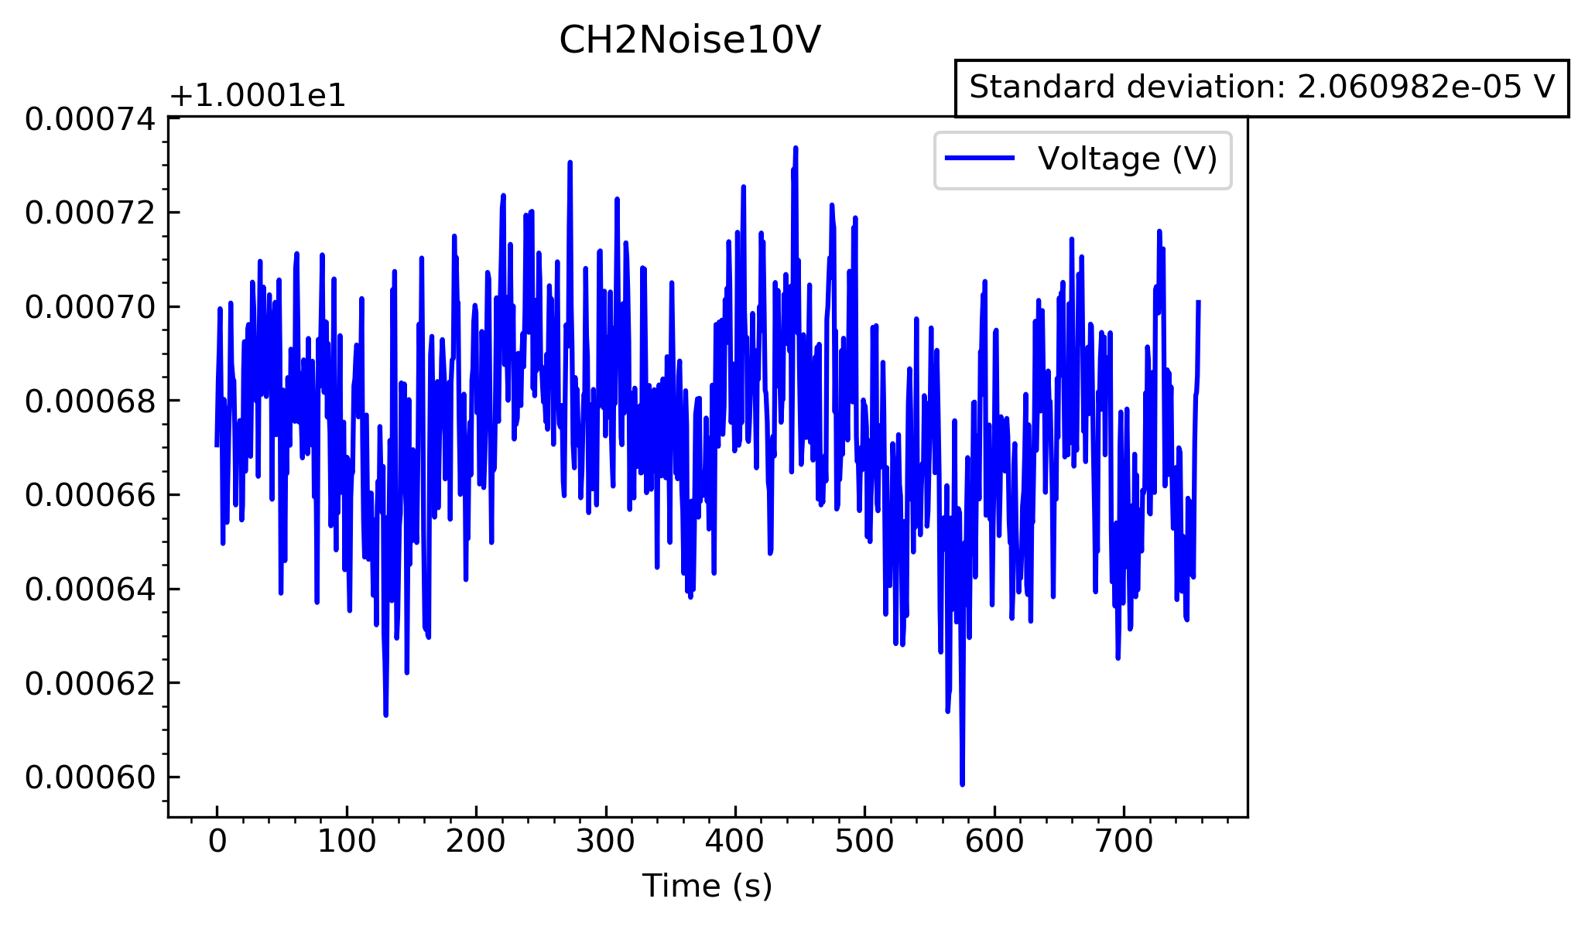Now look at the 10V range

This time they are both very similar, however there is a decrease in the voltage signal at the end of the second test. I am unsure why this happened. In any case the standard deviations are larger than in the 1V case, which are 2.061x10-5 V and 2.779x10-5 V for the first and second test respectively.

Channel 7:

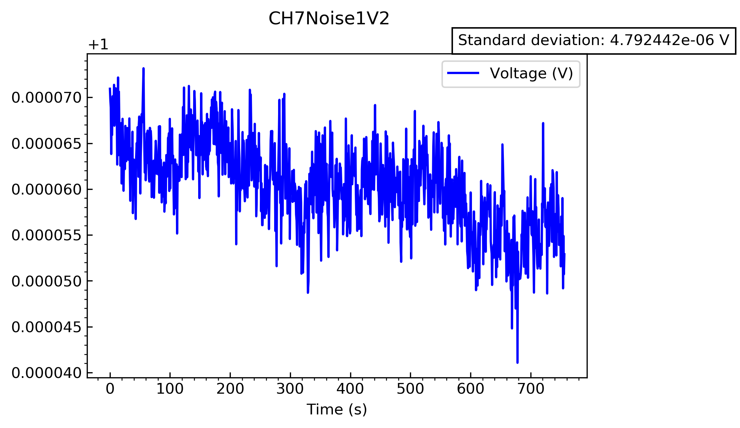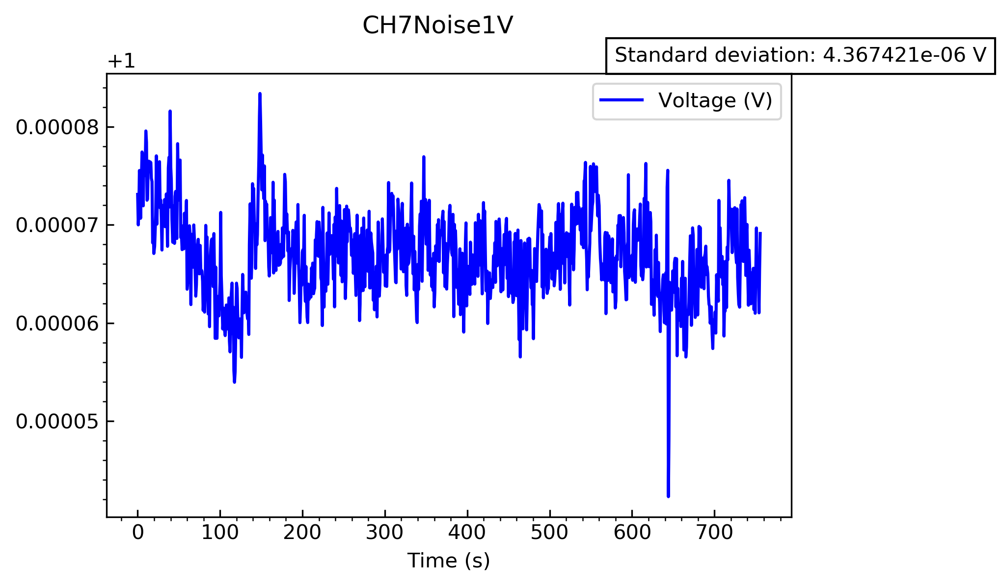Look at the 1V range again:

There were some strange peaks in the first test, which I will assume is just random interference with nearby electronic devices. The standard deviations look very similar to before, however they are slightly larger, being 4.367x10-6 V and 4.792x10-6 V.

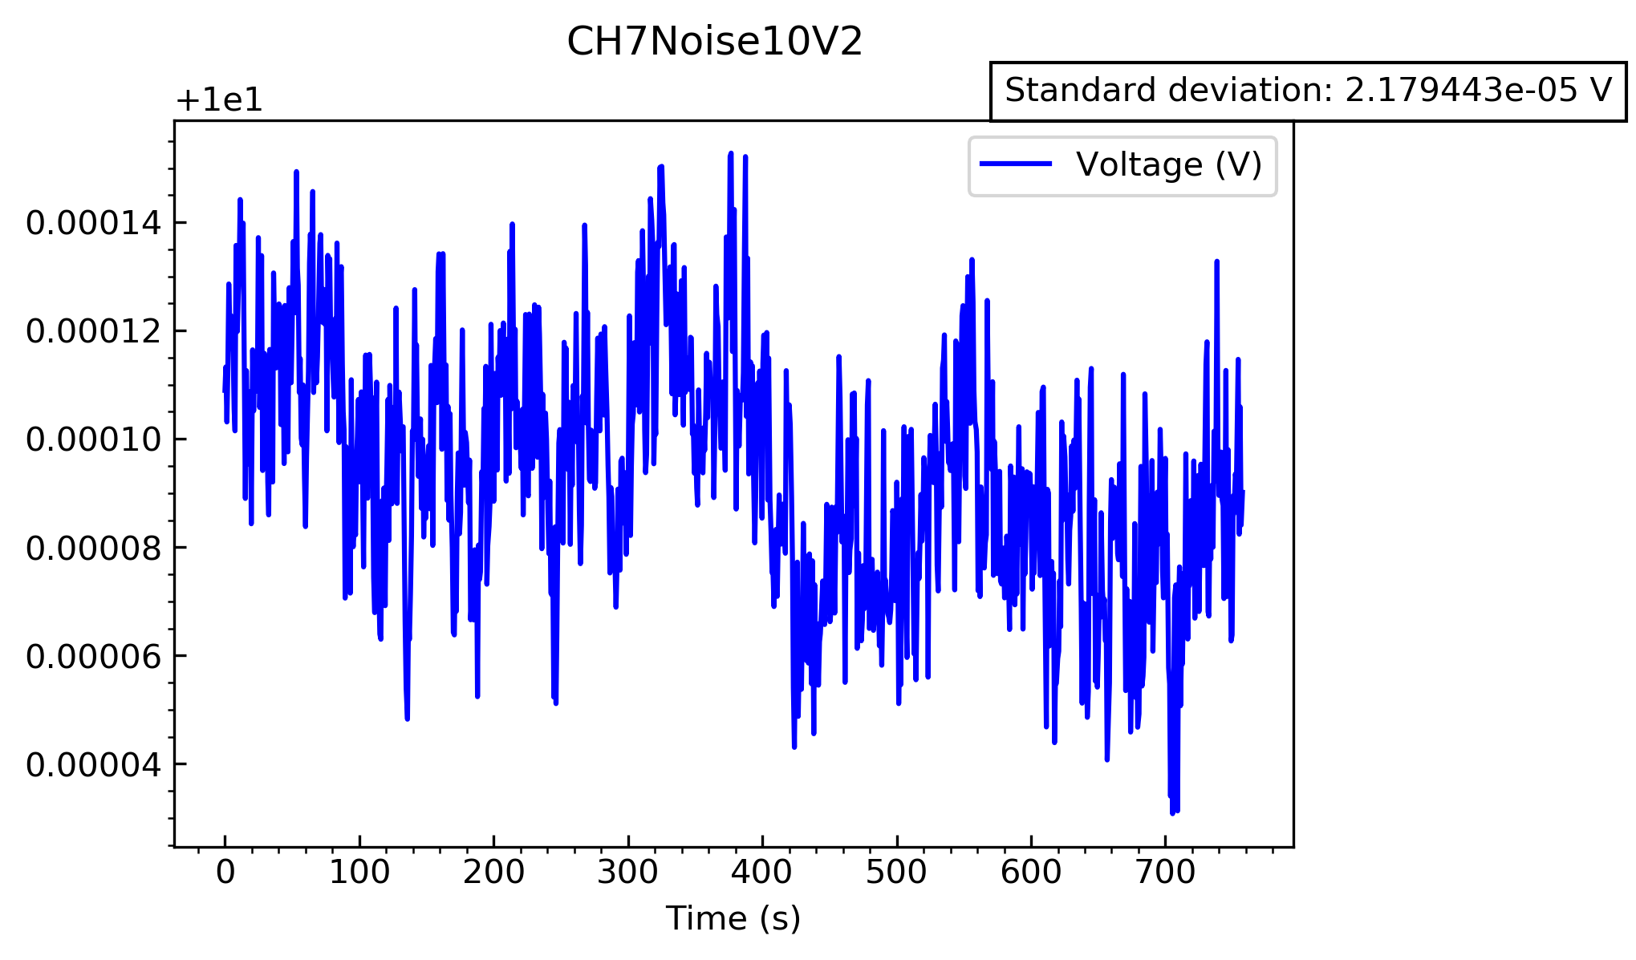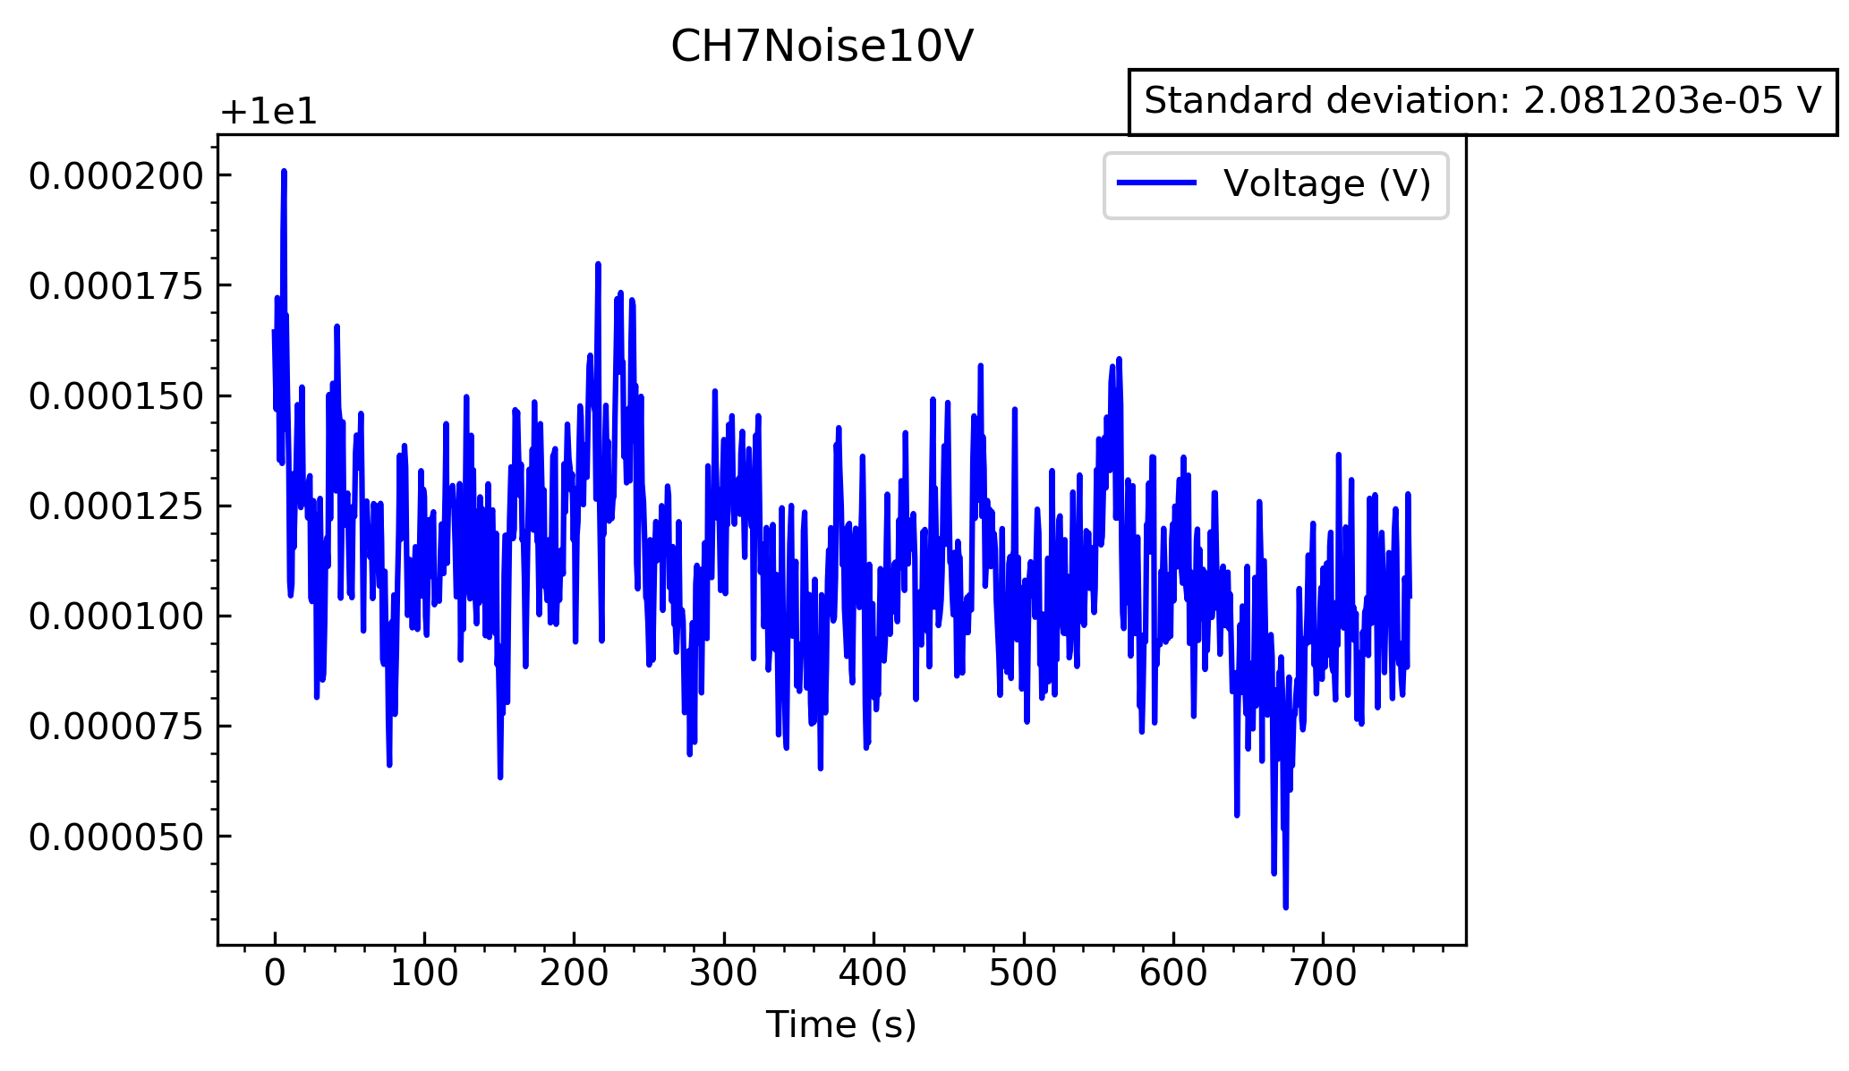Again, look at the 10V range

These graphs look very similar, and have a similar standard deviation, showing that these are consistent. The standard deviations here are 2.081x10-5 V and 2.179x10-5 V for the first and second test respectively.

Channel 10:

Do the same again, looking at the 1V range first, and the 10V range afterwards.

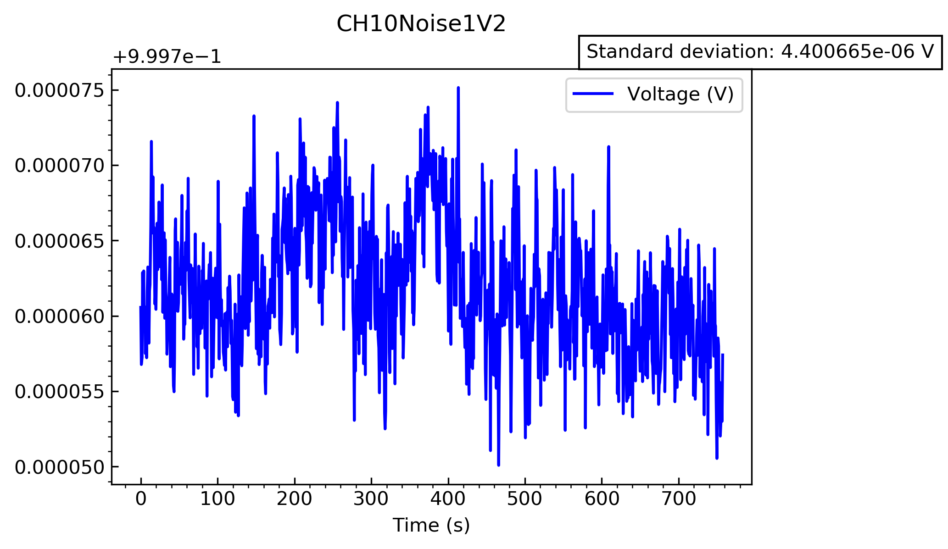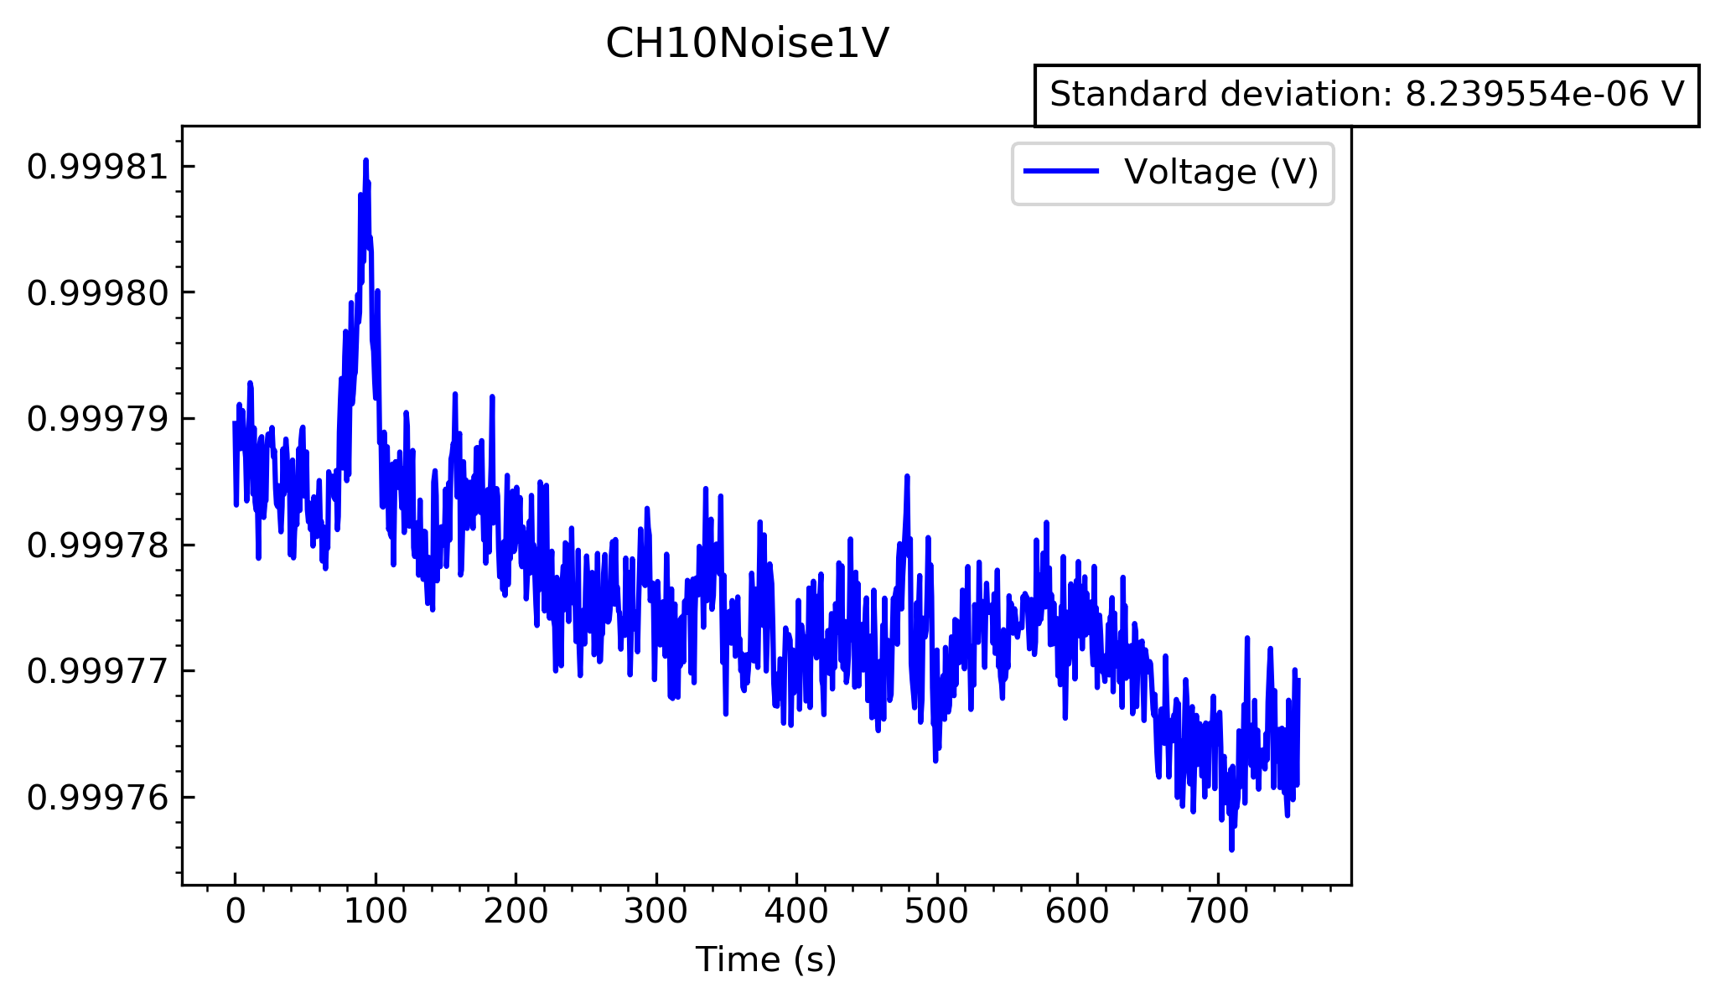

In the first test, there seems to be a clear decrease, and a large spike with a decent width. The decrease can be attributed to not enough time taken before starting the experiment and switching the range over. However, I am unsure where this thick peak has come from. Therefore, I will assume that the second experiment is more accurate, with a standard deviation of 4.401x10-6 V, which is similar to the other results obtained for this voltage range.

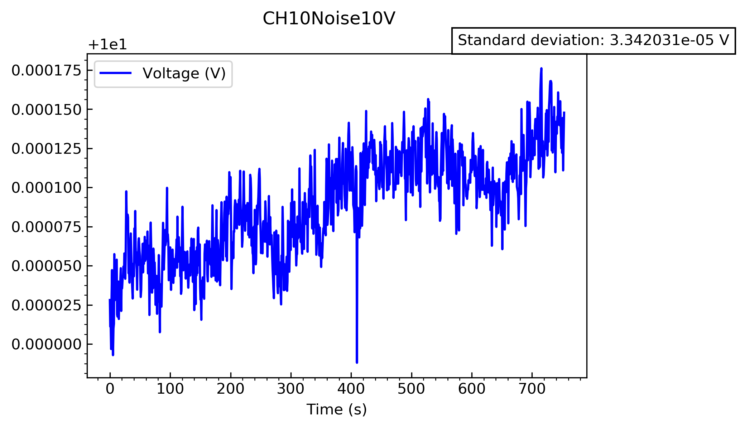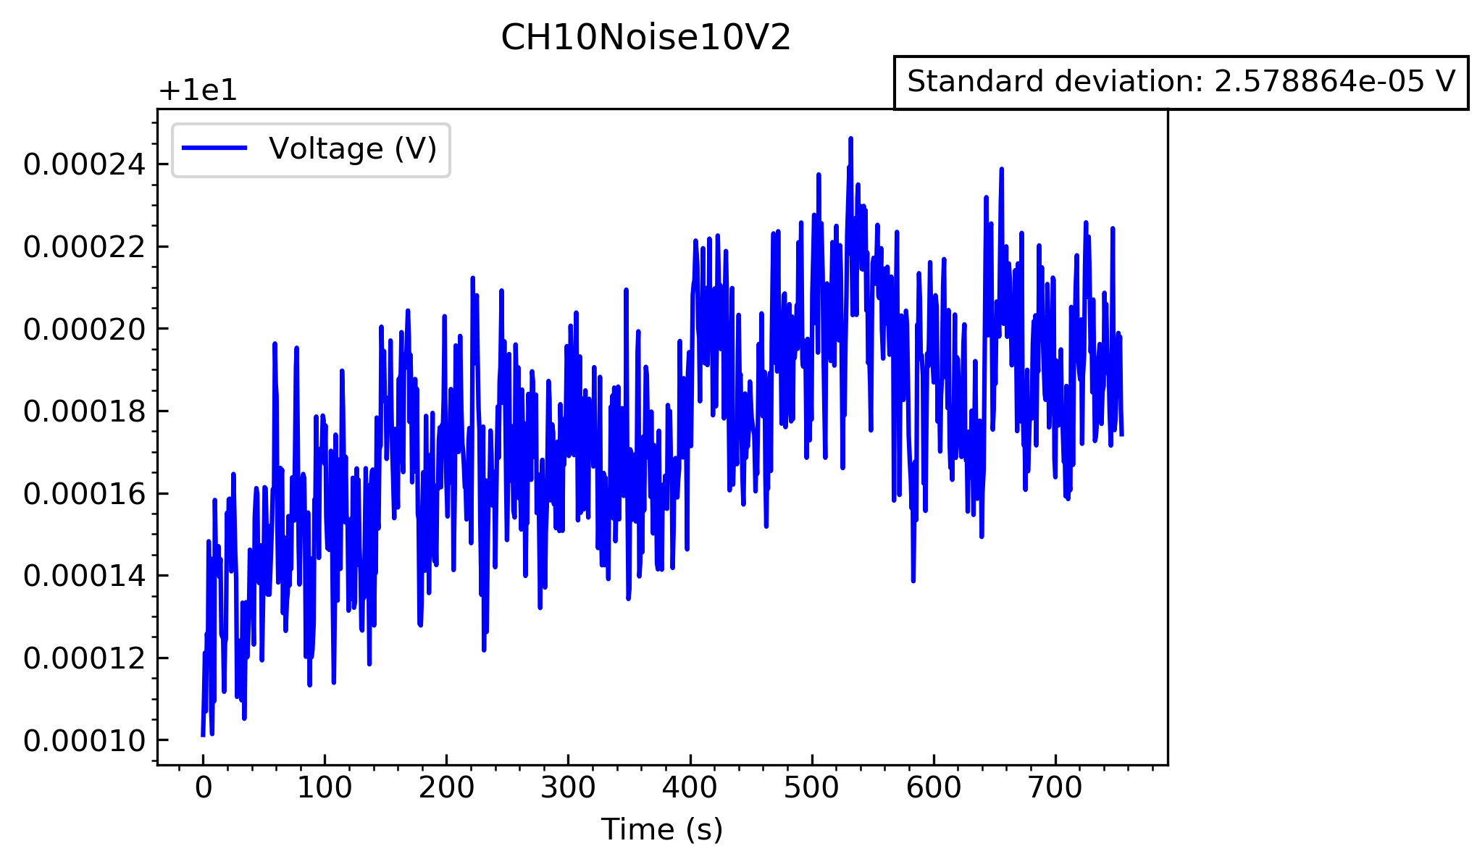Both of these graphs both display some sort of gradual increase in the signal voltage, which is very interesting. I am, again, unsure about where this may have come from. The standard deviations for this test will be taken with a grain of salt, and I would like to perform this part of the experiment again to see whether this phenomena appears again in a third test.

Overall, of the channels tested, they all work very well, and all deviate minimally from the chosen voltage.