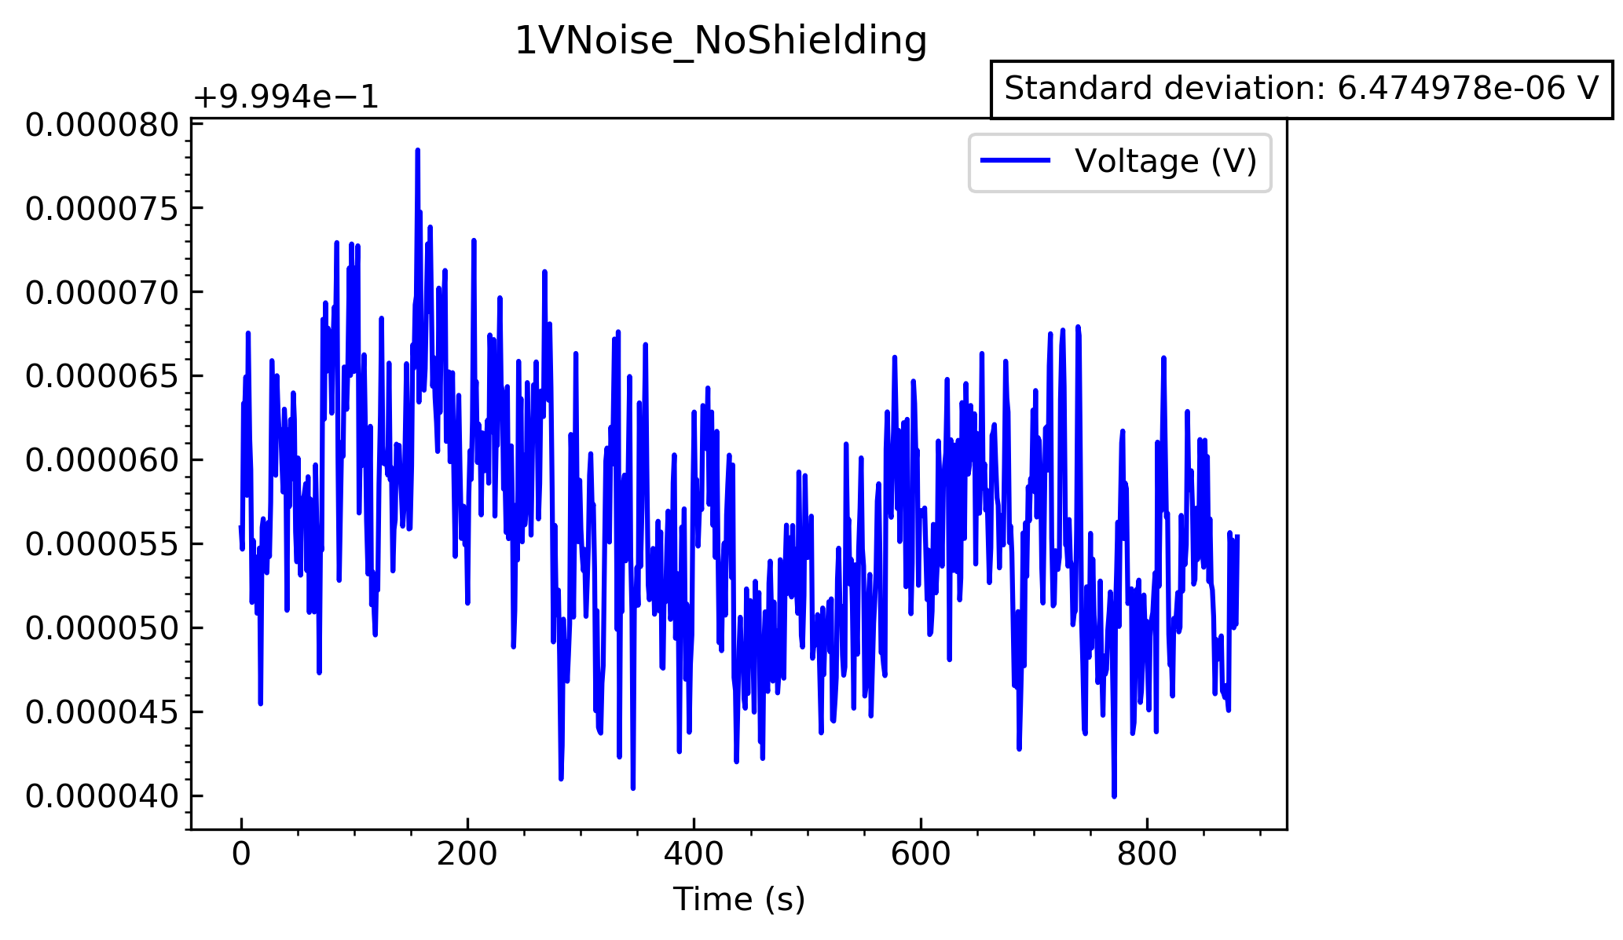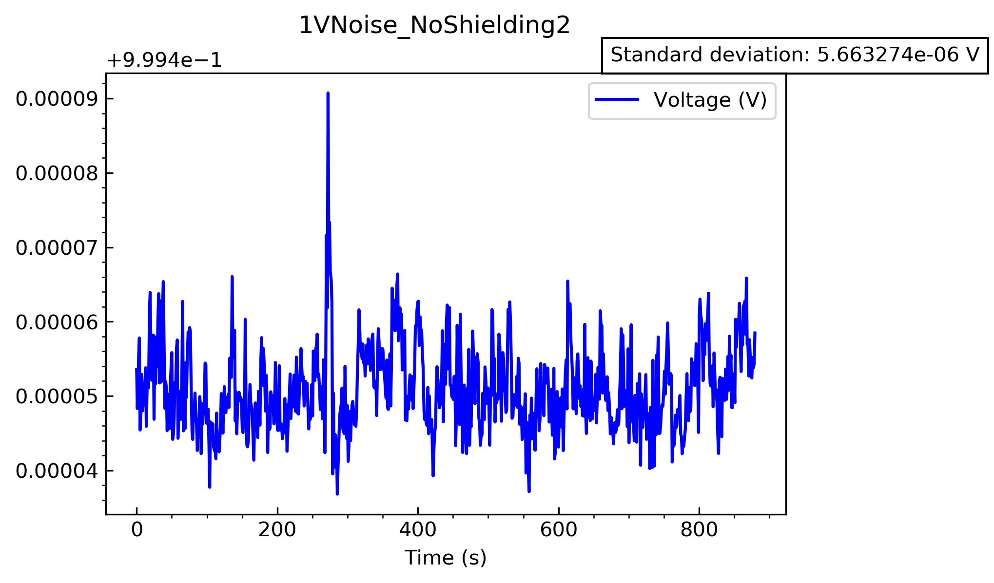These are the graphs to quantify the noise when the range was set to 1V without any shielding. The standard deviation for this ranged between 5.66x10-6 ­V and 6.47x10-6 V

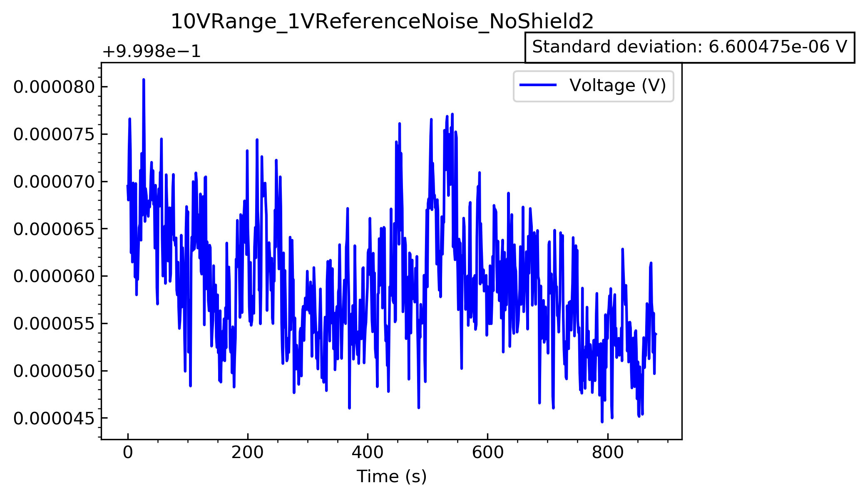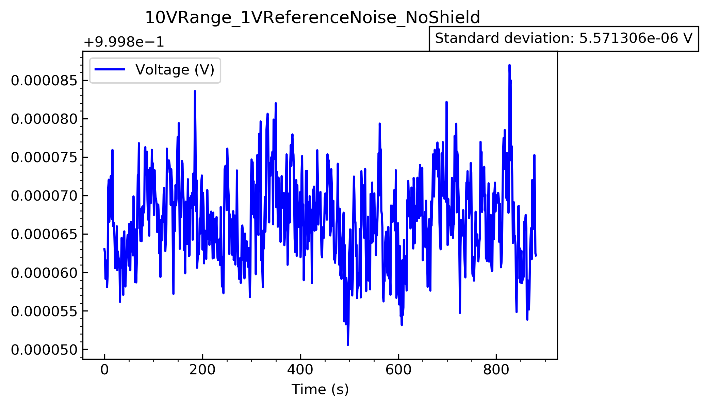

These are the graphs for when the range is set to 10V, but the voltage has been dialled down to 1V. As is clear, the noise graphs are very similar, and both give very similar standard deviations.

Therefore, the additional noise seen at 10V must be due to the op amp itself