Exploring the Mechanisms behind S. epidermidis Resistance to Vancomycin using Bioinformatics Analysis
Laís Carvalho^{1,2} [0009-0006-4769-139X], Ângela França^{1,3} [0000-0001-7117-6837] and Miguel Rocha^{1,3}[0000-0001-8439-8172]
1 LIBRO-Laboratório de Investigação em Biofilmes Rosário Oliveira, Centre of Biological Engineering, University of Minho, Braga, Portugal; 2 Bioinformatics Laboratory, Centre of Biological Engineering, University of Minho, Braga, Portugal; 3 LABBELS-Associate Laboratory, Braga/Guimarães, Portugal.
Abstract. The bacterium Staphylococcus epidermidis is a natural inhabitant of the skin and mucous membranes. In addition to being the main cause of infections related to medical materials, this bacterium is resistant to multiple drugs, including vancomycin. This study aimed to identify the mechanisms behind S. epidermidis resistance to vancomycin by investigating the metabolic pathways enriched in two strains with induced resistance to vancomycin. To search for enriched pathways, the ShinyGO (v0.80) tool and Python packages such as “Bio.KEGG” and “bioservices” were used. While in strain PT11011, the most enriched pathways were ribosome-related, in strain PT12035 were pathways related to phosphate transport and the YSIRK signal peptide. The pathways enriched in both strains were related to the bacteria's surface charge, which has been previously associated with a resistance mechanism against cationic antimicrobial peptides. These results suggest that the resistance to vancomycin may be associated with the identified pathways warranting, however, further validation with a broader collection of strains and functional assays that can lead us to the development of new and directed strategies to overcome the rise of resistance to vancomycin in S. epidermidis.
Keywords: S. epidermidis, vancomycin, bioinformatics, KEGG, enrichment.
- Introduction
The Staphylococcus genus is composed of bacteria that can be found as a natural constituent of human skin and mucous membranes and is divided into two groups: coagulase-positive and coagulase-negative (CoNS) [1], which are differentiated by their ability to produce free coagulase [2]. CoNS group, represented by heterogeneous and opportunistic bacteria, are a recurring concern in human health [3], due to their ability to colonize and form biofilms on medical devices (such as vascular catheters, prosthetic joints, vascular grafts, heart valve prostheses and peritoneal catheters), putting the success of medical procedures at risk [3, 4].
Within this group, the Staphylococcus epidermidis species is one of the most investigated, as it is the main bacterium isolated from medical-device-related infections [5], and because of its multidrug-resistance that complicates the treatment of these infections [6]. To develop more effective therapeutic strategies against the infections caused by S. epidermidis, it is necessary to understand how the bacterium responds, for instance, in the presence of antibiotics. In that sense, omics sciences, which enable a comprehensive understanding of biological systems, have been pivotal in creating new solutions to medical and scientific problems.
As such, this study aimed to use transcriptomics to characterize the response of S. epidermidis biofilm cells susceptible and with induced resistance to vancomycin to analyze differentially expressed genes and identify genetic networks and metabolic pathways potentially involved in the resistance to the antibiotic. For that, we presented the databases used to study this bacterium and the bioinformatics tools, for enriching a set of genes, that can help in the identification of antibiotic resistance mechanisms. Furthermore, a bioinformatic analysis of transcriptomic data of two different strains of S. epidermidis with induced resistance to vancomycin is presented.
- S. epidermidis and its implications
S. epidermidis is the bacterium most frequently isolated from the human epithelium, colonizing the armpits, head and nasal openings. The unfavorable conditions of this bacterium's natural habitat are overcome by its genetic makeup, which interestingly also gives it an advantage as an opportunist pathogen [7]. In addition to this, this bacterium has other mechanisms that increase resistance and/or virulence namely: (i) the ability to form biofilms and (ii) horizontal transfer of genes and elements related to antibiotic resistance [8].
  - Biofilm formation
Biofilms are aggregates of microorganisms adhered to biotic or abiotic surfaces and embedded in a matrix composed of extracellular molecules. These constitute a protective strategy against natural or artificial antibiotics, bacteriophages and phagocytic cells [9]. S. epidermidis can form biofilms on medical implants resulting in symptoms of infection, with the removal of the implant being the most efficient form of treatment [10]. This has important clinical implications, as well as an economic burden associated with extra costs related to longer hospital stays, and additional diagnosis and treatment.
Biofilm formation in S. epidermidis, as well as in other CoNS, is accomplished in three phases: (i) adhesion, which can occur on biotic or abiotic surfaces coated with molecules from the host, in which the adhesion is facilitated by ligand-receptor interactions and adhesins of the bacterial surface; (ii) maturation, where bacterial cells begin to divide and produce an extracellular matrix composed of polysaccharides, proteins, nucleic acids and molecules from the environment; and (iii) the dispersal stage, at which bacterial cells leave the biofilm and potentially colonize new surfaces, contributing to the spread of infection [8, 11]. Biofilm is, therefore, the main virulence factor of CoNS bacteria and has a well-established relationship with antibiotic resistance. [12, 13].
  - Antibiotic resistance
The introduction of antibiotics in human and veterinary medicines in the mid-1940s favored the development of antibiotic-resistant bacteria. According to the World Health Organization, antimicrobial resistance is one of the main global threats to public health and development, with an estimated 1.27 million global deaths in 2019 [19]. The beginning of the 2020s was marked by review articles highlighting the clinical emergence of CoNS bacteria [20-22], as well as original articles characterizing CoNS, such as S. epidermidis, resistant to different antibiotics, identifying genes associated with resistance as a way of understanding the mechanisms that give this group of bacteria this phenotype [23-27].
In recent decades, the number of S. epidermidis resistant to penicillin, oxacillin/methicillin, ciprofloxacin, clindamycin and erythromycin has increased dramatically [14]. β-Lactam antibiotics, such as methicillin, interfere in the biosynthesis of the bacterial cell wall, but their action is less effective due to the presence of the blaZ gene, located in plasmids and producing penicillinases, and the mecA gene present in the SCCmec chromosomal cassette, in which its phenotype is responsible for inactivating the activity of most β-lactams [8].
Due to the multi-resistance shown by CoNS, the number of alternative drugs for treating infections caused by this group has been reduced, with vancomycin as one of the last-line effective agents. As such, the development of resistance to this antibiotic is a medical concern.[15]. Vancomycin is an antibiotic from the glycopeptide group, widely used to treat infections caused by methicillin-resistant staphylococci. With the research carried out on the subject, several plasmid-mediated genes (such as vanA, vanB, vanB1, vanB2, vanC1, vanC2, vanC3, vanD, vanE, and vanG) have been associated with vancomycin resistance and were initially acquired through contact with Enterococcus faecalis, which is naturally resistant to this antibiotic [14]. In 1999, the first case of S. epidermidis less susceptible to the action of vancomycin was recorded in the United States [16], but before this, in 1979 and 1983, the first cases of CoNS-resistant to this antibiotic were recorded, in studies of the synergy of different drugs for the treatment of infections caused mainly by S. epidermidis [17, 18].
- Bioinformatic resources and tools in research on S. epidermidis
As one of the many approaches to understanding the mechanisms of resistance of different bacteria to antibiotics, omics data such as the transcriptome and metabolome are used to determine the genes or pathways under or over-expressed in resistant bacteria [19]. The high volume of data generated in omics experiments requires storage locations, which are biological databases. These online libraries are essential for searching for scientific information [20], and for carrying out bioinformatics analysis. Many bioinformatic analyses are dependent on the presence of data and the quality of biological annotations to guarantee the robustness and significance of the results. Taking this into account, different databases aggregate information on S. epidermidis and can serve as safe resources for requesting information, downloading datasets and contextualizing the results obtained.
  - Genomic and proteomic databases

Universal Protein Resource (UniProt)
UniProt (https://www.uniprot.org/) is a protein database, featuring amino acid sequences, annotations of functions, structures, interactions, sub-cellular localization, and gene expression, among others. UniProt Knowledgebase (UniProtKB) is the central resource that combines Swiss-Prot, which contains sequences annotated by literature review or peer review and TrEMBL, which contains sequences annotated automatically by computational predictions [21].
Serving mainly as a data server, it also features analysis tools capable of aligning sequences and generating phylogenetic trees between different organisms. Featuring more than 2400 protein records from different strains of S. epidermidis in Swiss-Prot, this database is commonly used in different studies with this opportunistic bacterium, such as in studies to discover non-human homologous targets and the development of new drugs, serving as a reliable source for downloading sequences from different strains [22, 23] and as a tool to elucidate the differences in enzymatic activity between two different growth states, biofilm and planktonic [24].

Bacterial and Viral Bioinformatics Resource Center (BV-BRC)
The BV-BRC (https://www.bv-brc.org/) is the result of combining the resources of the BCR, the Pathosystems Resource Integration Center (PATRIC), the Influenza Research Database (IRD) and the Virus Pathogen Database and Analysis Resource (ViPR). The most well-known and commonly used acronym for the BV-BRC is PATRIC, a platform for searching and analyzing pathosystem data, encompassing genomic information, annotations, metadata and non-genomic data, such as domains and motifs [25].
With PATRIC it is possible to perform gene expression analyses, predict metabolic pathways, analyze antibiotic resistance, phylogenetics, genome comparisons and analyze pathogenicity. Featuring different S. epidermidis strains, this database and its tools can be used to identify S. epidermidis defense mechanisms and mobile elements from the available annotations [6], or for assessing genome diversity and identifying virulence elements [26]. It can also be used for comparative genomics between S. aureus and S. epidermidis to identify homologous or unique genes of each species [27].
  - Database of metabolic pathways and functional annotations

Kyoto Encyclopedia of Genes and Genomes
KEGG (https://www.genome.jp/kegg/) is a database and software based on understanding and simulating the functional behavior of cells or organisms through their protein information [28]. This database contains different information, such as genomes, metabolic pathways, protein interactions, gene expression, modules and signalling pathways [29]. With wide applicability, it can be used to analyze the metabolic pathways of S. epidermidis, being functional in determining proteins involved in pathogenic pathways for the development of possible new drugs [30]. Another way of applying the functionalities of KEGG is through the identification of enriched metabolic pathways resulting from protein modifications [31].
KEGG presents data that can be requested and accessed automatically using pipelines created in different programming languages, such as R and Python. In Python, there are well-defined libraries for making database requests, including Biopython with its KEGG module, the KEGG API, and bioservices [32].

BioCyc
This database (https://biocyc.org/) contains genomic and metabolic pathway data, integrates information from other databases and uses computational tools to predict the organism's metabolic network [33]. It features software, Pathway Tools, which allows to obtain data from regulatory networks, metabolic modelling and ways to analyze omics data [34]. Linked to KEGG, this database has records of use with S. epidermidis to search for additional metabolic reactions in metabolic modelling studies [35], or to confirm the accuracy of the metabolic model created for this bacterium [36].

Gene Ontology (GO)
The GO (http://geneontology.org) is a vast database that presents functional data, such as gene functions, cellular components and biological processes [37], used as a source of information in research with S. epidermidis, is a safe resource for obtaining useful annotations to differentiate proteomic and transcriptomic profiles of bacterial biofilms grown under certain conditions [38]. It is linked to other databases or bioinformatics tools, enabling enrichment analyses, identification of metabolic pathways and functional annotation of genes.
- Gene Set Enrichment Analysis
Gene set enrichment analysis (GSEA) is a method used in bioinformatic analysis of experimental expression data and offers powerful biological insights. This method is used to determine whether a group of genes is differentially expressed in different phenotypes [39], and is a way of interpreting gene expression data and identifying relevant patterns. The method is based on: (i) obtaining expression data for the different phenotypic conditions of study and processing this data; (ii) carrying out differential expression analysis for individual genes using the most viable method, such as fold change, t-statistics, ANOVA coefficient, and others, (iii) defining a list of genes of interest; (iv) selecting a group of reference genes, this part is associated with databases such as KEEG, GO, and others, (v) carrying out the statistical method, which would be the application of GSEA or variant methods, and, finally, (vi) identifying enriched pathways, where the analysis reveals which biological pathways or processes are significantly overrepresented in the list of genes of interest compared to what would be expected by chance [40, 41].
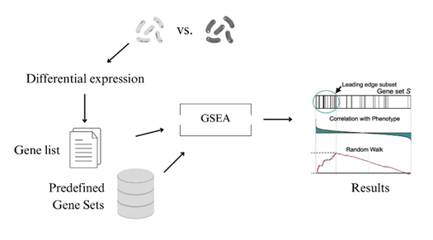
Figure 1. Workflow for gene set enrichment analysis [40–42].

There are different tools for carrying out this type of analysis that only differ in the statistical method used, such as The protein Analysis Through Evolutionary Relationships (PANTHER) tool, which is interconnected with GO, GSEA, DAVID, PAGE, topGO, Enrichr and ShinyGO [43–45]. Another way of carrying out GSEA is by using packages in R or Python after determining the reference genes. Some of the packages used in R are "fgsea" [46], GAGE [47] and “pathfindR” [48]. in Python, they are GSEAp [49] or Enrichr, which provides a Python API [45] and GeneSetAnalysis.
Some research has applied this type of analysis to determine the metabolic pathways enriched in states of dormancy among S. epidermidis biofilms using the Cytoscape v2.8.3 software [50], others have applied methods similar to GSEA, GAGE, to assess the plasticity of S. epidermidis under a range of stresses and nutrient-limited conditions [51]. Some studies use several databases to search for and build the annotations needed to carry out the enrichment analysis of a group of genes, as was done by [52], who used KEGG, GO and BioCyc to search for annotations and “fgsea” in conjunction with GSEA to understand the response of S. epidermidis to heat shock and medically relevant glucose levels.
  - ShinyGO
ShinyGO is a web-based functional enrichment tool designed for analysis with animals and plants, but it also extends its applications to other types of organisms, such as bacteria and archeal. It is a Shiny-based implementation for analyzing enriched GO terms. It contains an annotation base derived from Ensembl, STRING-db and KEGG and allows graphical visualization of enrichment results. The main input for carrying out the analysis is uploading the list of genes and selecting the species you want to investigate. With an easy-to-use interface, it is a valuable tool for exploring biological functions and to get a graphical representation of the results [43].
- Materials and Methods
Bioinformatic analysis was carried out for two strains of the bacterium S. epidermidis (PT11011 and PT12035) that exhibit induced resistance to vancomycin. Both strains had their transcriptomes previously sequenced, and the gene expression data was duly processed with the CLC Genomics tool (QIAGEN Bioinformatics, version 21.99), following the methodology used in [38, 53].
Stored in an Excel spreadsheet, the gene expression data was the base material for the study. To develop the bioinformatics analysis, the expression data from CLC Genomics was processed in Python (v3.11.5) using the “Pandas” package (v2.0.3). The processing aimed to carry out a differential expression analysis, selecting the names of the genes that had a significant FDR p-value (< 0.05) and a Fold Change greater than 2. Subseqently, a text file with the identifiers used in the STIRNG-db databases, from the names of the selected overexpressed genes, was created.
To obtain the most enriched pathways in the context of vancomycin resistance, the formulated text document was used as input in the online tool ShinyGO (v0.80). Another required input for the tool is the selection of the species corresponding to the genes being analyzed, in this case, S. epidermidis RP62A. The other parameters, including the FDR cutoff (0.05), search database, number of pathways to visualize (20), and the maximum (5000) and minimum (2) size of these pathways, were applied by default.
ShinyGO is a tool that allows the graphical visualization of the results of the enriched pathways, but due to various factors, such as the tool being out of date, the difficulty in integrating data from different sources for the specific organism being studied or the lack of annotation for the organism, the results that can be obtained by integrating different databases (KEGG) are limited. To obtain a graphical representation of the pathways, a Python (v3.11.5) pipeline was created to request the metabolic pathways associated with each gene on the list of genes of interest from the KEGG database [54, 55]. The pipeline also aimed to compare the pathways obtained with the result acquired from ShinyGO and generate a URL for each pathway with its graphical representation. The “KEGG” module of the “Biopython” library (v1.83) and the “bioservices” library (v1.11.2) were used to perform this task.
- Results and Discussion
  - ShinyGO results
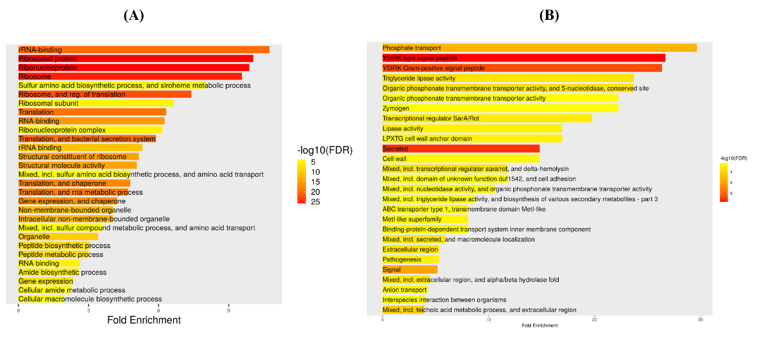
By using the ShinyGO tool, we identified the enriched metabolic pathways in the two vancomycin-resistant strains. Figure 2 highlights the main result obtained, which is organized by Fold Enrichment and the significance of the results (-log10(FDR)).
Figure 2. Barplot of the enriched lanes for strain PT11011 (A) and strain PT12035 (B). The results presented were obtained in ShinyGO.
In strain PT11011, it was found a significant enrichment of ribosomal pathways. This indicates that the bacterium's productive machinery is highly active, which, in turn, suggests that the proteins produced can be functional in inactivating or modifying antibiotics, as well as aiding bacterial maintenance in stressful situations [56]. In the case of strain PT12035, it was observed a higher enrichment on pathways related to phosphate transport. Previous studies have correlated phosphate transport with the integrity of the bacterial membrane [57]. As such, enriching this pathway could potentially affect the intracellular concentration of the antibiotic and, thus, the susceptibility of bacteria to vancomycin. In addition, since biofilm is related to bacterial resistance, biofilm stability and integrity may be important in antibiotic resistance, and phosphate transport was shown to contribute to both biofilm stability and integrity [58]. Furthermore, pathways related to the YSIRK signal peptide were also found significantly enriched, which is another important factor in S. epidermidis biofilms, as it helps to anchor surface proteins responsible for initial adhesion, and cohesion of the biofilms [59, 60].
  - KEGG results
The Python pipeline created allowed the enriched pathways to be requested graphically from the KEGG database. For strain PT11011, as expected, the pathway with the highest number of genes of interest was the ribosome pathway (23.65%, 35 out of the 148 genes of interest, those that served as input into ShinyGO) (Figure 3). Most of the genes associated with this pathway are part of the large subunit, which plays a fundamental role in protein synthesis, as it is responsible for the production and contains the site where peptide bonds are established [61].

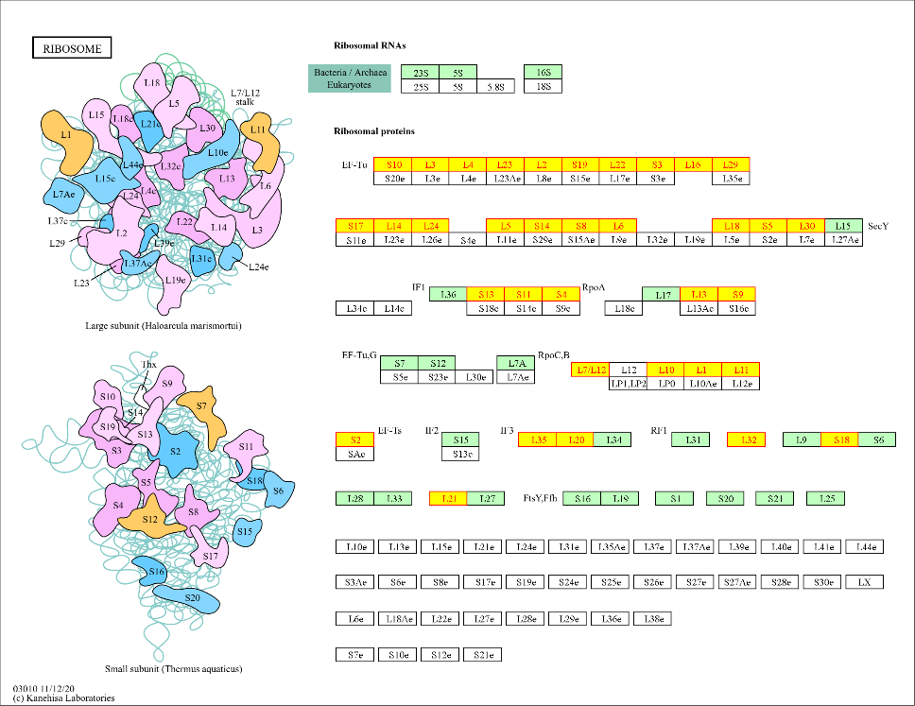
Figure 3. Ribosome, the main enriched metabolic pathway of strain PT11011. The genes highlighted in yellow are those present in the set of genes studied (fold change > 2).
For strain PT12035, the results obtained with the Python pipeline were consistent with those obtained with the ShinyGO analysis. The largest number of genes on the list of interest were associated with the ABC transporter pathway, mainly those related to phosphate transport, representing 50% of the 14 genes associated with this pathway. The genes identified as being related to the YSIRK signal peptide were mostly concentrated in the glycerolipid metabolic pathway (Figure 4). This is responsible for the formation of the bacterial membrane. Modifications to these pathways affect the sensitivity of bacteria to antibiotics [62] and, as previously mentioned, YSIRK signal peptides are fundamental in anchoring proteins to the membrane, being an essential part of maintaining the integrity and relationship of the bacteria with the external environment.
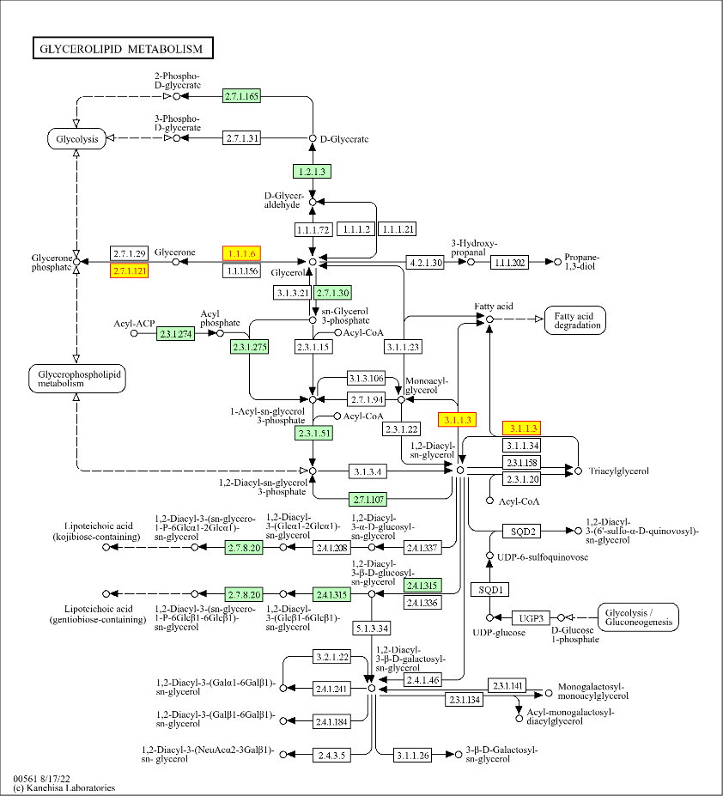
Figure 4. Glycerolipid metabolism, the metabolic pathway of the strain PT12035. The genes highlighted in yellow are those present in the set of genes studied (fold change > 2).
Since the long-term objective of this study is to identify potential targets for the development of new and effective strategies for the treatment of the infections caused by S. epidermidis, our primary goal is to identify mechanisms/pathways that are transversal to the species. When comparing the pathways obtained for the two strains studied, we identified that several of them are enriched in both. Although these results need further validation using a broader collection of strains, this result suggests that the identified mechanisms migh be species-wide, constituting potentially good targets for the development of treatments that can be widely applicable and effective. Among the similar pathways, we can highlight pathways such as two-component systems and quorum sensing, two fundamental pathways for the ability of microorganisms to adapt to the environment and respond to different conditions [63, 64].
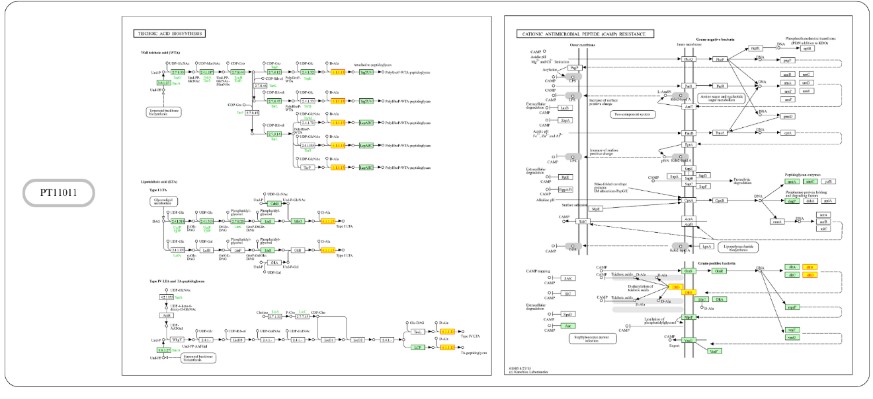
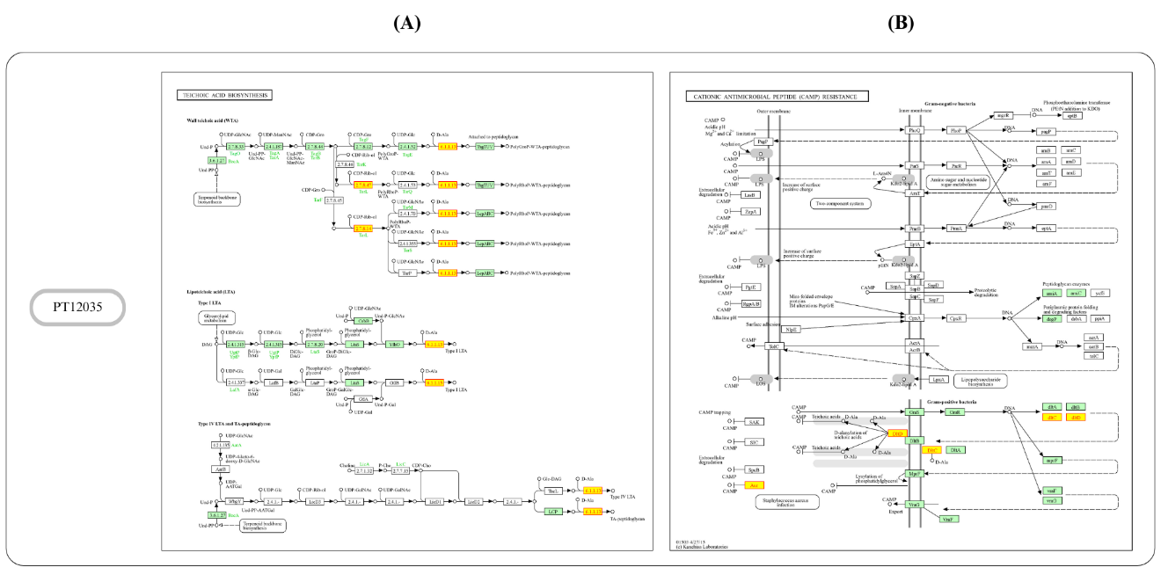
Other pathways that were identified and both strains analyzed were the teichoic acids tailoring modifications (both wall and lipo teichoic acids) and cationic antimicrobial peptide (CAMP) resistance pathways (as seen in Figure 5). It was possible to observe that most of the genes identified in both pathways were the genes dltD and dltC. These genes, which are part of the operon dltABCD, are essential for the D-alanylation of teichoic acids [65]. This modification can modulate the electrostatics of the bacterial surface, changing the surface net charge, which in addition to influencing the formation of biofilms, is considered a defense mechanism against CAMP. By making the bacterial surface more positive, the D-alanylation process creates repulsion against positively charged molecules. As vancomycin has a positive net charge and is considered a cationic antibiotic [66–68], it can be considered that the ability to alter the charge of S. epidemidis is a defense mechanism against the action of this antibiotic. The research described in [68] highlights this mechanism by inhibiting the D-alanylation capacity of Gram-positive bacteria and inferring that these bacteria showed greater susceptibility to vancomycin in conjunction with other drugs.
Figure 5. (A) represents the teichoic acid biosynthesis pathway, (B) represents the pathway of resistance to cationic antimicrobial peptides. The genes highlighted in yellow are those present in the set of genes studied (fold change > 2).

Figure 5, also shows that for strain PT12035, in the CAMPs pathway, the aur (aureolysin) gene is present among the overexpressed genes. This gene is a metalloprotease, an extracellular protein responsible for degrading extracellular proteins. The aur gene influences the formation of biofilms, can modify cell wall components and is considered a strategy for resistance to antimicrobial agents and peptide structures[69]. Although the aur gene is not directly linked to vancomycin resistance, it could be an interesting mechanism for future studies, evaluating its influence on the cell wall and biofilm formation.
- Conclusion
The investigation of S. epidermidis resistance to vancomycin, conducted using bioinformatic analysis, has provided insights into the mechanisms of resistance. Differential analysis of gene expression and gene set enrichment of differentially expressed genes revealed distinct patterns of gene regulation in the resistant strains, indicating the presence of specific mechanisms of adaptation and survival to the antibiotic, such as changes in surface charge, alterations in component transport systems and increased protein production. The significance of these findings goes beyond the framework of bacterial resistance. They are an indication of the pressing need for new research approaches to combat the existing advance of bacterial resistance to antibiotics, which is an increasingly global problem. Therefore, the use of bioinformatics tools migh be essential for guiding laboratory studies and for developing innovative strategies to solve public health challenges.

References
1. Namvar, A.E., Bastarahang, S., Abbasi, N., Ghehi, G.S., Farhadbakhtiarian, S., Arezi, P., Hosseini, M., Baravati, S.Z., Jokar, Z., Chermahin, S.G.: Clinical characteristics of Staphylococcus epidermidis: a systematic review. GMS Hyg. Infect. Control. 9, Doc23 (2014). https://doi.org/10.3205/dgkh000243.
2. Rogers, K.L., Fey, P.D., Rupp, M.E.: Coagulase-Negative Staphylococcal Infections. Infect. Dis. Clin. North Am. 23, 73–98 (2009). https://doi.org/10.1016/j.idc.2008.10.001.
3. Becker, K., Heilmann, C., Peters, G.: Coagulase-Negative Staphylococci. Clin. Microbiol. Rev. 27, 870–926 (2014). https://doi.org/10.1128/cmr.00109-13.
4. Casey, A.L., Lambert, P.A., Elliott, T.S.J.: Staphylococci. Int. J. Antimicrob. Agents. 29, S23–S32 (2007). https://doi.org/10.1016/S0924-8579(07)72175-1.
5. Fredheim, E.G.A., Klingenberg, C., Rohde, H., Frankenberger, S., Gaustad, P., Flægstad, T., Sollid, J.E.: Biofilm Formation by Staphylococcus haemolyticus. J. Clin. Microbiol. 47, 1172–1180 (2009). https://doi.org/10.1128/jcm.01891-08.
6. Asante, J., Hetsa, B.A., Amoako, D.G., Abia, A.L.K., Bester, L.A., Essack, S.Y.: Genomic Analysis of Antibiotic-Resistant Staphylococcus epidermidis Isolates From Clinical Sources in the Kwazulu-Natal Province, South Africa. Front. Microbiol. 12, (2021). https://doi.org/10.3389/fmicb.2021.656306.
7. Otto, M.: Staphylococcus epidermidis — the “accidental” pathogen: Nature Reviews Microbiology. Nat. Rev. Microbiol. 7, 555–567 (2009). https://doi.org/10.1038/nrmicro2182.
8. França, A., Gaio, V., Lopes, N., Melo, L.D.R.: Virulence Factors in Coagulase-Negative Staphylococci. Pathogens. 10, 170 (2021). https://doi.org/10.3390/pathogens10020170.
9. Oliveira, A., Cunha, M.: Bacterial biofilms with emphasis on coagulase-negative staphylococci. J. Venom. Anim. Toxins Trop. Dis. 14, 572–596 (2008). https://doi.org/10.1590/S1678-91992008000400003.
10. Wojtyczka, R.D., Orlewska, K., Kępa, M., Idzik, D., Dziedzic, A., Mularz, T., Krawczyk, M., Miklasińska, M., Wąsik, T.J.: Biofilm Formation and Antimicrobial Susceptibility of Staphylococcus epidermidis Strains from a Hospital Environment. Int. J. Environ. Res. Public. Health. 11, 4619–4633 (2014). https://doi.org/10.3390/ijerph110504619.
11. Foster, T.J.: Surface Proteins of Staphylococcus epidermidis. Front. Microbiol. 11, (2020). https://doi.org/10.3389/fmicb.2020.01829.
12. Oliveira, F., Cerca, N.: Antibiotic resistance and biofilm formation ability among coagulase-negative staphylococci in healthy individuals from Portugal. J. Antibiot. (Tokyo). 66, 739–741 (2013). https://doi.org/10.1038/ja.2013.90.
13. Chajęcka-Wierzchowska, W., Zadernowska, A., Nalepa, B., Sierpińska, M., Łaniewska-Trokenheim, Ł.: Coagulase-negative staphylococci (CoNS) isolated from ready-to-eat food of animal origin – Phenotypic and genotypic antibiotic resistance. Food Microbiol. 46, 222–226 (2015). https://doi.org/10.1016/j.fm.2014.08.001.
14. Goulart, D.B.: Pathogenicity and Antimicrobial Resistance in Coagulase-Negative Staphylococci. J. Biosci. Med. 11, 9–29 (2023). https://doi.org/10.4236/jbm.2023.115002.
15. Chajęcka-Wierzchowska, W., Gajewska, J., Zadernowska, A., Randazzo, C.L., Caggia, C.: A Comprehensive Study on Antibiotic Resistance among Coagulase-Negative Staphylococci (CoNS) Strains Isolated from Ready-to-Eat Food Served in Bars and Restaurants. Foods. 12, 514 (2023). https://doi.org/10.3390/foods12030514.
16. Garrett, D.O., Jochimsen, E., Murfitt, K., Hill, B., McAllister, S., Nelson, P., Spera, R.V., Sall, R.K., Tenover, F.C., Johnston, J., Zimmer, B., Jarvis, W.R.: The emergence of decreased susceptibility to vancomycin in Staphylococcus epidermidis. Infect. Control Hosp. Epidemiol. 20, 167–170 (1999). https://doi.org/10.1086/501605.
17. Siebert, W.T., Moreland, N., Williams, T.W.: Synergy of vancomycin plus cefazolin or cephalothin against methicillin-resistance Staphylococcus epidermidis. J. Infect. Dis. 139, 452–457 (1979). https://doi.org/10.1093/infdis/139.4.452.
18. Tuazon, C.U., Miller, H.: Clinical and microbiologic aspects of serious infections caused by Staphylococcus epidermidis. Scand. J. Infect. Dis. 15, 347–360 (1983). https://doi.org/10.3109/inf.1983.15.issue-4.05.
19. Vailati-Riboni, M., Palombo, V., Loor, J.J.: What Are Omics Sciences? In: Ametaj, B.N. (ed.) Periparturient Diseases of Dairy Cows: A Systems Biology Approach. pp. 1–7. Springer International Publishing, Cham (2017). https://doi.org/10.1007/978-3-319-43033-1_1.
20. Helmy, M., Crits-Christoph, A., Bader, G.D.: Ten Simple Rules for Developing Public Biological Databases. PLOS Comput. Biol. 12, e1005128 (2016). https://doi.org/10.1371/journal.pcbi.1005128.
21. The UniProt Consortium: UniProt: the universal protein knowledgebase. Nucleic Acids Res. 45, D158–D169 (2017). https://doi.org/10.1093/nar/gkw1099.
22. Sanober, G., Ahmad, S., Azam, S.S.: Identification of plausible drug targets by investigating the druggable genome of MDR Staphylococcus epidermidis. Gene Rep. 7, 147–153 (2017). https://doi.org/10.1016/j.genrep.2017.04.008.
23. Sethi, G., Sethi, S., Krishna, R.: Multi-epitope based vaccine design against Staphylococcus epidermidis: A subtractive proteomics and immunoinformatics approach. Microb. Pathog. 165, 105484 (2022). https://doi.org/10.1016/j.micpath.2022.105484.
24. Martínez-García, S., Peralta, H., Betanzos-Cabrera, G., Chavez-Galan, L., Rodríguez-Martínez, S., Cancino-Diaz, M.E., Cancino-Diaz, J.C.: Proteomic comparison of biofilm vs. planktonic Staphylococcus epidermidis cells suggests key metabolic differences between these conditions. Res. Microbiol. 172, 103796 (2021). https://doi.org/10.1016/j.resmic.2020.103796.
25. Olson, R.D., Assaf, R., Brettin, T., Conrad, N., Cucinell, C., Davis, J.J., Dempsey, D.M., Dickerman, A., Dietrich, E.M., Kenyon, R.W., Kuscuoglu, M., Lefkowitz, E.J., Lu, J., Machi, D., Macken, C., Mao, C., Niewiadomska, A., Nguyen, M., Olsen, G.J., Overbeek, J.C., Parrello, B., Parrello, V., Porter, J.S., Pusch, G.D., Shukla, M., Singh, I., Stewart, L., Tan, G., Thomas, C., VanOeffelen, M., Vonstein, V., Wallace, Z.S., Warren, A.S., Wattam, A.R., Xia, F., Yoo, H., Zhang, Y., Zmasek, C.M., Scheuermann, R.H., Stevens, R.L.: Introducing the Bacterial and Viral Bioinformatics Resource Center (BV-BRC): a resource combining PATRIC, IRD and ViPR. Nucleic Acids Res. 51, D678–D689 (2023). https://doi.org/10.1093/nar/gkac1003.
26. Cabrera-Contreras, R., Santamaría, R.I., Bustos, P., Martínez-Flores, I., Meléndez, E., Morelos, R., Barbosa-Amezcua, M., González-Covarrubias, V., Soberón, X., González, V.: Genomic diversity of antibiotic multi-resistant Staphylococcus epidermidis i solated from a tertiary care hospital in México City, https://peerj.com/preprints/27693v1, (2019). https://doi.org/10.7287/peerj.preprints.27693v1.
27. Ghattas, M.Z., ElRakaiby, M.T., Aziz, R.K., Zedan, H.H.: A novel PCR method targeting staphostatin genes differentiates Staphylococcus aureus from Staphylococcus epidermidis in clinical isolates and nasal microbiome samples, https://www.researchsquare.com/article/rs-4415/v2, (2024). https://doi.org/10.21203/rs.2.13709/v2.
28. Kanehisa, M.: The KEGG Database. In: ‘In Silico’ Simulation of Biological Processes. pp. 91–103. John Wiley & Sons, Ltd (2002). https://doi.org/10.1002/0470857897.ch8.
29. Kanehisa, M., Goto, S., Kawashima, S., Okuno, Y., Hattori, M.: The KEGG resource for deciphering the genome. Nucleic Acids Res. 32, D277–D280 (2004). https://doi.org/10.1093/nar/gkh063.
30. Wadood, A., Ghufran, M., Khan, A., Azam, S.S., Uddin, R., Waqas, M., Saleem, S.: The methicillin-resistant S. epidermidis strain RP62A genome mining for potential novel drug targets identification. Gene Rep. 8, 88–93 (2017). https://doi.org/10.1016/j.genrep.2017.06.002.
31. Zhao, Y., Han, Y., Sun, Y., Wei, Z., Chen, J., Niu, X., An, Q., Zhang, L., Qi, R., Gao, X.: Comprehensive Succinylome Profiling Reveals the Pivotal Role of Lysine Succinylation in Energy Metabolism and Quorum Sensing of Staphylococcus epidermidis. Front. Microbiol. 11, (2021). https://doi.org/10.3389/fmicb.2020.632367.
32. Cokelaer, T., Pultz, D., Harder, L.M., Serra-Musach, J., Saez-Rodriguez, J.: BioServices: a common Python package to access biological Web Services programmatically. Bioinformatics. 29, 3241–3242 (2013). https://doi.org/10.1093/bioinformatics/btt547.
33. Caspi, R., Altman, T., Dreher, K., Fulcher, C.A., Subhraveti, P., Keseler, I.M., Kothari, A., Krummenacker, M., Latendresse, M., Mueller, L.A., Ong, Q., Paley, S., Pujar, A., Shearer, A.G., Travers, M., Weerasinghe, D., Zhang, P., Karp, P.D.: The MetaCyc database of metabolic pathways and enzymes and the BioCyc collection of pathway/genome databases. Nucleic Acids Res. 40, D742–D753 (2012). https://doi.org/10.1093/nar/gkr1014.
34. Karp, P.D., Billington, R., Caspi, R., Fulcher, C.A., Latendresse, M., Kothari, A., Keseler, I.M., Krummenacker, M., Midford, P.E., Ong, Q., Ong, W.K., Paley, S.M., Subhraveti, P.: The BioCyc collection of microbial genomes and metabolic pathways. Brief. Bioinform. 20, 1085–1093 (2019). https://doi.org/10.1093/bib/bbx085.
35. Díaz Calvo, T., Tejera, N., McNamara, I., Langridge, G.C., Wain, J., Poolman, M., Singh, D.: Genome-Scale Metabolic Modelling Approach to Understand the Metabolism of the Opportunistic Human Pathogen Staphylococcus epidermidis RP62A. Metabolites. 12, 136 (2022). https://doi.org/10.3390/metabo12020136.
36. Leonidou, N., Renz, A., Winnerling, B., Grekova, A., Grein, F., Dräger, A.: Genome-scale metabolic model of Staphylococcus epidermidis ATCC 12228 matches in vitro conditions, http://biorxiv.org/lookup/doi/10.1101/2023.12.19.572329, (2023). https://doi.org/10.1101/2023.12.19.572329.
37. The Gene Ontology Consortium: The Gene Ontology Resource: 20 years and still GOing strong. Nucleic Acids Res. 47, D330–D338 (2019). https://doi.org/10.1093/nar/gky1055.
38. Carvalhais, V., França, A., Pier, G.B., Vilanova, M., Cerca, N., Vitorino, R.: Comparative proteomic and transcriptomic profile of Staphylococcus epidermidis biofilms grown in glucose-enriched medium. Talanta. 132, 705–712 (2015). https://doi.org/10.1016/j.talanta.2014.10.012.
39. Shi, J., Walker, M.G.: Gene Set Enrichment Analysis (GSEA) for Interpreting Gene Expression Profiles. Curr. Bioinforma. 2, 133–137 (2007). https://doi.org/10.2174/157489307780618231.
40. Ackermann, M., Strimmer, K.: A general modular framework for gene set enrichment analysis. BMC Bioinformatics. 10, 47 (2009). https://doi.org/10.1186/1471-2105-10-47.
41. Kwee, I.: How to Perform Gene Set Enrichment Analysis, https://bigomics.ch/blog/a-short-guide-to-gene-set-and-pathway-enrichment-analysis/, last accessed 2024/04/10.
42. Subramanian, A., Tamayo, P., Mootha, V.K., Mukherjee, S., Ebert, B.L., Gillette, M.A., Paulovich, A., Pomeroy, S.L., Golub, T.R., Lander, E.S., Mesirov, J.P.: Gene set enrichment analysis: A knowledge-based approach for interpreting genome-wide expression profiles. Proc. Natl. Acad. Sci. 102, 15545–15550 (2005). https://doi.org/10.1073/pnas.0506580102.
43. Ge, S.X., Jung, D., Yao, R.: ShinyGO: a graphical gene-set enrichment tool for animals and plants. Bioinformatics. 36, 2628–2629 (2020). https://doi.org/10.1093/bioinformatics/btz931.
44. Huang, D.W., Sherman, B.T., Lempicki, R.A.: Bioinformatics enrichment tools: paths toward the comprehensive functional analysis of large gene lists. Nucleic Acids Res. 37, 1–13 (2009). https://doi.org/10.1093/nar/gkn923.
45. Kuleshov, M.V., Jones, M.R., Rouillard, A.D., Fernandez, N.F., Duan, Q., Wang, Z., Koplev, S., Jenkins, S.L., Jagodnik, K.M., Lachmann, A., McDermott, M.G., Monteiro, C.D., Gundersen, G.W., Ma’ayan, A.: Enrichr: a comprehensive gene set enrichment analysis web server 2016 update. Nucleic Acids Res. 44, W90–W97 (2016). https://doi.org/10.1093/nar/gkw377.
46. Korotkevich, G., Sukhov, V., Budin, N., Shpak, B., Artyomov, M.N., Sergushichev, A.: Fast gene set enrichment analysis, https://www.biorxiv.org/content/10.1101/060012v3, (2021). https://doi.org/10.1101/060012.
47. Luo, W., Friedman, M.S., Shedden, K., Hankenson, K.D., Woolf, P.J.: GAGE: generally applicable gene set enrichment for pathway analysis. BMC Bioinformatics. 10, 161 (2009). https://doi.org/10.1186/1471-2105-10-161.
48. Ulgen, E., Ozisik, O., Sezerman, O.U.: pathfindR: An R Package for Comprehensive Identification of Enriched Pathways in Omics Data Through Active Subnetworks. Front. Genet. 10, (2019). https://doi.org/10.3389/fgene.2019.00858.
49. Fang, Z., Liu, X., Peltz, G.: GSEApy: a comprehensive package for performing gene set enrichment analysis in Python. Bioinformatics. 39, btac757 (2023). https://doi.org/10.1093/bioinformatics/btac757.
50. Carvalhais, V., França, A., Cerca, F., Vitorino, R., Pier, G.B., Vilanova, M., Cerca, N.: Dormancy within Staphylococcus epidermidis biofilms: a transcriptomic analysis by RNA-seq. Appl. Microbiol. Biotechnol. 98, 2585–2596 (2014). https://doi.org/10.1007/s00253-014-5548-3.
51. Spoto, M., Riera Puma, J.P., Fleming, E., Guan, C., Ondouah Nzutchi, Y., Kim, D., Oh, J.: Large-Scale CRISPRi and Transcriptomics of Staphylococcus epidermidis Identify Genetic Factors Implicated in Lifestyle Versatility. mBio. 13, e02632-22 (2022). https://doi.org/10.1128/mbio.02632-22.
52. Benjamin, K.N., Goyal, A., Nair, R., Endy, D.: Genome-Wide Transcription Response of Staphylococcus epidermidis to Heat Shock and Medically Relevant Glucose Levels, https://www.biorxiv.org/content/10.1101/2024.03.18.585582v2, (2024). https://doi.org/10.1101/2024.03.18.585582.
53. França, A., Carvalhais, V., Maira-Litrán, T., Vilanova, M., Cerca, N., Pier, G.: Alterations in the Staphylococcus epidermidis biofilm transcriptome following interaction with whole human blood. Pathog. Dis. 70, 444–448 (2014). https://doi.org/10.1111/2049-632X.12130.
54. 2.1. KEGG Tutorial — bioservices 1.11.1 documentation, https://bioservices.readthedocs.io/en/main/kegg_tutorial.html#introduction, last accessed 2024/06/18.
55. bioservices/src/bioservices/kegg.py at main · cokelaer/bioservices, https://github.com/cokelaer/bioservices/blob/main/src/bioservices/kegg.py, last accessed 2024/06/18.
56. Zhang, X., Li, Z., Pang, S., Jiang, B., Yang, Y., Duan, Q., Zhu, G.: The impact of cell structure, metabolism and group behavior for the survival of bacteria under stress conditions. Arch. Microbiol. 203, 431–441 (2021). https://doi.org/10.1007/s00203-020-02050-3.
57. Panda, G., Dash, S., Sahu, S.K.: Harnessing the Role of Bacterial Plasma Membrane Modifications for the Development of Sustainable Membranotropic Phytotherapeutics. Membranes. 12, 914 (2022). https://doi.org/10.3390/membranes12100914.
58. Schoenfelder, S.M.K., Lange, C., Prakash, S.A., Marincola, G., Lerch, M.F., Wencker, F.D.R., Förstner, K.U., Sharma, C.M., Ziebuhr, W.: The small non-coding RNA RsaE influences extracellular matrix composition in Staphylococcus epidermidis biofilm communities. PLOS Pathog. 15, e1007618 (2019). https://doi.org/10.1371/journal.ppat.1007618.
59. Decker, R., Burdelski, C., Zobiak, M., Büttner, H., Franke, G., Christner, M., Saß, K., Zobiak, B., Henke, H.A., Horswill, A.R., Bischoff, M., Bur, S., Hartmann, T., Schaeffer, C.R., Fey, P.D., Rohde, H.: An 18 kDa Scaffold Protein Is Critical for Staphylococcus epidermidis Biofilm Formation. PLOS Pathog. 11, e1004735 (2015). https://doi.org/10.1371/journal.ppat.1004735.
60. Büttner, H., Mack, D., Rohde, H.: Structural basis of Staphylococcus epidermidis biofilm formation: mechanisms and molecular interactions. Front. Cell. Infect. Microbiol. 5, (2015). https://doi.org/10.3389/fcimb.2015.00014.
61. Moore, P.B., Steitz, T.A.: The Structural Basis of Large Ribosomal Subunit Function. Annu. Rev. Biochem. 72, 813–850 (2003). https://doi.org/10.1146/annurev.biochem.72.110601.135450.
62. Hines, K.M., Waalkes, A., Penewit, K., Holmes, E.A., Salipante, S.J., Werth, B.J., Xu, L.: Characterization of the Mechanisms of Daptomycin Resistance among Gram-Positive Bacterial Pathogens by Multidimensional Lipidomics. mSphere. 2, 10.1128/msphere.00492-17 (2017). https://doi.org/10.1128/msphere.00492-17.
63. Stock, A.M., Robinson, V.L., Goudreau, P.N.: Two-component signal transduction. Annu. Rev. Biochem. 69, 183–215 (2000). https://doi.org/10.1146/annurev.biochem.69.1.183.
64. Waters, C.M., Bassler, B.L.: Quorum sensing: cell-to-cell communication in bacteria. Annu. Rev. Cell Dev. Biol. 21, 319–346 (2005). https://doi.org/10.1146/annurev.cellbio.21.012704.131001.
65. Fey, P.D., Olson, M.E.: Current concepts in biofilm formation of Staphylococcus epidermidis. Future Microbiol. 5, 917–933 (2010). https://doi.org/10.2217/fmb.10.56.
66. Yang, Z., Vorpagel, E.R., Laskin, J.: Influence of the charge state on the structures and interactions of vancomycin antibiotics with cell-wall analogue peptides: experimental and theoretical studies. Chem. Weinh. Bergstr. Ger. 15, 2081–2090 (2009). https://doi.org/10.1002/chem.200802010.
67. J. Flint, A., P. Davis, A.: Vancomycin mimicry: towards new supramolecular antibiotics. Org. Biomol. Chem. 20, 7694–7712 (2022). https://doi.org/10.1039/D2OB01381A.
68. May, J.J., Finking, R., Wiegeshoff, F., Weber, T.T., Bandur, N., Koert, U., Marahiel, M.A.: Inhibition of the D-alanine:D-alanyl carrier protein ligase from Bacillus subtilis increases the bacterium’s susceptibility to antibiotics that target the cell wall. FEBS J. 272, 2993–3003 (2005). https://doi.org/10.1111/j.1742-4658.2005.04700.x.
69. Sieprawska-Lupa, M., Mydel, P., Krawczyk, K., Wójcik, K., Puklo, M., Lupa, B., Suder, P., Silberring, J., Reed, M., Pohl, J., Shafer, W., McAleese, F., Foster, T., Travis, J., Potempa, J.: Degradation of Human Antimicrobial Peptide LL-37 by Staphylococcus aureus-Derived Proteinases. Antimicrob. Agents Chemother. 48, 4673–4679 (2004). https://doi.org/10.1128/aac.48.12.4673-4679.2004.

The documented code created, its dependencies and the data to reproduce the analyses can be found in the repository: https://github.com/lais-carvalho/Projeto-Bioinformatica.

