**The First Epitheliogenic Biomaterials Benefited over 16 Millions of Patients**

1. **Selected Animal Study for Wound Healing**

**Animal model of second-degree burn treated with Dr. Chou’s technology**

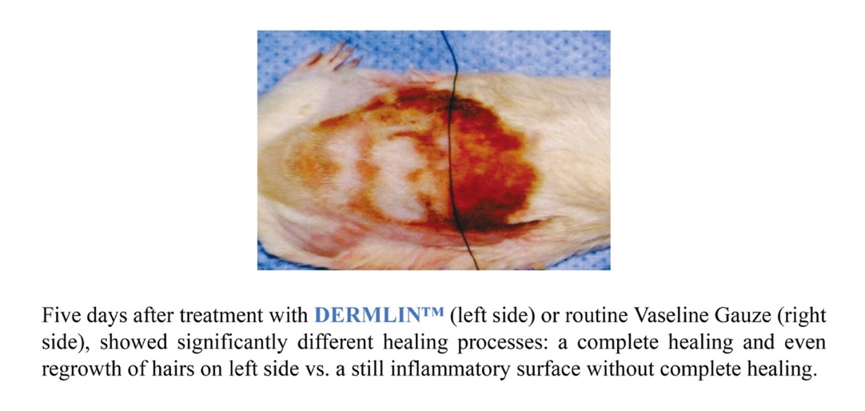

1. **Translating the Inventions into a Series of Products Named DERMLIN**

Dr. Chou has translated his discoveries and inventions from over 50 patents of in-vitro and in-vivo studies into a series of products named **DERMLIN** for medical application.

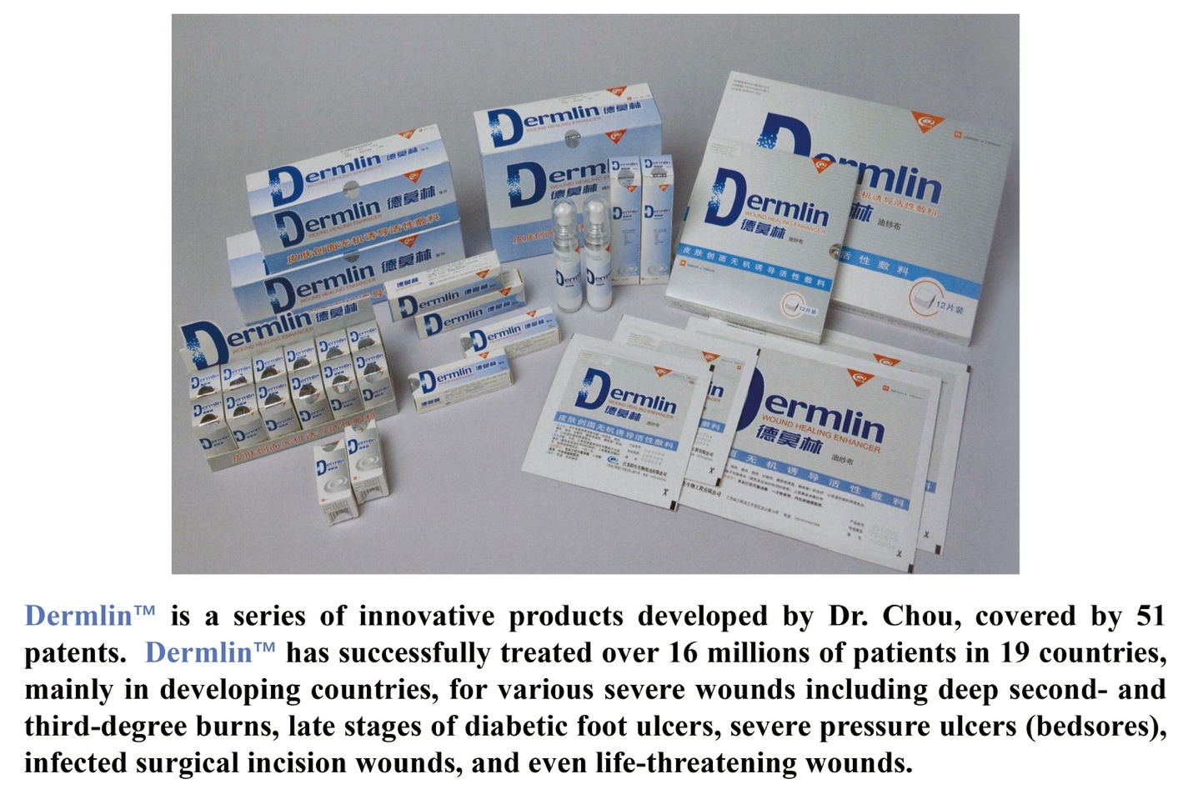

1. **Selected Patients Treated with DERMLIN**
2. **Severe surgical incision wound treated successfully with DERMLIN**

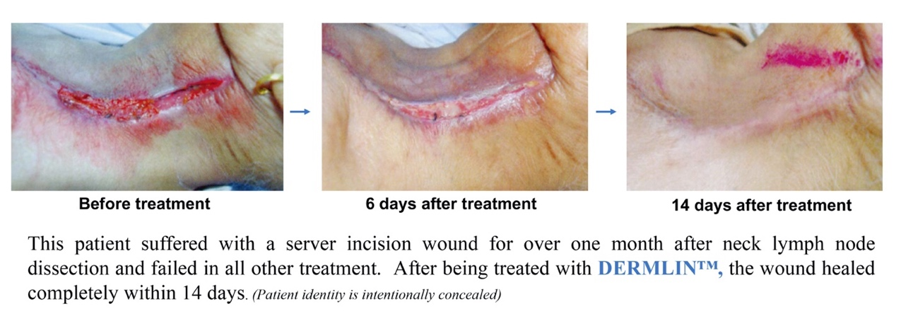

1. **Severely injured fingers treated successfully with DERMLIN**

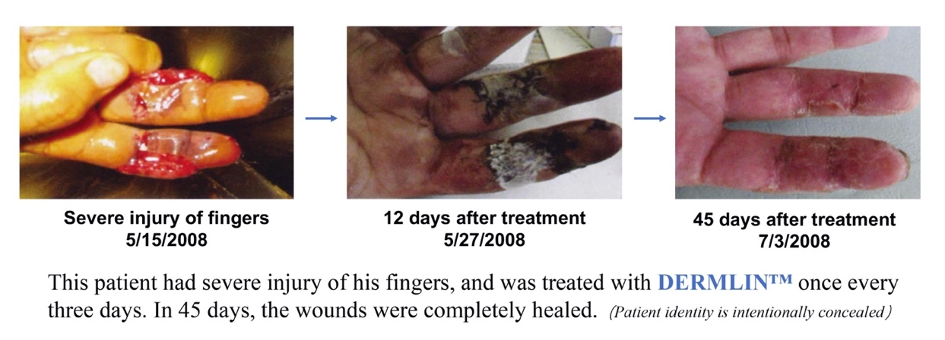

1. **Severe diabetic foot ulcer treated successfully with DERMLIN**

**5 weeks after treatment**

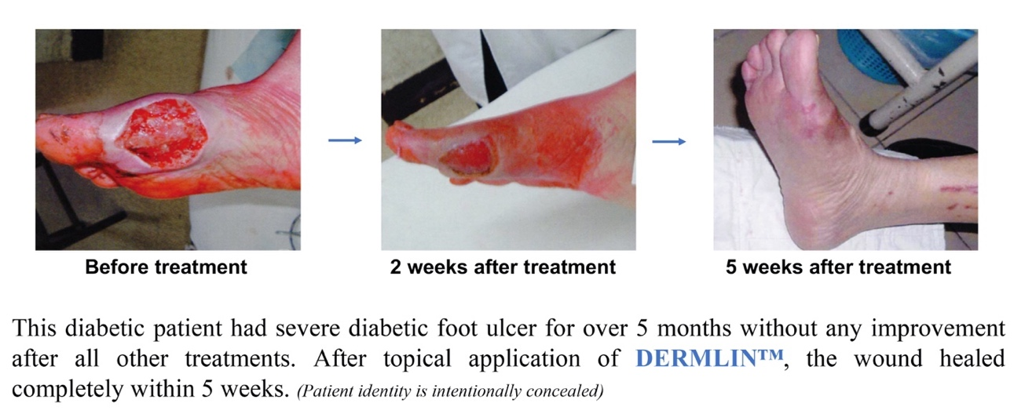

1. **Severe pressure ulcer (bedsore) treated successfully with DERMLIN**

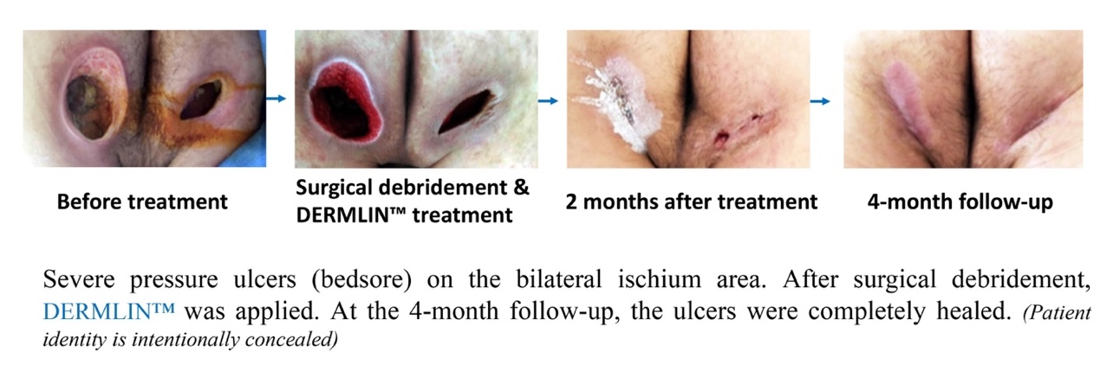

1. **Severe electric burn wound treated successfully with DERMLIN**

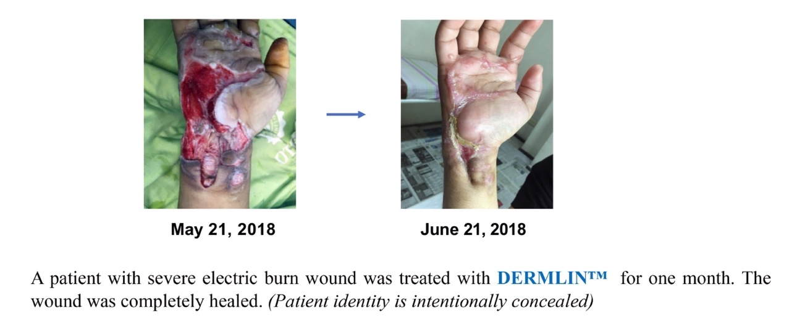

1. **Severe stasis ulcer treated successfully with DERMLIN**

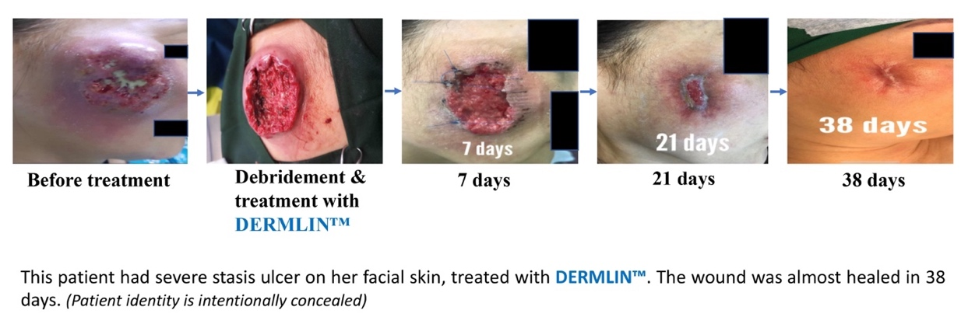

1. **Patents Covering the Invention and Production of DERMLIN**

The following 53 patents covered the inventions and productions of the **DERMLIN** products series”

Novel Materials to Enhance Would Healing. Russia. Publication Number: 2005134661, Patent Number: 2326697, 2008.

Novel Materials to Enhance Would Healing. India. Publication Number: 4926/DELNP?2005, Patent Number: 234290, 2009.

Novel Materials to Enhance Would Healing. Singapore. Publication Number: 200506436-5, Patent Number: 116155, 2007.

Novel Materials to Enhance Would Healing. Pakistan. Publication Number: 718/2004, Patent Number: 139120, 2007.

Novel Materials to Enhance Would Healing. Taiwan. Publication Number: 200610549, Patent Number: 288646, 2007.

Novel Materials to Enhance Would Healing. Iran. Publication Number: 38306765, Patent Number: 32074, 2005.

Novel Materials to Enhance Would Healing. China. Publication Number: CN1245220C, Patent Number: ZL03109623.9, 2006.

Safe and Efficient Freon-Free Aerosol Projectile System. China. Publication Number: CN100551988C, Patent Number: ZL200710020434.8, 2009.

Bone Tissue Repair Material Delivery Device for Minimally Invasive Surgery. China. Publication Number: CN2840998Y, Patent Number: ZL200520076281.5, 2006.

Composite Projectile System for Dermlin Skin Dressing. China. Publication Number: CN103920183A. Patent Number: ZL201410152332.1. 2014.

Continuous Three-Phase Suspension Aerosol Valve. China. Publication Number CN2813507Y, Patent Number ZL200520074888.X, 2006.

Waterproof Band-Aid Transparent Film. China. Publication Number: CN2848194Y, Patent Number: ZL200520076280.0, 2006.

Improved Three-Phase Suspension Aerosol Valve. China. Publication Number： CN201193140Y, Patent Number: ZL200829931748.8, 2009.

Round-Shaped Advanced Band-Aid. China. Publication Number: CN300921435D, Patent Number: ZL200830024338.6, 2009.

Powder Spray Nozzle for Inorganic Active Dressing on Skin Wound. China. Publication Number: CN204158881U, Patent Number: ZL201420543975.4, 2015.

Diamond-Shaped Advanced Band-Aid. China. Publication Number: CN300925356D, Patent Number: ZL200830024339.0, 2009.

Inorganic and Inductive Dressing for Skin Wounds. China. Publication Number: CN204158559U, Patent Number: ZL201420544257.9, 2015.

Inorganic and Active Excipient Spraying Device for Skin Wounds. China. Publication Number: CN204158880U, Patent Number: ZL201420543974.X, 2015.

Advanced Waterproof Band-Aid for Skin Wounds. China. Publication Number: CN204158558U, Patent Number: ZL201420544141.5, 2015.

Heat-Sealing Roller for Inorganic and Active Material Package for Skin Wounds. China. Publication Number: CN204160811U, Patent Number: ZL204120543950.4, 2015.

Automatic Loading and Unloading Device for Medical Patch. China. Publication Number: CN204162081U, Patent Number: ZL201420559578.6, 2015.

Paste Scraper Mixer for Oral Ulcer Patch. China. Publication Number: CN204159293U, Patent Number: ZL201420559619.1, 2015.

Board Punching Device for Medical Patch. China. Publication Number: CN204160544U, Patent Number: ZL201420559579.0, 2015.

Improved Hexagonal Patch for Skin Wounds. China. Publication Number: CN300921434D, Patent Number: ZL200830024337.1, 2009.

Punching Device with Automatic Loading and Unloading for Medical Patch. China. Publication Number: CN204159729U, Patent Number: ZL201420559616.8, 2015.

Absorbent Pad Applicator for Waterproof Medical Patch. China. Publication Number: CN206838384U, Patent Number: ZL201720346784.2, 2018.

Production Line for Advanced Wound Patch. China. Publication Number: CN2068426555U, Patent Number: ZL201720346846.X, 2018.

Three-Phase Suspension Aerosol Valve. China. Publication Number: CN207450717U, Patent Number: ZL201720393694.9, 2018.

Advanced Oval-Shaped Patch for Wounds. China. Publication Number: CN300921436D, Patent Number: ZL200830024340.3, 2015.

Paste Scraper Stirring Device for Oral Ulcer Patch. China. Publication Number: CN204159264U, Patent Number: ZL201420560835.8, 2015.

Easy-To-Tear Waterproof Film. China. Publication Number: CN207445109U, Patent Number: ZL201720363538.8, 2018.

Three-Phase Suspension Aerosol Bottle. China. Publication Number: CN207450718U, Patent Number: ZL201720393695.3, 2018.

Water Pressure Resistance Test Device for Waterproof Wound Patch. China. Publication Number: CN206848072U, Patent Number: ZL201720393708.7, 2018.

Three-Phase Suspension Aerosol Device. China. Publication Number: CN210365180U, Patent Number: ZL201921085197.8, 2020.

A Device for Inorganic Wound Healing Powder Spry. China. Publication Number: CN213192103U, Patent Number: ZL202021703592.0, 2021.

A Powder Spray Nozzle for Inorganic and Inductive Dressing for Skin Wounds. China. Publication Number: CN213192104U, Patent Number: ZL202021706895.8, 2021.

A Grinding Device for Inorganic Wound Healing Materials. Chine. Publication Number: CN21471028U, Patent Number: ZL202023192421.9, 2021.

A Wound Healing Material Containing Bio-Inductive Substances. China. Publication Number: CN215020453U, Patent Number: ZL202023192413.4, 2021.

A Sealed Storage Device for Skin Wound Dressing. Chine. Publication Number: CN214730576U, Patent Number: ZL202023192407.9, 2021.

A Device for Packaging Bioactive Wound Healing Patch. China. Publication Number: CN214731282U, Patent Number: ZL202023192422.3, 2021.

A Waterproof Wound Healing Patch. China. Publication Number: CN215349970U, Patent Number: ZL202023274002.X, 2021.

A Cutting Method for Bioactive Wound Healing Dressing. China. Publication Number: CN214724756U, Patent Number: ZL202023267393.2, 2021.

An Active Healing Bandage for Skin Wounds. China. Publication Number: CN215020455U, Patent Number: ZL202023274067.4, 2021.

Device for Grinding and Assembling Patch for Wounds. China. Publication Number: CN214717234U, Patent Number: ZL202023267395.1, 2021.

A Spray Device for Wound Healing Powder. China. Publication Number: CN214691104U, Patent Number: ZL202023274070.6, 2021.

An Adhesive Device for Wound Healing Patch. China. Publication. Number: CN215020454U, Patent Number: ZL202023267391.3, 2021.

A Composite Projectile System for Wound Healing Materials. China. Publication Number: CN1134766468B, Patent Number: ZL202110879745.X, 2022.

A Mixer for the Production of Inorganic Dressing for Internal Wounds. China. Publication Number: CN216702135U, Patent Number: ZL202123143629.6, 2022.

A Multi-Stage Crusher for Production of Inorganic Dressing Materials for internal Wounds. China. Publication Number: CN216704552U, Patent Number: ZL202123143652.5, 2022.

A Box-Type Electric Furnace for Production of Inorganic Dressing Materials for Internal Wounds. China. Publication Number: CN216716956U, Patent Number: ZL202123222621.9, 2022.

A Tunnel Oven for Production of Inorganic Dressing Materials for Internal Wounds. China. Publication Number: CN216716919U, Patent Number: ZL202123222595.X, 2022.

Dressing for Fast Healing Wounds. China. Publication Number: CN115191009B, Patent Number: ZL202211323602.1, 2023.

1. **Articles Published by the Independent Clinicians Who Used DERMLIN in Their Clinics with Successful Outcomes**
2. **Success in Treating Diabetic Foot Ulcers**

**Observation on the efficacy of Dermlin spray in treating blisters in the elderly with diabetes**

X. Song, W. Liu. Zhongguo Wuzhenxue zazhi. Vol. 10(24), 5889, 2010.

Abstract: To observe the efficacy of **Dermlin** Spray in treating spontaneous skin blisters in elderly patients with diabetes, **Dermlin** treatment group (16 cases) and the conventional treatment group (16 cases) were compared. *Results:* The curative effect of **Dermlin** Spray group was significantly better than that of the control group (P<0.05), and the average effective time of **Dermlin** group was significantly shorter than those of the control group. *Conclusion:* **Dermlin can significantly improve the healing rate of spontaneous skin blisters in elderly patients with diabetes and significantly shorten the healing time.**

<http://218.28.6.71:81/Qikan/Article/Detail?id=34946740>

<https://d.wanfangdata.com.cn/periodical/zgwzxzz201024086>

**Inorganic active dressing on skin wounds combined with hyperbaric oxygen in the treatment of diabetic foot ulcers**

M. Wu, X. Tan, N. Wu, Y. Chen, L. Gong. China Pharmacist. Vol. 12, 1793-1794, 2011.

Abstract: 60 patients with diabetic chronic foot ulcers were randomly divided into 3 groups of 20 patients each. Group A was treated with **Dermlin** plus hyperbaric oxygen, group B was treated with hyperbaric oxygen alone, and group C was treated with silver ion dressing plus hyperbaric oxygen. The effectiveness, healing rate and healing time were compared among the three groups. *Results:* Group A had an effective rate of 85.0%, a cure rate of 65.0%, an average healing time of 62.5±3.6 days. All indicators of Group A were better than those of groups B and C (P<0.05). *Conclusion:* **Using Dermlin plus hyperbaric oxygen to treat diabetic foot ulcers can improve the treatment efficiency and cure rate, shorten the healing time, and reduce amputation.**

<https://xueshu.baidu.com/usercenter/paper/show?paperid=f7e5019f0d634a700c392c4badd0df8d&site=xueshu_se>

<https://cstj.cqvip.com/Qikan/Article/Detail?id=41005390&from=Qikan_Article_Detail>

**Application of Dermlin in Wound Care of Diabetic Foot Ulcer**

Y. Bao, H. Dai. Journal of Anhui College of Health and Technology. 10.3969/j.issn.1671-8054.2010.

Abstract: A total of 80 patients with diabetic foot were randomly divided into a treatment group (48 cases) and a control group (32 cases). After routine wound cleaning, the treatment group used **Dermlin** to directly spray the ulcer wound. The control group were treated with routine method. The ulcer wound healing conditions and healing time of the two groups were observed. *Results:* In the treatment group, the effective rate was 39.59%, the improvement rate was 52.08%, and the total effective rate was 91.67%. In the control group, the effective rate was 25%, and the improvement rate was 46.88%, the total effective rate is 71.88%. The difference in the total effective rate between two groups was statistically significant (P<0.05). *Conclusion:* **Dermlin can significantly improve the healing rate and shorten the healing time of diabetic foot ulcer wounds.**

<https://xueshu.baidu.com/usercenter/paper/show?paperid=6a56549fa0996633880174162dddfdb6&site=xueshu_se&hitarticle=1>

**Preliminary clinical observation on the treatment of diabetic foot with Dermlin**

Z. Lv, W. Huang. Chongqing Medicine. Vol. 38, 39, 2009.

Abstract: The **Dermline** group (10 cases) and conventional treatment group (11 cases) were compared. *Results:* The effective average time of Demoline group was significantly shorter than those in the control group. *Conclusion:* **Dermline can significantly improve the healing of diabetic foot ulcer and significantly shorten the time for healing.**

<https://www.alljournals.cn/view_abstract.aspx?pcid=A9DB1C13C87CE289EA38239A9433C9DC&cid=BB33F1C95224820A&jid=351F61BE18A88D6818F7EC3DB2F48EC5&aid=7E03CBA53599CE6821F0B21BF03123AC&yid=DE12191FBD62783C&vid=&iid=&sid=&eid=&from_absract=1>

<https://xueshu.baidu.com/usercenter/paper/show?paperid=1u2n0a00rt020af0sp090ea0sa761472&site=xueshu_se>

**Treatment of diabetic foot using potassium permanganate combined with Dermlin dressing**

Z. Xu, L. Yuan, Z. Tang, C. Mo. Nursing Practice and Research. 10.3969/j.issn.1672-9676.2011.

Abstract: The clinical symptoms and extent of diabetic foot ulcers in 20 patients were evaluated according to the Wagner classification of diabetic foot. After a routine immersion in potassium permanganate solution, **Dermlin** was used on 20 diabetic feet. Ideal results were achieved under conditions of good blood sugar control, with an effective rate of 95%. *Conclusion:* **The use of potassium permanganate solution soaking combined with Dermlin for dressing treatment of diabetic foot is safe and effective, and is worthy of clinical promotion and application**.

<https://xueshu.baidu.com/usercenter/paper/show?paperid=29d6f82401d0d4bddcd0cb2006bd3d7f&site=xueshu_se>

<https://xueshu.baidu.com/usercenter/paper/show?paperid=1p1p08n0463h06505g2j0v40cg410109&sc_from=pingtai4&cmd=paper_forward&title=%E9%AB%98%E9%94%B0%E9%85%B8%E9%92%BE%E8%81%94%E5%90%88%E5%BE%B7%E8%8E%AB%E6%9E%97%E6%8D%A2%E8%8D%AF%E7%94%A8%E4%BA%8E%E7%B3%96%E5%B0%BF%E7%97%85%E8%B6%B3%E7%9A%84%E7%96%97%E6%95%88%E8%A7%82%E5%AF%9F%E5%8F%8A%E6%8A%A4%E7%90%86&fr=wise&tn=SE_baiduxueshuwise_y5e9t2rx&wise=1>

**Experimental study on the treatment of diabetic foot ulcers with Shengji ointment combined with Dermlin**

H. Sun, J. Chu, J. Liu, C. Ma, J. Yang. Chinese Journal of Traditional Medicine and Emergency. Vol. 19(4), 213-215, 2012.

Abstract: To evaluate the therapeutic effect of Shengji ointment combined with **Dermlin** in the treatment of diabetic foot ulcers in rats, a diabetic model of 20 rats was replicated with Grade 3 diabetic foot ulcers according to Wagner's standard. One group (n=10) was treated with **Dermlin**, and the control group was Shengji ointment. After treatment for 11 d and 15 d, the wound in **Dermlin** group shrank more significantly than the control group (11 d: 0.350±0.035 vs. 0.380±0.025, 15 d: 0.240±0.025 Ratio 010±0.026, P＜0.05 and P＜0.01). *Conclusion:* **The Dermlin significantly accelerated the healing of diabetic foot ulcer.**

<https://www.nstl.gov.cn/paper_detail.html?id=71d3f0db14f6a05b097568af2bdfda48>

1. **Success in Treating Deep Second- And Third-Degree Burn Wounds**

**An application of inorganic active dressings on residual skin wounds after deep burns**

X. Gao, A. Jia. Chinese Medication and Pharmacy. Vol. 11, 82, 2011.

Abstract: To observe the efficacy of inorganic active dressing on treatment of residual skin wounds after deep burns, 40 patients with residual skin wounds from deep burns were randomly divided into an experimental group (20 cases) and a control group (20 cases). The experimental group were treated with **Dermlin**, and the control group were treated with routine method of iodophor gauze. Results: The healing rates of wounds in the **Dermlin** group at 7 and 14 days after treatment were significantly higher than those in the control group (P<0.05), and the healing time of residual burn wounds in the **Dermlin** group was much shorter than that of the control group, (P<0.01); the average pain score of the **Dermlin** group was (2.36±0.12) points, and the average pain score of the control group was (4.35±0.31) points. The difference between the two groups was statistically significant (P<0.01). Conclusion: **Dermlin can significantly improve the healing rate of residual wounds in deep burns, shorten the healing time, and reduce the pain of patients. The effect is definite.**

<http://www.cqvip.com/qk/97963a/201111/38353919.html>

<https://xueshu.baidu.com/usercenter/paper/show?paperid=93237f4cebd188281f1567ada4bb5423&site=xueshu_se>

**The efficacy of inorganic active dressing in repairing 2nd degree burn wounds**

X. Xiang, G. Zhou, J. Shi, Z. Lv. Jiangsu Medical Journal. CNKI:SUN:YIYA.0.2010.

Abstract: Ninety-two patients of II° burn were randomly divided into inorganic active dressing **Dermlin** group (Group D) and Vaseline gauze group (Group V). The wound healing time, and conduct wound bacterial culture before and after use were observed. Result: The healing time of group D was significantly shorter than that of group V (P<0.01). After treatment, the positive rate of bacterial culture in group D was significantly lower than that of group V (P<0.05). Conclusion: **The application of inorganic active dressing Dermlin can accelerate the healing of II° burn wounds and reduce the occurrence of infection.**

<https://xueshu.baidu.com/usercenter/paper/show?paperid=14660mt03g010vj00f520a3067744605&site=xueshu_se>

**Clinical observation on treating acute radiation skin burn with inorganic active dressing**

S. Mu, J. Li, X. Wang. Chinese Journal of Misdiagnostics. Vol. 1, 57, 2010.

Abstract: To explore the clinical value of inorganic active dressings on the third-grade acute radiation skin burns, 28 patients of malignant tumors who developed the third-grade acute radiation-induced skin damage during or after radiotherapy were randomly grouped for observation. The observation group were treated with inorganic active dressing on skin wounds; the control group were treated with routine gentian violet externally. Results: The healing effect of the third-grade acute radiation skin burns in the observation group was significantly higher than that in the control group (P<0.05). Conclusion: **The clinical value of inorganic active dressings is significant in treating the third-grade acute radiation skin burns.**

<https://xueshu.baidu.com/usercenter/paper/show?paperid=3154a40d77f47d93e6eb959c706f9485&site=xueshu_se>

**The efficacy of Dermline on residual burn wounds**

H. Wang, K. Su, Z. Liu, J. Yao. Chinese Journal of Gerontology. 10.3969/j.issn.1005-9202, 2012.

Abstract: To evaluate the clinical efficacy and significance of **Dermlin**, an inorganic active dressing for skin wounds, on residual burn wounds, 100 burn patients were randomly divided into two groups, with 50 cases in each group. Patients in study group were treated with Dermlin, and patients in control group were treated with conventional drugs. The results showed that the healing time of patients using **Dermlin** was significantly shorter than that of control group (P<0.05). The wound healing rate of patients using **Dermlin** was 96.3%, which was significantly better than the control group of 52.2% (P<0.05). Conclusion: **Clinical application of Dermlin has significant effects on residual burn wounds. It can help patients recover early and improve their quality of life.**

<https://xueshu.baidu.com/usercenter/paper/show?paperid=38d251e93cafe288c7ef55b0099e9826>

<https://www.docin.com/p-2729582907.html&key=%E7%83%A7%E4%BC%A4%E6%80%8E%E4%B9%88%E6%B2%BB>

**Effect of Dermlin and nursing care in treatment of superficial 2nd degree burn**

Q. Mao. Journal of Pharmaceutical Practice. Vol. 6, 449-450, 2012.

Abstract: Objective: To explore the effect of **Dermlin** and nursing care in treatment of superficial 2nd degree burn. Patients were randomly divided into two groups: one treated by Dermlin, and one treated by traditional methods as control. Results: The clinical efficacy in the Dermlin group was significantly higher than the control group (P<0.05). The healing time and infection complications in **Dermlin** group were significantly lower than the control group (P<0.05). Conclusion: **Dermlin and nursing care had better wound healing effect than the traditional treatment for superficial 2nd degree burn.**

<http://qikan.cqvip.com/Qikan/Article/Detail?id=44181845>

<https://cstj.cqvip.com/Qikan/Article/Detail?id=44181845&from=Qikan_Article_Detail>

**The efficacy of Dermlin combined with nanosilver dressing in the treatment of second-degree burns in the elderly**

X.Wu, Y. Jun, K. Sun, J. Yang, S. Li. Chinese Journal of Gerontology. Vol. 6, 1291-1292, 2013.

Abstract: 80 elderly patients with second-degree burns were randomly divided into a treatment group with **Dermlin** and a control group with 0.5% lipiodol gauze. Comparative analysis was conducted on the wound healing time and bacterial detection rate of the two groups. Results: The wound healing time of the **Dermlin** group was significantly shorter than that of the control group, (8.6±1.3) d and (12.8±2.4) d for the superficial second-degree burn, (14.1±2.2 )d and (21.8±3.3)d for the deep second-degree burns respectfully (P<0.05). Conclusion: **Dermlin combined with nanosilver dressing can effectively inhibit or kill burn wound pathogenic bacteria, significantly shorten the burn wound healing time.**

<https://www.zhangqiaokeyan.com/academic-journal-cn_chinese-journal-gerontology_thesis/0201231780104.html>

<https://xueshu.baidu.com/usercenter/paper/show?paperid=49054ae2dacf27a698acafbcdb5445f2&site=xueshu_se>

**Application of Dermlin in second-degree burn wounds**

L. Li, Y. Wang, W. Chen, Y. Wu. China’s Naturopathy. Vol. 20(1), 20, 2012.

Abstract: A total of 90 patients with deep second-degree burns were divided into two groups: 45 patients in the experimental group were treated with **Dermlin**, and 45 patients in the control group were treated with traditional methods. Results: The healing time of the experimental group was 18 days, and that of the control group was 23 days (P<0.05). Conclusion: **Dermlin can significantly promote the healing of deep second-degree burn wounds.**

<https://wenku.baidu.com/view/b500d3708e9951e79b89277f.html?_wkts_=1713799999196>

1. **Success in Treating Severe Pressure Wounds (Bedsore):**

**Effects of Dermlin combined with Mepilex Border and oxygen therapy on bedsore**

L. Zhu, Y. Huang, X. Wang, B. Cui, Q. Li. Journal of Modern Nursing. Vol. 17(27), 38, 2011.

Abstract：A total of 60 neoplastic hematologic disorder patients suffering from bedsores were randomly divided into observational group (n =30) and control group (n =30). The former group was treated by **Dermlin** and Mepilex Border combined with oxygen therapy, the latter one was treated by timing irradiation of infrared lamp and routine surgical methods. *Results*: The effective rate of the observational group was significantly higher than those of the control group [( 100％ vs 60％ ) ;x2 =17.78 ,P ＜0. 01]. There were significant differences in healing time and times of dressing change between both groups [( 11.4 ± 1.13 ) h vs ( 3.9 ± 1.13 ) h, (21.2 ± 1.39) vs (2.8 ± 0. 71 ) ;t =3. 403,3.411;P ＜ 0. 01]. *Conclusions:* **Dermlin and Mepilex Border combined with oxygen therapy has satisfactory effects on treating bedsores arising**.

<https://d.wanfangdata.com.cn/periodical/xdhl201127041>

**Sixty-two cases of Stage III bedsores treated with Dermlin spray**

F. Liu, Z. Gu. China and Foreign Medical Treatment. Vol. 32, 103-105, 2013.

Abstract: 62 patients with Stage III bedsores were selected and treated in this hospital and randomly divided into two groups, with 31 patients in each group. The observation group was treated with **Dermlin** spray, the control group was treated with mupirocin ointment. *Results:* The total effective rate of 31 patients in the observation group was 96.77%, and the total effective rate of 31 patients in the control group was 87.10%. The difference was statistically significant (P<0.05). The recovery time of the observation group was (10.34±0.97)d, and the recovery time of the control group was (14.27±1.26)d. The difference between the groups was statistically significant (P<0.05). *Conclusion****:* Dermlin spray treatment for Stage III bedsores can not only promote clinical efficacy, but also shorten the recovery time.**

<https://wenku.baidu.com/view/b2b97199ef3a87c24028915f804d2b160b4e8681.html?_wkts_=1713572298542&bdQuery=%E5%BE%B7%E8%8E%AB%E6%9E%97%E5%96%B7%E6%B4%92%E6%B2%BB%E7%96%97%E2%85%A2%E6%9C%9F%E8%A4%A5%E7%96%AE62%E4%BE%8B%E7%9A%84%E7%96%97%E6%95%88%E8%A7%82%E5%AF%9F%E5%8F%8A%E6%8A%A4%E7%90%86%E6%8E%A2%E8%AE%A8>

**The efficacy of Dermlin in the treatment of Stage IV pressure ulcers**

X. Xie. Shiyong Yufang Yixue. Vol. 17(10), 2027-2028, 2010.

Abstract: 164 patients with Stage IV pressure ulcers were randomly divided into treatment group and control group. The treatment group was treated with **Dermlin**, and the control group was treated with conventional method. The therapeutic effect of these two groups after 6 weeks of treatment were evaluated. *Results:* The treatment group had a higher cure rate, a shorter healing time (P＜0.05), and the total effective rate was significantly higher than the control group (P＜0.01). *Conclusion:* **Dermlin is highly effective in treating Stage IV pressure ulcers.**

<https://www.zhangqiaokeyan.com/academic-journal-cn_detail_thesis/02012104680637.html>

**Application of inorganic active dressings on skin wounds in the care of pressure ulcers in patients with advanced cancer**

T. Liu, Y. Liu. China Medical Herald. 10.3969/j.issn.1673-7210. 2010.

Abstract: To explore the clinical effect of inorganic active dressing on skin wounds in the treatment of pressure ulcers, twelve patients of advanced cancer with pressure ulcers were treated with topical application of inorganic active dressing on the skin wounds. *Results:* The inorganic active dressing on skin wounds has a satisfactory therapeutic effect on pressure ulcers. *Conclusion:* Inorganic active dressings on skin wounds can be used to treat pressure ulcers.

<https://xueshu.baidu.com/usercenter/paper/show?paperid=2c995f9a7e4c7e9948c345e4b077fca0&site=xueshu_se>

**Evaluation of the effectiveness of Dermlin in severe decubitus ulcers**

R. Wang, L. Mo, X. Li, X. Shuai, X. Si. International Journal of Nursing. 10.3760/cma.j.issn.1673-4351.2013.

Abstract: A total of 52 patients with severe decubitus ulcers were selected and randomly divided into an observation group and a control group, 26 cases in each group. The control group was given conventional medication, and the observation group was treated with conventional medication plus Dermlin spray was added. The results showed that the total effective rate of the observation group was significantly higher than that of the control group (P<0.05), and the average healing time was significantly shorter than that of the control group (P<0.05). *Conclusio:* **Dermlin can upregulate tissue cell proliferation, effectively avoid wound infection and reduce scarring.**

<https://rs.yiigle.com/cmaid/224946>

**Efficacy of moxibustion combined with external spraying of Dermlin in the treatment of bedsores**

X. Li, W. Xu. Chinese Medicine Modern Distant Education. CNKI:SUN:ZZYY.0.2011.

Abstract: Decubitus ulcers are a common complication of patients who are bedridden or paralyzed for a long time, and are a common problem in rehabilitation treatment and clinical care. They are caused by long-term pressure on local tissues, resulting in continuous ischemia, hypoxia, and malnutrition, resulting in tissue ulceration and necrosis. Most of the patients in our department are elderly and bedridden. Since 2010, a total of 37 patients with bedsores have been nursed and treated with moxibustion combined with inorganic active dressing for skin wounds (hereinafter referred to as Dermlin, Jiangsu Yangsheng Bioengineering Co., Ltd. production) with remarkable curative effect.

<https://www.zhangqiaokeyan.com/academic-journal-cn_chinese-medicine-modern-distance-education-china_thesis/0201220507176.html>

**Observation on the clinical efficacy of Dermlin in the treatment of Stage III residual pressure ulcers**

L. Yang. Journal of Frontiers of Medicine. Vol. 28, 211-212, 2013.

Abstract: A total of 42 cases of Stage III residual pressure ulcers in our department from 2008 to 2012 were collected, and the treatment status was retrospectively analyzed. Dermlin treatment was used as the observation group. The cure time was (5±1.68) days and the cure rate was 100% on observation group, compared with the control group of cure time (15±2.32 days), cure rate 52.38%. *Conclusion:* **Dermlin is more effective than ordinary dressing therapy in treating Stage III residual pressure ulcers.**

<https://d.wanfangdata.com.cn/periodical/yiyqy201328213>

**The efficacy of Dermlin spray in the treatment of Stage III bedsores**

H. Chen. Strait Pharmaceutical J Purnal.Vol. 25(2), 213-214, 2013.

Abstract: Selected patients with Stage III bedsores were randomly divided into experimental group and control group. The experimental group was given **Dermlin** dressing change, and the control group was given mupirocin ointment dressing change. The clinical efficacy and recovery time of the two groups were compared. *Results:* The total effective rate of the experimental group (97.78%) was significantly higher than that of the control group (87.67%), and the difference was statistically significant (χ2=3.873, P=0.049 ). The recovery time of the experimental group was (10.35±0.98) d, significantly lower than that of the control group (14.26±1.24) d, and the difference was statistically significant (t=-16.595, P<0.01). *Conclusion:* Dermlin can improve clinical efficacy and reduce recovery time in treatment of Stage III bedsores>

<https://www.nstl.gov.cn/paper_detail.html?id=6ce1f723d5c02c18115f9308f5bb6adc>

**Application of Dermlin in the care of Stages III and IV pressure ulcers**

Y. Xia. Chinese Journal of Modern Nursing. Vol. 22, 3122-3123, 2007.

Abstract: Pressure ulcers are tissue damage and necrosis caused by long-term pressure on local tissues of the body, blood circulation disorders, and lack of tissue nutrition. Pressure ulcers are a common complication of clinical chronic diseases, such as high paraplegia, advanced cancer, long-term bed rest, and other stroke and hemiplegia. For patients with complicated pressure ulcers, the healing process is often slow, and the treatment effect for deep pressure ulcers is poor. A total of 80 patients with Stages III and IV pressure ulcers seen between 2005-2006 in our hospital were treated with the combination of routine hydrogen peroxide and DERMLIN. This treatment significantly accelerated the healing of Stages III and IV pressure ulcers and achieved satisfactory care effect.

<https://www.zhangqiaokeyan.com/academic-journal-cn_chinese-journal-modern-nursing_thesis/0201227039557.html>

**Nursing care of 8 cases of Stage Ⅱ bedsores treated with Dermlin spray**

F. Wang. Chinese Journal of Misdiagnostics.Vol. 7(29), 7053, 2007.

Abstract: Bedsores (decubitus ulcers or pressure ulcers) are caused by long-term continuous ischemia, hypoxia, and malnutrition in local tissues of the body, which lead to blood circulation disorders and the formation of local tissue ulcers and necrosis. It is one of the common complications in patients who are bedridden for a long time. In recent years, many methods have been used to treat pressure ulcers. Our department applied Demolin spray to 8 patients with pressure ulcers from 2005 to 2006, and achieved remarkable results.

<https://xueshu.baidu.com/usercenter/paper/show?paperid=3ed5df4a645fc962ef52e3aeedaf8040&site=xueshu_se>

<https://yyws.alljournals.cn/view_abstract.aspx?pcid=A9DB1C13C87CE289EA38239A9433C9DC&cid=2F92804C2B75A393&jid=0AEF43B51B7B10DD8C04CADE57561A0E&aid=21144E685D827D6E192C3A2D88948012&yid=A732AF04DDA03BB3&vid=DF92D298D3FF1E6E&iid=771469D9D58C34FF&sid=B5210BA56FFA2883&eid=B5210BA56FFA2883&referenced_num=>

**Observation on the efficacy of Dermlin Spray in the Stage III pressure ulcer care**

Zhao, F. Shi, L. Liu. China Practical Medicine. Vol. 5(25), 219-220, 2010.

Abstract: From August 2006 to August 2009, the clinical results of 14 patients with Stage III pressure ulcers treated with **Dermlin** Spray were retrospectively analyzed. 28 patients were randomly divided into a control group of 14 patients who received conventional medication, and an observation group of 14 patients who received **Dermlin** spray on the basis of conventional medication. *Results:* The observation group had higher effective healing rate (78.6%) compaired to the control group (35.7%). *Conclusion****:* Dermlin reduces the pain of patients, medical expenses, and is convenient, fast, cost-effective. No allergies or other adverse reactions have been found during clinical application of Dermlin.**

<https://d.wanfangdata.com.cn/periodical/zgsyyy201025188>

<https://www.docin.com/p-1234966900.html>

**Application of inorganic active dressings on skin wounds in the treatment of Stage III pressure ulcers**

M. Yan. Chinese Journal of Trauma and Disability Medicine. Vol. 11, 391, 2013.

Abstract: 28 patients with Stage III pressure ulcers were divided into an observation group of 16 cases and a control group of 12 cases. The patients in observation group were treated with inorganic active dressings on the skin wounds, while the patients in the control group were treated with dressing changes using the traditional method of Vaseline gauze. *Results:* The healing time of the observation group was significantly shorter than that of the control group, and the cure rate was significantly higher than that of the control group. *Conclusion:* The application of inorganic active dressings to treat Stage III pressure ulcers can promote wound healing, reduce infection, shorten the healing time of pressure ulcers, and reduce hospitalization costs.

<https://www.zhangqiaokeyan.com/academic-journal-cn_chinese-journal-trauma-disability-medicine_thesis/0201272065121.html>

**Inorganic active dressing for skin wounds in the treatment of diabetes mellitus complicated with pressure ulcers**

S. Zhang, Q. Sun. Journal of Nursing. Vol. 12, 41-42, 2009.

Abstract: 53 patients with diabetes and pressure ulcers were randomly divided into observation group (28 cases) and control group (25 cases). The observation group was treated with inorganic active dressings on the skin wounds; the control group was treated with conventional dressing changes and 0.5% iodophor. Results: Compared with the efficacy and healing time between the two groups, the difference was statistically significant (P<0.05). *Conclusion:* The inorganic active dressing on skin wounds is safe, convenient and effective in treating diabetic pressure ulcers.

<https://www.zhangqiaokeyan.com/academic-journal-cn_journal-nursing-science_thesis/0201266316067.html>

**Two cases of the Stage II pressure ulcer cured by inorganic active dressing**

L. Wang. Nursing Practice and Research. Vol. 20, 128, 2009.

Abstract: To explore the effect of inorganic dressings on skin wounds in the treatment of pressure ulcers, two patients with Stage II pressure ulcers admitted to our department and treated with inorganic active dressings on skin wounds. *Results:* In one case, the wound was completely healed within 12 days of treatment, another case was completely healed after 18 days of treatment. *Conclusion:* The inorganic active dressing on skin wounds has good clinical effect in treating pressure ulcers, reducing the patient's pain and shortening the wound healing time.

<https://www.zhangqiaokeyan.com/academic-journal-cn_nursing-practice-research_thesis/0201226410852.html>

**Experience on the application of Dermlin in pressure ulcer care**

H. Ji, X. Su. Psychological Doctor. Vol. 9, 1, 2015.

Abstract: Pressure ulcers are localized injuries to the skin, muscles, and subcutaneous tissue caused by pressure, shearing force, or friction on the skin or subcutaneous tissue. **Dermline** (inorganic active dressing for skin wounds) was used to treat 50 cases of pressure from January 2013 to April 2015 in our department. The satisfactory clinical effects were achieved.

<https://d.wanfangdata.com.cn/periodical/xlys-x201509106>

**Application of Dermlin Spray in Stage II-III Pressure Ulcer Care**

J. Zhao, Z. Wang. Chinese Journal of Health Care and Medicine. Vol. 10(5), 361, 2008.

Abstract: The occurrence of pressure ulcers is a complex pathological process caused by multiple factors, and is one of the common complications in patients who are bedridden for a long time. In 2008, our department used **Dermlin** spray to treat 4 patients with Stages II-III pressure ulcers, and achieved good results.

<https://www.nstl.gov.cn/paper_detail.html?id=ca3c5622e5601dc4b885a7b720348b55>

**The application of Deemlin dressing on bedsore care**

F. Ding, F. Jiang, H. Lu. Haerbing Journal of Medicine. Vol. 27(5), 71-72, 2007.

Abstract: Our department used **Dermlin** dressing to treat Stages II-III bedsores from 2006 to 2007 and achieved greatly satisfied results with the curative effect.

<https://d.wanfangdata.com.cn/periodical/hebyy200705070>

<https://www.taodocs.com/p-16595118.html>

**Clinical observation on the effect of Dermlin in treating pressure ulcers**

J. Wang. Journal of Medical Information. Vol. 16, 1-3, 2014.

Abstract: Pressure ulcer patients who meet the requirements were randomly divided into experimental and control groups. When all conditions and nursing conditions were the same, the observation group was treated with **Dermlin**. The efficacy, infection and healing time of the two groups were observed. *Results:* The effective rate of the observation group was significantly higher than that of the control group, and the average healing time was significantly lower than that of the control group. There was no infection in the observation group but 5 cases of infection in the control group. *Conclusion:* **Dermlin has a good therapeutic effect on pressure ulcers. It can promote wound healing and reduce the infection rate.**

<https://wenku.baidu.com/view/2dbb755c6aec0975f46527d3240c844768eaa092?fr=xueshu_top&_wkts_=1713574095558>

<https://xueshu.baidu.com/usercenter/paper/show?paperid=f5c62f1b21d9ca3fd88457b640d7380e&site=xueshu_se>

**Application of Dermlin in the care of multiple pressure ulcers in patients with cancer**

X. Zhu, H. Wang, Z. Yan, H. Zhou, J. Wang, X. Liang, L. Han. Journal of Practical Medicine. Vol. 33(4), 650-653, 2017.

Abstract: A total of 75 cancer patients with multiple pressure ulcers were admitted for treatment with Dermlin sprayed on the pressure ulcer site. *Results:* After Dermlin treatment, 0 cases of patients' pressure ulcers worsened, 34 cases (45.8%) improved, and 41 cases (54.2%) healed. The hospitalization time was 18 to 23 (19.65±4.16) days. *Conclusion:* Dermlin treatment for multiple pressure ulcers in patients with tumors has significant clinical curative effect, greatly reducing the patient's hospitalization time, and improving the quality of patients’ life.

<https://d.wanfangdata.com.cn/periodical/syyxzz201704042>

**Application of Dermlin combined with iodophor in treatment of patients with bedsores**

N. Qin, J. Wang. Medicine and Health. Vol. 5, 182, 2015.

Abstract: 14 cases of pressure sores occurred after cardiac surgery were randomly divided into an experimental group treated with **Drermlin** and a control group treated with routine iodophor dressing. *Results:* The treatment effect of the **Dermlin** group was better than that of the control group (P<0.05), and the healing time of the sore surface (7.0±1.5) days was significantly shorter than that of the control group (16.0±1.5) days (P<0.05). *Conclusion:* **Dermlin can significantly improve the clinical efficacy and reduce the healing time in the treatment of bedsores.**

<http://www.cqvip.com/QK/72001x/201509/epub666784037.html>

<https://wenku.baidu.com/view/fd2b4396be23482fb5da4cba.html?_wkts_=1713583855249&bdQuery=%E5%BE%B7%E8%8E%AB%E6%9E%97%E8%81%94%E5%90%88%E7%A2%98%E4%BC%8F%E6%B2%BB%E7%96%97%E8%A4%A5%E7%96%AE%E6%82%A3%E8%80%85%E4%B8%AD%E7%9A%84%E5%BA%94%E7%94%A8%E6%95%88%E6%9E%9C%E8%A7%82%E5%AF%9F>

**The effect of Dermlin combined with 10% cod liver oil in the treatment of pressure ulcers**

G. Shi, S. Luo, X. Yin. China Modern Medicine. CNKI:SUN:ZGUD.0.2014.

Abstract: 60 hospitalized patients with pressure ulcers were randomly divided into a control group with conventional medication and an experimental group treated with **Dermlin** and 10% cod liver oil. As a result, 23 cases in the experimental group were cured, 4 cases were markedly effective, 3 cases were effective, 0 cases were ineffective, and the total effective rate was 100%. In the control group, 15 cases were cured, 2 cases were markedly effective, 4 cases were effective, and 9 cases were ineffective and the total effective rate was 70%. The difference between the two groups was statistically significant (χ2=6.58, P0.05). The wound healing time of the experimental group was (14.85±1.50)d, the control group was (21.85±3.50)d (P<0.05). *Conclusion*: Dermlin combined with 10% cod liver oil shortened the treatment time of pressure ulcers, improves the cure rate, relieves patients' pain, and improves the quality of life.

<http://www.doc88.com/p-9773618873807.html>

<https://xueshu.baidu.com/usercenter/paper/show?paperid=eced931499fc4caf88371a8b81d09d22&site=xueshu_se>

**Effect of Dermlin spray on patients with pressure ulcers**

L. Zhang. Chinese Journal of Biochemical Pharmaceutics. Vol. 10, 401-402, 2017.

Abstract: 56 patients with pressure sores were selected and randomly divided into the control group of 28 patients with routine treatment, and the study group of 28 patients with **Dermlin** treatment. The therapeutic effects of the two groups were compared and analyzed. *Results:* The effective rate of treatment in the study group was 85.71 %, which was significantly higher than 64.28 % in the control group (P<0.05). The cure time of the study group was significantly shorter than that of the control group (P<0.05). Conclusion **Dermlin spray can significantly improve the clinical efficacy in treating the pressure ulcers.** <https://xueshu.baidu.com/usercenter/paper/show?paperid=1t4e0pd0150m0gt04s6u0820vn213513&site=xueshu_se>

**The efficacy and nursing experience of Dermlin in treating pressure ulcers in neurosurgery patients**

Y. Cehng, J. Fang, X. Zhu. Journal of Anhui Health Vocational & Technical College. Vol. 3, 73-74, 2018.

Abstract: 89 inpatients of neurosurgery with pressure ulcers were randomly divided into **Dermlin** treatment group of 47 cases and Vaseline control group of 42 cases. The efficacy, healing effect and infection of the two groups were compared. *Results:* The average healing yimr of the Dermlin group was significantly shortened and the effective rate was significantly increased compared with control group (P<0.01). there were no cases of infection in the dermlin group and 5 cases of infection in the control group. *Conclusion:* **Dermlin has a good therapeutic effect on pressure ulcers. It can promote wound healing and reduce the risk of infection.**

<https://wenku.baidu.com/view/ac253ae628f90242a8956bec0975f46527d3a7a6.html?_wkts_=1713812591244&bdQuery=%E5%BE%B7%E8%8E%AB%E6%9E%97%E6%B2%BB%E7%96%97%E7%A5%9E%E7%BB%8F%E5%A4%96%E7%A7%91%E6%82%A3%E8%80%85%E5%8E%8B%E7%96%AE%E7%96%97%E6%95%88%E5%92%8C%E6%8A%A4%E7%90%86%E4%BD%93%E4%BC%9A>

<https://www.zhangqiaokeyan.com/academic-journal-cn_journal-anhui-health-vocational-technical-college_thesis/0201243280043.html>

**Clinical observation on the treatment of stage III pressure ulcers using inorganic active dressing based on TIME principle**

W. Zhong, X. Wang. Modern Medicine Journal of China. Vol. 21(2), 74-76, 2019.

Abstract: Pressure ulcers occur due to continuous ischemia, hypoxia and nutritional disorders in the skin and deep tissues under a certain pressure and sufficient pressure time, eventually leading to local tissue damage and necrosis. If there is combined infection or sepsis, the mortality rate exceeds 50%. In this study, after evaluating the wound through the TIME principle, an inorganic active dressing (**Dermlin** Spray, Jiangsu Yangsheng Bioengineering Co., Ltd.) was used on the skin wound to treat 62 cases of Stage III pressure ulcer with satisfactory results,

<https://wenku.baidu.com/view/89a0215b31687e21af45b307e87101f69f31fb5d?fr=xueshu_top&_wkts_=1713813851087>

<https://xueshu.baidu.com/usercenter/paper/show?paperid=1m330mx0xn5n0ef0b90n0xp0bx428317&site=xueshu_se>

**Clinical observation on the treatment of stage III pressure ulcers using inorganic active dressing based on TIME principle**

W. Zhong, X. Wang. Modern Medicine Journal of China. Vol. 21(2), 74-76, 2019.

Abstract: Pressure ulcers occur due to continuous ischemia, hypoxia and nutritional disorders in the skin and deep tissues under a certain pressure and sufficient pressure time, eventually leading to local tissue damage and necrosis. If there is combined infection or sepsis, the mortality rate exceeds 50%. In this study, after evaluating the wound through the TIME principle, an inorganic active dressing (**Dermlin** Spray, Jiangsu Yangsheng Bioengineering Co., Ltd.) was used on the skin wound to treat 62 cases of Stage III pressure ulcer with satisfactory results,

<https://wenku.baidu.com/view/89a0215b31687e21af45b307e87101f69f31fb5d?fr=xueshu_top&_wkts_=1713813851087>

<https://xueshu.baidu.com/usercenter/paper/show?paperid=1m330mx0xn5n0ef0b90n0xp0bx428317&site=xueshu_se>

1. **Success in Treating Surgical Incision Wounds:**

**Effect of Dermlin on healing of cesarean section incisions**

P. Gao, m. Yao, Y. Jia, X. Chen, C. Fu, W. Dong. Chinese Journal of Coal Industry Medicine. Vol. 16(3), 355-356, 2013.

Abstract: A total of 200 pregnant women with strict indications for cesarean section were randomly divided into a **Dermlin** group of 100 cases (**Demolin** dressing applied to surgical incisions) and a control group of 100 cases (sterile gauze was used for surgical incisions). The fat liquefaction rate of surgical incisions, incision healing rate and scar formation of the two groups were calculated. *Results:* The fat liquefaction rate of surgical incisions, incision healing and scar formation of the two groups were significantly (P<0.05). *Conclusion:* **Dermlin dressing applied to cesarean section incisions can promote incision healing, reduce fat liquefaction rate, reduce scars, thereby reducing maternal hospitalization time and costs compared with traditional incision fixation methods.**

<https://xueshu.baidu.com/usercenter/paper/show?paperid=49924755468523269a49152dcd5bc59b&site=xueshu_se>

<https://yyws.alljournals.cn/view_abstract.aspx?pcid=A9DB1C13C87CE289EA38239A9433C9DC&cid=BB33F1C95224820A&jid=9417EA30230A4A64CFC2183205D7F35F&aid=8DBC96E2ECD6AF860CC9650B9D341D4E&yid=FF7AA908D58E97FA&vid=7801E6FC5AE9020C&iid=38B194292C032A66&sid=26AEEED215BE97D0&eid=35E8A259891FB32F&referenced_num=>

**The evaluation of Dermlin effect on inflammatory response of wounds using SIRS score**

P. Gao, M. Yao, S. Zhang, Y. Jia, X. Gao. Chinese Nursing Research. 2, 211-212, 2016.

Abstract: A total of 100 primiparous women who underwent cesarean section were randomly divided into intervention group treated with Dermlin and control group were covered with traditional sterilized medical gauze. The SIRS scores, incision healing grades, and healing time were compared between the two groups. *Results:* There were statistically significant differences in maternal SIRS scores, incision grade A healing rate, and incision healing time between the two groups (P<0.05). *Conclusion:* **Deemlin can promote the healing of surgical incisions, shorten the healing time, reduce inflammatory reactions, and prevent the occurrence of infection.**

<https://xueshu.baidu.com/usercenter/paper/show?paperid=74b5b1f270ac11c858255983231a279a&site=xueshu_se>

<http://kns.cnki.net/KCMS/detail/detail.aspx?dbcode=CJFD&filename=SXHZ201602033>

**The effect of Dermlin on abdominal incision for cesarean section**

P. Gao, S. Zhang, S. Kang, X. Gao, G. Pu, X. Gao. Chinese Journal of Coal Industry Medicine. Vol. 2, 317-319, 2015.

Abstract: 100 cesarean section mothers were randomly divided into two groups. 50 cases in the **Dermlin** group were treated with **Dermlin** dressing; 50 cases in the control group were treated with sterile dressing. Grade A healing rate and incision healing time were examined. *Results:* The grade A healing rate of the **Dermlin** group was significantly higher than that of the control group, and the healing time of the surgical incision was significantly shorter in Dermlin group than that of the control group. *Conclusion****:* Dermlin dressing applied to abdominal wall incisions after cesarean section can not only improve the grade A healing rate of surgical incisions, but also shorten the incision healing time and maternal hospitalization time.** <http://www.cqvip.com/qk/91135x/2015002/663649937.html>

**The effects of Dermlin dressing and ordinary dressing in cesarean section incision care**

C. Gao. China Medical Cosmetology. Vol. 6, 146, 2014.

Abstract: A total of 300 patients who underwent cesarean section in our hospital from June 2013 to June 2014 were selected were randomly divided into a study group treated with Dermlin and a control group treated with ordinary dressing, with 150 cases in each group. The scar formation of maternal surgical incisions and the Grade A healing rate were compared. *Results:* The treatment effect of the patients in the Dermlin group was significantly better than that of the patients in the control group in terms of scar formation and grade A healing rate (P<0.05). *Conclusion****:* Dermlin dressing has obvious curative effect in the care of cesarean section incisions, with fast healing and less scars.**

<https://d.wanfangdata.com.cn/periodical/zgylmr201406125>

**The effects of Dermlin dressing and ordinary dressing in cesarean section incision care**

P. Gao, S. Zhang, M. Yao, Y. Jia, Y. Liu. Chinese Nursing Research. Vol. 28(5A), 1600-1601, 2014.

Abstract: 150 women who underwent cesarean section were selected and randomly divided into the **Dermolin** group and the ordinary dressing control group. The grade A healing rate and scar formation of surgical incisions were compared between the two groups. *Results:* The difference in grade A healing rate and scar formation between the two groups was statistically significant (P<0.05). Conclusion: Applying **Dermlin** dressing in the early stage of cesarean section surgical incisions is better than using ordinary dressings to wrap the wound. **Dermlin can improve the Class A healing rate of surgical incisions and reduce scars.**

<https://wenku.baidu.com/view/3f7e3135fd0a79563d1e7249.html?_wkts_=1713549785650&bdQuery=%E5%BE%B7%E8%8E%AB%E6%9E%97%E6%95%B7%E8%B4%B4%E4%B8%8E%E6%99%AE%E9%80%9A%E6%95%B7%E6%96%99%E5%9C%A8%E5%89%96%E5%AE%AB%E4%BA%A7%E6%89%8B%E6%9C%AF%E5%88%87%E5%8F%A3%E6%8A%A4%E7%90%86%E4%B8%AD%E7%9A%84%E5%BA%94%E7%94%A8%E6%95%88%E6%9E%9C%E6%AF%94%E8%BE%83>

**The clinical effects of Dermlin dressing and ordinary dressing in cesarean section incision care**

G. Fan. China Medical Cosmetology. Vol. 6, 123-124, 2014.

Abstract: The clinical data of 84 patients with cesarean section were discussed and divided into a Dermlin treatment group and a routine treatment control group, both with 42 cases. The scar formation and healing status of the two groups of patients were comparatively analyzed. *Results:* The Grade A healing rate of surgical incisions and the Grade I scar formation rate of surgical incisions in the Dermlin group were 97.62% and 97.62%, respectively, compared with 80.95% and 76.19% of the patients in the control group, with significant differences (P<0.05). *Conclusion:* **Dermlin application has a significant effect in the care of cesarean section incisions.**

<https://d.wanfangdata.com.cn/periodical/zgylmr201406105>

**The effect of Dermlin on promoting the healing of cesarean section incisions**

P. Gao, X. Sun, X. Ai, X. Zhao, Y. Liu, Z. Meng. Chinese Journal of Aesthetic Medicine. 10.3969/j.issn.1008-6455.2012.

Abstract: A total of 168 pregnant women with strict indications for cesarean section were randomly divided into two groups: 86 cases in the **Dermlin** group were treated with **Dermlin** dressing; 82 cases in the control group used routine sterile dressings to observe the incision healing and grade A healing rate. *Results:* The grade A healing rate of the Dermlin group was significantly higher than the control group. *Conclusion:* **Application of Dermlin dressing once after cesarean section can improve the grade A healing rate of surgical incisions, reduce patient pain, and shorten hospitalization time.**

<https://xueshu.baidu.com/usercenter/paper/show?paperid=a6cd26cbba4525d6ed4f4255e6751644&site=xueshu_se>

**Application of Dermlin dressing in wound care after cesarean section**

P. Gao, M. Yao, S. Zhang, Y. Jia, X. Gao, J. Chen. Chinese Nursing Journal. Vol. 29(12B), 4448-4449, 2015.

Abstract: 100 primiparous women were randomly divided evenly into study group and control group. The postoperative surgical incision of the study group was covered with Dermlin dressing, while the surgical incision of the control group was covered with traditional sterilized medical gauze. The wound pain, comfort and incision scar conditions of the two groups were compared 6 months after surgery. *Results:* There were statistically significant differences in the wound pain, comfort scores, and incision scars of the two groups (P<0.05). *Conclusion:* **The application of Dermlin dressing on surgical incisions can reduce or avoid scar formation, promote incision healing, and improve maternal comfort.**

<https://xueshu.baidu.com/usercenter/paper/show?paperid=523a9b7e5b55501539b882456d34b13e&site=xueshu_se>

<https://www.doc88.com/p-6981560564809.html>

<https://wenku.baidu.com/view/ba115c22c9aedd3383c4bb4cf7ec4afe04a1b189.html?_wkts_=1713547946150&bdQuery=%E5%BE%B7%E8%8E%AB%E6%9E%97%E6%95%B7%E8%B4%B4%E5%9C%A8%E5%89%96%E5%AE%AB%E4%BA%A7%E6%9C%AF%E5%90%8E%E4%BC%A4%E5%8F%A3%E6%8A%A4%E7%90%86%E4%B8%AD%E7%9A%84%E5%BA%94%E7%94%A8%E7%A0%94%E7%A9%B6>

**Application of Dermlin dressing in cesarean section incision care**

P. Gao, M. Yao, Y. Jia, G. Chen, Z. Meng, X. Wang. Chinese Journal of Coal Industry Medicine. 10.11723/mtgyyx 1007-9564, 2013.

Abstract: 180 cases of cesarean section women were divided into observation group treated with **Dermlin** and control group treated with routine sterile gauze. Results: In **Dermlin** group, the pain of incision dressing change was significantly lower than that of the control group, and the grade A healing rate of parturient women in the **Dermlin** group was significantly higher than that of the control group. *Conclusion:* **Using Dermlin dressing for cesarean section incisions can effectively relieve the pain of surgical incision dressing change and promote incision healing, and shortening hospitalization time.**

<https://xueshu.baidu.com/usercenter/paper/show?paperid=672180351a327cce02133632c566ce14&site=xueshu_se>

**Analysis of the clinical effects of Dermlin dressing and ordinary dressing on abdominal incision care**

X. Zhou, H. Zhu. Chinese Medical Cosmetology. Vol. 5, 71-71, 2014.

Abstract: To assess the efficacy of **Dermlin** for abdominal surgical incision healing, a total 120 patients were included, randomly assigned to two groups. A study group of 60 patients received **Dermlin** treatment. The control group of 60 patients received regular wound healing methods. The results showed a significant increase in Class A healing rate, a decreases in fatty liquefaction rate and pain in **Dermlin** group (P<0.05). *Conclusion:* **Dermlin has much higher healing effect for abdominal surgical incision wounds compared to regular care.**

<https://wenku.baidu.com/view/9a2533fba417866fb84a8e93.html?_wkts_=1713542252297&bdQuery=%E5%BE%B7%E8%8E%AB%E6%9E%97%E6%95%B7%E8%B4%B4%E4%B8%8E%E6%99%AE%E9%80%9A%E6%95%B7%E6%96%99%E5%BA%94%E7%94%A8%E4%BA%8E%E8%85%B9%E9%83%A8%E5%88%87%E5%8F%A3%E6%8A%A4%E7%90%86%E7%9A%84%E4%B8%B4%E5%BA%8A%E6%95%88%E6%9E%9C%E5%88%86%E6%9E%90>

**Effect of Dermlin on promoting the healing of calf surgical incisions**

Q. Li, P. Hao, H. Zhang, S. Wang. Medicasl Aesthetics and Cosmetology, Vol. 4, 1-3, 2014.

Abstract: To study the effect of Dermlin on the healing of surgical incisions in patients' lower legs, 60 cases of calf surgery were randomly divided into two groups, one for treatment with **Dermlin** and one for routine treatment as control*. Results:* The incision healing time of the **Dermlin** group was significantly shorter than that of control group, and the postoperative scars were lighter in **Dermlin** group than those of control group. *Conclusion:* **The application of Dermlin dressing after calf surgery can shorten the healing time of surgical incisions and reduce scars.**

<https://d.wanfangdata.com.cn/periodical/ChpNaW5lclBlcmlvZGljYWxDSEkyMDIzMDMyMRISeXhteG1yLXp4MjAxNDA0MzMxGghnMnMxb25pNw%3D%3D>

<https://wenku.baidu.com/view/0c037b082aea81c758f5f61fb7360b4c2f3f2a34.html?_wkts_=1713543255590&bdQuery=%E5%BE%B7%E8%8E%AB%E6%9E%97%E6%95%B7%E8%B4%B4%E4%BF%83%E8%BF%9B%E5%B0%8F%E8%85%BF%E6%89%8B%E6%9C%AF%E5%88%87%E5%8F%A3%E6%84%88%E5%90%88%E7%9A%84%E4%B8%B4%E5%BA%8A%E8%A7%82%E5%AF%9F>

**Effect of topical application of Dermlin and microwave therapy after abdominal operation**

S. Liu, W. Liu. China Medicine and Pharmacy. Vol. 15. 1-5, 2012.

Abstract: A retrospective survey was used to compare the treatment methods for fat liquefaction occurred in various abdominal surgeries in the hospital from January 2011 to April 2012. 50 cases were treated with **Dermlin**, and 46 cases were treated with routine 0.5% iodine as the control. Results: The average treatment time and average postoperative incision recovery time of **Dermlin** group were significantly shorter than those of the control group (P <0.05). *Conclusion:* **Dermlin combined with microwave physiotherapy can effectively control incision exudation and promote wound healing.**

<https://wenku.baidu.com/view/c248e4ee001ca300a6c30c22590102020640f250?fr=xueshu_top&_wkts_=1713577938881>

<https://xueshu.baidu.com/usercenter/paper/show?paperid=4d62934f527fb0ebf4f1b1d5d22bc8af&site=xueshu_se>

**The preventive effect of Dermline, an inorganic active dressing, on fat liquefaction in abdominal surgical incisions in elderly obese patients with gastric cancer surgery**

Y. Chu, Z. Yin, H. Hao. Chinese Journal of Clinical Rational Drug Use. Vol. 19, 94. 2016.

Abstract: A total of 100 patients with gastric cancer who required surgical treatment were selected and randomly divided into treatment groups treated with **Dermlin** and control groups treated with routine incision suturing and dressing change. The liquefaction of incisional fat was observed. *Results:* The incidence rate of incisional fat liquefaction in patients with **Dermlin** was 2.17%, which was significantly lower than that in the control group (14.29%), and the difference was statistically significant (P < 0.05). *Conclusion:* **Dermlin has a significant preventive effect on fat liquefaction in abdominal surgical incisions in obese patients.**

<https://xueshu.baidu.com/usercenter/paper/show?paperid=2eb84c2ecb0a47048c6b7588795bc45e>

1. **Success in Treating Radiotherapy-Associated Wounds:**

**Efficacy of Dermlin on Skin Injury after radio-therapy of patients with throat cancer**

J. Han, S. Wu. Chinese Journal of Traditional Medical Science and Technology. Vol. 21, 151-152, 2014.

Abstract: 76 patients of throat cancer suffering from class Ⅱ to Ⅳ skin injury of the neck after radio-therapy were randomly divided into trial group with **Dermlin** and control group, with 38 cases in each group. Clinical efficacy, chemotherapy duration, hospitalization time and hospitalization cost were compared between 2 groups after 2 weeks of treatment. *Results:* The total effective rate of trial group (92.11%) was significantly higher than in control group (73.68%); there was statistical significance (χ2=4.547, P=0.033). Chemotherapy duration，hospitalization time and hospital costs were (33.72±4.12)d, (40.49±5.13)d and (2.63±0.27) ten thousand yuan in trial group, which were significantly lower than that in control group (P<0.05) 0.05. *Conclusions:* **Dermlin has a better effect on skin injury of the neck in throat cancer patients accepted radiotherapy. It contributes to receiving continuous radiotherapy, reducing hospitalization time and hospitalization cost.**

<http://wap.china-pharmacy.com/attached/wenjian/1/201603/11194401_1341.pdf>

**Dermlin prevents acute radiation skin damage after postoperative radiotherapy for breast cancer**

Y. Han. Medical Journal of Health. Vol. 21(8), 832, 2009.

Abstract: A total of 86 patients with breast cancer who required radiotherapy after surgery were randomly divided into two groups. 43 patients were given **Dermlin** after the first radiotherapy as the study group, and 45 patients without particular treatment as the control group. *Results:* The incidence rates of acute skin reactions in the control group and study group were 93.8% and 30.4%, mild radiation reaction (grade 1+2) was 66.7% and 28.6% respectively. Skin reaction dose: 41 cases (91.1%) in the control group appeared before irradiation of 40Gy, and only 5 cases (38.5%) in the study group. *Conclusion:* **Dermlin can effectively prevent the occurrence of acute radiation dermatitis during postoperative radiotherapy for breast cancer, reduce the pain of patients, and ensure the smooth progress of radiotherapy.**

<http://www.cqvip.com/QK/81082A/20098/30182780.html>

<https://wenku.baidu.com/view/8bf2e1f1f705cc1755270934.html?_wkts_=1713582194713&bdQuery=%E5%BE%B7%E8%8E%AB%E6%9E%97%E9%A2%84%E9%98%B2%E4%B9%B3%E8%85%BA%E7%99%8C%E6%9C%AF%E5%90%8E%E6%94%BE%E7%96%97%E6%80%A5%E6%80%A7%E6%94%BE%E5%B0%84%E6%80%A7%E7%9A%AE%E8%82%A4%E6%8D%9F%E4%BC%A4>

**Efficacy of Dermlin in treatment of radiation-induced skin burns of nasopharyngeal carcinoma patients**

P. Chen, J. Zhou, Y. Hu. Laser Journal. Vol. 30(4), 9, 2009.

Abstract: 20 patients suffered radioactive burns to the neck skin were sequentially divided into an experimental group of 10 patients treated with **Dermlin** and a control group of 10 patients treated with traditional methods. *Results:* Compared with the control group, **Dermlin has high efficacy, short wound healing time, and is easy to use. It provides an effective treatment method for the recovery of skin lesions caused by radiotherapy in patients with nasopharyngeal carcinoma.**

<https://www.doc88.com/p-95051297043.html>

<https://apps.wanfangdata.com.cn/perios/article:jgzz200904034>

**The clinical effect of Dermlin spray on radiation dermatitis**

K. Wan, G. Zhang, R. Fan, Y. Wang, R. Cheng, L. Li, R. Kang. Journal of Practical Medicine. Vol. 33(4), 312-314, 2016.

Abstract: 60 patients with third- and fourth-grade radiation dermatitis who underwent radiotherapy were screened and randomly divided into an experimental group of 30 cases treated with **Dermlin** and a control group of 30 cases treated with routine burn ointment. *Results:* The cure rate of the experimental group was significantly higher than that of the control group (P=0.002). *Conclusion*: **Dermlin spray can significantly accelerate the skin repair speed and improve the healing effect in the care of severe radiation dermatitis.**

<https://xueshu.baidu.com/usercenter/paper/show?paperid=69df0de04d98272dd88d906e51e2cb39&tn=SE_baiduxueshu_c1gjeupa&ie=utf-8&site=baike>

<https://www.nstl.gov.cn/paper_detail.html?id=27701f3ada7acaf5bc8044ef13d9a5db>

**Observation on the therapeutic effect of Dermlin spray on second-degree radiation dermatitis of cervical cancer**

Y. Jiang, H. Liu, L. Hu. Lab Med. Clin. Vol. 14(12), 1801-1802, 2017.

Abstract: 60 patients Patients who developed second-degree radiodermatitis during cervical cancer radiotherapy were randomly divided into a study group of 30 cases threated with **Dermlin** and a control group of 30 cases treated with conventional post-radiotherapy skin care. As a result, the total effective rate of skin healing in the study group was 93.3%, which was significantly higher than the 76.7% in the control group (χ~2=31.067, P<0.05). *Conclusion:* **Dermlin spray has the significant effect on treating cervical cancer radiation dermatitis.**

<https://wenku.baidu.com/view/c5291f71876fb84ae45c3b3567ec102de2bddf92?fr=xueshu_top&_wkts_=1713810884175>

<https://xueshu.baidu.com/usercenter/paper/show?paperid=0b86e95aab78aef681f98dc2634d8e45&site=xueshu_se>

**The therapeutic effect of Dermlin spray on second-degree radiation dermatitis of cervical cancer patients**

L. Liu, N. Han. Journal of Frontiers of Medicine. Vol. 61-3, 2020.

Abstract: 100 patients of cervical cancer with second-degree radiation dermatitis were selected and randomly divided into two groups: the conventional group treated with traditional protective agents and the study group treated with Dermlin spray. *Results:* The difference in the total effectiveness of treatment between the study group and the control group was statistically significant ( P<0.05). *Conclusion:* **Dermlin spray has outstanding therapeutic effect on second-degree radiation dermatitis of cervical cancer, can effectively improve the performance of skin damage, is simple and quick to operate, and is worthy of clinical application.**

<https://wenku.baidu.com/view/bc9566d027c52cc58bd63186bceb19e8b9f6ecf3?fr=xueshu_top&_wkts_=1713810704188>

<https://xueshu.baidu.com/usercenter/paper/show?paperid=1h3a0440ss550j90uy440ec0h2276677&site=xueshu_se>

1. **Success in Treating Large Surgical Wounds After Cancer Surgery and Lymph Node Dissection:**

**Dermlin to promote wound healing after radical surgery for breast cancer**

J. Li, L. Wang, B. Han, Y. Wang, Y. Guo, Y. Hong, Q. Fu. Chinese Modern Doctors.Vol. 2, 56-57, 2009.

Abstract: 129 breast cancer patients with large skin wounds after radical mastectomy were randomly divided into two groups. One group of 66 patients were treated with **Dermlin**. Another group of 63 patients did not use Dermlin as control. As a result, the average drainage volume in the 72 hours in the **Dermlin** group was 90 mL, significantly lower than the 260 mL in the control group (P<0.01). The skin edge of the Dermlin group was necrotic in 3 cases (4.5%) of Dermlin group which was significantly lower than the 10 cases (15.9%) in the control group (P<0.05). *Conclusion****:* The use of Dermlin on the wound surface after radical surgery for breast cancer can effectively reduce subcutaneous fluid accumulation, blood accumulation, reducing the skin edge necrosis rate, which is beneficial to the patient's early recovery.**

<https://xueshu.baidu.com/usercenter/paper/show?paperid=7e462b3b42cf818ff96393c344808648&site=xueshu_se>

<http://www.cqvip.com/qk/71135x/201107/29293907.html>

**Application of Dermlin to promote incision healing after cancer surgery**

Y. Wang, Y. Liu. World Health Digest. 10.3969/j.issn.1672-5085.2011.

Abstract: Ten patients, who received after breast cancer exaggerated radical surgery, pectoralis muscle resection, and lymph node dissection, were treated with **Dermlin** for the difficult skin incision wounds. The result showed that **all cases’ surgical wounds healed without complication, ensuring the smooth progress of the patient's postoperative radiotherapy and chemotherapy.**

<https://wenku.baidu.com/view/cd68f489588102d276a20029bd64783e09127d99.html?_wkts_=1713888249357&bdQuery=%E5%BE%B7%E8%8E%AB%E6%9E%97%E4%BF%83%E8%BF%9B%E7%99%8C%E7%97%87%E6%9C%AF%E5%90%8E%E5%88%87%E5%8F%A3%E6%84%88%E5%90%88%E7%9A%84%E5%BA%94%E7%94%A8%E4%BD%93%E4%BC%9A>

<https://xueshu.baidu.com/usercenter/paper/show?paperid=8cd4406fcb516b3f0d99d67330480a58&site=xueshu_se>

1. **Success in Treating Other Wounds:**

**Clinical observation and nursing care of 11 cases of refractory skin wounds treated with Dermlin spray**

Z. Yu, F. Gong. Journal of Qilu Nursing. Vol. 16(12), 81-82, 2010.

Abstract: Patients with refractory skin wounds (14 males and 10 females) between 11 cm x 6 cm and 2 cm x 3 cm in size were randomly divided into two groups, one group of 11 patients was treated with Dermlin spray, and the other group of 13 patients was treated with conventional treatment. The result was that the Dermlin group was 63.64% effective, and the control group was 7.69% effective (P < 0.05). Conclusion: **Dermlin spray is significantly more effective in treating refractory skin wounds than conventional treatment.**

[https://wenku.baidu.com/view/c210c4cd360cba1aa811da7f.html?_wkts_=1713530794413&bdQuery=%E5%BE%B7%E8%8E%AB%E6%9E%97%E5%96%B7%E9%9B%BE%E5%89%82%E6%B2%BB%E7%96%97%E9%9A%BE%E6%84%88%E6%80%A7%E7%9A%AE%E8%82 %A4%E5%88%9B%E9%9D%A211%E4%BE%8B%E4%B8%B4%E5%BA%8A%E8%A7%82%E5%AF%9F%E4%B8%8E%E6%8A%A4%E7%90%86](https://wenku.baidu.com/view/c210c4cd360cba1aa811da7f.html?_wkts_=1713530794413&bdQuery=%E5%BE%B7%E8%8E%AB%E6%9E%97%E5%96%B7%E9%9B%BE%E5%89%82%E6%B2%BB%E7%96%97%E9%9A%BE%E6%84%88%E6%80%A7%E7%9A%AE%E8%82%20%20%20%20%20%A4%E5%88%9B%E9%9D%A211%E4%BE%8B%E4%B8%B4%E5%BA%8A%E8%A7%82%E5%AF%9F%E4%B8%8E%E6%8A%A4%E7%90%86)

**Observation of Dermlin used for patient of fecal incontinence patients with perianal skin ulcer**

Y. Wang, X. Zhu, M. Zhou. Chinese Nursing Research. Vol. 3, 776-777, 2011.

Abstract: *Objective:* To verify the effect of Dermlin for patients of fecal incontinence with perianal skin ulcer, a total of 62 senior patients with severe skin ulcers caused by fecal incontinence were divided into observation group using Dermlin and control group using epidermal growth factor (EGF), 31 cases in each. *Results:* The effective rate was 93.5% in observation group and 58.1% in control group with statistically significant difference between both group (P<0.05). *Conclusion:* **Dermlin is better than EGF for treating severe perianal skin ulcer caused by fecal incontinence.**

<http://218.28.6.71:81/Qikan/Article/Detail?id=37633733&from=Qikan_Article_Detail>

**The efficacy of Dermlin spray powder in the treatment of chronic refractory ulcers**

H. Li. World Medicine Information Update. Vol. 31. 87, 2014.

Abstract: Fifth-two patients with chronic refractory ulcers were randomly divided into two groups: 26 patients were treated with Dermlin spray as experiemental group and 26 patients as a control group were treated with iodophorin as the traditional method. The results showed that the experimental group had much more effective than control group (P <0.05). Conclusion: **Dermlin spray powder is a simple method, with less pain, low cost, fast healing, fast curative effect, and easy acceptance by patients with chronic refractory ulcers.**

<https://www.zhangqiaokeyan.com/academic-journal-cn_world-latest-medicine-information_thesis/0201256389823.html>

<https://d.wanfangdata.com.cn/periodical/sjzxyy-e201431064>

**The effect of Dermlin on the care of refractory wounds on penile skin**

W. Zhang, L. Wang, G. Zhang. Chinese Nursing Research. Vol. 28(8B), 2896-2897, 2014.

Abstract: Refractory wounds on the penis heal slowly and have a long course, causing physical and mental pain to the patient, seriously affecting the patient's quality of life. How to deal with the difficult-to-heal penile wounds poses a huge challenge to medical staff. From December 2011 to December 2013, the author used **Dermlin** to treat 20 patients with refractory wounds on the penis skin, and compared it with 20 patients with refractory wounds treated with ordinary traditional dressings as control group. *Result:* **Compared with the control group, Dermlin significantly shortened the wound healing time and increased the cure rate (p<0.01).**

<https://wenku.baidu.com/view/89a9dbe57e21af45b207a879.html?_wkts_=1713540196690&bdQuery=%E5%BE%B7%E8%8E%AB%E6%9E%97%E6%95%B7%E8%B4%B4%E5%9C%A8%E9%98%B4%E8%8C%8E%E7%9A%AE%E8%82%A4%E9%9A%BE%E6%84%88%E6%80%A7%E5%88%9B%E9%9D%A2%E6%8A%A4%E7%90%86%E4%B8%AD%E7%9A%84%E5%BA%94%E7%94%A8%E6%95%88%E6%9E%9C%E8%A7%82%E5%AF%9F>

<https://d.wanfangdata.com.cn/periodical/sxhlzz201423040>

**Effects of inorganic elements on epithelial cell proliferation in chronic ulcer tissue of rats**

B. An, Y.Li, Q. Zhao, B. Tan, L. Fan, Y. Liu, D. Wang, X. Zhao, N. Jia. Hebei Medical Journal. Vol. 34(8), 2012.

Abstract: To determine the effect of inorganic elements (**Dermlin**) on the proliferation of chronic ulcer tissue cells in rats and explore its mechanism of action, two groups of SD rat chronic ulcer model were prepared, one with Dermlin and one with routine disinfection. The local granulation tissue, flow cytometry, RT-PCR for expression of PCNA, CyclinD1, and P27 related genes in the granulation tissue were examined. Conclusion: Dermlin can significantly promote the proliferation of chronic ulcer granulation tissue with the mechanism of promoting the expression of PCNA, CyclinD1 and P27 (P<0.05).

<https://d.wanfangdata.com.cn/periodical/hbyy201208005>

**The effects of Dermlin on the expression of Collagen Ⅰ and Collagen Ⅲ on the refractory healing wound**

J. Zhuang, G. Lin, Q. Zheng. Journal of Trauma and Emergency. Vol. 1, 17-23, 2018.

Abstract: To explore the possible mechanism of **Dermlin** on rats with refractory healing wound, expression of Collagen Ⅰ mRNA/protein and Collagen Ⅲ mRNA/protein on eighteen rats with refractory healing wound were studied. *Conclusion:* **Dermlin can significantly promote the refractory wound healing (P<0.05), which may be associated with the mechanism that Dermlin up-regulates the expression of Collagen Ⅰ and Collagen Ⅲ.**

<https://qikan.cqvip.com/Qikan/Article/Detail?id=676155120>

**The efficacy of dressing change with potassium permanganate plus Dermlin in the treatment of skin ulcers in dermatomyositis**

J. Jing. Strait Pharmaceutical Journal. Vol. 24(11), 100-101, 2012.

Abstract: To observe the efficacy of potassium permanganate plus **Dermline** dressing in the treatment of dermatomyositis skin ulcers, patients who met the inclusion criteria were randomly divided into an experimental group and a control group. The Experimental group was given potassium permanganate plus Dermline dressing change. The control group was given routine surgical dressing change and routine nursing. As a result, the total effective rate of the experimental group (93.75%) was significantly higher than that of the control group (71.88%) (χ2=5.379, P=0.020). Conclusion: **Potassium permanganate plus Dermline has good efficacy in the treatment of dermatomyositis skin ulcers.**

<https://www.zhangqiaokeyan.com/academic-journal-cn_strait-pharmaceutical-journal_thesis/0201240585746.html>

**Inorganic active dressing applied to skin wounds caused by extravasation of contrast agent** H. Li, X. Li, C. Tian, C. Song, J. Li. Chinese Journal of Nosocomiology. CNKI:SUN:ZHYY.0.2010.

Abstract: Contrast agent extravasation may cause soreness, swelling and skin wounds. 45 patients after CT coronary angiography with contrast agent extravasation at the injection site were randomly divided into 3 groups: inorganic active dressing on skin wounds group (Group A), magnesium sulfate wet compress group (Group B), and Jinhuang Powder wet compress group (Group C). After 48 hours of treatment, the swelling in the three groups was compared. Group A reduced swelling faster than groups B and C (P<0.01). Conclusion: **Inorganic active dressing on skin wounds can be used to analgesic extravasation of contrast media, has a rapid swelling relief, and reduces the pain of patients.**

<https://xueshu.baidu.com/usercenter/paper/show?paperid=a4032991bd9defe45777c13c4e7f6599&site=xueshu_se>

**The efficacy of Dermlin in patients with leukemia and perianal infection**

L. Dong, H. Wang, J. Tnag. Academic Journal of Chinese Pla Medical School. Vol. 1, 39, 52, 2010.

Abstract: To explore the effect of Dermlin (inorganic induction dressing for skin wounds) in the treatment of perianal infection, 60 patients with perianal infection were randomly divided into 2 groups: 30 patients received Dermlin and 30 patients in the control group received routine method. The curative effects of the two groups were compared. Results: The curative effect of the Dermlin group was significantly higher than that of the control group (P<0.01). Conclusion: **Dermlin effectively improved the effectiveness in treating perianal infections, improving the cure rate and reducing patient pain.**

<https://www.360qikan.com/jfjyxyxb/201001/1527001.html>

<https://www.zhangqiaokeyan.com/academic-journal-cn_academic-journal-chinese-pla-medical-school_thesis/0201244911133.html>

**The effect of Dermlin on superficial phlebitis in elderly patients**

R. Li, S. Wang, X. Huo. Chinese Journal of Hospital Infectious Diseases. CNKI:SUN:ZHYY.0.2010.

Abstract: A total of 100 patients with superficial phlebitis who were hospitalized for infusion treatment were randomly divided into the experimental group treated with **Dermlin** and the control group treated with Ruyi Jinhuang Powder. Results: The 12-hour total effective rates of the two groups were: 100.0% in the experimental group and 86.0% in the control group; the 24-hour total effective rates were 100.0% in the experimental group and 84.0% in the control group. The difference between the two groups was statistically significant (P<0.05). Conclusion: It was proved that Dermlin is effective in treating superficial phlebitis in elderly patients.

<https://www.zhangqiaokeyan.com/academic-journal-cn_detail_thesis/02012103600365.html>

**Dermlin's experimental study on rat scald model**

Z. Lu, G. Zhou, X. Xiang. Sichuan Medical Journal. Vol. 31(6), 712-713, 2010.

Abstract: Randomized and autologous controlled experimental methods were made with second-degree burn wounds of the same depth on the back of the rat. The treatment group were treated with Dermlin, and the control group were applied with routine silver sulfadiazine cream. The healing condition and healing rate of the wound skin were observed at 5, 7, 10, 14, and 18 days of treatment. Results: The time of granulation tissue proliferation in the treatment group was significantly earlier than that in the control group, and the healing rate of the wounds in the treatment group was significantly higher than that in the control group (P<0.05). Conclusion: **Dermlin has a significant effect on promoting the healing of burn wounds.**

<https://wenku.baidu.com/view/875bd01a03d8ce2f006623ef?fr=xueshu_top&_wkts_=1713579178559>

<https://wenku.baidu.com/view/a8e407b3730abb68a98271fe910ef12d2bf9a967.html?_wkts_=1713579135903&bdQuery=%E5%BE%B7%E8%8E%AB%E6%9E%97%E5%AF%B9%E5%A4%A7%E7%99%BD%E9%BC%A0%E7%83%AB%E4%BC%A4%E6%A8%A1%E5%9E%8B%E7%9A%84%E5%AE%9E%E9%AA%8C%E7%A0%94%E7%A9%B6>

**Comparison of the efficacy of Dermlin and Ruyijinhuang powder on superficial phlebitis caused by long-term continuous intravenous injection**

R. Mei. Acta Academiae Medicinae Jiangxi. Vol. 50(7), 78-82, 2010.

Abstract: A total of 100 patients with superficial phlebitis caused by long-term continuous intravenous injection were divided into 2 groups according to the order of inclusion, 50 cases in each group. The study group was treated with Dermlin, and the control group was treated with Ruyi Jinhuang glycerin for external application for 7 days. Results: The study group and the control group had the efficiencies of 100.0% and 72.0% respectively (P<0.05). The healing time of the study group was shorter than that of control group [(2.3±0.3)d vs (5.0±0.2)d, P<0.05]. Conclusion: The use of Demolin can effectively improve the superficial phlebitis caused by long-term continuous intravenous injection in elderly patients, shorten the healing time, allowing the best conditions for intravenous injection.

<https://wenku.baidu.com/view/7732df47312b3169a451a4f8?fr=xueshu_top&_wkts_=1713582712733>

<https://xueshu.baidu.com/usercenter/paper/show?paperid=386c453e8ceed74e616dc9cbee5675b0&site=xueshu_se>

**The treatment of perianal skin wounds caused by fecal incontinence with Dermlin and EGF peptides**

Y. Wang, X. Zhu, M. Zhou. Chinese Nursing Research. 10.3969/j.issn.1009-6493.2011.

Abstract: 62 elderly patients with perianal skin wounds caused by fecal incontinence were randomly divided into a control group with EGF peptides and an observation group with **Dermlin**, 31 cases in each group. Results: The effective rate in the control group was 58.1%, and in the observation group effective rate was 93.5% (P<0.05). Conclusion**: Dermlin is more effective than EGF peptides in treating perianal skin ulceration.**

<https://xueshu.baidu.com/usercenter/paper/show?paperid=e8b70e20925360794ea470e025bdcacd&site=xueshu_se>

**Application of Dermlin in treating residual wounds after open fractures**

1. He, Y. Chen. Hainan Medicine. Vol. 7, 1156-1157, 2016.

Abstract: 82 patients with residual skin wounds after open fracture surgery were selected and randomly divided into a study group of 42 cases treated with **Dermlin** and a control group of 40 cases treated with routine dressing. The pain level, healing time and effectiveness of the two groups were compared. Results: The total effective rate of the study group was 100.00% (42/42), which was higher than the control group's 87.50% (35/42) (P<0.05); the pain score in the study group was 4.16±1.21, which was lower than that of the control group of 6.45±1.82 (P<0.05); the healing time of study group was 14.16±3.69 d, which was shorter than the control group of 23.36±8.57 d (P<0.05). Conclusion: **Dermlin can promote its healing, reduce pain and shorten the hospitalization time of patients with residual wounds after open fracture.**

<https://www.fx361.com/page/2016/0310/18525757.shtml>

<https://www.zhangqiaokeyan.com/academic-journal-cn_hainan-medical-journal_thesis/0201247215418.html>

**Application of Dermlin spray in post-operative wound care of orthopedic patients**

Y. Zhou. Nursing of Integrated Traditional Chinese and Western Medicine. Vol. 2(6), 202-203, 2016.

Abstract: 128 patients with traumatic fractures were randomly divided into 2 groups: the experimental group treated with Dermlin spray and the control group used conventional nursing methods. The wound exudation, infection, healing time, scar formation and other indicators were observed. As a result, the wound exudation, infection, healing time, scar formation and other indicators of the experimental group were significantly better than those of the control group. Conclusion: Dermlin spray can quickly heal skin wounds, reduce the risk of wound infection.

<https://www.doc88.com/p-6941370507926.html>

<https://www.360qikan.com/zxyjhhlzyw/201606/7691076.html>