1. **The First Oral Ulcer Healing Material Already Benefited Over a Million Patients**

Close to one fifth of the global population suffer recurrent oral ulcers. Apart from the use of steroids with potential side effects, no other safe and effective method was available for treating oral ulcers prior to 2006. In that year, Dr. Chou invented the first FDA-, CFDA- or CE-approved silicon delivery patch for faster healing of oral ulcers with no reliance on steroids. As of Feb. 2024, **1,801,013 patients** have benefited by these novel products for their recurrent oral ulcers.

1. **Translating the inventions into a product named ULCELOOCIN**

Based on the discoveries of silicon’s effect on would healing and multi-centered clinical trials, Dr. Chou also developed a product named **ULCELOOCIN** for recurrent oral ulcers that has been approved by FDA, CFDA, and CE markets, covered by 20 patents.

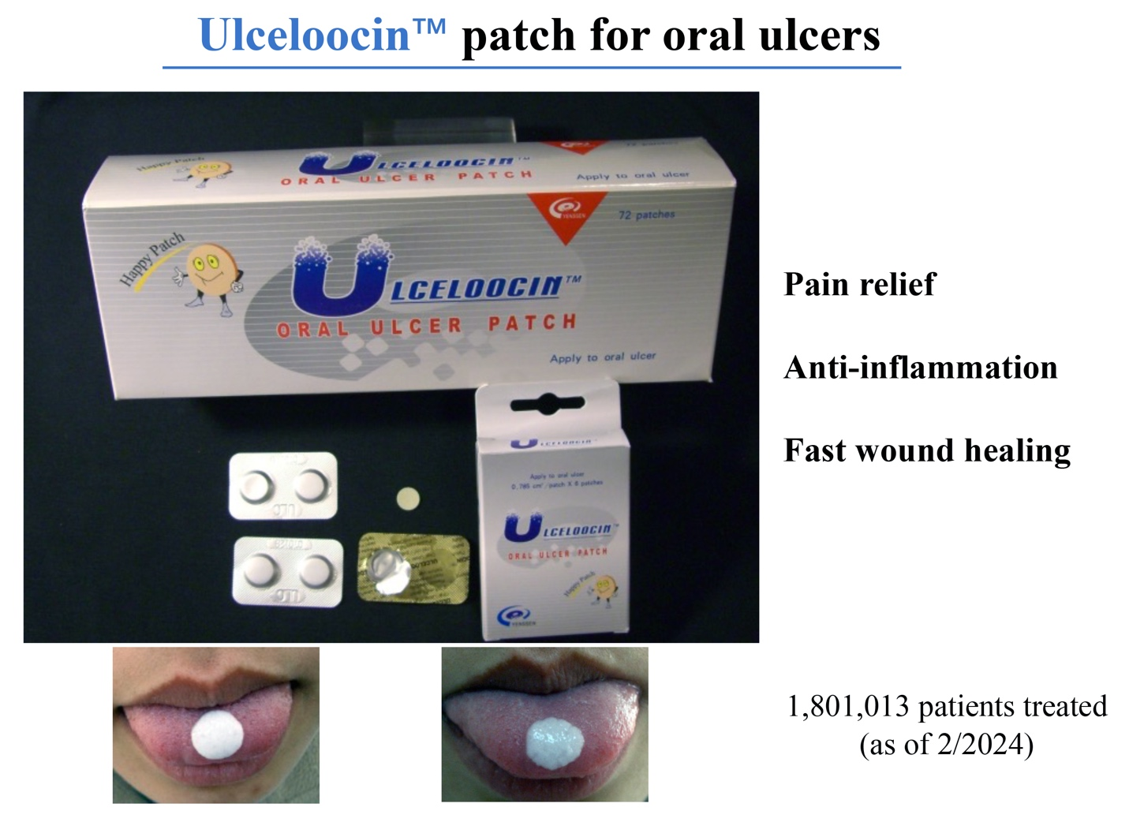

1. **Selected Patients Treated with ULCELOOCIN**

The following selected patients treated with **ULCELOOCIN** showed fast healing of the oral ulcers with much shortened time, significantly relieve the pain and discomfort.

Case a

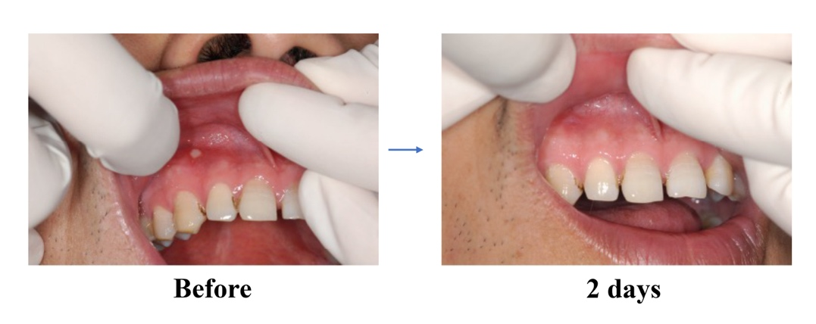

Case b

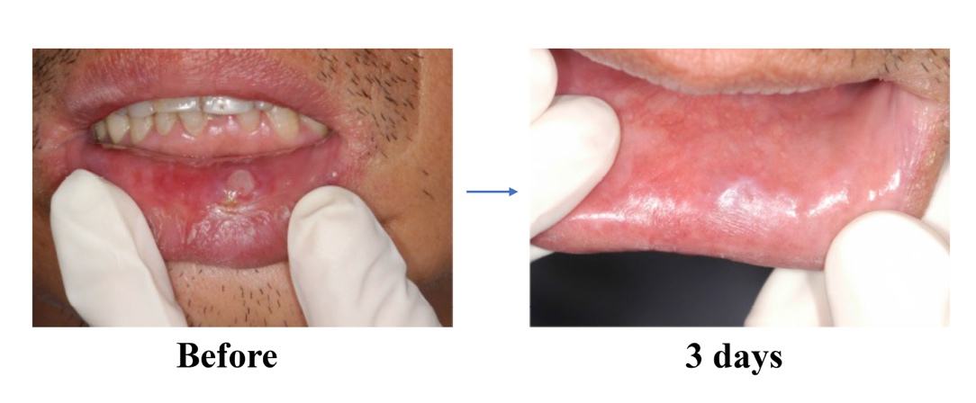

Case c

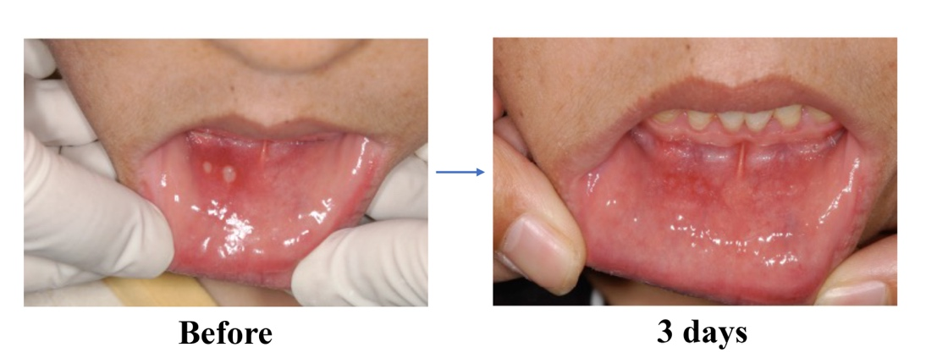

Case d

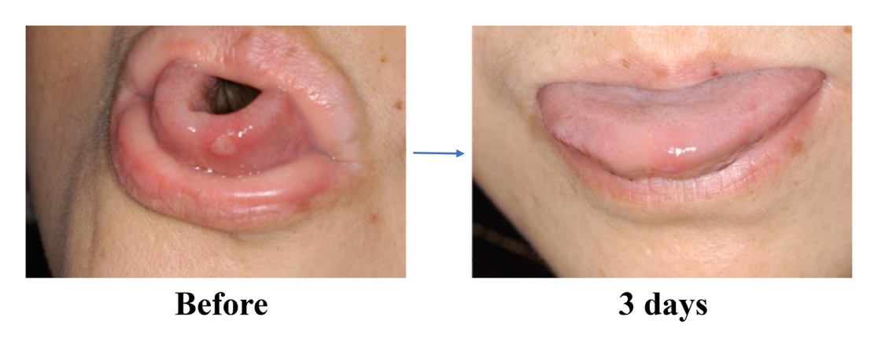

Case e

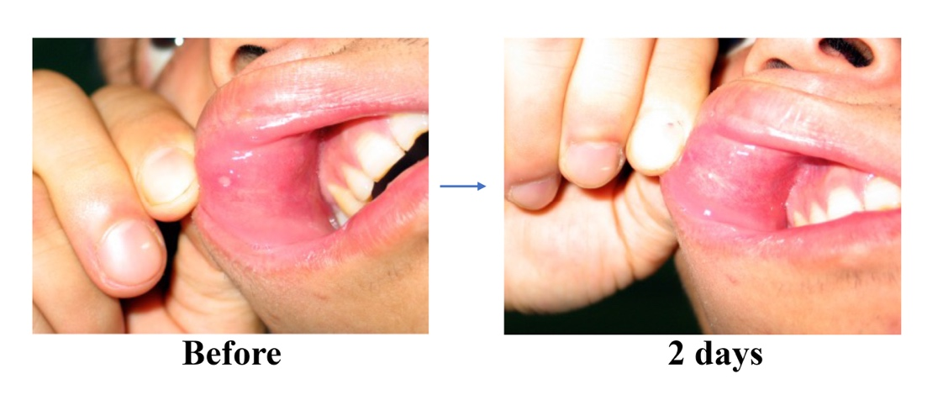

1. **Patents Covering the Invention and Production of ULCELOOCIN**

The invention and production of **ULCELOOCIN** were covered by the following patents:

Novel Materials to Enhance Would Healing. China. Publication Number: CN1245220C, Patent Number: ZL03109623.9, 2006.

Novel Materials to Enhance Would Healing. Russia. Publication Number: 2005134661, Patent Number: 2326697, 2008.

Novel Materials to Enhance Would Healing. India. Publication Number: 4926/DELNP?2005, Patent Number: 234290, 2009.

Novel Materials to Enhance Would Healing. Singapore. Publication Number: 200506436-5, Patent Number: 116155, 2007.

Novel Materials to Enhance Would Healing. Pakistan. Publication Number: 718/2004, Patent Number: 139120, 2007.

Novel Materials to Enhance Would Healing. Taiwan. Publication Number: 200610549, Patent Number: 288646, 2007.

Novel Materials to Enhance Would Healing. Iran. Publication Number: 38306765, Patent Number: 32074, 2005.

Soft Drug Sustained-Release Oral Patch. China. Publication Number: CN202008658Y, Patent Number: ZL200620076318.9.

Non-Stick Oral Patch. China. Publication Number: CN204158876U, Patent Number: ZL201420544146.8, 2015.

Automatic Loading and Unloading Device for Medical Patch. China. Publication Number: CN204162081U, Patent Number: ZL201420559578.6, 2015.

Paste Scraper Mixer for Oral Ulcer Patch. China. Publication Number: CN204159293U, Patent Number: ZL201420559619.1, 2015.

Board Punching Device for Medical Patch. China. Publication Number: CN204160544U, Patent Number: ZL201420559579.0, 2015.

Punching Device with Automatic Loading and Unloading for Medical Patch. China. Publication Number: CN204159729U, Patent Number: ZL201420559616.8, 2015.

Paste Scraper Stirring Device for Oral Ulcer Patch. China. Publication Number: CN204159264U, Patent Number: ZL201420560835.8, 2015.

A Device for Packaging Bioactive Wound Healing Patch. China. Publication Number: CN214731282U, Patent Number: ZL202023192422.3, 2021.

A Powder Spray Device for Oral Ulcers. China. Publication Number: CN215025011U, Patent Number: ZL2020233315417.7, 2021.

A Dissolving and Mixing Device for Production of Oral Mucosal Ulcer Patch. China. Publication Number: CN219744531U, Patent Number: ZL202320694227.5, 2023.

Drying Device for Oral Mucosal Ulcer Dressing Production. China. Publication Number: CN22602125U, Patent Number: ZL202321827404.9, 2023.

Paste Stirring and Cleaning Device for Oral Mucosal Ulcer Dressing Production. China. Publication Number: CN206838697U, Patent Number: ZL201720363622.X, 2018.