**E) The World’s First Head and Neck PET/CT System for Better Diagnosis and Treatment of Cancer Patients**

1. **The world’s first Head and Neck PET/CT Device**

Although PET/CT (positron emission tomography/computed tomography) has been used for decades to detect and locate the metabolic activities in the patients, there is still an unmet need of having a tailored PET/CT device with higher resolution and lower radiation specifically for detecting and monitoring the diseases in head and neck of the body.

In 2016, Dr. Chou, as the founder and president of the company, with his team, invented the first Head and Neck PET-CT scanner for head and neck cancer diagnosis and monitoring, marked by the award of 48 patents covering the scan’s unique signaling system and design, and achieved twice the resolution with 70 percent less radiation than current full-body PET-CT scans. The innovative design affords real-time observation of surgical success in removing head and neck tumors. The device could also serve unmet needs for imaging diagnosis of Alzheimer’s disease and monitoring the progress of its treatment. This scan is now slated for CFDA clinical trials.

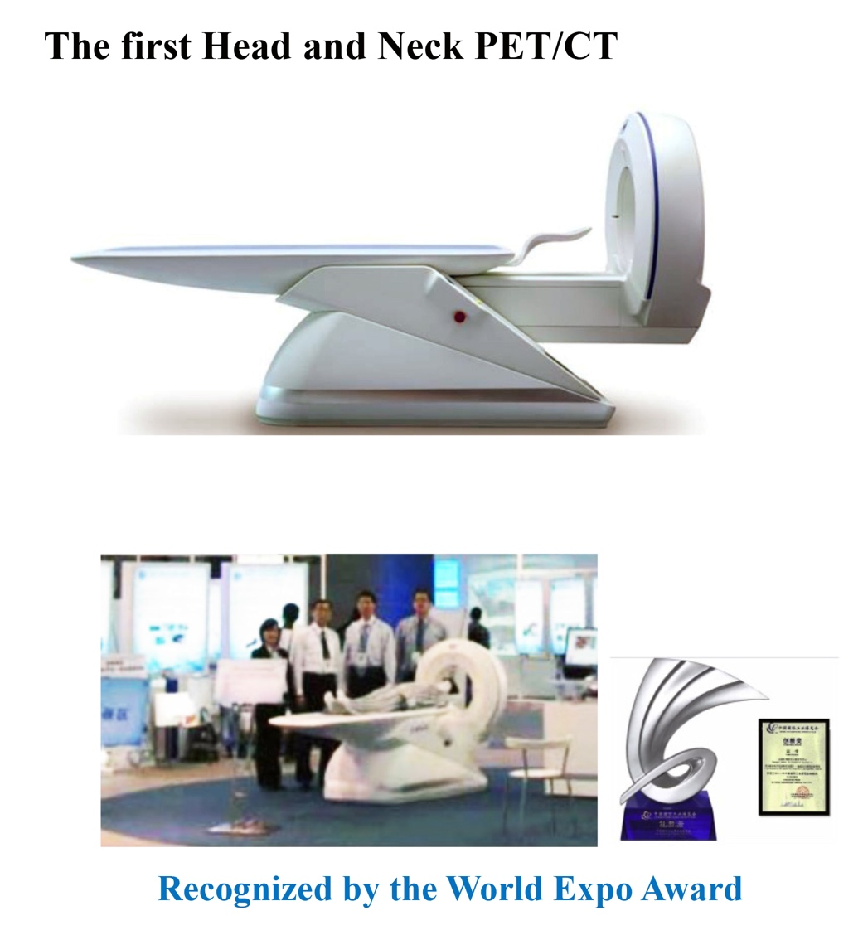

Dr. Chou and his team also developed a human full-body PET/CT device with enhanced resolution by 40% and reduced radiation by 70% compared to current market PET/CT. The device is now under CFDA inspection and multi-centered clinical trial and will soon formally enter the clinic field to benefit the public.



1. **Advanced Animal PET/SPECT/CT Series**

Molecular imaging devices, such as PET/CT, SPECT/CT and Micro CT are the critical tools for the mandatory evaluation and tests of bioefficacy and biosafety of drugs and biomedical products. There is an unmet need of high-resolution molecular imaging system for research institutes and pharmaceutical companies. With the technology invented in production of human Head and Neck PET/CT, Dr. Chou, as the founder and president of the PINGSENG company <https://www.pingseng.com/en/about/>, and his team also developed a series of animal PET/SPECT/CT devices with the following advanced features:

- Digital SiPM detection imaging technology  
- Large axial field & high imaging sensitivity

- High throughput scanning & uniform and clear imaging in whole vision  
- Dynamic imaging technique  
- Accurate quantitative analysis

- Accurate registration  
- A full set of experimental platform system  
- Gating Technology and Physiological Information Monitoring System

The above pre-clinical imaging systems (PET/CT and CT) represent the best of its kind, and have been the top brand in the field within 3 years and distributed to the international market.

The below products are now distributed to research institutes, pharmaceutical companies and pet hospitals for research, drug development and animal cares:

1. **Mira® Micro PET/CT with the highest resolution in the world**

At the end of 2019, Dr. Chou and his team developed a small animal PET/CT, Mira® Micro PET/CT, with the highest resolution in the world.

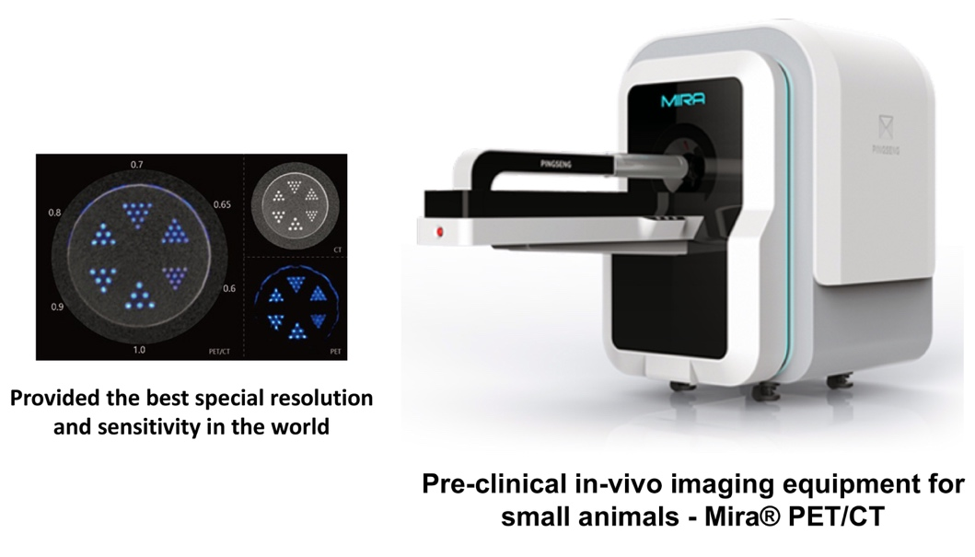

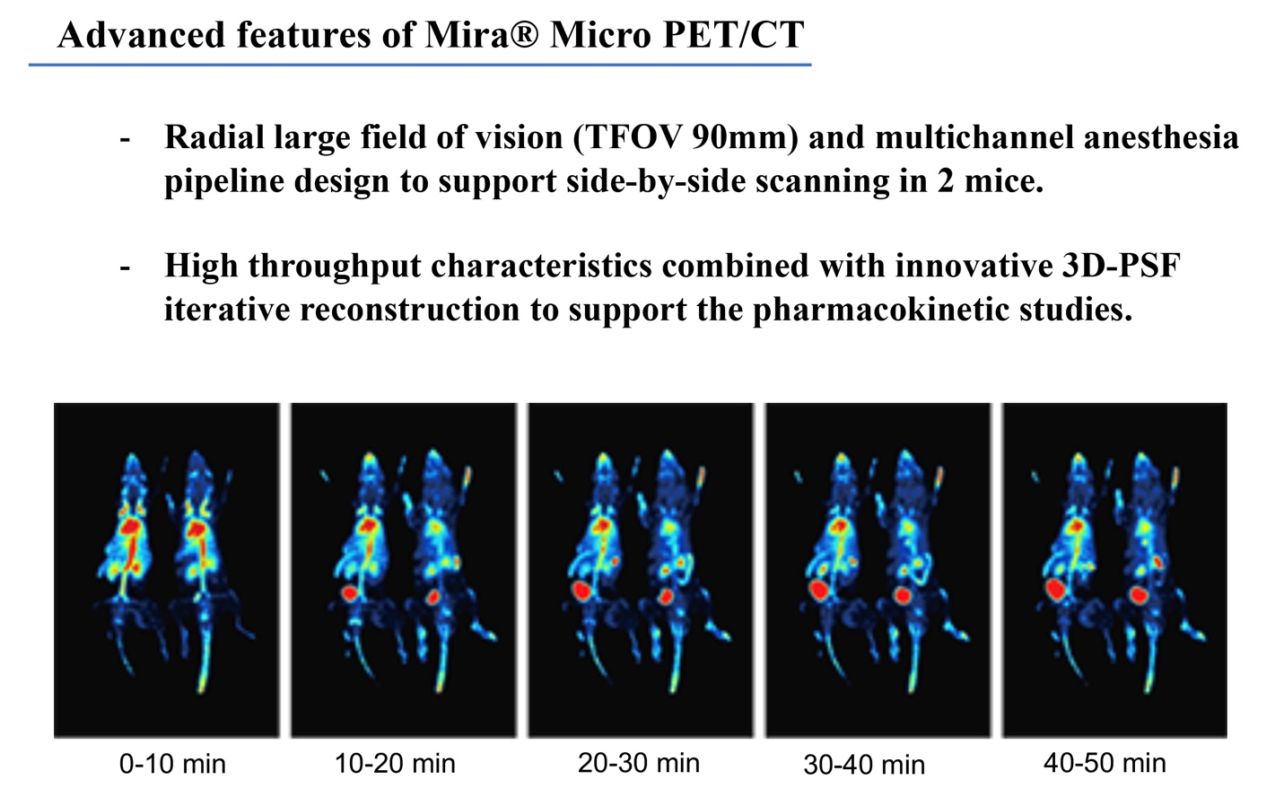

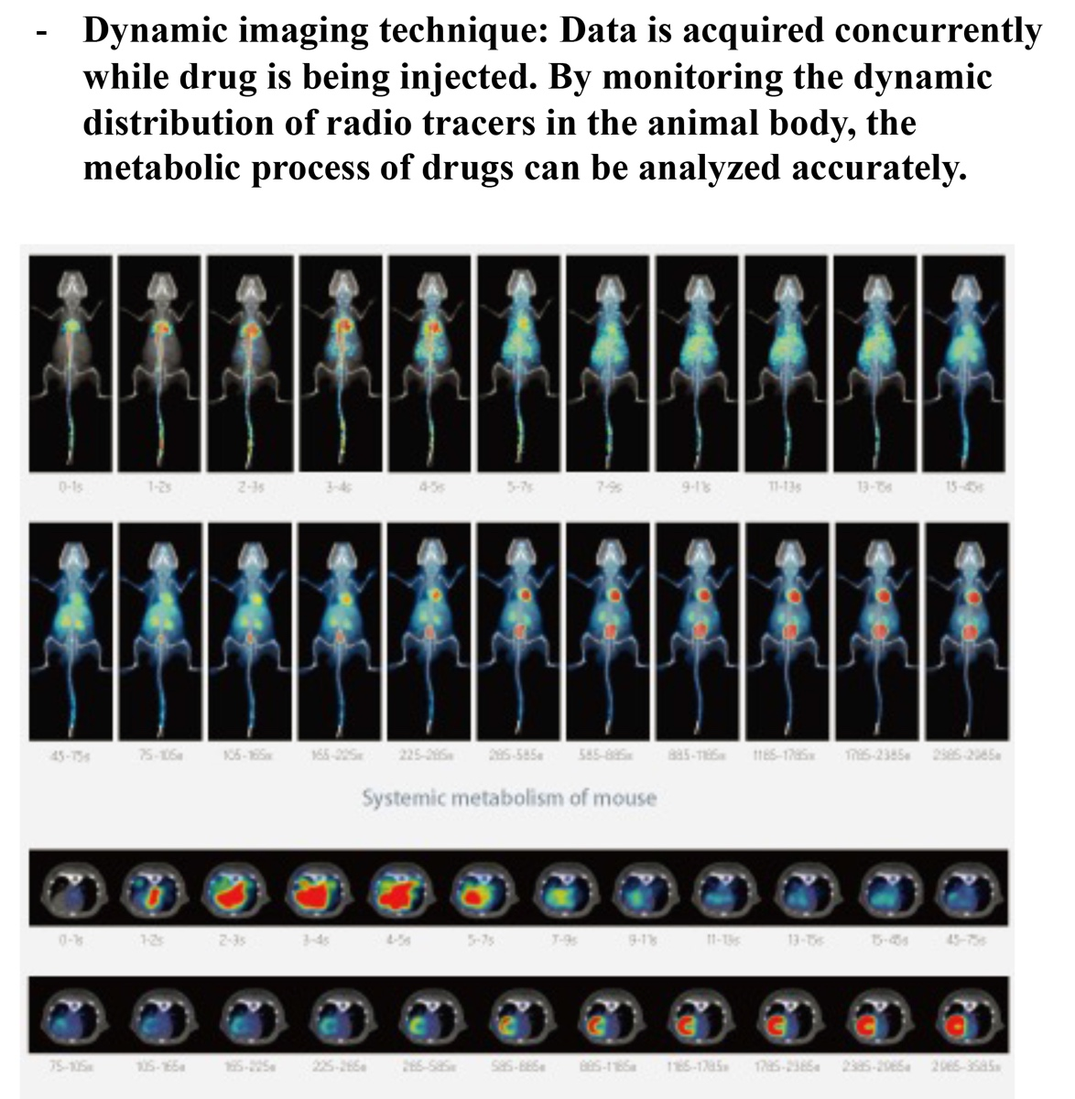

* **High sensitivity. With the unique fine crystal cutting and detection ring design, it can detect and capture more photon signals and improve the imaging sensitivity. Absolute sensitivity >12% (150~750 keV).**



**2-D PET/CT 3-D PET/CT**

**Case Presentation:**

* **Rat Bone PET/CT Scan**

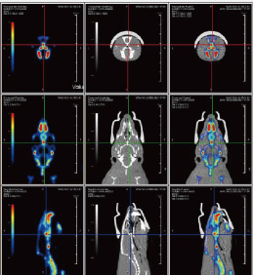

18F-NaF PET imaging

of rat bone PET/CT imaging of head bone

* **Arthritis PET/CT study**

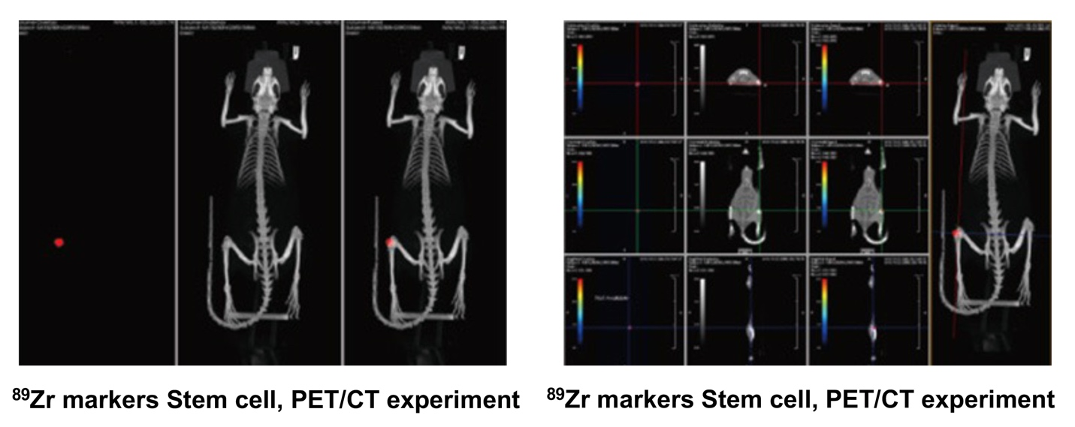

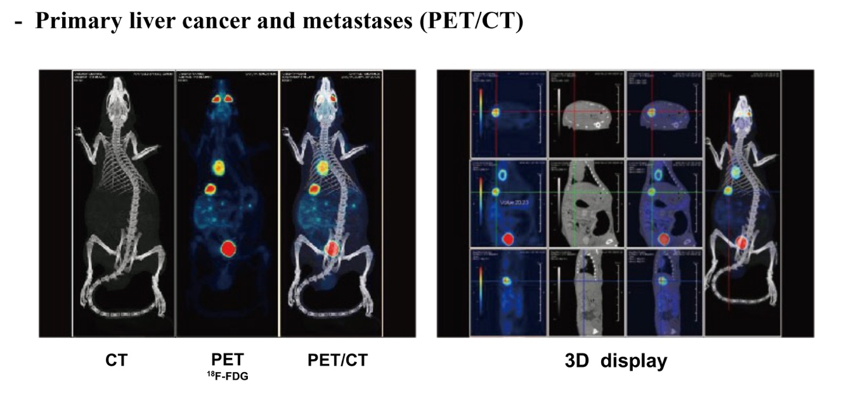

1. **Mars®, the first animal SPECT/CT**

In 2022, Dr. Chou led his team developed the world’s first animal SPECT/CT (single photon emission computed tomography/ computed tomography). This innovative device allows the use of multiple radioisotopes for multiple molecular probes, allowing the researchers to advance their studies in basic medicine and medical imaging.

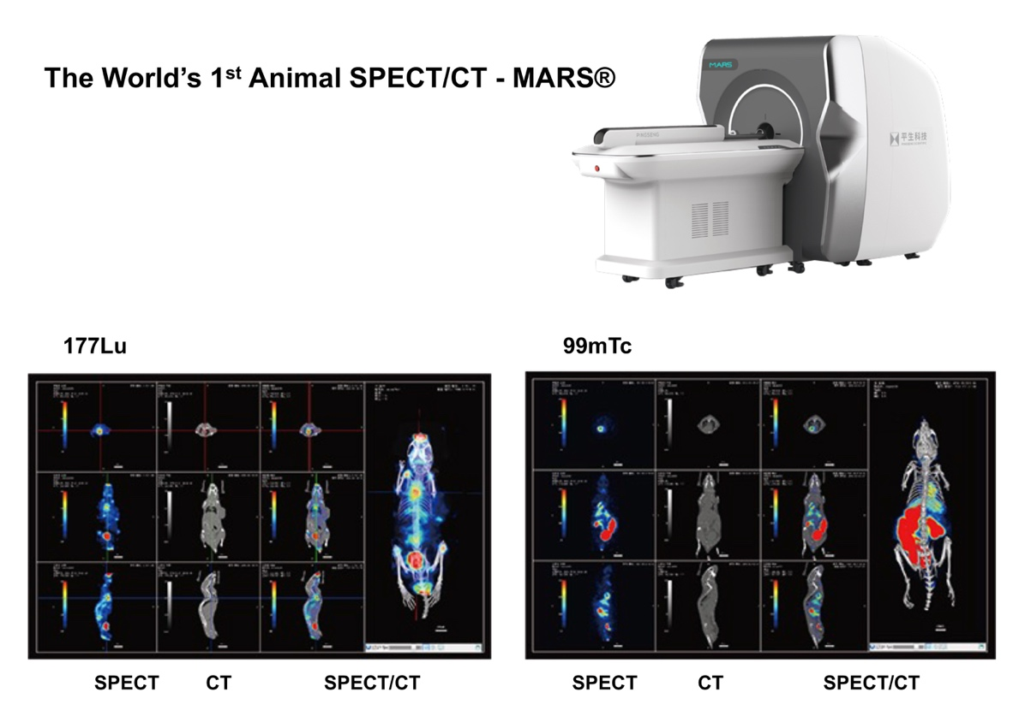

1. **Sirius®, the first animal PET/SPECT/CT**

In 2023, Dr. Chou and his team developed the world’s first animal PET/SPECT/CT, **Sirius®**, to meet the unmet need in pharmaceutical research and development.

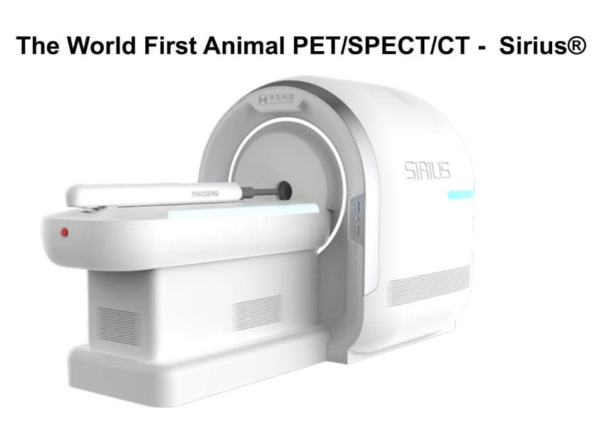

1. **Super Nova® pre-clinical in-vivo PET/CT (Generation III)**

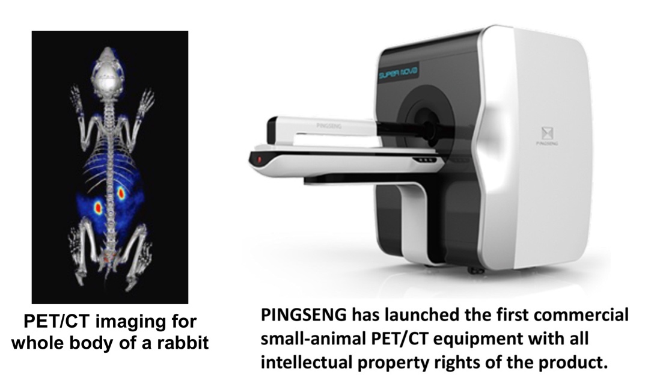

**3）Patents Covering the Invention and Production of Advanced Molecular Imaging System (PET/SPECT/CT):**

The invention and production of human Head and Neck PET/CT and animal PET/CT, SPEC/CT, PET/SPEC/CT were covered by the following 42 patents:

An Integrated High-Energy Radiation Detection and Positioning Method. China. Patent Number: ZL200910083671.8, 2012.

A Device and Testing Method for PET Compliance System. China. Patent Number: ZL201110123488.3, 2014.

A Method for Obtaining Geometric Correction Parameters of PET System. China. Patent Number: ZL201110129632.4, 2015.

Integrated Detector for Positron Emission Tomography. China. Patent Number: ZL201110131435.6, 2014.

A Detection Device for Positron Emission Tomography Imaging Equipment. China. Patent Number: ZL201020298875.1, 2011.

A Signal Transmitter Used for Debugging and Calibration of Positron Emission Tomography Scanners. China. Patent Number： ZL201020577992.1, 2011.

A Monte Carlo Simulation Computing Cluster System for Tomography. China. Patent Number: ZL201020661889.5, 2011.

Measuring Instruments for Precise Positioning of CT Imaging System. China. Patent Number： ZL201120147446.9, 2011.

A Device for CT Geometric Correction. China. Patent Number： ZL201120147454.3, 2012.

Head and Neck PET Diagnostic Imaging System. China. Patent Number: ZL2010305333178.5, 2011.

Head and Neck PET Diagnostic Imaging System. China. Patent Number: ZL201030591010.x, 2011.

Combined Method for Detecting and Positioning High Energy Radiation. USA. Patent Number: US8692205B2, 2014.

A Scintillator Panel and Its Manufacturing Method. China. Patent Publication Number: CN104157320A, ZL201410415050.6. 2016.

An Anti-Glare Film-Encapsulated Radiation Detector Crystal Panel and Its Production Method. China. Publication Number: CN104020486B, Patent Number: ZL201410256381X. 2014.

A Packaging Method and Structure of a Deliquescent Radiation Crystal Panel. China. Patent Publication Number: CN1014022047B, Patent Number: ZL2014102555940. 2018.

Full-Body Positron Emission Computed Tomography Equipment for Medical Diagnostic Imaging. China. Patent Publication Number: CN303043396S. Patent Number: ZL2014300980443. 2014.

Radiation-Proof Animal Sample Delivery Device for Small Animal CT and PET/CT Equipment. China. Patent Publication Number: CN206114111U. Patent Number: ZL2016208279544. 2016.

A Radiation-Proof Animal Sample Delivery Device for Small Animal CT and PET/CT Equipment. China. Patent Publication Number: CN106239956A. Patent Number: zl2016106239956. 2017.

Dynamic DR Detector. China. Patent Publication Number: CN206576887U. Patent Number: ZL2616211832415. 2016.

Tomography Imaging Equipment. China. Patent Publication Number: CN304560907S. Patent Number: ZL2017304348225. 2017.

In-Vitro and In-Vivo Integrated Micro-CT Equipment. China. Patent Publication Number: CN305500109S. Patent Number: ZL2019300509566. 2019.

A PET-CT Integrated Equipment. China. Patent Publication Number: CN213189666U. Patent Number: ZL2020205920519. 2020.

An Integrated Flat Panel Detector. China. Patent Publication Number: CM211653641U. Patent Number: ZL2020205291574. 2020.

A Micro-CT Equipment. China. Patent Publication Number: CN2123321478U. Patent Number: ZL2020205851773. 2020.

A Miniaturized PET Equipment. China. Patent Publication Number: CN212853495U. Patent Number: ZL2020205997718. 2020.

A Miniaturized Animal Cabin Transport Mechanism in PET Equipment. China. Patent Publication Number: CN212939730U. Patent Number: ZL2020206046372. 2020.

Micro-CT Equipment with Lifting Function. China. Patent Publication Number: CN212134530U. Patent Number: ZL2020206079037. 2020.

Micro-CT Equipment with Heat Dissipation System. China. Patent Publication Number: CN212134529U. Patent Number: ZL2020205854127. 2020.

Desktop Micro-CT Equipment. China. Patent Publication Number: CN306191734S. Patent Number: ZL2020301745681. 2020.

Digital Positron Emission Computed Tomography Imaging System. China. Patent Publication Number: CN306205684S. Patent Number: ZL2020301779616. 2020.

Digital Positron Emission Computed Tomography Imaging Equipment. China. Patent Publication Number: CN306205683S. Patent Number: ZL2020301777540. 2020.

An X-Ray Imaging Device. China. Patent Publication Number: CN214174199U. Patent Number: ZL2020231462794. 2020.

A Scintillation Crystal Luminescence Detection System. China. Patent Publication Number: CN113510077B. Patent Number: 2020102793164. 2020.

A Positioning Mechanism and X-Ray Imaging Device. China. Patent Publication Number: CN214374405U. Patent Number: ZL2020231464018. 2020.

A Panoramic X-Ray Imaging Analyzer. Patent Publication Number: CN306934924S. Patent Number: ZL2021304655446. 2021.

An Image Compression Method and Device. China. Patent Publication Number: CN115118989B. Patent Number: ZL2022110375145. 2022.

Scanning Imaging System. China. Patent Publication Number: CN218998685U. Patent Number: ZL2022232329737. 2022.

Correctable X-Ray Imaging Device. China. Patent Publication Number: CN218762405U. Patent Number: ZL2022232834736. 2022.

Collection Method, Correction Method and Collection Device of Forward and Inversion Data for Cone Beam CT. China. Patent Publication Number: CN109875594A. Patent Number: pending. 2019.

Xial Correction Method, System, Medium and Device for Bed Position in Micro-CT. China. Patent Publication Number: CN114601489A. Patent Number: pending. 2020.

Method of Imaging and Storage. China. Patent Publication Number: CN114419175A. Patent Number: pending. 2021.

An Animal Medical Cabin. China. Patent Publication Number: CN114099053A. Patent Number: pending. 2021.

Method and Device for Image Reconstruction and Storage. China. Patent Publication Number: CN114896075A. Patent Number: pending. 2022.

An Experimental Cabin and Method for Image Segmentation and Storage. China. Patent Publication Number: CN115760877A. Patent Number: pending. 2023.

A Rapid Loading and Positioning Mechanism for Sample Cabins. China. Patent Publication Number: CN117017217A. Patent Number: pending. 2023.

Cell Irradiator. China. Patent Publication Number: CN308486089S. Patent Number: pending. 2023.

Afterimage Correction Method, Device, and Storage Medium. China. Patent Publication Number: CN116934631A. Patent Number: pending. 2023.

Centering and Fine-Tuning Mechanism and Scanning Imaging Machine. China. Patent Publication Number: CN220730085U. Patent Number: pending. 2023.