Auspify Technologies
Task 2 (Easy) – Content Type Analysis Dashboard
Analyze the distribution of Movies and TV Shows available on Netflix.

1. Objective
The objective of this task is to analyze the distribution of Movies and TV Shows available in the Netflix dataset.
The analysis calculates the number and percentage of Movies and TV Shows and presents the results using visualizations.

2. Tools Used
- Python
- Pandas
- Matplotlib
- Seaborn
- Jupyter Notebook
- Visual Studio Code

3. Dataset Loading
The cleaned Netflix dataset generated during Task 1 was loaded using Pandas.
Code used :
df = pd.read_csv("../Task_1_Data_Cleaning/netflix_cleaned.csv")

df.head()

Result :
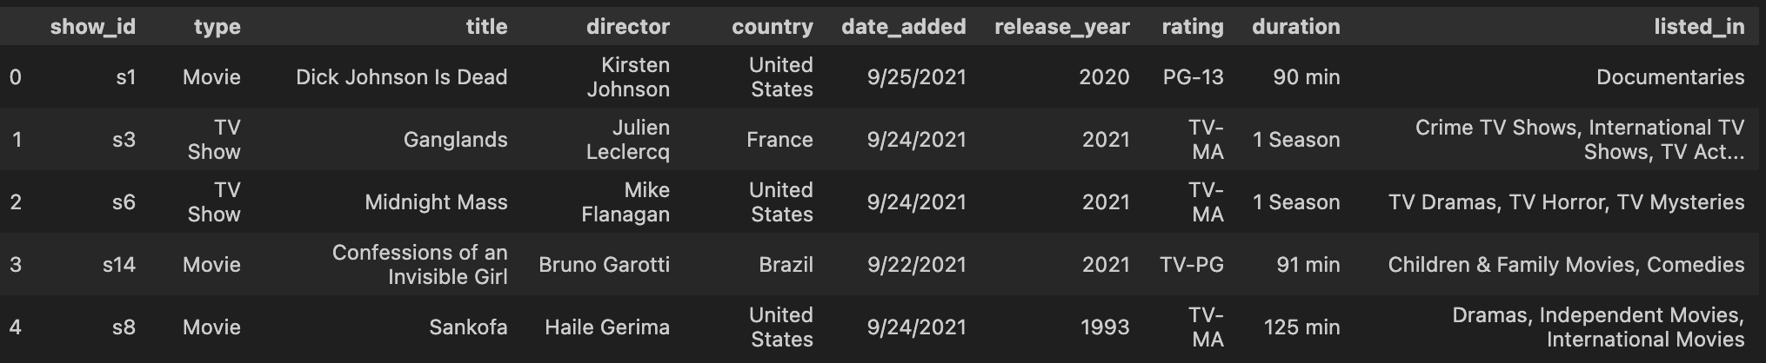

4. Content Type Analysis
The type column was analyzed to calculate the number of Movies and TV Shows.
Used code :

type_counts = df["type"].value_counts()

print(type_counts)

Result :
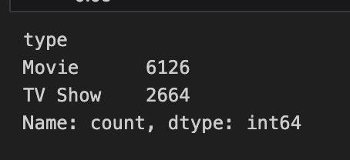

5. Percentage Analysis
The percentage distribution was calculated using:

Used code :
type_percent = df["type"].value_counts(normalize=True) * 100

print(type_percent)

Result :
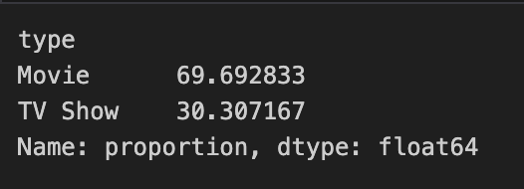

6. Data Visualization

6.1 Bar Chart
A bar chart was created to compare the number of Movies and TV Shows.
Insert your bar-chart screenshot here.
Figure 1: Netflix Content Type Distribution

6.2 Pie Chart
A pie chart was created to show the proportional distribution of Movies and TV Shows.
Insert your pie-chart screenshot here.
Figure 2: Netflix Movies vs TV Shows

7. Key Findings
The analysis produced the following findings:
- The dataset contains 6,126 Movies.
- The dataset contains 2,664 TV Shows.
- Movies represent 69.69% of the dataset.
- TV Shows represent 30.31% of the dataset.
- Movies constitute a larger proportion of the analyzed Netflix content.
- The bar chart provides a comparison based on the number of titles.
- The pie chart provides a visual representation of the percentage distribution.

8. Conclusion
This task demonstrated how Python and Pandas can be used to analyze categorical data.
The type column was used to identify and compare Movies and TV Shows. Matplotlib was then used to create visualizations that make the distribution easier to understand.
The analysis shows that Movies account for 69.69% of the dataset, while TV Shows account for 30.31%.

