Task 3 – Country-Wise Netflix Content Analysis
Auspify Technologies
Internship: Data Analysis Using Python

1. Objective
The objective of this task is to analyze the availability of Netflix content across different countries. The analysis focuses on extracting country information, calculating the number of Netflix titles associated with each country, identifying the top content-producing countries, and visualizing the results.

2. Tools and Technologies Used
- Python
- Pandas
- Matplotlib
- Seaborn
- Jupyter Notebook
- VS Code

3. Dataset
The analysis was performed using the cleaned Netflix dataset generated during Task 1 – Data Cleaning.
The dataset contains information such as:
- Show ID
- Content Type
- Title
- Director
- Country
- Date Added
- Release Year
- Rating
- Duration
- Listed-in Categories
Used code :
df = pd.read_csv("../Task_1_Data_Cleaning/netflix_cleaned.csv")

df.head()

4. Country Data Extraction and Cleaning
The country column was analyzed to identify the countries associated with each Netflix title.
Some titles contain multiple countries separated by commas. Therefore, the country values were split and expanded into separate rows using Pandas.

Used code :
country_df = df.assign(
country=df["country"].str.split(", ")
).explode("country")

country_df["country"] = country_df["country"].str.strip()

country_df.head(10)

Output :

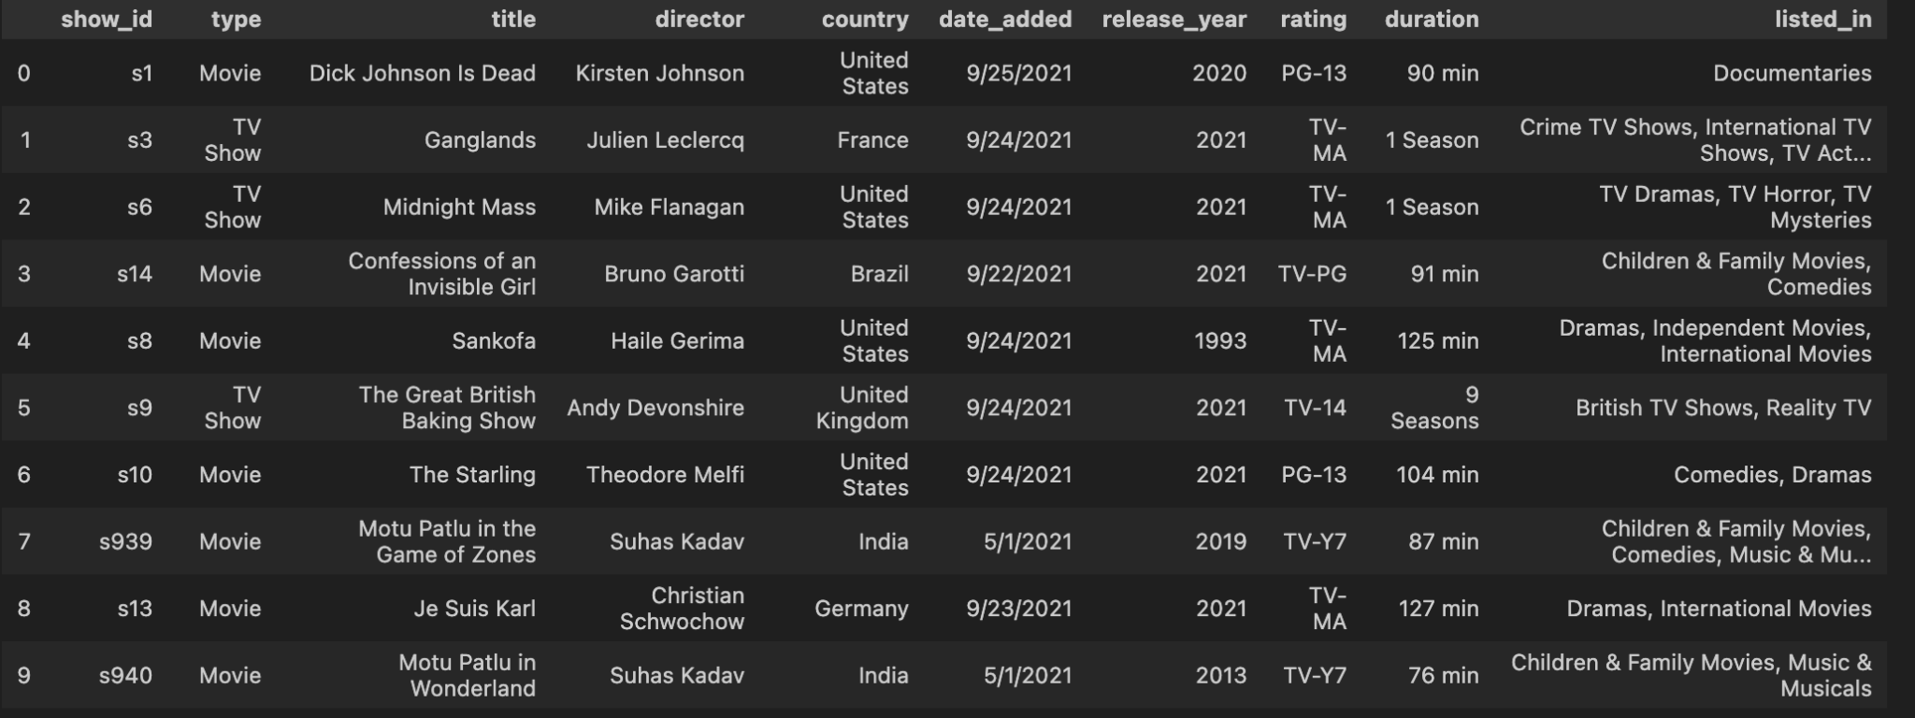

5. Country-Wise Content Count
The number of Netflix titles associated with each country was calculated using the value_counts() function.
Used code :
country_counts = country_df["country"].value_counts()

country_counts.head(20)

6. Top 10 Countries
The top 10 countries were selected using:
The results show that the United States has the highest number of titles in the dataset, followed by India and the United Kingdom.
top_10_countries = country_counts.head(10)

top_10_countries

7. Country-Wise Visualization
A horizontal bar chart was created to visualize the top 10 countries by Netflix content.
top_10_countries.sort_values().plot(
kind="barh"
)

plt.title("Top 10 Countries by Netflix Content")
plt.xlabel("Number of Titles")
plt.ylabel("Country")

plt.tight_layout()
plt.show()

8. Key Findings
Based on the analysis:
- The United States has the highest number of Netflix titles in the dataset, with 3,240 titles.
- India is the second-highest country with 1,057 titles.
- The United Kingdom has 638 titles.
- Pakistan has 421 titles, with a comparatively high number of TV Shows.
- The dataset contains country entries where country information is unavailable, represented as "Not Given".
- The Movies and TV Shows distribution differs across countries.
- The analysis demonstrates how country-level data can be used to understand the geographic distribution of Netflix content.

9. Conclusion
This analysis provided a country-wise view of Netflix content using Python and Pandas. By splitting multiple-country entries, counting content by country, ranking countries, and creating visualizations, the analysis helps identify geographic patterns in the Netflix dataset.
The task also demonstrated practical applications of GroupBy-style data aggregation, data cleaning, ranking, cross-tabulation, and visualization techniques.

