Part 2 Individual Report
By Zhang Liqian
In the ShuffleVector project, we are to examine whether there exist convenient and fast intrinsics or other instructions that can replace the ShuffleVector instruction for optimization. This optimization may concern with two levels: one is llvm-IR level, in which level we may write a llvm Pass to detect the existence of ShuffleVector instructions and check whether it can be replaced according to its operands and masks, for better performance; the other level is backend. Since some instructions are target-dependent, only when we touch the real machine environment can we complete their replacement of shufflevector.

The whole process I’ve experienced can be divided into two phases: in the first period I check and compare the performance before and after substitution. In the second period, since I’m interested in the recognition of kinds of patterns in the mask of ShuffleVector instruction (operands are also involved in recognition), I work on the first level of optimization as mentioned --- the llvm-IR level, to make a systematic approach to detect the pattern lying in the mask, and then to replace the instruction.

In the first period, I examined the performance with two examples in the website, the ShuffleVector instructions that can be replaced by llvm.bswap and SIMDly-done logical bit operations (i.e.shl lshr), respectively. Firstly, I got to generally be familiar with the IR instructions and manually wrote some benchmarks for testing. Afterwards our leader told me to first write C-code framework, which is much efficient and clear. My main goal is to construct a context where there is a ShuffleVector instruction that can be replaced with llvm.bswap for example, with this block in a loop for 10000 times. Then I used command “perf -stat” as a measure. Unfortunately the time-measure result in either the bswap example or the bit operation example is not improved. But we can actually reduce the generated assembly size. So it’s worthwhile to do the replacement in some regular patterns. I think this period is a good start and helps me get to the IR and llvm infrastructure. I did some instruction replacement in this period and it helps me understand how to replace ShuffleVector instruction with certain mask. Then I’ll make it automatic.

In the second period, I started to work on the ShufflePatternLibrary. Before I study the contents from website by Professor, I found that an efficient way to recognize the pattern is to differentiate the mask and evaluate the difference, which coincides with the diff and signature functions in the website. I tried to use a concept like “continuous block” to approach it. For example, mask (1, 2, 3, 0) yields to difference (1, 1, -3). I receive continuous 1 as continuous block, when I find -3, I check the number of 1s, and the length is 2. So I receive -3 as a circular end of 1s. Similarly -4 is the end of 3 1s. The dual circumstance is (-1, -1, 3) which can be handled in the same way. But the situation became more and more complex. Then I learned the approach in the website and marvels at its standardization and systematicness. Afterwards I learned that my divorce of reality makes it such complex.

I arrange the process in the website in 5 steps (I also presented this process and result obtained once in class): Step 1 canonical form transformation; Step 2 vector size expansion to 2^k; Step 3 lane detection; Step 4 pattern recognition; Step 5 instruction replacement. The first three steps I strictly realize the function in accordance with the website, including the rule to transpose the position of v1 and v2 in step1, the rule to extend the size of operands, and the rule to recursively detect the lane number.

In step 4, since I mainly deal with the front level at llvm-IR level. So I implement the detection of patterns in term of the rotate pattern, the shift left pattern, the shift right logical pattern, the shift right logical pattern, and the blend pattern (then the zero-extend pattern is also realized by another member Li Wan peng). I wrote a class pattern_rec to recognize the pattern. It includes some basic helpful scalable functions, which can be easily extended to recognize new patterns. For example, my count_number function count the occurrence of certain “eigenvalue” in the mask (for example 1, n-1), new pattern will also have its eigenvalue. In this way I turn the process to input its eighenvalue and signature (namely the difference of the mask) and check the result.

In step 5, I implemented two kinds of replacement, the shift left pattern and the blend pattern. The rest is done by Li Wanpeng. I wrote a class instruction_rep to realize this functionality. It accepts the pattern recognition results in step 4 as input and change the instruction environment around the ShuffleVector instruction by llvm’s API.

Note that the whole process is done in llvm Pass. Before this our leader taught me how to write a Pass outside the source code of llvm by CMake and command “opt”, and this is the way I implement the 5-step work told above. In the learning and coding process, I can feel my progress coding in the environment of llvm. I think llvm provides a more usable debug information than C++ std, which makes me get to it quickly. For example SmallVector instead of std::vector. But llvm has a complex inheritance relation network between classes. I leaned how to use these classes and their API in the official documentation. In this process I find that looking up what you need in the documentation is a practical skill in coding and I gradually improve this skill. It’s really meaningful. In the code generation process (Step 5), when I need to produce one constant argument or type for instruction , I need to get the llvmcontext from the ShuffleVector instruction instance. It’s a bit troublesome, but interesting.

Part 3 Transformations implemented

In our llvm-IR level transformation, we write a Pass to optimize the codes by inputting a .bc (or .ll) file and outputting a .bc file. Since we test the replacement of ShuffleVector instruction, so we can write a function containing this instruction as test inputs.
The whole process, as said, is:
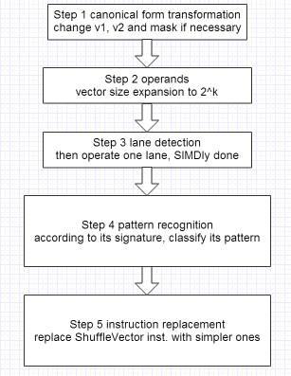
Specifically, In Step 5 instruction replacement is like:
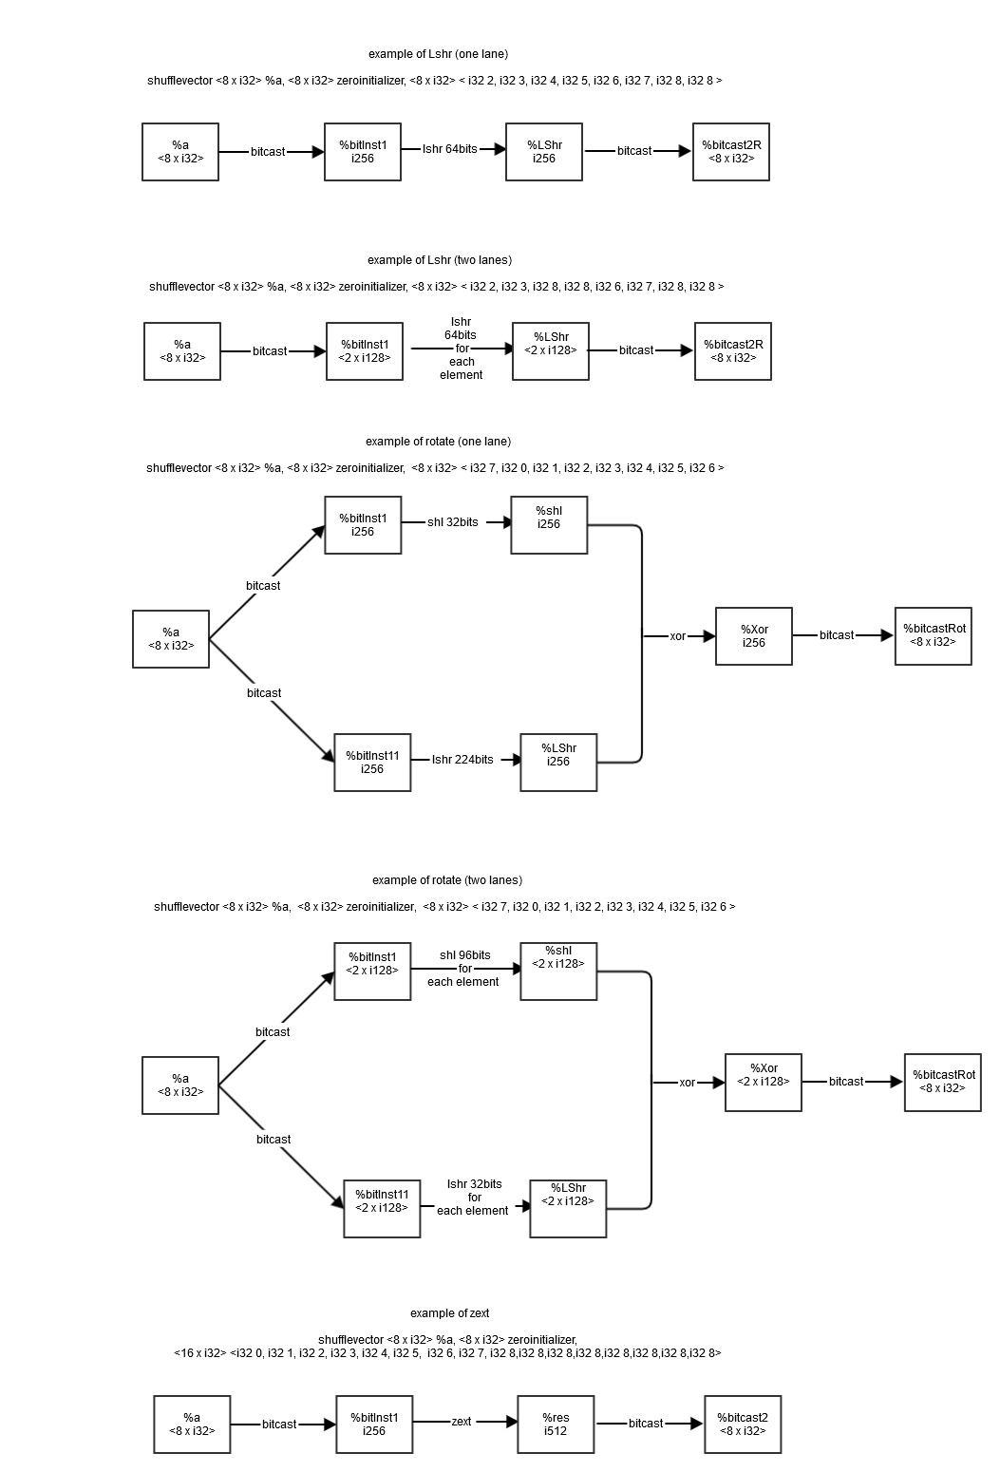
The following covers most of situations we can handle.
Example 1.1, shift left pattern, single lane.
Input:
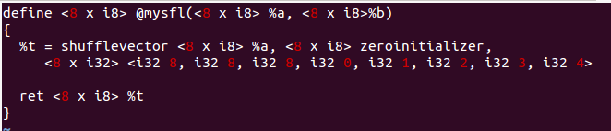
Run opt our pass:
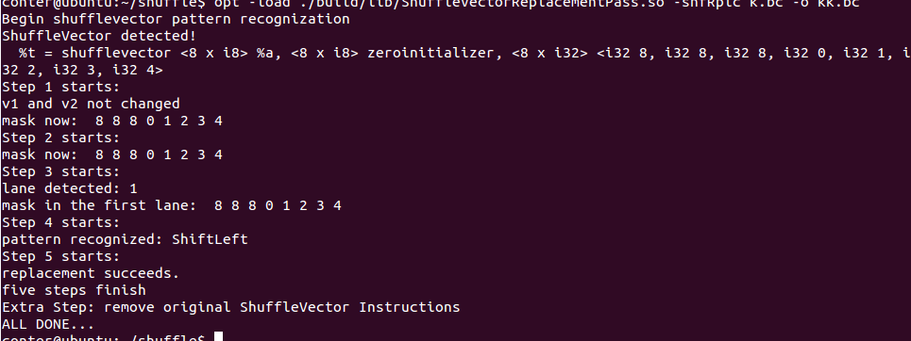
Output:
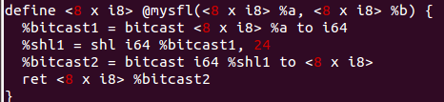

Example 1.2, shift left pattern, single lane, unaligned.
Input:
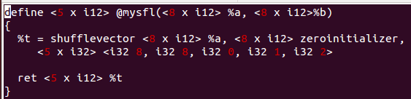
Run opt：
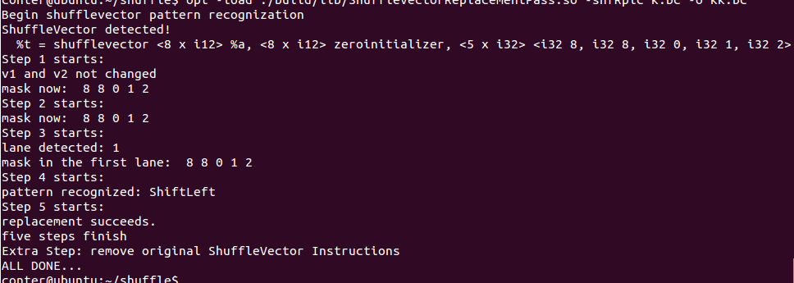
Output:
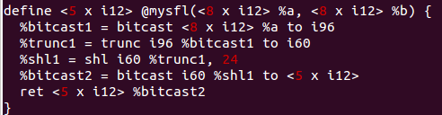

Example 1.3, shift left pattern, 2-lane.
Input:
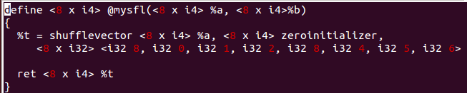
Run opt:
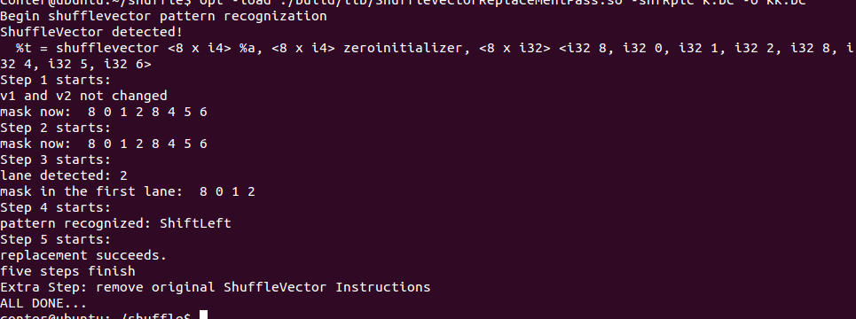
Output:
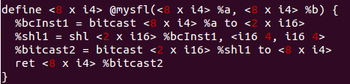

Example 1.4, 2-lane, unaligned.
Input:
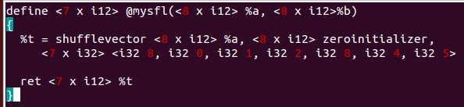
Run opt:
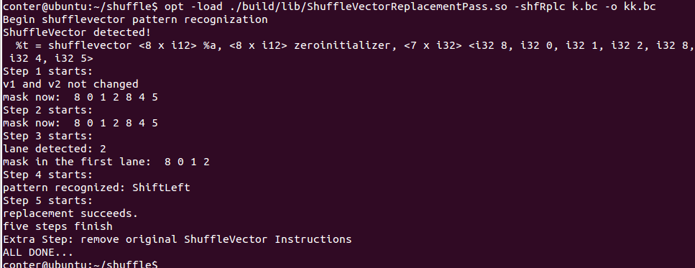
Output:
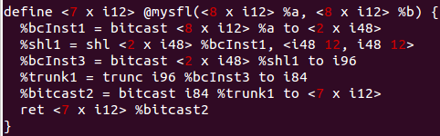

Example 1.5, canonical form transformation & vector size expansion.
Input:
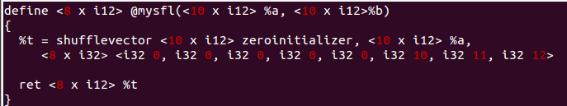
Run opt:
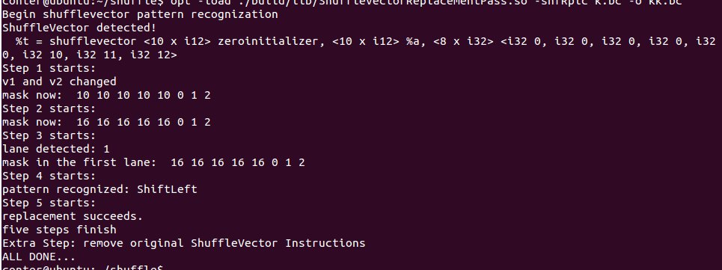
Output:
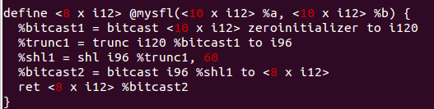

They all transform the ShuffleVector instruction to the expected instructions.
Note: At first I go too far from practice. Therefore the first replacement I implemented can support many ill-formed input and still output the correct replacement by bitcasting and truncating. This shows its robustness. Then Professor told me that we can assume the input well-formed. So in the following pattern we don’t test the illegal or abnormal inputs.

Example 2.1: the blend pattern
Input:
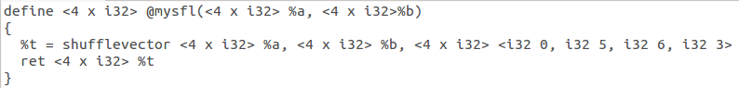
Run opt:
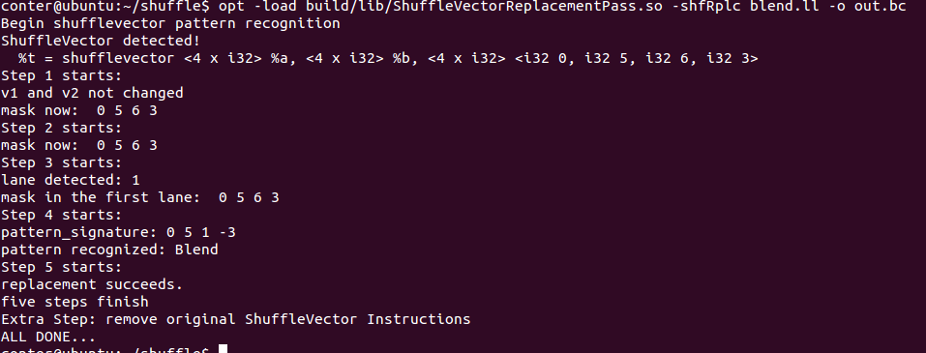
Output:

Example 2.2, the blend pattern, unaligned.
Input:
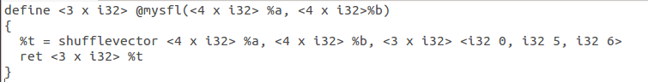
Run opt:
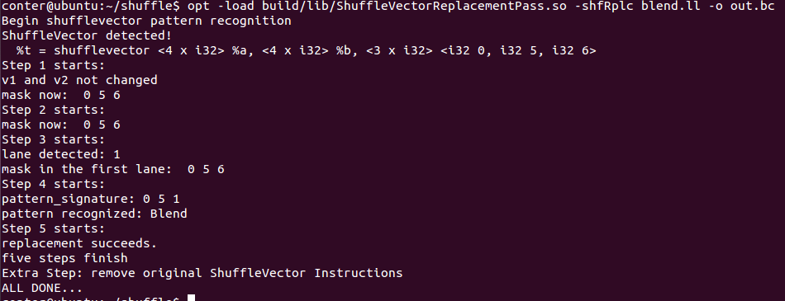
Output:
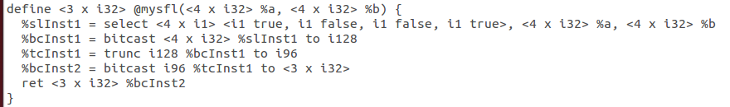

Example 3.1, the shift right logical pattern, single lane.
Input:
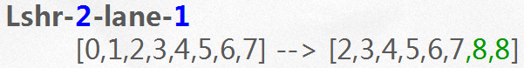
Run opt:
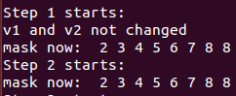
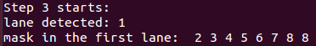
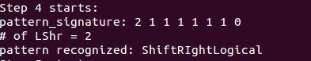
Output:
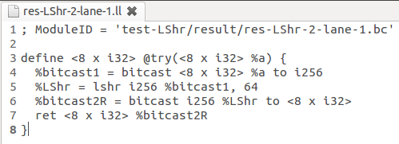

Example 3.2, the shift right logical pattern, 2-lane.
Input:
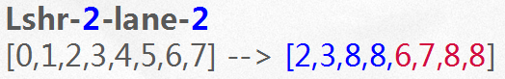
Run opt:
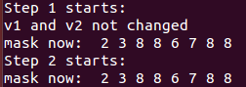
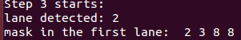
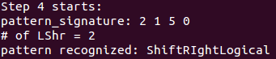
Output:
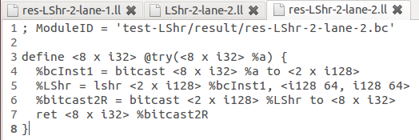

Example 4.1, the rotate pattern, single lane.
Input:
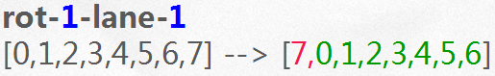
Run opt:
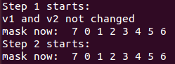
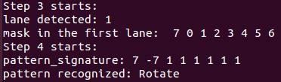
Output:
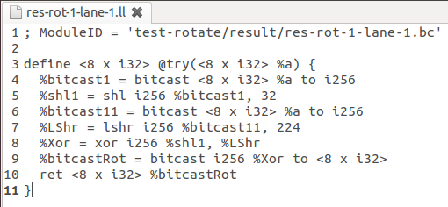

Example 4.2, the rotate pattern, 2-lane.
Input:
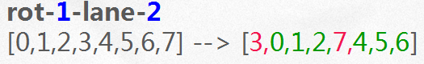
Run opt:
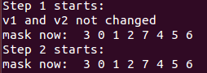
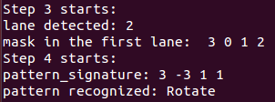
Output:
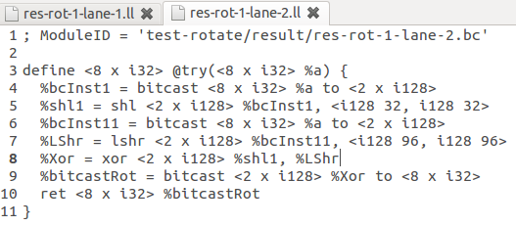

Example 5.1, the zero-extend pattern.
Input:
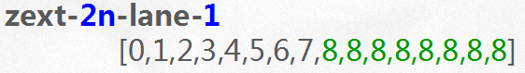
Run opt:
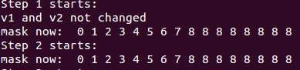
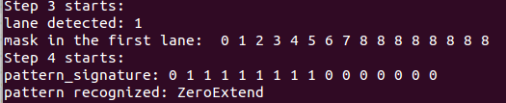
Output:
