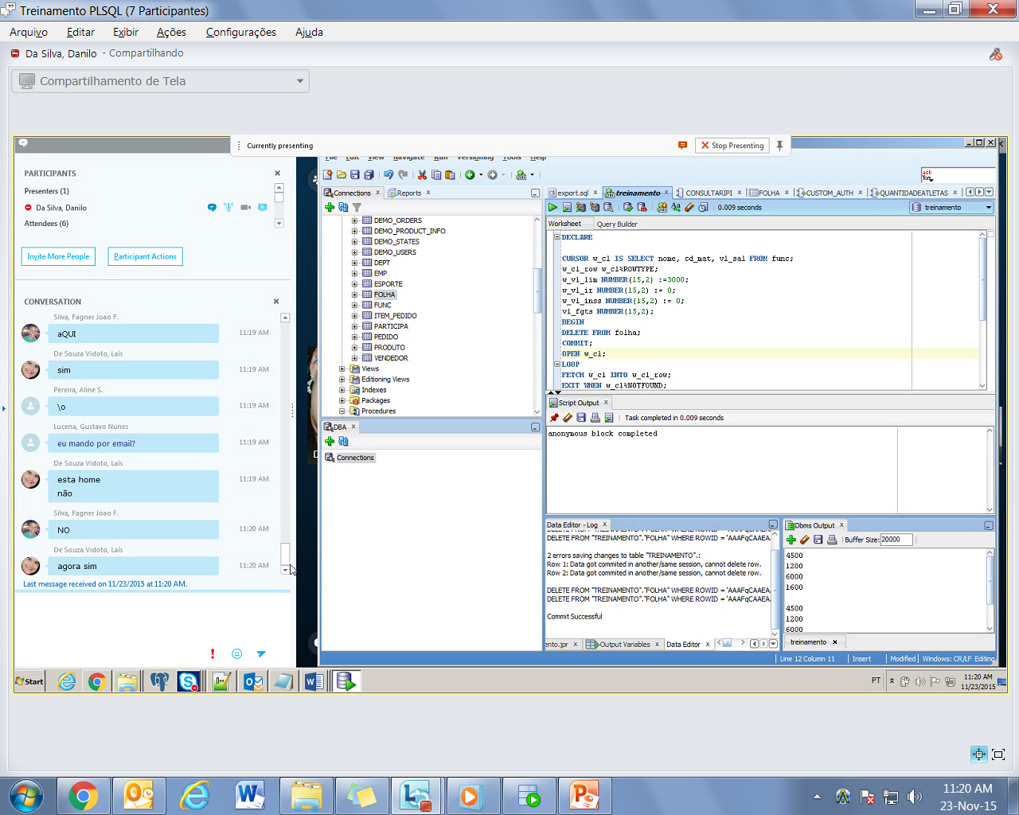

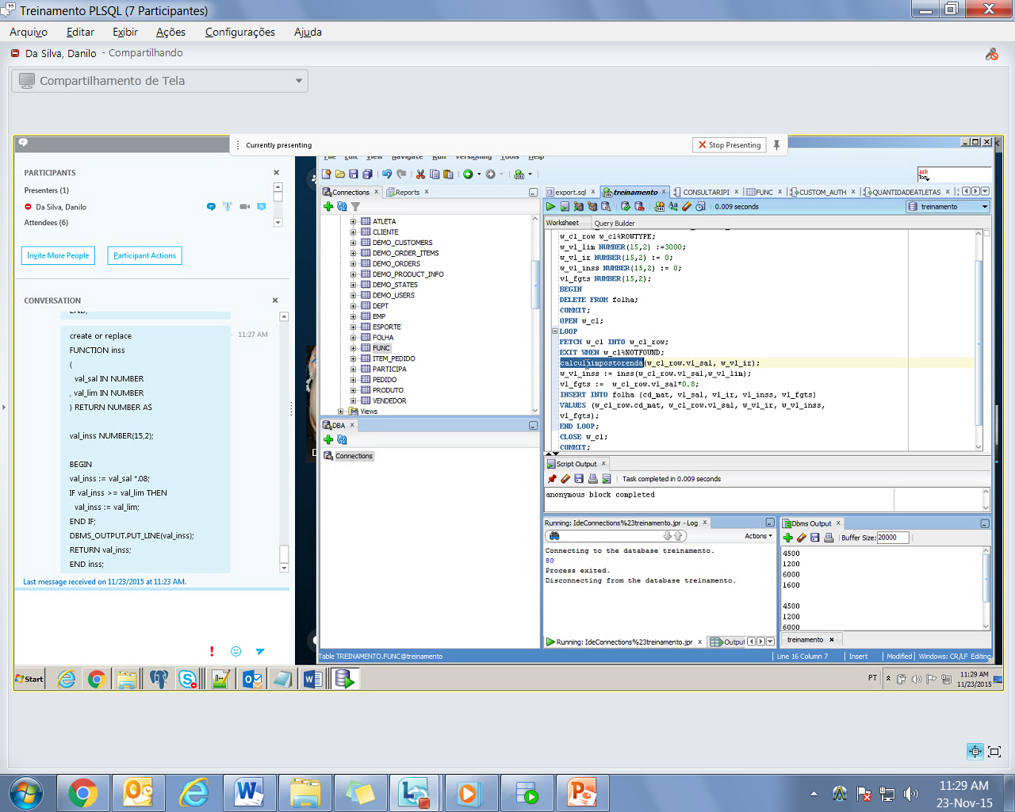

**DECLARE**

**CURSOR** w_c1

**IS**

**SELECT** nome

,cd_mat

,vl_sal

**FROM** func;

w_c1_row w_c1%ROWTYPE;

w_vl_lim **NUMBER**(15,2):= 3000;

w_vl_ir **NUMBER**(15,2):= 0;

w_vl_inss **NUMBER**(15,2):= 0;

vl_fgts **NUMBER**(15,2);

**BEGIN**

**DELETE FROM** folha;

**COMMIT;**

**OPEN** w_c1;

**LOOP**

**FETCH** w_c1 **INTO** w_c1_row;

**EXIT**

**WHEN** w_c1%NOTFOUND;

calculaimpostorenda(w_c1_row.vl_sal, w_vl_ir);

w_vl_inss:= inss(w_c1_row.vl_sal,w_vl_lim);

vl_fgts:= w_c1_row.vl_sal*0.8;

**INSERT INTO** folha( cd_mat,vl_sal,vl_ir,vl_inss,vl_fgts)

**VALUES**( w_c1_row.cd_mat,w_c1_row.vl_sal,w_vl_ir,w_vl_inss,vl_fgts);

**END LOOP;**

**CLOSE** w_c1;

**COMMIT;**

**END**

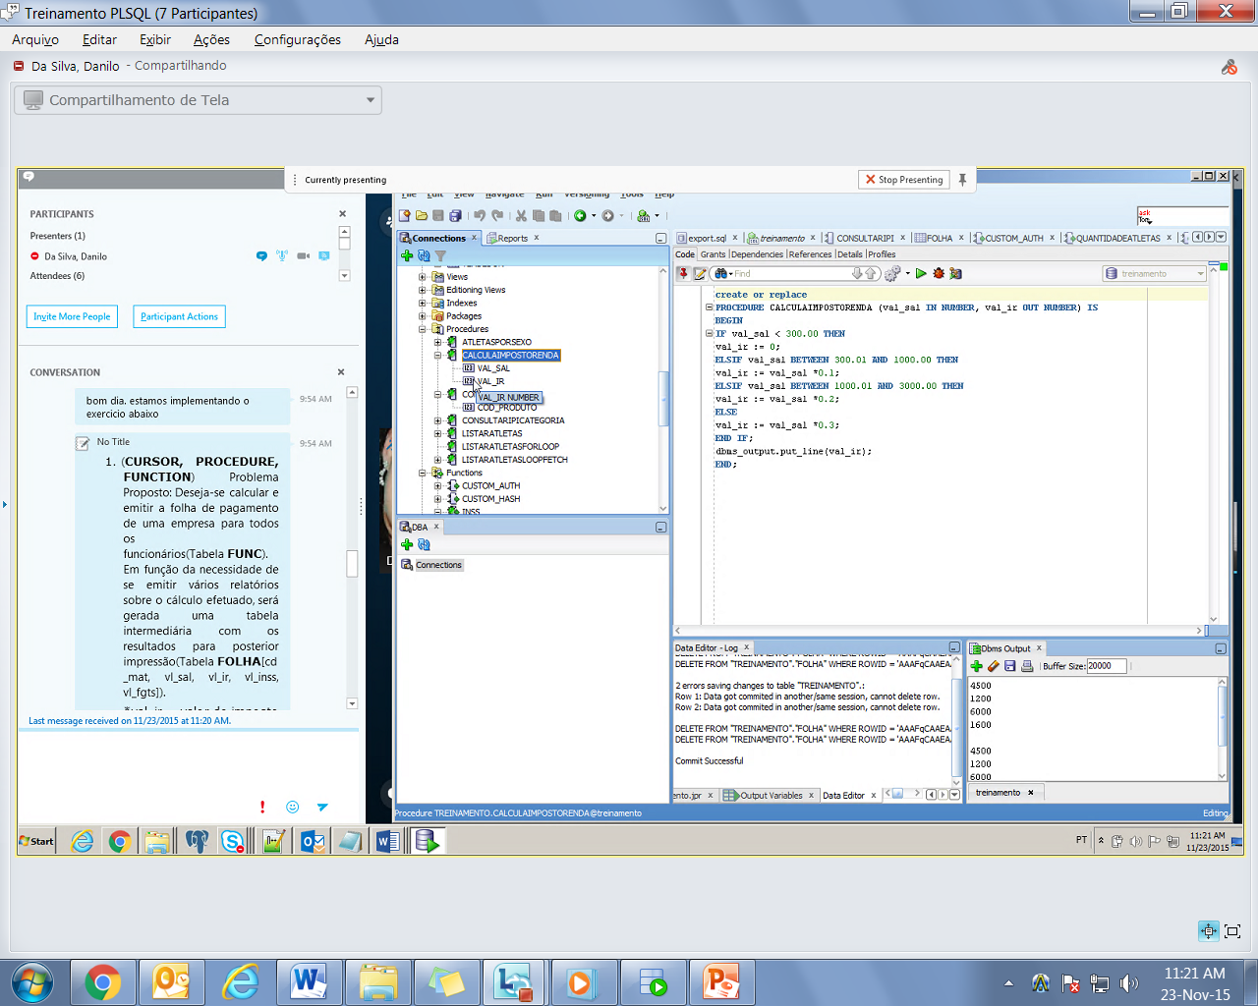

**CREATE OR REPLACE PROCEDURE** CALCULAIMPOSTORENDA( val_sal **IN NUMBER**,

val_ir **OUT NUMBER**

)

**IS**

**BEGIN**

**IF** val_sal < 300.00 **THEN**

val_ir := 0;

**ELSE**

**IF** val_sal **BETWEEN** 300.01 **AND** 1000.00 **THEN**

val_ir := val_sal *0.1;

**ELSE**

**IF** val_sal **BETWEEN** 1000.01 **AND** 3000.00 **THEN**

val_ir := val_sal *0.2;

**ELSE**

val_ir := val_sal *0.3;

**END IF;**

dbms_output.put_line(val_ir);

**END IF;**

**END IF;**

**END IF;**

**END;**

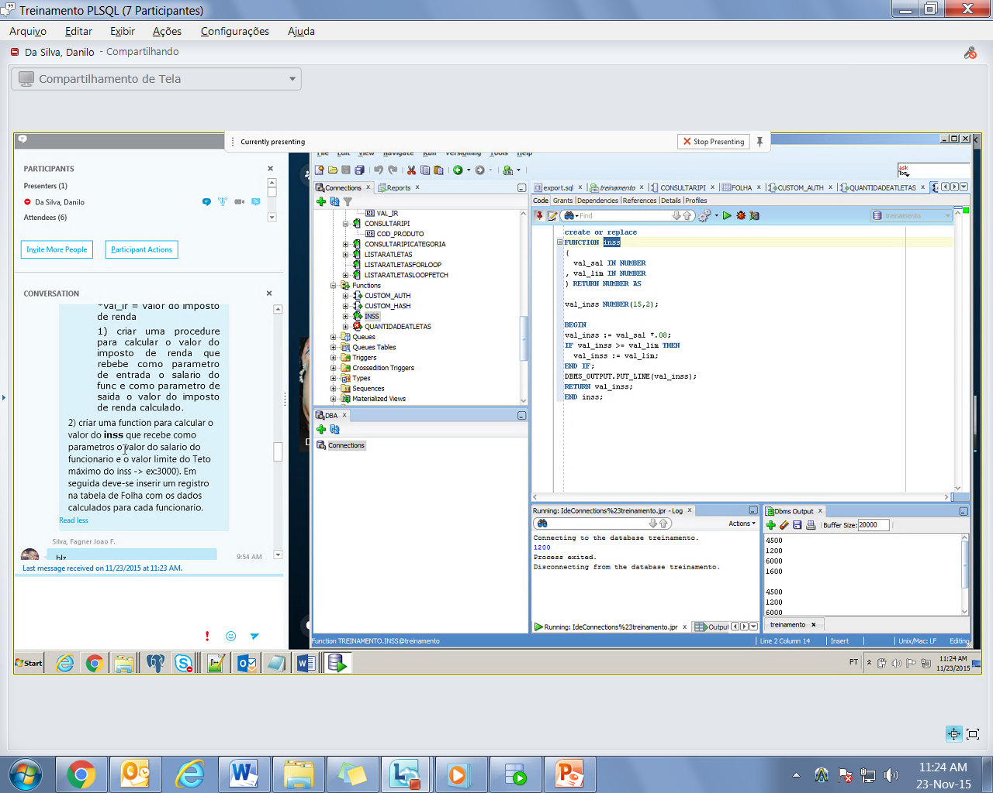

**CREATE OR REPLACE FUNCTION** inss( val_sal **IN NUMBER** ,

val_lim **IN NUMBER** )

**RETURN NUMBER**

**AS**

val_inss **NUMBER**(15,2);

**BEGIN**

val_inss := val_sal *.08;

**IF** val_inss >= val_lim **THEN**

val_inss := val_lim;

**END IF;**

DBMS_OUTPUT.PUT_LINE(val_inss);

**RETURN** val_inss;

**END** inss;