PL-SQL

Caminhos para achar o que se quer:

C:\Users\lais.de.souza.vidoto\Accenture\Downloads\sqldeveloper-4.1.2.20.64-x64.zip\sqldeveloper

C:\oraclexe\app\oracle\product\11.2.0\server\network\ADMIN

Arquivos modificados-> tnsnames.ora e listener.ora

HOST = MW71F7EXTRA2AI

links para baixar os programas necessários:

**Oracle Database Express Edition 11*g* Release 2**

<http://www.oracle.com/technetwork/database/database-technologies/express-edition/downloads/index.html>

**Oracle SQL Developer**

<http://www.oracle.com/technetwork/developer-tools/sql-developer/downloads/index.html>

No windows procurer pôr services

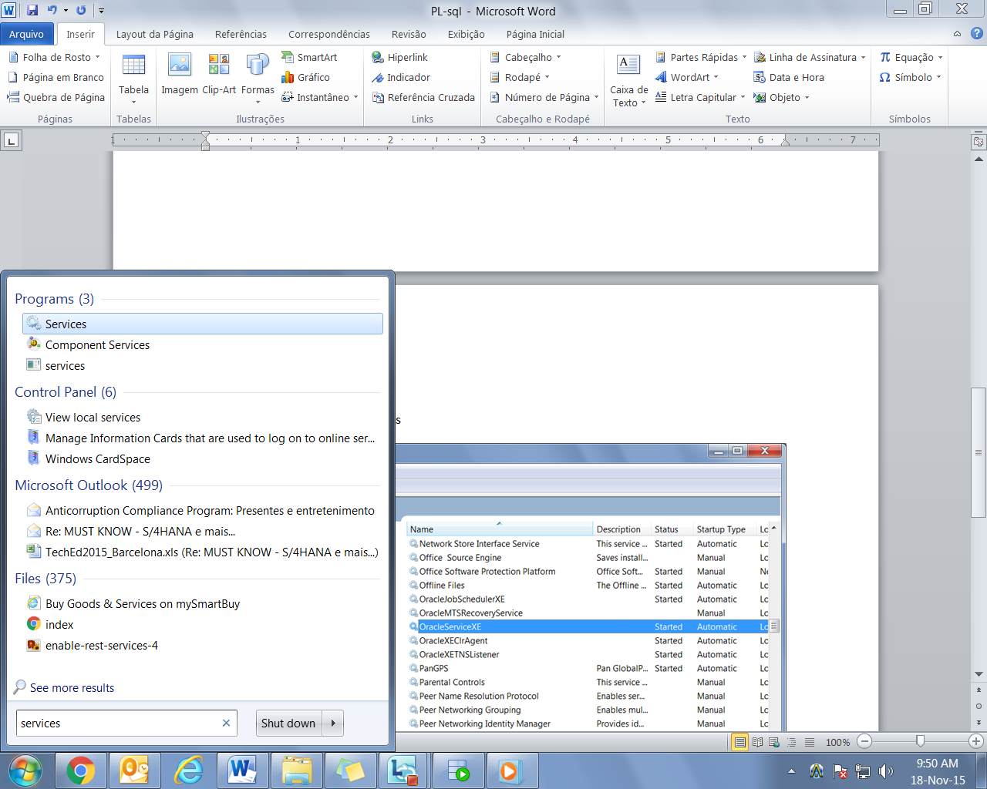

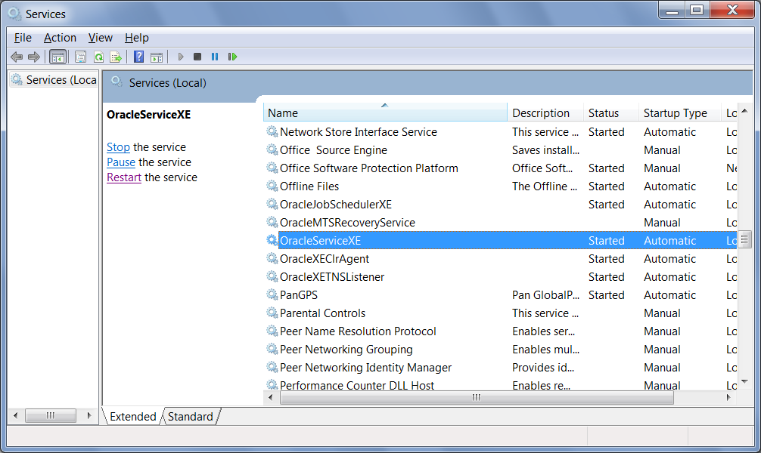

Deixar-los automaticos e startados