

**Faculty of Engineering and Technology**

**Computer Science Department**

**COMP4382-SP.TOP: WEB SERVICES TECHNOLOGY**

**06-May-2023**

## **Assignment #1**

**Design and implement Hospital Management System Rest APIs**

# Summary

This is the first assignment where each student needs to work individually on:

1. Identify 4 core resources required by Hospital Management System, example: Doctor, Doctor-Specialty, Patient, Appointment …etc
2. Create new repository under your GitHub account with name “hospital-management-system”
3. Prepare the ER diagram and push it on GitHub as part of the readme.md file.

**Due date of this part is 12 My 2023 00:00.**

1. Prepare the design and documentation for each resource as per to the following template, refer to the slides for more info:



1. Implement the above required resources.
2. Push your project on the GitHub
3. Put the design and documentation on readme.md.

Sample Spring boot project can be accessed via:

[mohkharma/sp-rest-api (github.com)](https://github.com/mohkharma/sp-rest-api)

1. Prepare Postman collection for APIs testing. Then export them as below and push into GitHub repository

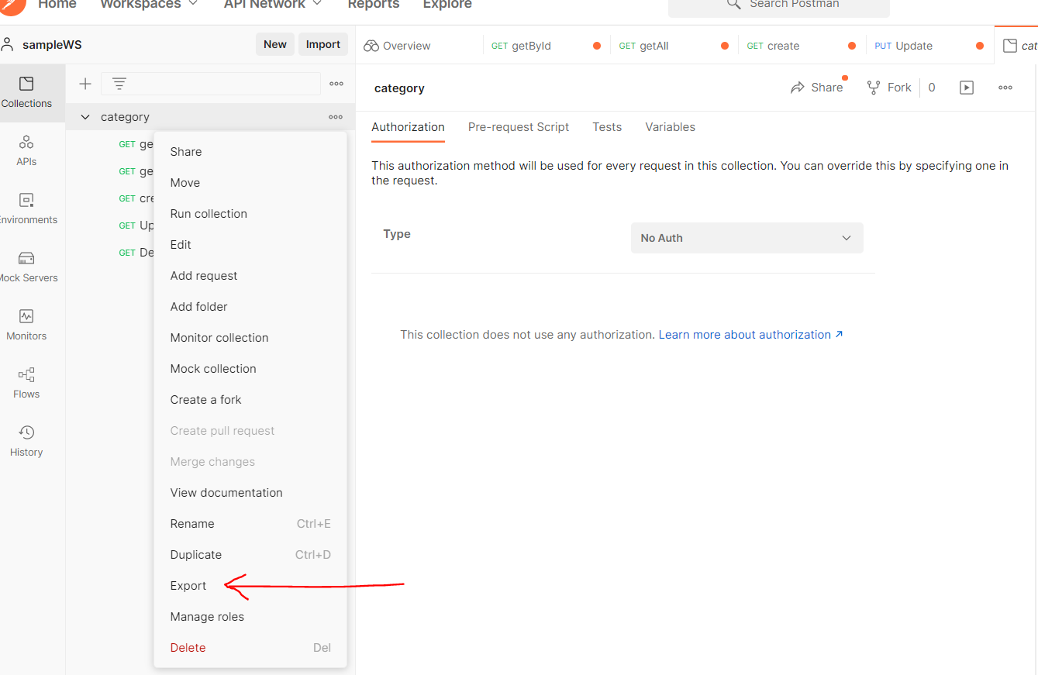

# Evaluation criteria:

1. Design and code documentation available on GitHub.
2. Working project and Postman testing.
3. You should work on this assignment on your own, copy/paste is prohibited.

|  |  |
| --- | --- |
| Identify 4 core resources required by the application and the ER diagram. | 4 |
| Design and code documentation available on GitHub. | 6 |
| Overall design and understanding | 5 |
|  |  |

# Submission:

Due date: 23 May 2023 4:00 PM. You have to reply on the assignment message on Ritaj with your GitHub repository link only.