|  |
| --- |
| **Proposal** |
| **Sample Project 3: Complex SaaS application** |
| Technical part by |
| Financial part by |
| **4/9/2013** |

|  |
| --- |
|  |

**Contents**

Technical Part

1. Short project description

2. List of important requirements

3. Possible Risks

4. System Architecture

5. Technologies

6. Documentation

7. Communication

8. Project Breakdown with time efforts estimation

9. Project delivery plan by stages

Financial Part

10. Budget details

11. Payment terms

12. Warranty

13. Maintenance and support terms

General information

14. Company information

15. Contact Details

# 

# Technical Part

## 

## 1. About The Project

**Technology Used**: .

## 2. List of important requirements

In this field, you can summarize the major requirements for the future project in your own words. We suggest to list here those requirements which singificantly determine work scope of the project.

**Important requirements:**

* Requirement 1
* Requirement 2
* Requirement 3
* Requirement 4
* Requirement 5
* Requirement N....

## 3. Possible Risks

In this field, you can make a note of every possible risk in project development, for example technical issues or any other issue that may lead to missing deadlines, not staying within budget, or not completing the project.

**Important risks:**

* Risk 1
* Risk 2
* Risk 3
* Risk N....

## 4. Task

## 4. System Architecture

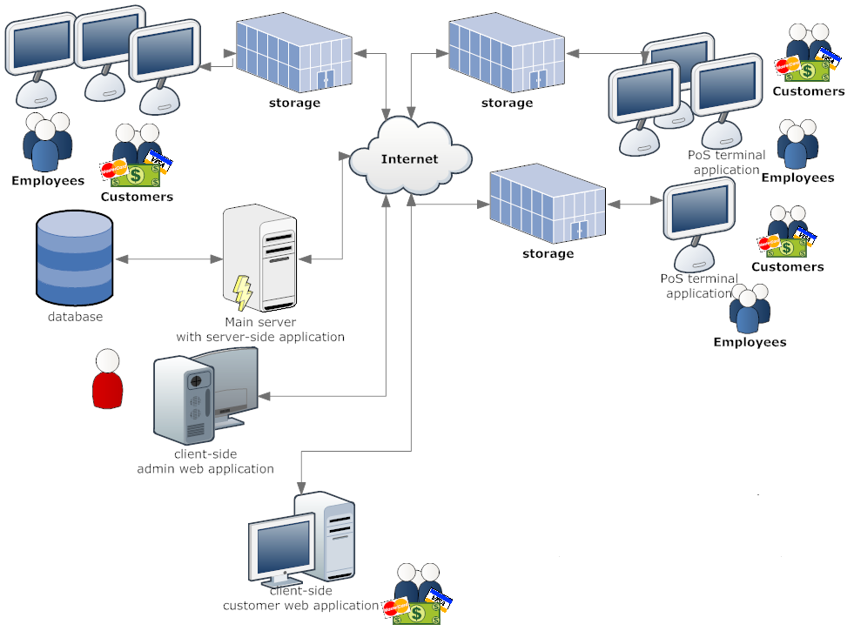

The system will consist of following major sections:

1. Administrator web-based application  
 2. MS SQL Server database  
 3. POS terminal application   
 4. Web users application  
 5. Service system application

## 5. Technologies

suggests building the system using the following technologies:

1. Crystal Reports  
 2. WPF  
 3. HTML 5  
 4. jQuery  
 5. Microsoft Windows  
 6. Javascript  
 7. Microsoft.NET 4.0  
 8. ASP.NET MVC3  
 9. Entity Framework

## 6. Documentation

will provide:

1. Commented source code   
 2. Mockups  
 3. Software requirements specification  
 4. Technical documentation

## 7. Communication

will ensure excellent communication over the entire course of the project:

Day to Day

a. Direct access to the latest development version of the system (demo site)   
 b. Client will be able to communicate with a project manager via a desired instant messenger, Skype, e-mail

Weekly

1. Conference call with presentation of results achieved (shared desktop)

## 8. Project Breakdown with time efforts estimation

Timeline and price in this proposal are referred to the entire application.

|  |  |  |
| --- | --- | --- |
| **№** | **Stages/Tasks** | **Efforts, man-hours** |
| **Stage 1** | **Analysis and Design** |  |
| 1.1 | Analysing Requirments | 16 |
| 1.2 | Web site design | 16 |
| 1.3 | Work plan | 18 |
| 1.4 | System architecture | 24 |
| **Stage 2** | **Implementation** |  |
| 2.1 | Multi-tenant architecture |  |
| 2.1.1 | Registration of new tenant | 20 |
| 2.1.2 | Adaptation of current database structure | 40 |
| 2.1.3 | Subscription, tenant properties | 20 |
| 2.1.4 | Adaptation of existing reports | 40 |
| 2.2 | Customer Tab |  |
| 2.2.1 | Customer Maintanence |  |
| 2.2.1.1 | Customer Form | 24 |
| 2.2.1.2 | Category Form (Category maintainence) | 8 |
| 2.2.1.3 | Upload Photo Dialog | 6 |
| 2.2.1.4 | Address Editor | 6 |
| 2.2.1.5 | Email button | 1 |
| 2.2.1.6 | Customer Secodary Id Form | 8 |
| 2.2.1.7 | Purchaser Form | 8 |
| 2.2.1.8 | Report (SQL Reporting) with selecting Order | 4 |
| 2.2.1.9 | Redeem Ronald Svewept s Frequent Shopper points | 8 |
| 2.2.2 | Instore Carge AR Maintainence |  |
| 2.2.2.1 | Main Form | 24 |
| 2.2.2.2 | Charges | 16 |
| 2.2.2.3 | Payments | 16 |
| 2.2.2.4 | AutoApply Payments | 4 |
| 2.2.2.5 | Credit memo | 16 |
| 2.2.2.6 | Instore Charge Finance | 16 |
| 2.2.2.7 | Customer Attriutes | 16 |
| 2.2.2.8 | Aging Report | 8 |
| 2.2.2.9 | Statement Report | 8 |
| 2.2.2.10 | Activity Report | 8 |
| 2.2.2.11 | Balance Detail Report | 8 |
| 2.2.2.12 | Balance Summary Report | 8 |
| 2.3 | Inventory |  |
| 2.3.1 | Cost Calculator | 12 |
| 2.3.2 | Receive an Invoice |  |
| 2.3.2.1 | Form (+CRUD) | 24 |
| 2.3.2.2 | Search | 12 |
| 2.3.2.3 | PO Adjustment | 16 |
| 2.3.2.4 | Create Batch | 8 |
| 2.3.2.5 | Preview (Report) | 4 |
| 2.4 | Ribbon Bar implementation | 40 |
| 2.5 | BarTender integration | 32 |
| 2.6 | Testing | 40 |
| **Stage 3** | **Implementation** |  |
| 3.1 | Point of Sale |  |
| 3.1.1 | Store Sales |  |
| 3.1.1.1 | Main Form + CRUD | 20 |
| 3.1.1.2 | Stores Graph Diagram | 32 |
| 3.1.1.3 | Memo Dialog | 4 |
| 3.1.1.4 | Report | 4 |
| 3.1.1.5 | Agregate Report | 4 |
| 3.1.1.6 | Taxes Dialog(Summary/Detail view + Report) | 20 |
| 3.1.2 | Product Sales | 24 |
| 3.1.2.1 | Main Form | 20 |
| 3.1.2.2 | Filters | 6 |
| 3.1.2.3 | Product Movement | 4 |
| 3.1.2.4 | Report | 4 |
| 3.1.3 | Weekly Balance Summary |  |
| 3.1.3.1 | Main Page | 16 |
| 3.1.3.2 | Setting page | 4 |
| 3.1.3.3 | Report | 4 |
| 3.1.4 | Till Statistics and Balancing |  |
| 3.1.4.1 | Main Page | 16 |
| 3.1.4.2 | Report | 4 |
| 3.1.4.3 | Get Employee Popup | 6 |
| 3.1.4.4 | Convert concurency | 4 |
| 3.1.4.5 | Till Status Report | 4 |
| 3.1.4.6 | Settings - Balance by cashier/by lane | 8 |
| 3.1.5 | Safe Statistics and Balancing |  |
| 3.1.5.1 | Page | 32 |
| 3.1.5.2 | Report | 4 |
| 3.1.5.3 | Make a deposit (Deposit form + Check form) | 32 |
| 3.1.5.4 | Show till monitor (dialog) | 16 |
| 3.1.5.5 | Safe Adjustment | 6 |
| 3.1.5.6 | Countdown dialog | 12 |
| 3.1.5.7 | Date search | 4 |
| 3.1.5.8 | Safe audit report | 4 |
| 3.1.6 | Balancing Overview |  |
| 3.1.6.1 | Main Page | 24 |
| 3.1.6.2 | Report | 4 |
| 3.1.6.3 | Discount and Coupon Summary Report | 4 |
| 3.1.7 | Electronic Journal |  |
| 3.1.7.1 | Page | 16 |
| 3.1.7.2 | Retail Search | 8 |
| 3.1.7.3 | Analyze Transition | 8 |
| 3.1.7.4 | Analyze Order | 8 |
| 3.1.7.5 | Show All Employees | 4 |
| 3.1.7.6 | Report | 4 |
| 3.1.8 | Print EFT Charges Report |  |
| 3.1.8.1 | Report configure dialog | 8 |
| 3.1.8.2 | Report | 6 |
| 3.1.9 | Products |  |
| 3.1.10 | Product Maintenance |  |
| 3.1.10.1 | Main Form | 32 |
| 3.1.10.2 | Report | 4 |
| 3.1.10.3 | Product Groups | 6 |
| 3.1.10.4 | Additional Vendors | 6 |
| 3.1.10.5 | Inventory | 6 |
| 3.1.10.6 | Product Movement |  |
| 3.1.10.7 | Price History | 2 |
| 3.1.10.8 | Product Batches | 2 |
| 3.1.10.9 | Scale Data ( + 1 subform) | 12 |
| 3.1.10.10 | Power Edit | 2 |
| 3.1.10.11 | Cost Calculator | 6 |
| 3.1.11 | Product Batches Maintenance |  |
| 3.1.11.1 | Main Form | 16 |
| 3.1.11.2 | Report | 4 |
| 3.1.11.3 | Add New Batches | 4 |
| 3.1.11.4 | Find a Batch (batch table) | 4 |
| 3.1.11.5 | Date Change | 4 |
| 3.1.11.6 | Product Movement |  |
| 3.1.11.7 | Apply Change | 4 |
| 3.1.11.8 | Review Related Batches | 4 |
| 3.1.11.9 | Prouct Ad Loss Report | 4 |
| 3.1.11.10 | Prices that will remain in effect | 4 |
| 3.1.12 | Product Group Maintenance |  |
| 3.1.12.1 | Form | 16 |
| 3.1.12.2 | Report | 4 |
| 3.1.13 | Power Edit |  |
| 3.1.13.1 | Form | 16 |
| 3.1.13.2 | Report | 4 |
| 3.1.14 | Print Custom Labels |  |
| 3.1.14.1 | Form | 24 |
| 3.1.14.2 | Printing (Report) | 8 |
| 3.1.15 | Convert Currency | 16 |
| 3.1.16 | Product Movement (used in other forms + Report ) | 24 |
| 3.2 | Testing | 64 |
| **Stage 4** | **Implementation** |  |
| 4.1 | Administration |  |
| 4.1.1 | Customer Maintenance | 16 |
| 4.1.2 | Employee Maintenance | 24 |
| 4.1.3 | Vendor Maintenance |  |
| 4.1.3.1 | Vendor page | 20 |
| 4.1.3.2 | Report | 4 |
| 4.1.4 | Template Maintenance |  |
| 4.1.4.1 | Template page | 16 |
| 4.2 | Crystal Reports deployment | 16 |
| **Stage 5** | **Testing and other QA tasks** |  |
| 5.1 | Final testing of all implemented functionality | 160 |
| 5.2 | Debugging, Bugs fixing | 120 |
| **Stage 6** | **Deployment** |  |
| 6.1 | Deployment of customer server | 8 |
| 6.2 | Knowledge transfer to customer staff | 16 |
| 6.3 | Technical documentation | 16 |

Total estimated efforts: 1733 man-hours

## 9. Project delivery plan by stages

The project will be implemented in the following stages:

**Stage 1. Analysis and Design**

|  |  |
| --- | --- |
| **Tasks** | Analysing Requirments;Web site design;Work plan ;System architecture; |
| **Deliverables** | System architecture, work plan and web design of application |
| **Estimate (work days)** | 5 |
| **Total man-hours by stage** | 74 |

|  |  |  |  |
| --- | --- | --- | --- |
| **Labor category** | **Man-hours per category** | **Staff quantity** | **Man-hours per person** |
| Project manager | 34 | 1 | 34 |
| Senior software engineer | 24 | 1 | 24 |
| Web designer | 16 | 1 | 16 |

**Stage 2. Implementation**

|  |  |
| --- | --- |
| **Tasks** | Multi-tenant architecture;Registration of new tenant;Adaptation of current database structure;Subscription, tenant properties ;Adaptation of existing reports;Customer Tab;Customer Maintanence;Instore Carge AR Maintainence;Inventory;Cost Calculator;Receive an Invoice;Ribbon Bar implementation;BarTender integration; |
| **Deliverables** | Updated version of application on developer s server |
| **Estimate (work days)** | 22 |
| **Total man-hours by stage** | 529 |

|  |  |  |  |
| --- | --- | --- | --- |
| **Labor category** | **Man-hours per category** | **Staff quantity** | **Man-hours per person** |
| Senior software engineer | 162 | 1 | 162 |
| Software engineer | 327 | 2 | 163.5 |
| Software test engineer | 40 | 1 | 40 |

**Stage 3. Implementation**

|  |  |
| --- | --- |
| **Tasks** | Point of Sale;Store Sales;Product Sales;Weekly Balance Summary;Till Statistics and Balancing;Safe Statistics and Balancing;Balancing Overview;Electronic Journal;Print EFT Charges Report;Products;Product Maintenance;Product Batches Maintenance;Product Group Maintenance;Power Edit;Print Custom Labels;Convert Currency;Product Movement (used in other forms + Report ); |
| **Deliverables** | Updated version of application on developer s server |
| **Estimate (work days)** | 23 |
| **Total man-hours by stage** | 714 |

|  |  |  |  |
| --- | --- | --- | --- |
| **Labor category** | **Man-hours per category** | **Staff quantity** | **Man-hours per person** |
| Senior software engineer | 98 | 1 | 98 |
| Software engineer | 528 | 3 | 176 |
| Software test engineer | 64 | 1 | 64 |

**Stage 4. Implementation**

|  |  |
| --- | --- |
| **Tasks** | Administration;Customer Maintenance;Employee Maintenance;Vendor Maintenance;Template Maintenance; |
| **Deliverables** | Completed application with some bugs on developer s server |
| **Estimate (work days)** | 5 |
| **Total man-hours by stage** | 96 |

|  |  |  |  |
| --- | --- | --- | --- |
| **Labor category** | **Man-hours per category** | **Staff quantity** | **Man-hours per person** |
| Senior software engineer | 36 | 1 | 36 |
| Software engineer | 60 | 2 | 30 |

**Stage 5. Testing and other QA tasks**

|  |  |
| --- | --- |
| **Tasks** | Final testing of all implemented functionality;Debugging, Bugs fixing; |
| **Deliverables** | Competed application on developer s server |
| **Estimate (work days)** | 10 |
| **Total man-hours by stage** | 280 |

|  |  |  |  |
| --- | --- | --- | --- |
| **Labor category** | **Man-hours per category** | **Staff quantity** | **Man-hours per person** |
| Software engineer | 120 | 2 | 60 |
| Software test engineer | 160 | 2 | 80 |

**Stage 6. Deployment**

|  |  |
| --- | --- |
| **Tasks** | Deployment of customer server;Knowledge transfer to customer staff;Technical documentation; |
| **Deliverables** | Completed application on client s server |
| **Estimate (work days)** | 2 |
| **Total man-hours by stage** | 40 |

|  |  |  |  |
| --- | --- | --- | --- |
| **Labor category** | **Man-hours per category** | **Staff quantity** | **Man-hours per person** |
| Project manager | 16 | 1 | 16 |
| Senior software engineer | 8 | 1 | 8 |
| Software test engineer | 16 | 1 | 16 |

Total project timeframe: 14 weeks.

Total estimated efforts: 1733 man-hours

**Total estimated efforts:**

|  |  |
| --- | --- |
| Project manager | 50 |
| Senior software engineer | 328 |
| Software engineer | 1035 |
| Web designer | 16 |
| Software test engineer | 280 |

# Financial Part

## 

## 10. Budget details

**Hour rates**

|  |  |
| --- | --- |
| Project manager | 40 USD per hour |
| Senior software engineer | 38 USD per hour |
| Software engineer | 31 USD per hour |
| Web designer | 25 USD per hour |
| Software test engineer | 22 USD per hour |

**Budget calculation**

|  |  |  |  |
| --- | --- | --- | --- |
| **Labor category** | **Duration, man-hours** | **Cost per category** | **Total cost per category** |
|  |  |  |  |
| Project manager | 50 | 40 USD per hour | 2000 USD |
| Senior software engineer | 328 | 38 USD per hour | 12464 USD |
| Software engineer | 1035 | 31 USD per hour | 32085 USD |
| Web designer | 16 | 25 USD per hour | 400 USD |
| Software test engineer | 280 | 22 USD per hour | 6160 USD |

**Additional Services**

|  |  |
| --- | --- |
| Knowledge transfer and client's staff education | 3500 USD |
| Cloud Amazon hosting rent and deployment | 1600 USD |

Total Price: 58209 USD

**The total cost includes:**

• Development and testing efforts to create the entire project  
 • Final deliverables in accordance with project work scope listed in proposal  
 • 12 months of free bug fixing

## 11. Payment terms

|  |  |  |
| --- | --- | --- |
| Pre-payment | 20 % | 11641.8 USD |
| After completion of Stage 2 | 15 % | 8731.35 USD |
| After completion of Stage 3 | 15 % | 8731.35 USD |
| After completion of Stage 4 | 15 % | 8731.35 USD |
| After completion of Stage 5 | 15 % | 8731.35 USD |
| After completion of Stage 6 | 20 % | 11641.8 USD |

**Methods of payment:**

• accepts payment via Wire transfer  
 • accepts payment via PayPal  
 • accepts payment via Check  
 • accepts payment via Cash  
 • accepts payment via Credit card

**Payment Notes**

We will provide source code only after full payment.

## 12. Warranty

All errors that are discovered within the first three months of system operation will be fixed at no additional cost.

## 13. Maintenance and support terms

Will be discussed after project completion.

# General information

## 14. Company information

**Founded in**:

Key Services:

Key Skills:

**Full-Time Employees**:

Location: United States

|  |
| --- |
|  |

## 15. Contact Details

Email: sspal@yahoo.com

|  |
| --- |
|  |