ARTIFICIAL INTELLIGENCE APPROACH FOR PREDICTING THE COMPRESSIVE STRENGTH OF CONCRETE MIXTURE

Alziber Mohammed, University of Khartoum, Sudan, alziber50@gmail.com

Ayman Salah, University of Khartoum, Sudan, aymanelmahadi40@gmail.com

Moayad Jamal, University of Khartoum, Sudan, moayad29@gmail.com

Omer Ali, University of Khartoum, Sudan, Eomerzx60@gmail.com

D. Yousif Hummaida Ahmed, University of Khartoum, Sudan, y.hummaida@uofk.edu

## Abstract

*In this study, an artificial intelligence approach is utilized to determine the compressive strength of concrete and the slump, aiming to minimize the time and cost which are consumed using conventional methods. An artificial neural network (ANN) model is programmed using the Keras framework (python) to predict concrete mix compressive strength and slump based on the input of proportions and properties of its ingredients. The data of 1557 samples are collected and converted manually from hard copy to soft copy. The (ANN) model gives results of a good accuracy for the compressive strength after 7 days, 28 days and the slump. In conclusion, using AI in the prediction of concrete strength is convenient and practical to a significant extent.*

**Keywords***:* Artificial Intelligence, Artificial neural networks, Compressive Strength, Concrete, Keras framework (python).

# INTRODUCTION

It’s known all over the world that concrete is the most utilized material in civil engineering. This is justifiable due to its effectiveness in the process of construction, this effectiveness is represented in its characteristics including strength against compression, workability, durability, fire resistance, and impact resistance.

Mechanical strength (Compressive strength) is the most important property of concrete due to it being descriptive of the quality of concrete. It’s the result of concrete mixture design to be used in construction. In general, it is obtained by measuring the specimen of concrete after standard curing of 28 days. It’s important to predict the 28-day compressive strength to get an idea about the development of that strength, and so it is necessary to measure the strength of the concrete specimen at its early stages. Conventional methods to predict the 28-day compressive strength of concrete are based on statistical analysis by which many linear and non-linear regression equations have been formed to model such a problem. The compressive strength is affected by multiple factors and components of concrete. The goal of most research in material modelling is to generate mathematical models to describe the relationship between components and material behaviour. These models consist of mathematical rules and expressions that capture these varied and complex behaviours, and concrete, it is a highly non-linear material, so modelling its behaviour is a difficult task.

Concrete as a material is created by the proper mixing of its four major components which are cement, coarse aggregates which includes gravel, fine aggregates which include sand and an adequate and controlled amount of water, studies have shown that the long-term properties of concrete can be improved by controlling some parameters of concrete such as the grade of cement, the water-cement ratio and slump (Ni and Wang, 2000).

## Materials:

It is justifiable to say that concrete is a complex material, and that is due to the multiple parameters involved in its composition which can significantly change the properties and behaviour of concrete. These components also have different effects depending on the current state of concrete whether it is in the fresh state or the hardened state.

### Cement: It is a very crucial material in the formation of concrete, and this is because the cohesion and solidarity of concrete are generated from the interaction between the chemical compounds of cement and water. In the fresh state of concrete, increasing the amount of cement will result in the reduction of consistency due to the increase of the resistance to flow. In the hardened state, cement should fit the appropriate standard required for concrete to acquire the best possible strength. In general, the increase in cement content increases in concrete strength. However, it must be taken into account that it should not result in the reduction of consistency due to the reduction of water since it will cause the concrete to become difficult to compact and strength will become less. (CALcrete, no date)

### Water: As said before, the stiffness of concrete results from the formation of hydration products between cement and water. Although water makes concrete more consistent, the higher the amount of it the less strong concrete will be. Therefore, to have better strength less water-cement ratio is preferable, which means less water.

### Coarse aggregates (gravel): It aids in the workability of concrete, the coarser aggregates in the formation of concrete the more consistency it will have. If any increase in the amount of gravel occurs it will result in the increase of compressive strength due to the reduction of the surface area of solid particles which in return will lower the water demand, which means less water-cement ratio.

### Fine aggregates (sand): It causes the water demand to rise, which aids in the concrete being more consistent and workable in the fresh state. On the other hand, it has the opposite impact on the compressive strength of concrete, this strength increases as the number of sands decreases due to the increase of the surface area of solid particles.

Admixtures: “An admixture is defined as a material other than water, aggregate, and hydraulic cement which might be added to concrete before or during its mixing”.

## Artificial neural networks:

Artificial intelligence was born in the 1950s when some great computer scientists were wondering if computers could be made to think, a question that humans are still trying to solve. A simple definition of this field would be the effort to automate human intellectual tasks. Artificial intelligence is a general field, it includes deep learning and machine learning, but also includes many methods that don’t involve any learning.

Machine learning is about the question of can a computer -We know how to order it to perform- and on its own learn how to do a specific task? Can a computer surprise us? Instead of programmers handcrafting data-processing rules, can a computer learn the rules automatically by looking at data? (Chollet, 2017)

A machine-learning system is not explicitly programmed but rather trained. It’s provided with a lot of examples related to a task, and using these examples it finds a statical structure that allows the system to generate rules for automating the task. For example, if you want to automate the process of tagging your vacation images, you could try a machine learning system with a lot of images already tagged by humans, and this system would learn to associate specific images to specific tasks using statistical rules.

# RELATED STUDIES

Since the start of the previous decade, researchers have been trying to use artificial intelligence for non-destructive compressive strength prediction. Most of the authors in the literature used the Artificial neural network method (ANN).

(Badawi and Ahmed, 2020) used data from the lab of materials of the University of Khartoum collected in the past 10 years. They used MATLAB to produce an artificial neural network (ANN) model to predict the compressive strength after 7 days and the workability of concrete. Their model got acceptable results. We used the same data and added more recent concrete mixtures data that were done in the years (2017 – 2021). We developed a new model using KERAS to predict the compressive strength after 7 days, after 28 days and the workability of concrete.

(Tayfur, Erdem and Kırca, 2014) tried 2 different models to predict the compressive strength of high strength concrete and compared them against each other. He used the Silica fume ratio and age of the mixture as input and the compressive strength as an output. The first was a fuzzy logic (FL) model. And the second was an artificial neural network model (ANN) with 3 layers and a sigmoid as activation function. From the results, he concluded that FL and ANN models have good capability in predicting the strength of high strength concrete.

(Chopra, Sharma and Kumar, 2016) proposed an artificial intelligence model to predict the compressive strength of concrete. The dataset used in this research is of 2 types; in one of them, 15% of cement was replaced with fly ash and the other without replacement. He tried several training algorithms along with various network architectures. It was found out that Levenberg-Marquardt with tan-sigmoid is best for the prediction of compressive strength.

(Gupta, 2013) proposed a method to predict the 28-days compressive strength of high strength concrete. The data he used in this research consisted of cement, water, silica fume, aggregate (coarse and fine), fly ash, superplasticizer and granulated grated blast furnace slag. The results showed a relative error of 7.02% in training and 12.64% which showed that ANN can work effectively in predicting the compressive strength of high strength concrete.

(Naderpour, Rafiean and Fakharian, 2018) aimed to predict the compressive strength of recycled aggregate concrete (RCA) using an artificial neural network. The model used six input features: water-cement ratio, water absorption, fine aggregate, natural coarse aggregate, RCA and water-total material ratio. The network type was backpropagation ANN with a sigmoid activation function and linear output layer. The results concluded that the ANN method can accurately predict RCA compressive strength.

(Ghazanfari *et al.*, 2017)used in his study MLP and GMDH artificial neural networks to discover relationships, predict mechanical properties and identify non-linear patterns in concrete mixtures. The results imply acceptable accuracy of the GMDH algorithm in predicting the compressive strength and workability.

# METHODOLOGY

## Neural network structure:

As (Basheer and Hajmeer, 2000) stated, a neural network revolves around the following objects:

1- Data.

2- Layers.

3- Optimizer.

4- Loss function.

### Data:

*Data preparation:*

The dataset used in this study was collected separately: 545 mixed designs samples were gathered from the lab of materials of the University of Khartoum, and 1012 mixed designs samples were collected in the previous 9 years (2009-2017) in Sudan and published by (Abdelatif *et al.*, 2018) to end up with 1557 samples.

Data used in the model has been tabulated, organized, analysed by plots and graphs to more observing odd data and structured into a spreadsheet. The data includes the main mix designs proportions in terms of cement content, water, and fine and coarse aggregate with added admixtures dosage. Moreover, the data provide the result of the slump test, concrete strength in 7 and 28 days for those mix designs. The data also includes properties of aggregates such as aggregate type, maximum size, percentage passing sieve 0.6 mm and hardened concrete density. The data is explained in Table 1.

|  |  |  |  |  |  |
| --- | --- | --- | --- | --- | --- |
| **Parameter** | **Designation** | **Minimum**  **value** | **Maximum value** | **Average value**  **(Most common)** | **Type** |
| Type of coarse aggregates | X1 | Natural | Crushed | N/A | Input |
| Type of fine aggregates | X2 | Natural | Crushed | N/A | Input |
| Maximum size of coarse aggregates | X3 | 10 | 40 | 20 | Input |
| Percentage of aggregates passing sieve 0.6 mm | X4 | 17 | 96.9 | 45 | Input |
| Cement content (Kg/m3) | X5 | 250 | 450 | 350 | Input |
| Water cement ratio (w/c) | X6 | 0.4 | 0.72 | 0.5 | Input |
| Water content (Kg/m3) | X7 | 100 | 290 | 180 | Input |
| Additive type | X8 | N/A | N/A | Type G | Input |
| Dosage of additive (lit) | X9 | 0 | 9 | 1.15 | Input |
| Amount of fine  aggregates (Kg/m3) | X10 | 477 | 865 | 1875 | Input |
| Amount of coarse aggregates (Kg/m3) | X11 | 990 | 1365 | 1162 | Input |
| Workability slump (mm) | Y1 | 90 | 230 | 150 | Output |
| Strength in 7 days (N/mm2) | Y2 | 19 | 45.9 | 29.6 | Output |
| Strength in 28 days (N/mm2) | Y3 | 16.1 | 57 | 38 | Output |

***Table 1:*** *Data used in the research and its properties*

#### Data completion: After collecting the data, we found that recent year’s data has missing values like the percentage of passing sieve 0.6mm. To solve this a regression model was used to predict the missing value.

*Data division:* To get optimized results and better performance of the model the data was divided into 70% as the training set, 15% as the validation set and 15% as the test set.

Data normalization*:* In this research’s data, the water to cement ratio ranges between 0.33 - 0.72 and the cement content ranges between (220– 450). If features ranges are different, it would be problematic, the network might be able to automatically adapt to such heterogeneous data, but it would make learning more difficult. So, the normalization process was applied to the data.

The method that was used for normalization is called the Z-Score method. This method uses the mean and standard deviation to scale the data similar to (Singh and Singh, 2020). The normalized input is calculated using Equation (1).

|  |  |  |
| --- | --- | --- |
|  | $$x^{'}=\frac{x-μ}{σ}$$ | (1) |

Where:

$x$: the input

$x^{'}$: The new normalized data

$μ$: the mean of data

$σ$: the standard derivation

### Layers:

Every network consists of layers of neurons connected, starting with the input layer passing data to the hidden layers and generating output in the output layer. Each layer consists of a specific number of neurons.

After a lot of trial and error the chosen model was as follows:

* Input layer with normalization operation.
* First hidden layer with 160 neurons.
* 2nd hidden layer with 80 neurons with Relu as an activation function.
* Dropout layer that has a 0.2 dropout ratio.
* 3rd hidden layer with 40 neurons with Sigmoid as an activation function.
* 4th hidden layer with 20 neurons with Relu as an activation function.
* 5th hidden layer with 10 neurons with Sigmoid as an activation function.
* First hidden layer with 5 neurons with Relu as an activation function.
* Output layer with one neuron.

### Optimizer:

After trying two optimizers Stochastic gradient descent and Adam optimizers, we found out we should use the Adam optimizer. It implements a specific variant of stochastic gradient descent (SGD).

### Loss function:

The loss function that was used in this study is the mean squared error (MSE), it’s calculated using Equation (2).

|  |  |  |
| --- | --- | --- |
|  | $$MSE= \sum{\frac{{(y^{'}-y)}^{2}}{n}}$$ | (2) |

Where:

$y^{'}$: represents the predicted value of the model

$y$: represents the real output data

$n$: number of samples

## Neural network parameters:

### Learning rate:

To get better efficiency of this model a learning rate that’s not so big to not get bad efficiency and not too small to slow the learning. So, it was selected to be 0.01.

### Number of epochs:

The model was set up to train for 20000 epochs with an early stopping mechanism that stops the training if more than 2000 epochs passed and no improvements happened to avoid overfitting.

# RESULTS

To tell if any model is working well or not, we test it against the test set to see if the output of the prediction is close to the real output of the test set or not. This is done by calculating the difference. In this study the following error measure methods were used:

1. Root mean squared error (RMSE) calculated using Equation (3).

|  |  |  |
| --- | --- | --- |
|  | $$RMSE=\sqrt{\frac{\sum{{\left(y^{'}-y\right)}^{2}}}{n}}$$ | (3) |

1. Mean absolute percentage error (MAPE) calculated using Equation (4).

|  |  |  |
| --- | --- | --- |
|  | $$MAE=\frac{\sum{\frac{y^{'}-y}{y}}*100\text{\%}}{n}$$ | (4) |

Where:

$y^{'}$: predicted output

$y$: real output

$n$: number of samples

## Result of the strength after 7 days:

The 1068 samples of predicted strength after 7 days are randomly divided into training (748 samples), validation (160 samples) and test sets (160). The results are shown in Table 2. And the trend line graphs are shown in Figure 1 (training, test, and validation respectively).

|  |  |  |  |  |
| --- | --- | --- | --- | --- |
| Data type | Average error | RMSE | MAPE | R2 |
| Training data | 3.00 | 3.85 | 10.4% | 0.623 |
| Validation data | 4.28 | 5.27 | 14.9% | 0.38 |
| Testing data | 3.84 | 4.65 | 13.4% | 0.44 |

***Table 2:*** *results of prediction of concrete compressive strength after 7 days.*

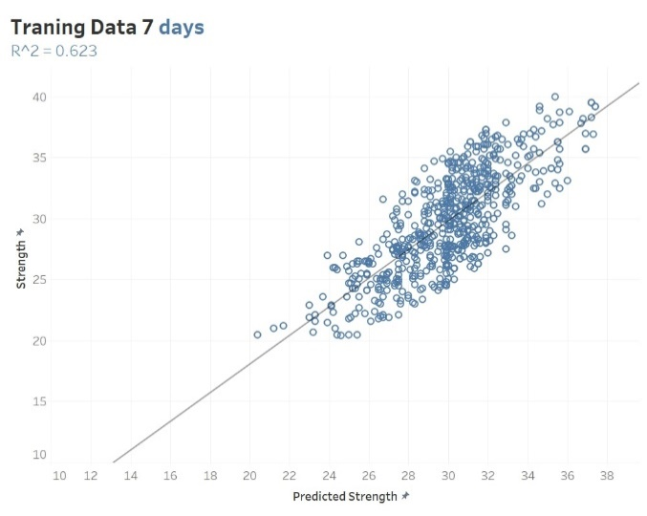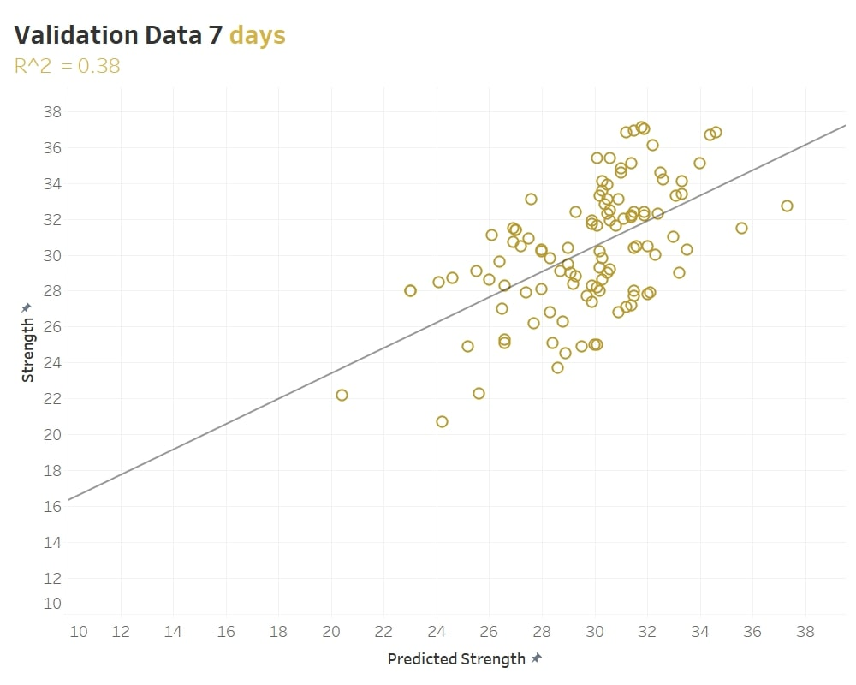

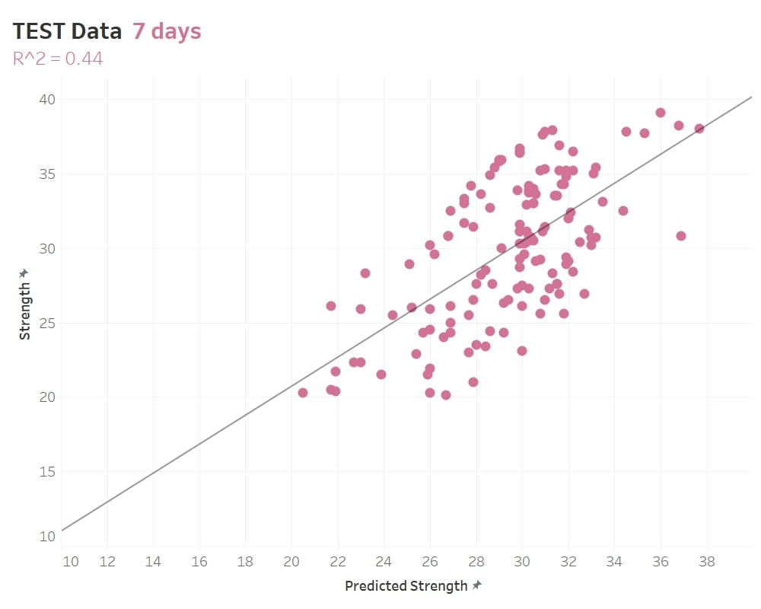

**Figure 1:** Comparison of prediction and actual results of compressive strength after 7 days

## Results of the strength after 28 days:

The 470 samples of predicted strength after 28 days are randomly divided into training (329 samples), validation (71 samples) and test sets (70). The results are shown in Table 3. And the trend line graphs are shown in Figure 2 (training, test, and validation respectively).

|  |  |  |  |  |
| --- | --- | --- | --- | --- |
| Data type | Average error | RMSE | MAPE | R2 |
| Training data | 2.77 | 3.60 | 7.44% | 0.65 |
| Validation data | 3.51 | 4.24 | 9.6% | 0.42 |
| Testing data | 2.84 | 3.66 | 7.16% | 0.62 |

***Table 3:*** *results of prediction of concrete compressive strength after 28 days.*

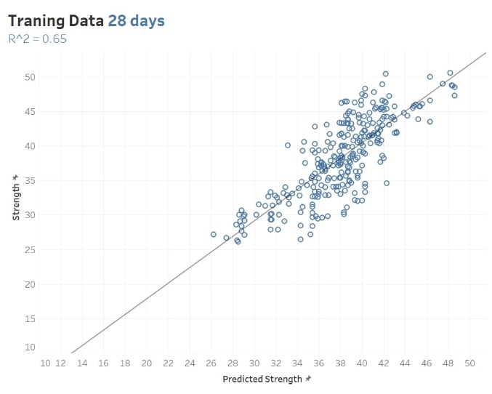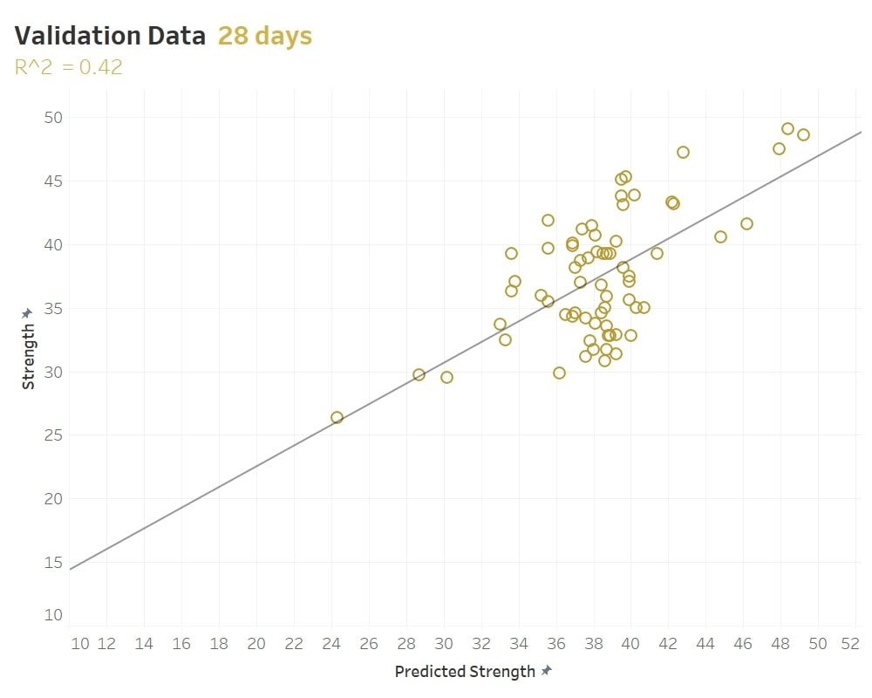

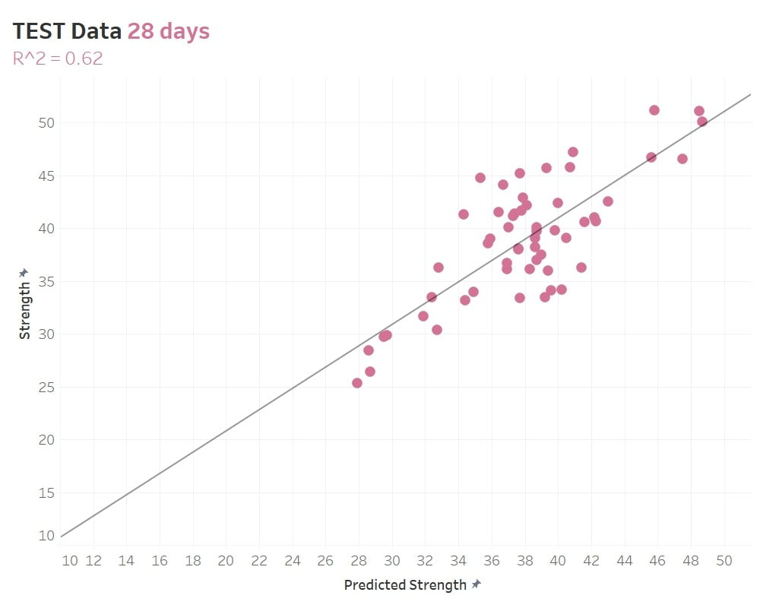

**Figure 2**: Comparison of prediction and actual results of compressive strength after 28 days

## Results of the slump:

The 1066 samples of the predicted slump are divided randomly into training (747 samples), validation (159 samples) and test sets (160). The results are shown in Table 3. Moreover, the trend line graphs are shown in Figure 3 (training, test, and validation respectively).

|  |  |  |  |  |
| --- | --- | --- | --- | --- |
| Data type | Average error | RMSE | MAPE | R2 |
| Training data | 20.4 | 25.7 | 14.8% | 0.6 |
| Validation data | 29.9 | 34.5 | 19.2% | 0.284 |
| Testing data | 28.4 | 35.6 | 22.6% | 0.39 |

***Table 4:*** *results of prediction of a slump.*

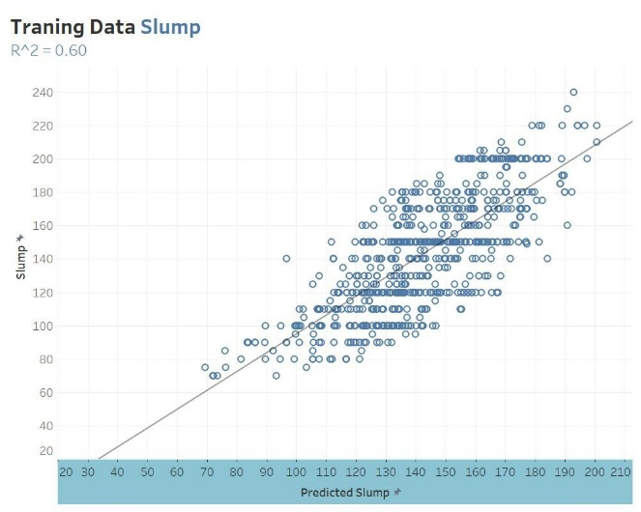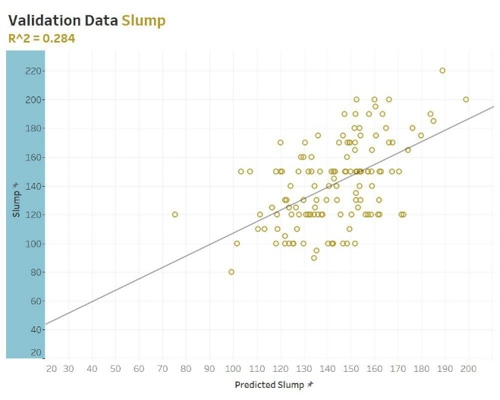

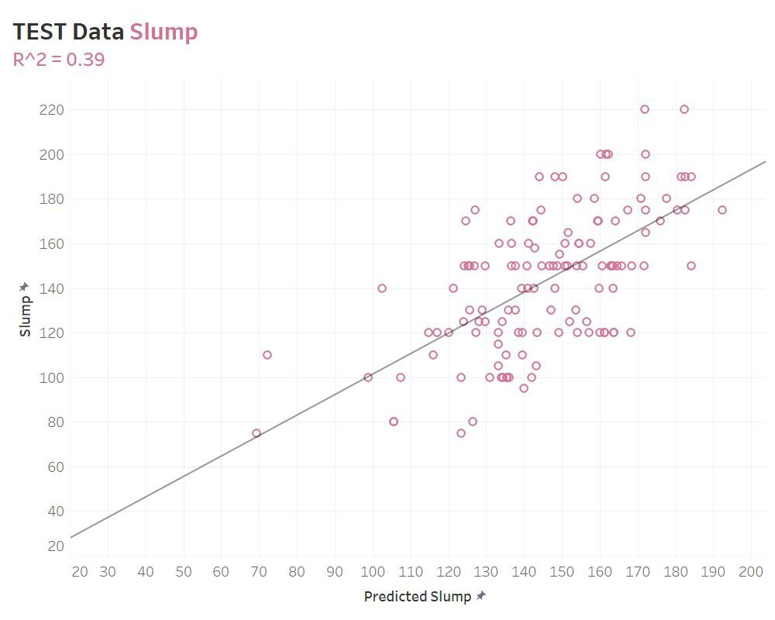

**Figure 3:** Comparison of prediction and actual results of the slump

# CONCLUSION

The results show an average error of less than 5 for the strength after 7 days which is accepted at some level. This research used a small number of samples of 1557 samples from these samples only 1086 samples contained the compressive strength after 7 days, yet an RMSE error of 4.65 was found. Of 470 samples contained the compressive strength after 28 days and got an RMSE error of 3.66 was found. Of 1166 samples containing the slump an RMSE error of 35.6 was found.

The results are acceptable to some extent. And to improve these results collecting more data is recommended (especially these containing compressive strength after 28 days).

# ACKNOWLEDGEMENTS

The authors of this paper would like to thank all the technicians and engineers at the Materials lab of the University of Khartoum, Especially Eng. Abdulrahim. Their efforts and data helped us completing this research.

# LIST OF REFERENCES

Abdelatif A., Shaddad A., Fathallah M., Ibrahim M. and Twfeeq M*.* (2018) “Concrete mix design and aggregate tests data between 2009 and 2017 in Sudan,” *Data in brief*, 21, pp. 146–149. doi:10.1016/J.DIB.2018.09.061.

Badawi, Y.M.H. and Ahmed, Y.H. (2020) “Prediction of Concrete Compressive Strength & Slump using Artificial Neural Networks (ANN),” *FES Journal of Engineering Sciences*, 9(2), pp. 84–89. Available at: http://journal.oiu.edu.sd/index.php/fjes/article/view/682 (Accessed: April 20, 2022).

Basheer, I.A. and Hajmeer, M. (2000) “Artificial neural networks: fundamentals, computing, design, and application,” *Journal of Microbiological Methods*, 43(1), pp. 3–31. doi:10.1016/S0167-7012(00)00201-3.

*CALcrete* (no date). Available at: https://www.concretecentre.com/Resources/Design-tools-and-software/CALcrete.aspx (Accessed: April 25, 2022).

Chollet, F. (2017) *Deep learning with Python*. Second. New York: Manning publications. Available at: https://www.manning.com/books/deep-learning-with-python-second-edition (Accessed: January 1, 2022).

Chopra, P., Sharma, R.K. and Kumar, M. (2016) “Prediction of Compressive Strength of Concrete Using Artificial Neural Network and Genetic Programming,” *Advances in Materials Science and Engineering*, 2016, pp. 1–10. doi:10.1155/2016/7648467.

Ghazanfari N., Gholami S., Emad A., Shekarchi M., Student M. *et al.* (2017) “Evaluation of GMDH and MLP Networks for Prediction of Compressive Strength and Workability of Concrete,” *Bulletin de la Société Royale des Sciences de Liège*, 86, pp. 855–868.

Gupta, S. (2013) “Using Artificial Neural Network to Predict the Compressive Strength of Concrete containing Nano-silica,” *Civil Engineering and Architecture*, 1(3), pp. 96–102. doi:10.13189/cea.2013.010306.

Naderpour, H., Rafiean, A.H. and Fakharian, P. (2018) “Compressive strength prediction of environmentally friendly concrete using artificial neural networks,” *Journal of Building Engineering*, 16, pp. 213–219. doi:10.1016/j.jobe.2018.01.007.

Ni, H.-G. and Wang, J.-Z. (2000) “Prediction of compressive strength of concrete by neural networks,” *Cement and Concrete Research*, 30(8), pp. 1245–1250. doi:10.1016/S0008-8846(00)00345-8.

Singh, D. and Singh, B. (2020) “Investigating the impact of data normalization on classification performance,” *Applied Soft Computing*, 97, p. 105524. doi:10.1016/j.asoc.2019.105524.

Tayfur, G., Erdem, T.K. and Kırca, Ö. (2014) “Strength Prediction of High-Strength Concrete by Fuzzy Logic and Artificial Neural Networks,” *Journal of Materials in Civil Engineering*, 26(11), p. 04014079. doi:10.1061/(ASCE)MT.1943-5533.0000985.