Sequential crises reorder the dominant shortfall in energy systems: counterfactual evidence from ASEAN-6, 2010–2023
Tie Wei¹, Xiao Ying Lai¹
¹ Affiliation to be completed by the authors.
Abstract
Crises test energy systems on three fronts at once: keeping service continuous, keeping prices tolerable, and keeping decarbonisation on schedule. Which front gives way first is difficult to establish from indicator levels, because energy indicators carry secular trends strong enough for a continued trajectory to resemble a crisis effect. This study measures crisis-period performance in six Southeast Asian economies over 2010–2023 as the deviation of an observed outcome from a counterfactual path fitted on pre-crisis data. Energy-service security, macro-price stability, and low-carbon continuity are reported separately. The counterfactual form is matched to each indicator’s data-generating process, since linear extrapolation of bounded or mean-reverting series produces expected values outside the feasible region. Pre-crisis placebo windows and rolling-origin backtests bound every estimate. During the COVID-19 stage no dimension departed measurably from its expected path. During the 2022–2023 compound crisis, macro-price stability fell to −0.767 standard deviations, the only regional estimate whose cross-country interval excludes zero and which is more extreme than every pre-crisis placebo window, while energy-service security (−0.103) and low-carbon continuity (+0.102) remained near their expected paths. Scaled by the forecast error of its own benchmark, the macro-price deviation is the largest of the three (0.86, against 0.54 for service security and 0.23 for low-carbon continuity), and the dominant diagnosed shortfall moved toward prices by 0.887 standard deviations between the two episodes. Within the low-carbon dimension, the carbon content of electricity contributed +0.049 and renewable capacity +0.003. With six countries no gap exceeds its own forecast error, so the estimates are reported as bounded diagnostics. Crisis preparedness in the region can concentrate on price transmission.
Keywords
Energy transition; Crisis resilience; Counterfactual analysis; Macro-price stability; ASEAN; Southeast Asia

1. Introduction
Global energy systems faced two major shocks within three years. COVID-19 reduced energy demand, disrupted supply chains, and strained public finances in 2020–2021. In 2022–2023, pressures shifted as fuel and electricity prices rose sharply, prompting governments to introduce subsidies, tariff caps, and targeted transfers (Zakeri et al. 2022; Guan et al. 2023). Hence, these episodes raise a central question: which dimensions of energy-system performance deviated most from their pre-crisis trajectories under successive shocks?
Existing studies mainly document observed changes during these episodes, including shifts in renewable deployment, emissions, end-user prices, and government responses (Quitzow et al. 2021; Tian et al. 2022; Li et al. 2022; Crnčec et al. 2023). Research on the 2022–2023 price episode also examines household energy burdens in Europe, firm responses in Germany, and implications for decarbonisation in the United Kingdom (Mersch et al. 2023; Jaeger-Erben et al. 2025; Horbach and Rammer 2026). Related work considers whether recovery spending reinforced fossil-fuel dependence or supported clean investment (D’Orazio 2024; Evro et al. 2025). Most of this evidence is based on indicator levels or year-on-year changes.
Interpreting crisis-period changes from observed levels alone is problematic because many energy indicators follow strong secular trends. In fast-growing economies, renewable capacity, electrification, and electricity carbon intensity may change substantially over four years even without a major shock (Nijsse et al. 2023). An observed decline may therefore continue an earlier trend, while an increase may still fall short of the expected trajectory. Composite indices provide limited resolution because they benchmark performance against other countries or an implicit target rather than against each country’s own pre-crisis path (OECD/JRC 2008).
Resilience assessment provides a useful reference framework by evaluating resistance and recovery relative to a system’s pre-disturbance functionality and measuring the magnitude and duration of subsequent deviations (Roege et al. 2014; Jasiūnas et al. 2021; Monie et al. 2025). Recent studies formalise resilience as a four-phase process of preparedness, mitigation, response, and recovery (Zhang et al. 2026), or estimate the amplitude and duration of recession–recovery cycles (Fan et al. 2023). Related energy-security research similarly distinguishes performance under disturbance from average system performance (Schmitz et al. 2025; Zhang et al. 2026b). These approaches, however, generally require sub-annual measures of system functionality or observations covering several completed shock cycles. National energy-transition indicators do not meet these requirements because they are typically reported annually and provide only a short pre-2020 time series. This study therefore retains the principle of evaluating performance against a pre-disturbance reference while adapting the estimation strategy to short annual panels.
Southeast Asia provides a useful setting for examining this question. The six largest ASEAN economies combine rapid growth in energy demand with persistent fossil-fuel dependence and uneven renewable deployment (Aleluia et al. 2022; Bai et al. 2023; Fahim et al. 2023). Their exposure to the 2022–2023 price episode also varied markedly. Singapore imports almost all of its primary energy, whereas Indonesia exports thermal coal, with the other four economies occupying intermediate positions. Regional decarbonisation is further shaped by cross-border transmission and financing arrangements that remain under development (Jindal et al. 2024; Zhong et al. 2025; Kim et al. 2025). At the national level, all six countries use administered pricing mechanisms, including subsidies, tariff caps, and price-smoothing funds (Hu and Weng 2024; Kilinc-Ata and Proskuryakova 2024). These measures can influence the domestic transmission of external energy-price movements, making macro-price stability relevant to crisis-period energy governance.
This study measures crisis-period performance in Indonesia, Malaysia, the Philippines, Singapore, Thailand, and Vietnam over 2010–2023. Performance is expressed as the deviation of an observed outcome from a counterfactual path fitted on 2010–2019 data. Three dimensions are reported separately: energy-service security, macro-price stability, and low-carbon continuity. Reporting these dimensions separately allows differences in their crisis-period trajectories to be examined directly. The counterfactual form is matched to each indicator. Linear extrapolation of a bounded or mean-reverting series yields inadmissible expected values, including electrification above 100 per cent for four economies and negative inflation for three. The procedure is validated with pre-crisis placebo windows and rolling-origin backtests, and every reported magnitude is compared against the forecast error of its own benchmark.
This study makes three contributions. First, it evaluates crisis-period performance against each country’s pre-crisis trajectory, using counterfactual specifications adapted to the statistical properties of individual indicators. Second, it identifies different patterns across the two crisis stages and three outcome dimensions. In 2022–2023, the largest regional shortfall occurred in macro-price stability, whereas energy-service security and low-carbon continuity remained closer to their expected paths. Third, it evaluates each maintenance gap relative to the forecast error of its benchmark. Because none of the regional gaps exceeds the corresponding forecast error and the analysis covers only six countries, the findings are interpreted as descriptive diagnostics rather than causal estimates.
The remainder of the paper is organized as follows. Section 2 reviews research on energy transitions during crises and situates the proposed measurement approach within the literature on composite indices and resilience assessment. Section 3 presents the data, counterfactual specifications, and validation procedures. Section 4 reports the findings, while Section 5 discusses their implications for crisis-period energy governance in Southeast Asia. Section 6 concludes.

2. Literature review
Research on energy transitions under crisis conditions ranges from global analyses of shock transmission to country-level assessments of policy responses. This review first considers the mechanisms through which crises affect transition trajectories and then examines evidence from the COVID-19 and 2022–2023 episodes, with particular attention to Southeast Asia. It also reviews relevant policy and institutional responses and the methods used to assess crisis-period performance.

2.1 Crisis conditions and transition trajectories
Crises affect energy transitions through competing channels. Demand contraction, fiscal strain, and higher financing costs can delay investment, whereas rising fossil-fuel prices may improve the relative competitiveness of renewables and recovery packages may provide funding for clean-energy projects (Zakeri et al. 2022; Hussain et al. 2023). The balance between these effects depends on a country’s fuel mix, import exposure, and fiscal capacity. Shocks may also widen differences between economies because their ability to sustain transition investment varies considerably (Quitzow et al. 2021). Policy priorities provide another channel: when governments respond to affordability pressures, fiscal and administrative resources may shift towards price relief and away from transition programmes (Jaeger-Erben et al. 2025). Therefore, the overall effect is uncertain and likely to differ across countries and crisis episodes.

2.2 Evidence from the COVID-19 and 2022–2023 episodes
Evidence from the pandemic period suggests that low-carbon transitions continued in several major economies. Tian et al. (2022) identify sustained global low-carbon momentum after 2020, while Li et al. (2022) and Xu and Sharma (2022) report continued low-carbon power generation in China and an accelerated shift towards renewables in India, respectively. In Europe, recovery instruments also reshaped the energy-transition agenda (Crnčec et al. 2023). Research on the 2022–2023 price episode focuses more on its distributional, economic, and decarbonisation consequences. Existing studies examine household energy burdens across countries, implications for the United Kingdom’s net-zero pathway, household responses in Europe, and short-term firm adjustments in Germany (Guan et al. 2023; Mersch et al. 2023; Jaeger-Erben et al. 2025; Horbach and Rammer 2026). Whether crisis-related spending supported a green recovery or reinforced fossil-fuel dependence remains contested (D’Orazio 2024; Evro et al. 2025). Overall, this literature relies mainly on indicator levels or year-on-year changes and concentrates on Europe, China, India, and other OECD economies.

2.3 Energy transition and crisis exposure in Southeast Asia
Research on Southeast Asia’s energy transition highlights rapid demand growth, persistent fossil-fuel dependence, and uneven progress in renewable deployment. Existing studies examine the role of government policy in accelerating clean-energy investment, assess regional transition performance using composite measures, and evaluate renewable-energy pathways against carbon-neutrality and 2030 targets (Aleluia et al. 2022; Bai et al. 2023; Fahim et al. 2023; Safrina and Utama 2023). Related work explores the contribution of cross-border transmission to power-sector decarbonisation, projects regional emissions under shared socioeconomic pathways, and examines climate-governance cooperation among ASEAN members (Hu and Weng 2024; Zhong et al. 2025; Kim et al. 2025). Exposure to external energy-price movements nevertheless varies markedly across the region. Singapore imports almost all of its primary energy, whereas Indonesia exports thermal coal, with the other economies occupying intermediate positions. Most studies focus on long-term transition progress under non-crisis conditions, leaving limited evidence on how recent shocks affected the region.

2.4 Policy and institutional responses to crisis-period pressure
All six economies manage domestic energy prices through combinations of fuel subsidies, electricity tariff caps, and price-smoothing funds. These interventions mediate the transmission of external energy-price movements to domestic consumers (Kilinc-Ata and Proskuryakova 2024). Governments also maintained transition-related measures, including electric-vehicle incentives and energy-efficiency programmes, whose regional cost and emissions implications have been assessed separately (al Irsyad et al. 2025; Champeecharoensuk et al. 2025). Financing mechanisms capable of sustaining clean investment during periods of fiscal stress remain incomplete, although just-transition instruments have been proposed for Indonesia, Vietnam, and the Philippines (Jindal et al. 2024). Evidence from Belt and Road economies further suggests that the relationship between energy-transition progress and energy-security risk varies with import structure (Aslam et al. 2024). Existing studies document the policy instruments adopted during crises but provide less evidence on whether their functions corresponded to the dimensions experiencing the greatest pressure.

2.5 Measuring crisis-period performance
Five measurement approaches are relevant to this study. Composite transition indices assess multidimensional country performance using established construction procedures (OECD/JRC 2008). Multidimensional resilience indices instead measure attributes expected to support resilience, such as robustness, redundancy, and diversity (Roege et al. 2014; Jasiūnas et al. 2021). Phase-explicit approaches derive preparedness, mitigation, response, and recovery measures from functionality-degradation curves (Monie et al. 2025; Zhang et al. 2026a), while process-based approaches estimate the amplitude and duration of recession–recovery cycles using regime-switching models (Fan et al. 2023). Panel-econometric studies treat resilience scores as outcomes and examine their covariates across larger samples (Zhao et al. 2025). Related energy-security research similarly distinguishes system performance under disturbance from average performance (Schmitz et al. 2025; Zhang et al. 2026b). Table 1 compares these approaches from a measurement perspective.
Table 1
Measurement-level comparison of approaches to crisis-period energy performance.
Approach | What the number measures | Benchmark | Phase covered | Principal constraint
Composite transition indices (OECD/JRC 2008) | Cross-sectional level of performance and readiness | Other countries in the same year | None; no shock model | A crisis-period change cannot be separated from a country’s own trajectory
Multidimensional resilience indices (Roege et al. 2014; Jasiūnas et al. 2021) | Level of attributes presumed to confer resilience | Implicit; higher is better | Preparedness proxies only | Silent on whether the presumed capacity was drawn on during a shock
Phase-explicit indices (Monie et al. 2025; Zhang et al. 2026a) | Depth and duration of functionality loss and restoration | The system’s own pre-disturbance functionality | All four phases | Requires sub-annual functionality series through a disruption
Process and regime-switching measures (Fan et al. 2023) | Amplitude and period of a recession–recovery cycle | The system’s own normal regime | Response and recovery | Requires several completed shock cycles; dimension-agnostic
Panel-econometric studies (Zhao et al. 2025; Aslam et al. 2024) | Association between a performance score and covariates | Within-unit variation under fixed effects | None; the score enters as a level | Requires cross-sectional degrees of freedom unavailable at N = 6
Counterfactual deviation (this study) | Deviation of observed performance from a fitted pre-crisis path | The country’s own counterfactual, with form matched per indicator | Resistance only | Magnitudes bounded by the forecast error of the estimated benchmark

Notes: The comparison addresses measurement, and not the substantive merit of each tradition. Phase terminology follows Monie et al. (2025).
These approaches differ mainly in their reference points and data requirements. Composite and attribute-based indices compare countries with their peers or with an implicit benchmark, rather than with the path each country might have followed without the disturbance. Phase-explicit and process-based methods use a system’s own pre-disturbance condition as the reference, but generally require higher-frequency data or observations covering completed shock cycles. Such data are rarely available for annual national energy-transition indicators. In addition, uncertainty in the estimated benchmark is seldom reported explicitly, making it difficult to determine whether an observed deviation exceeds normal forecast error.

2.6 Research gaps
Three gaps motivate this study. First, crisis-period energy research generally reports indicator levels or year-on-year changes, although strong secular trends can make the continuation of an existing trajectory appear to be a shock-related change (Nijsse et al. 2023). Second, resilience assessment provides a suitable reference-point framework, but its phase-explicit and process-based methods require higher-frequency or longer time series than those available for national energy-transition indicators. Third, research on Southeast Asia focuses mainly on long-term transition progress under normal conditions, while the COVID-19 and 2022–2023 episodes have been examined primarily in Europe, China, and other OECD economies.
This study addresses these gaps by measuring crisis-period performance as the deviation of an observed outcome from a country-specific benchmark path estimated from pre-crisis data. The counterfactual specification is adapted to the statistical properties of each indicator, avoiding the implausible or out-of-range values that uniform linear extrapolation can produce for bounded and mean-reverting series. Pre-crisis placebo windows and rolling-origin backtests are then used to quantify benchmark uncertainty and evaluate the magnitude of each observed gap. This design identifies which dimensions departed most from their expected paths during each episode and reports each estimate alongside the corresponding forecast uncertainty.

3. Data and methods
This study evaluates crisis-period performance by comparing observed outcomes with country-specific paths estimated from pre-crisis data. Its analytical reference is drawn from resilience assessment, while the estimation strategy is adapted to annual national indicators. This section presents the analytical framework, sample and periodization, outcome measurement, counterfactual specifications, indicator decomposition, policy inventory, and validation procedures.

3.1 Analytical framework
The analysis covers three outcome dimensions: energy-service security, macro-price stability, and low-carbon continuity. Each captures a distinct aspect of crisis-period performance. Energy-service security reflects the maintenance of electricity access and distribution performance. Macro-price stability captures economy-wide inflation pressure, as measured by headline consumer-price inflation. Low-carbon continuity reflects progress in renewable deployment, energy efficiency, and power-sector decarbonisation. The dimensions are reported separately because the same crisis may affect them differently, a pattern that an aggregate index may obscure (Roege et al. 2014; Jasiūnas et al. 2021).
The choice of reference point follows resilience assessment, which evaluates performance relative to a system’s pre-disturbance condition and measures the magnitude of subsequent deviations (Monie et al. 2025; Fan et al. 2023). As the energy indicators often follow strong secular trends, the pre-disturbance benchmark is represented by an extrapolated path (Nijsse et al. 2023). A gap near zero indicates that a country maintained its pre-crisis trajectory, while a negative gap indicates performance below that trajectory and a positive gap indicates performance above it.
The framework is limited to the resistance phase of the resilience process. Assessing recovery and adaptation requires observations after the disturbance has passed, while the panel ends in 2023 with the second episode still unfolding. The analysis therefore measures departures from expected paths during the two crisis stages; post-crisis restoration remains outside its scope (Schmitz et al. 2025).

3.2 Sample, periodisation, and empirical sequence
The study covers Indonesia, Malaysia, the Philippines, Singapore, Thailand, and Vietnam from 2010 to 2023. The balanced panel contains 84 country-year observations and complete data for all eight indicators. These six economies account for most of Southeast Asia’s energy demand and differ substantially in power-system structure, import exposure, income, and renewable deployment (Aleluia et al. 2022; Bai et al. 2023).
The study period is divided into a pre-crisis estimation window (2010–2019), the COVID-19 stage (2020–2021), and the compound-crisis stage (2022–2023). The final stage captures the energy-price episode during an incomplete post-pandemic adjustment, allowing the two stages to be examined as consecutive periods of stress with different dominant transmission channels (Zakeri et al. 2022).
The analysis proceeds in four steps. First, the indicators are standardised using the pooled ASEAN-6 distribution for 2010–2019. Second, country-specific counterfactuals estimated from pre-crisis data generate expected values for 2020–2023. Third, maintenance gaps are calculated as the difference between observed and expected outcomes. Finally, the low-carbon gap is decomposed into indicator contributions and evaluated through placebo, backtest, and sensitivity analyses.

3.3 Outcome measurement and standardisation
Table 2 presents the eight indicators, their directions, and data sources. Energy-service security combines electricity access with transmission and distribution losses. Macro-price stability is measured using headline consumer-price inflation, with the indicator oriented so that higher scores represent lower inflationary pressure. It captures economy-wide price pressure, of which energy prices form only one component. Low-carbon continuity combines renewable energy in final consumption, electricity carbon intensity, primary energy intensity, renewable capacity per capita, and the renewable share of electricity generation. All indicators are obtained from official statistical sources and enter the analysis as raw values, with their directions in the analysis code.
Table 2
Outcome dimensions, indicator definitions, directions, and sources.
Dimension | Indicator and unit | Variable | Direction | Source
Energy-service security | Electric power transmission and distribution losses (% of output) | TDLoss | − | World Bank WDI, EG.ELC.LOSS.ZS
 | Access to electricity (% of population) | AccessElec | + | World Bank WDI, EG.ELC.ACCS.ZS
Macro-price stability | Inflation, consumer prices (annual %) | Inflation | − | World Bank WDI, FP.CPI.TOTL.ZG
Low-carbon continuity | Renewable energy consumption (% of total final energy consumption) | RenTFEC | + | UN SDG 7.2.1, EG_FEC_RNEW
 | Electricity carbon intensity (gCO₂/kWh) | CO2IntElec | − | Ember
 | Primary energy intensity (MJ per constant 2021 PPP GDP) | EnergyIntensity | − | UN SDG 7.3.1, EG_EGY_PRIM
 | Renewable power capacity per capita (W/person) | RenCap | + | IRENA
 | Renewable electricity share (% of generation) | RenElec | + | Ember

Notes: A plus sign indicates that a higher raw value supports the outcome. A minus sign indicates that a higher raw value weakens the outcome and is multiplied by −1 once before standardisation. World Bank (2026); United Nations Statistics Division (2026); Ember (2024); IRENA (2024). Crisis-year observations are used as published, with no interpolation or model-based imputation.
Indicators are standardised on the pooled ASEAN-6 distribution over 2010–2019, a fixed reference of 60 country-year observations for each indicator. For indicator j, country i, and year t:
zᵢⱼₜ = dⱼ (xᵢⱼₜ − μⱼ,pre) / σⱼ,pre (1)
where dⱼ equals +1 for a positive indicator and −1 for a negative one. Holding the reference distribution fixed prevents crisis observations from redefining the benchmark used to evaluate them. The dimension score is the arithmetic mean of its standardised indicators:
Dᵢₖₜ = (1 / Jₖ) Σⱼ∈ₖ zᵢⱼₜ (2)
where Jₖ is the number of indicators in dimension k. Equal weighting within dimensions limits discretionary parameter choices and keeps the contribution accounting in Section 3.5 exact (OECD/JRC 2008). No overall composite index is calculated.

3.4 Counterfactual specification and maintenance gaps
The counterfactual specification is adapted to the statistical characteristics of each indicator. Applying a common functional form to all eight indicators can produce implausible or out-of-range projections. For example, linear extrapolation of the 2010–2019 disinflation trend projects sustained deflation in three economies by 2023, while linear trends in electricity access generate values above 100% for four economies. Table 3 reports the specification selected for each indicator and the empirical feature motivating that choice.
Table 3
Counterfactual specification by indicator.
Indicator | Feature of the series | Counterfactual form | Training window | Basis for the assignment
TDLoss | Secular decline, far from bounds | Linear trend | 2010–2019 | Standard specification for a trending, unconstrained series
AccessElec | Share bounded at 100 per cent | Logit trend | 2010–2019 | Linear extrapolation yields expected access above the physical ceiling for four economies
Inflation | Stationary and mean-reverting | Pre-crisis mean | 2015–2019 | Linear extrapolation implies deflation for three economies; window selected on backtest bias and RMSE
RenTFEC | Secular growth, far from bounds | Linear trend | 2010–2019 | Standard specification for a trending, unconstrained series
CO2IntElec | Secular decline | Linear trend | 2010–2019 | Standard specification for a trending, unconstrained series
EnergyIntensity | Secular decline | Linear trend | 2010–2019 | Standard specification for a trending, unconstrained series
RenCap | Multiplicative growth, about eighteenfold across the panel | Log-linear trend | 2010–2019 | Deployment compounds once established, so growth is proportional and not additive (Nijsse et al. 2023)
RenElec | Secular growth, far from bounds | Linear trend | 2010–2019 | Standard specification for a trending, unconstrained series

Notes: Counterfactuals are fitted on raw indicator values and standardised afterwards using the parameters in Eq. (1). Fitting on standardised scores is equivalent for affine forms alone and is inadmissible for the log and logit forms. An automated feasibility check rejects any specification that produces expected access above 100 per cent, negative renewable capacity, or implied deflation below −1 per cent.
For indicator j in country i, the counterfactual fᵢⱼ is estimated on the training window Tᴿ and evaluated at each crisis year. The standardised indicator gap is:
gᵢⱼₜ = zᵢⱼₜ − dⱼ (fᵢⱼ(t) − μⱼ,pre) / σⱼ,pre (3)
The dimension gap averages the indicator gaps within a dimension, and stage maintenance averages the annual gaps within a two-year crisis stage:
Gᵢₖₛ = (1 / |Tₛ| Jₖ) Σₜ∈Tₛ Σⱼ∈ₖ gᵢⱼₜ (4)
Positive values indicate performance above the counterfactual path and negative values indicate a shortfall. Regional gaps are unweighted country means, giving each economy equal influence. Crisis reordering is the change between stages:
Rᵢₖ = Gᵢₖ,2022–2023 − Gᵢₖ,2020–2021 (5)
This contrast records how the configuration of gaps changed between the two episodes. It does not identify the independent effect of either shock. Regional gaps are reported with Student-t intervals across the six country values (df = 5, t = 2.571), which summarise cross-country dispersion and carry no implication of sampling from a larger population.

3.5 Indicator decomposition and policy-function inventory
The low-carbon gap is decomposed at indicator level using the same counterfactuals. For low-carbon indicator j in stage s:
Cᵢⱼₛ = (1 / |Tₛ| J_LC) Σₜ∈Tₛ gᵢⱼₜ (6)
The five contributions sum exactly to the low-carbon dimension gap, and the reconciliation error is retained as a computational audit. Negative contributions identify drags on maintenance and positive contributions identify offsets.
The policy inventory groups documented annual actions into three functions: price cushioning, targeted support, and transition continuity. Each function is coded by documented presence and summed within a stage, producing counts from zero to two. Sources comprise the IMF policy tracker, the IEA Policies and Measures Database, World Bank records, and national policy documents (International Monetary Fund 2021; International Energy Agency 2024). The counts describe functional coverage. They record presence and carry no information on fiscal scale, duration, targeting quality, or implementation strength, so no association between policy and outcome is estimated.

3.6 Validation design
Seven alternative specifications test whether the results depend on scaling, functional form, training window, or sample composition. Pre-crisis min–max scaling replaces z-scores. A uniform linear form replaces the assignments in Table 3. A five-year training window replaces the ten-year window for every indicator. The counterfactual path is replaced by the 2017–2019 mean and by the 2019 level. Each country is removed in turn, and each low-carbon indicator is removed in turn with the dimension re-estimated under equal weights. Agreement with the main specification is reported as a Pearson correlation and a sign-agreement rate across all thirty-six country-dimension-stage gaps.
Two temporal diagnostics bound the magnitudes. Pre-crisis placebo windows construct two-year pseudo-stages evaluated at the same forecast horizon as the crisis stage they validate, with counterfactuals fitted only on observations preceding each window. Five windows are available at the COVID-19 horizon and three at the compound-crisis horizon, and the comparison uses a one-sided signed rank test. With $k$ windows the smallest attainable p-value is 1/(k + 1), so the design admits 0.167 and 0.250 as its respective floors, and both the p-value and its floor are reported.
Rolling-origin backtests fit counterfactuals at country-level origins from 2014 to 2018 and evaluate horizons of one to four years, with all evaluation years falling inside the pre-crisis window (Tashman 2000). Bias, mean absolute error, and root mean squared error are computed for all three dimensions. Every reported gap is compared against the root mean squared error at the horizon its stage spans, which supplies the scale against which each magnitude is judged. Analysis code and the full data-revision log accompany the paper as a reproducibility package.
Dimensions differ in the number of indicators they average, and a dimension built on one indicator carries more noise than one built on five, since averaging across imperfectly correlated indicators reduces variance. Raw gaps are therefore not directly comparable across dimensions. Each gap is also reported scaled by the root mean squared error of its own dimension at the relevant horizon, as a ratio to RMSE. This ratio places the three dimensions on a common footing and states how large a deviation is relative to what the procedure can resolve for that dimension.

4. Results
All scores are oriented so that higher values indicate stronger maintenance relative to the benchmark. A negative gap indicates that the observed outcome fell below its country-specific pre-crisis counterfactual path, while a positive gap indicates performance above that path. The results are presented in sequence, covering regional changes, cross-country patterns, indicator contributions, policy-function coverage, and validation.

4.1 Sequential crises reordered the regional constraints
The regional results reveal a divergence between low-carbon continuity and short-term price and service pressures. During the COVID-19 stage, the ASEAN-6 mean gaps were −0.077 for energy-service security, +0.120 for macro-price stability, and +0.035 for low-carbon continuity. In 2022–2023, the energy-service gap declined to −0.103 and the macro-price stability gap to −0.767, while the low-carbon gap increased to +0.102.
The change between stages indicates a reordering of regional pressures. From 2020–2021 to 2022–2023, the macro-price stability gap declined by 0.887 standardized units and the energy-service gap by 0.026, while low-carbon continuity increased by 0.067. The compound-crisis stage was therefore characterized by greater macro-price pressure, with the regional low-carbon dimension remaining above its counterfactual path. The macro-price gap is the only regional estimate that combines a descriptive cross-country interval excluding zero with a value below every corresponding pre-crisis placebo window. As the macro-price stability is measured by one indicator and low-carbon continuity averages five, the cross-dimensional magnitudes are also evaluated against each dimension’s forecast error. The absolute gap-to-RMSE ratios are 0.86 for macro-price stability, 0.54 for energy-service security, and 0.23 for low-carbon continuity, confirming that macro-price stability recorded the largest relative deviation.
Table 4
Regional maintenance gaps by crisis stage
Dimension | COVID-19 gap (ratio to RMSE) | 95% CI | Compound-crisis gap (ratio to RMSE) | 95% CI | Stage reordering
Energy-service security | −0.077 (0.65) | [−0.125, −0.029] | −0.103 (0.54) | [−0.330, +0.124] | −0.026
Macro-price stability | +0.120 (0.14) | [−0.308, +0.547] | −0.767 (0.86) | [−1.508, −0.026] | −0.887
Low-carbon continuity | +0.035 (0.14) | [−0.211, +0.281] | +0.102 (0.23) | [−0.382, +0.586] | +0.067

Notes: Values are unweighted ASEAN-6 means of country-level actual-minus-expected gaps; indicator-specific counterfactuals are defined in Table 3. Student-t intervals (df = 5) describe cross-country dispersion. Stage reordering equals the compound-crisis gap minus the COVID-19 gap. Parentheses report the absolute gap-to-RMSE ratio, which supports comparison across dimensions with different numbers of indicators.
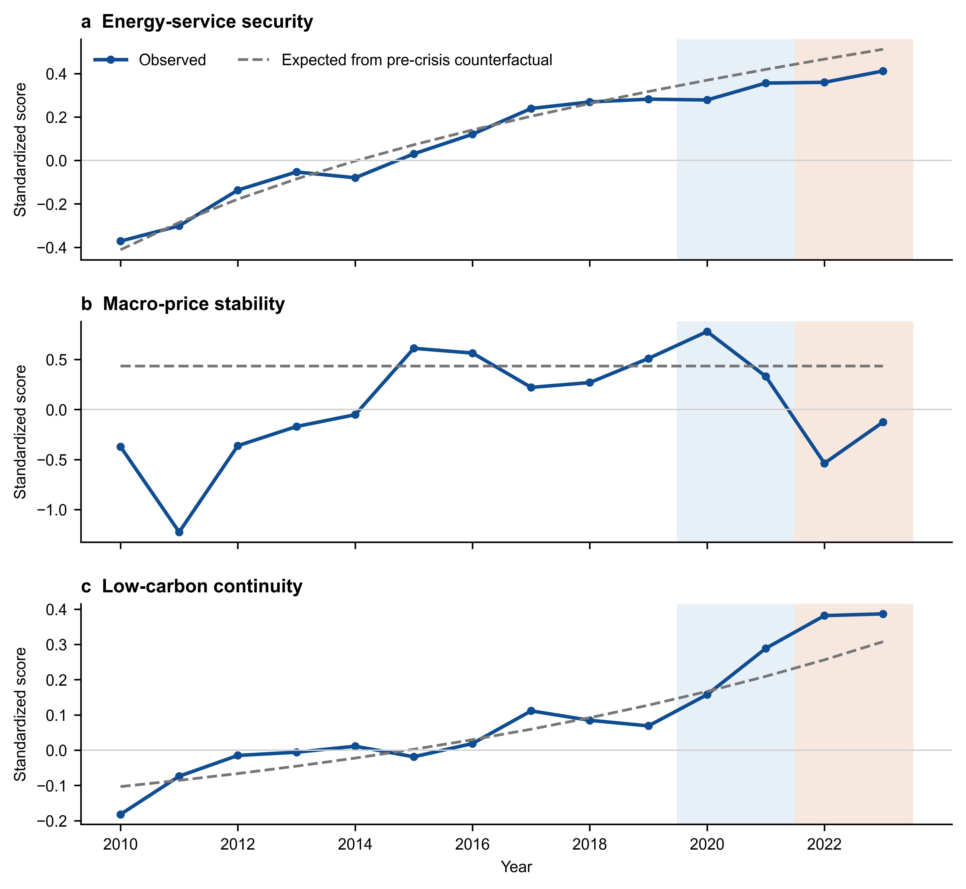
Fig. 1. Observed outcomes and pre-crisis counterfactual trajectories, 2010–2023.
Notes: Solid lines show annual ASEAN-6 means of observed dimension scores. Dashed lines show means of country-specific expected values from the indicator-specific counterfactuals. Vertical shading separates the COVID-19 and compound-crisis stages. Higher scores indicate stronger maintenance.

4.2 Country gaps reveal common price stress and heterogeneous low-carbon paths
The compound-crisis pattern was strongest for macro-price stability. Five countries recorded negative gaps: Singapore (−1.816), the Philippines (−1.150), Thailand (−1.117), Malaysia (−0.342), and Vietnam (−0.194). Indonesia remained close to its counterfactual at +0.016. The distribution shows a common regional pressure with meaningful national differences.
Energy-service security was below its counterfactual in five countries. The Philippines recorded the largest gap (−0.445), followed by Vietnam (−0.232), Singapore (−0.109), Thailand (−0.018), and Malaysia (−0.002). Indonesia remained above its path at +0.185. The result separates a regional mean shortfall from heterogeneous country exposure.
Low-carbon continuity followed a different pattern. Vietnam (+0.851), Singapore (+0.246), Indonesia (+0.145), and the Philippines (+0.107) remained above their expected paths. Malaysia (−0.507) and Thailand (−0.230) fell below them. The positive regional mean therefore reflects a mixed national configuration, not a uniform country response.
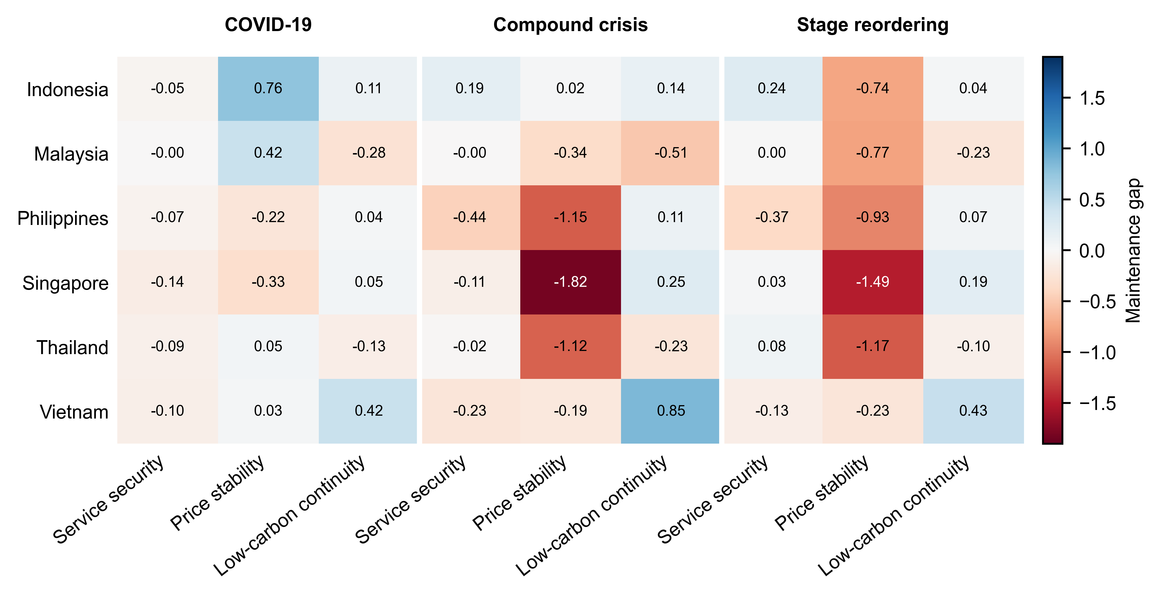
Fig. 2. Country- and dimension-specific maintenance gaps and stage reordering.
Notes: Cells report stage-average actual-minus-expected gaps. Blue values indicate performance above the pre-crisis trend; red values indicate shortfalls. Reordering is the compound-crisis gap minus the COVID-19 gap.

4.3 Cleaner electricity, not capacity growth, accounts for the regional low-carbon gap
The indicator decomposition explains why low-carbon continuity remained positive. During 2020–2021, renewable capacity per capita contributed +0.025 to the regional gap. Renewables in final energy (+0.022), renewable electricity (+0.011), and electricity carbon intensity (+0.007) added further offsets. Energy intensity contributed −0.030, leaving a net gap of +0.035.
The 2022–2023 composition was broader. Electricity carbon intensity (+0.049), renewables in final energy (+0.039), and renewable electricity (+0.038) supported maintenance. Renewable capacity per capita added only +0.003, while energy intensity was the only regional drag (−0.027). These five terms reconcile to the +0.102 low-carbon gap with zero computational error at machine precision.
Table 5
Indicator contributions to the regional low-carbon maintenance gap
Indicator | COVID-19 | Compound crisis | Role in 2022–2023
Renewables in final energy | +0.022 | +0.039 | Positive offset
Electricity carbon intensity | +0.007 | +0.049 | Positive offset
Energy intensity | −0.030 | −0.027 | Regional drag
Renewable capacity per capita | +0.025 | +0.003 | Small offset
Renewable electricity share | +0.011 | +0.038 | Positive offset
Net low-carbon gap | +0.035 | +0.102 | Exact sum

Notes: Each contribution equals the stage mean of the raw-indicator actual-minus-expected gap after standardization, divided by five. Positive carbon-intensity contributions indicate that emissions intensity was lower than its expected path after direction adjustment.
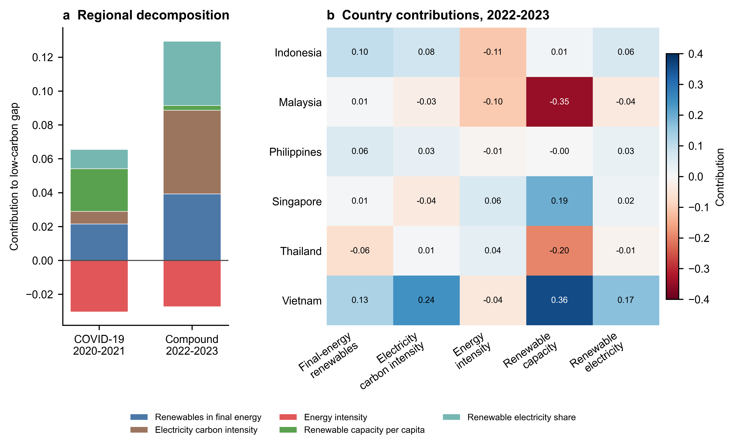
Fig. 3. Indicator-level decomposition of low-carbon maintenance.
Notes: Panel a reports regional contributions in both crisis stages. Panel b reports country contributions during 2022–2023. Contributions sum to the corresponding low-carbon gap. Positive values are offsets; negative values are drags.

4.4 National low-carbon configurations differed in source and scale
The same regional balance arose from distinct national configurations. Vietnam's +0.851 gap was anchored by renewable capacity (+0.358), electricity carbon-intensity improvement (+0.243), and renewable electricity (+0.166), while energy intensity provided its largest drag (−0.041). Singapore also relied on renewable capacity (+0.194), with a small negative contribution from electricity carbon intensity (−0.039).
Indonesia and the Philippines recorded smaller positive gaps. Renewables in final energy provided the largest positive contribution in both countries, while energy intensity was the main negative term. Malaysia's −0.507 gap was dominated by weak renewable-capacity performance (−0.348) and additional negative contributions from energy intensity, renewable electricity, and electricity carbon intensity. Thailand faced a renewable-capacity drag (−0.197), with positive energy-intensity and carbon-intensity contributions unable to offset it.
Table 6
Country configurations of the 2022–2023 low-carbon maintenance gap
Country | Net gap | Largest negative term | Contribution | Largest positive term | Contribution
Indonesia | +0.145 | Energy intensity | −0.109 | Renewables in final energy | +0.099
Malaysia | −0.507 | Renewable capacity per capita | −0.348 | Renewables in final energy | +0.009
Philippines | +0.107 | Energy intensity | −0.011 | Renewables in final energy | +0.057
Singapore | +0.246 | Electricity carbon intensity | −0.039 | Renewable capacity per capita | +0.194
Thailand | −0.230 | Renewable capacity per capita | −0.197 | Energy intensity | +0.039
Vietnam | +0.851 | Energy intensity | −0.041 | Renewable capacity per capita | +0.358

Notes: Largest terms refer to indicator contributions within each country's low-carbon dimension. They identify the dominant observed component and do not constitute an intrinsic country ranking.

4.5 Policy inventories show overlapping functions, not estimated effects
The 2022–2023 policy inventory shows broad functional coverage. Five countries recorded at least one price-cushioning action; Singapore recorded none in the coding window. All six recorded targeted support and transition-continuity actions. Indonesia and Malaysia covered all three functions in both years. Coverage was less continuous in the Philippines, Thailand, and Vietnam.
Macro-price stability was the largest shortfall in four countries during 2022–2023. Malaysia's largest shortfall was low-carbon continuity, Vietnam's was energy-service security, and Indonesia had no negative dimension gap in that stage. Policy presence therefore coincided with heterogeneous pressure points, but the counts do not reveal effectiveness, scale, targeting quality, or fiscal cost. The inventory is used only to describe how policy functions overlapped with the diagnosed constraints.
Table 7
Policy-function coverage and largest observed gap, 2022–2023
Country | Price cushioning | Targeted support | Transition continuity | Largest observed gap
Indonesia | 2 | 2 | 2 | None; all dimension gaps positive
Malaysia | 2 | 2 | 2 | Low-carbon continuity (−0.507)
Philippines | 2 | 2 | 1 | Macro-price stability (−1.150)
Singapore | 0 | 2 | 2 | Macro-price stability (−1.816)
Thailand | 2 | 1 | 1 | Macro-price stability (−1.117)
Vietnam | 1 | 1 | 2 | Energy-service security (−0.232)

Notes: Counts range from zero to two and indicate the number of years within the stage in which a documented action was present. The values do not measure policy intensity or causal impact.

4.6 Robustness checks retain the regional direction but bound its magnitude
The positive regional low-carbon direction survives alternative scaling, baseline choices, and leave-one-indicator-out checks. Min–max scaling produces +0.030 and a 0.955 Pearson correlation with the main gaps. A shorter 2015–2019 trend produces +0.170, with Pearson r = 0.964 and an 88.9% sign agreement across country-dimension gaps.
Level baselines also remain positive at regional level. The 2017–2019 mean yields +0.296 and the 2019 level yields +0.315, but their country sign agreement is 50.0% and 66.7%. Country composition is consequential: leave-one-country-out estimates range from −0.048 to +0.224, with the sign reversing when Vietnam is omitted. Removing one low-carbon indicator at a time yields +0.066 to +0.162. The regional positive result is robust to indicator omission but sensitive to country composition.
Table 8
Sensitivity of the 2022–2023 regional low-carbon maintenance gap
Check | Diagnostic | Regional gap | Interpretive boundary
Main specification | Indicator-specific counterfactuals | +0.102 | Reference
Pre-crisis min–max scaling | Pearson r = 0.955; sign match = 100% | +0.030 | Direction retained
Trend window 2015–2019 | Pearson r = 0.964; sign match = 88.9% | +0.170 | Magnitude changes
2017–2019 mean | Country low-carbon sign match = 50.0% | +0.296 | Country classification sensitive
2019 level | Country low-carbon sign match = 66.7% | +0.315 | Country classification sensitive
Leave one country out | Range across six exclusions | −0.048 to +0.224 | Vietnam omission reverses sign
Leave one indicator out | Range across five exclusions | +0.066 to +0.162 | Direction retained

Notes: Correlations and sign-match rates compare alternative and main actual-minus-expected gaps. Leave-one-out ranges refer to the regional low-carbon gap during 2022–2023.
Horizon-matched placebo windows were estimated for all three dimensions. COVID-19 placebos use a one-year first horizon; compound-crisis placebos use a three-year first horizon. Three windows are retained for each stage, so the rank p-value floor is 1/(3+1) = 0.250. These checks are descriptive and do not supply conventional inference.
Rolling-origin backtests cover all three dimensions and horizons from one to four years. Macro-price stability has positive bias that grows from +0.435 to +0.728, while low-carbon continuity has negative bias from −0.063 to −0.214. RMSE also rises with horizon, reaching 0.970 for macro-price stability and 0.554 for low-carbon continuity at four years. The diagnostics bound magnitude claims and reinforce the interpretation of the gaps as descriptive maintenance measures. Measured against the rolling-origin forecast error at the corresponding horizon, no regional gap exceeds its own uncertainty: the compound-stage macro-price gap reaches 0.86 of its RMSE, the low-carbon gap 0.23. Magnitudes are therefore reported as bounded diagnostics.
Table 9
Pre-crisis placebo gaps and rolling-origin forecast errors
Diagnostic | Dimension and stage | Window / horizon | Range, bias and MAE | p-value / RMSE
Placebo | Energy-service security; COVID-19 | 2016–2018 | −0.026 to +0.044 | p = 0.250; floor 0.250
Placebo | Energy-service security; compound | 2016–2018 | −0.106 to +0.046 | p = 0.500; floor 0.250
Placebo | Macro-price stability; COVID-19 | 2016–2018 | +0.127 to +0.632 | p = 1.000; floor 0.250
Placebo | Macro-price stability; compound | 2016–2018 | +0.630 to +0.925 | p = 0.250; floor 0.250
Placebo | Low-carbon continuity; COVID-19 | 2016–2018 | −0.091 to −0.021 | p = 0.250; floor 0.250
Placebo | Low-carbon continuity; compound | 2016–2018 | −0.227 to −0.155 | p = 0.250; floor 0.250
Backtest | Energy-service security | h = 1 | +0.002; MAE 0.074 | RMSE 0.099
Backtest | Energy-service security | h = 2 | +0.015; MAE 0.108 | RMSE 0.137
Backtest | Energy-service security | h = 3 | +0.029; MAE 0.142 | RMSE 0.173
Backtest | Energy-service security | h = 4 | +0.013; MAE 0.175 | RMSE 0.213
Backtest | Macro-price stability | h = 1 | +0.435; MAE 0.594 | RMSE 0.860
Backtest | Macro-price stability | h = 2 | +0.472; MAE 0.605 | RMSE 0.802
Backtest | Macro-price stability | h = 3 | +0.520; MAE 0.673 | RMSE 0.812
Backtest | Macro-price stability | h = 4 | +0.728; MAE 0.827 | RMSE 0.970
Backtest | Low-carbon continuity | h = 1 | −0.063; MAE 0.125 | RMSE 0.208
Backtest | Low-carbon continuity | h = 2 | −0.088; MAE 0.180 | RMSE 0.281
Backtest | Low-carbon continuity | h = 3 | −0.122; MAE 0.246 | RMSE 0.348
Backtest | Low-carbon continuity | h = 4 | −0.214; MAE 0.377 | RMSE 0.554

Notes: Placebo values are regional six-country means. The p-value is the one-sided rank statistic in the observed direction and the floor is 1/(k+1). Backtests use country-level rolling origins from 2014 to 2018 and evaluate only pre-crisis observations. MAE is mean absolute error; RMSE is root mean squared error.
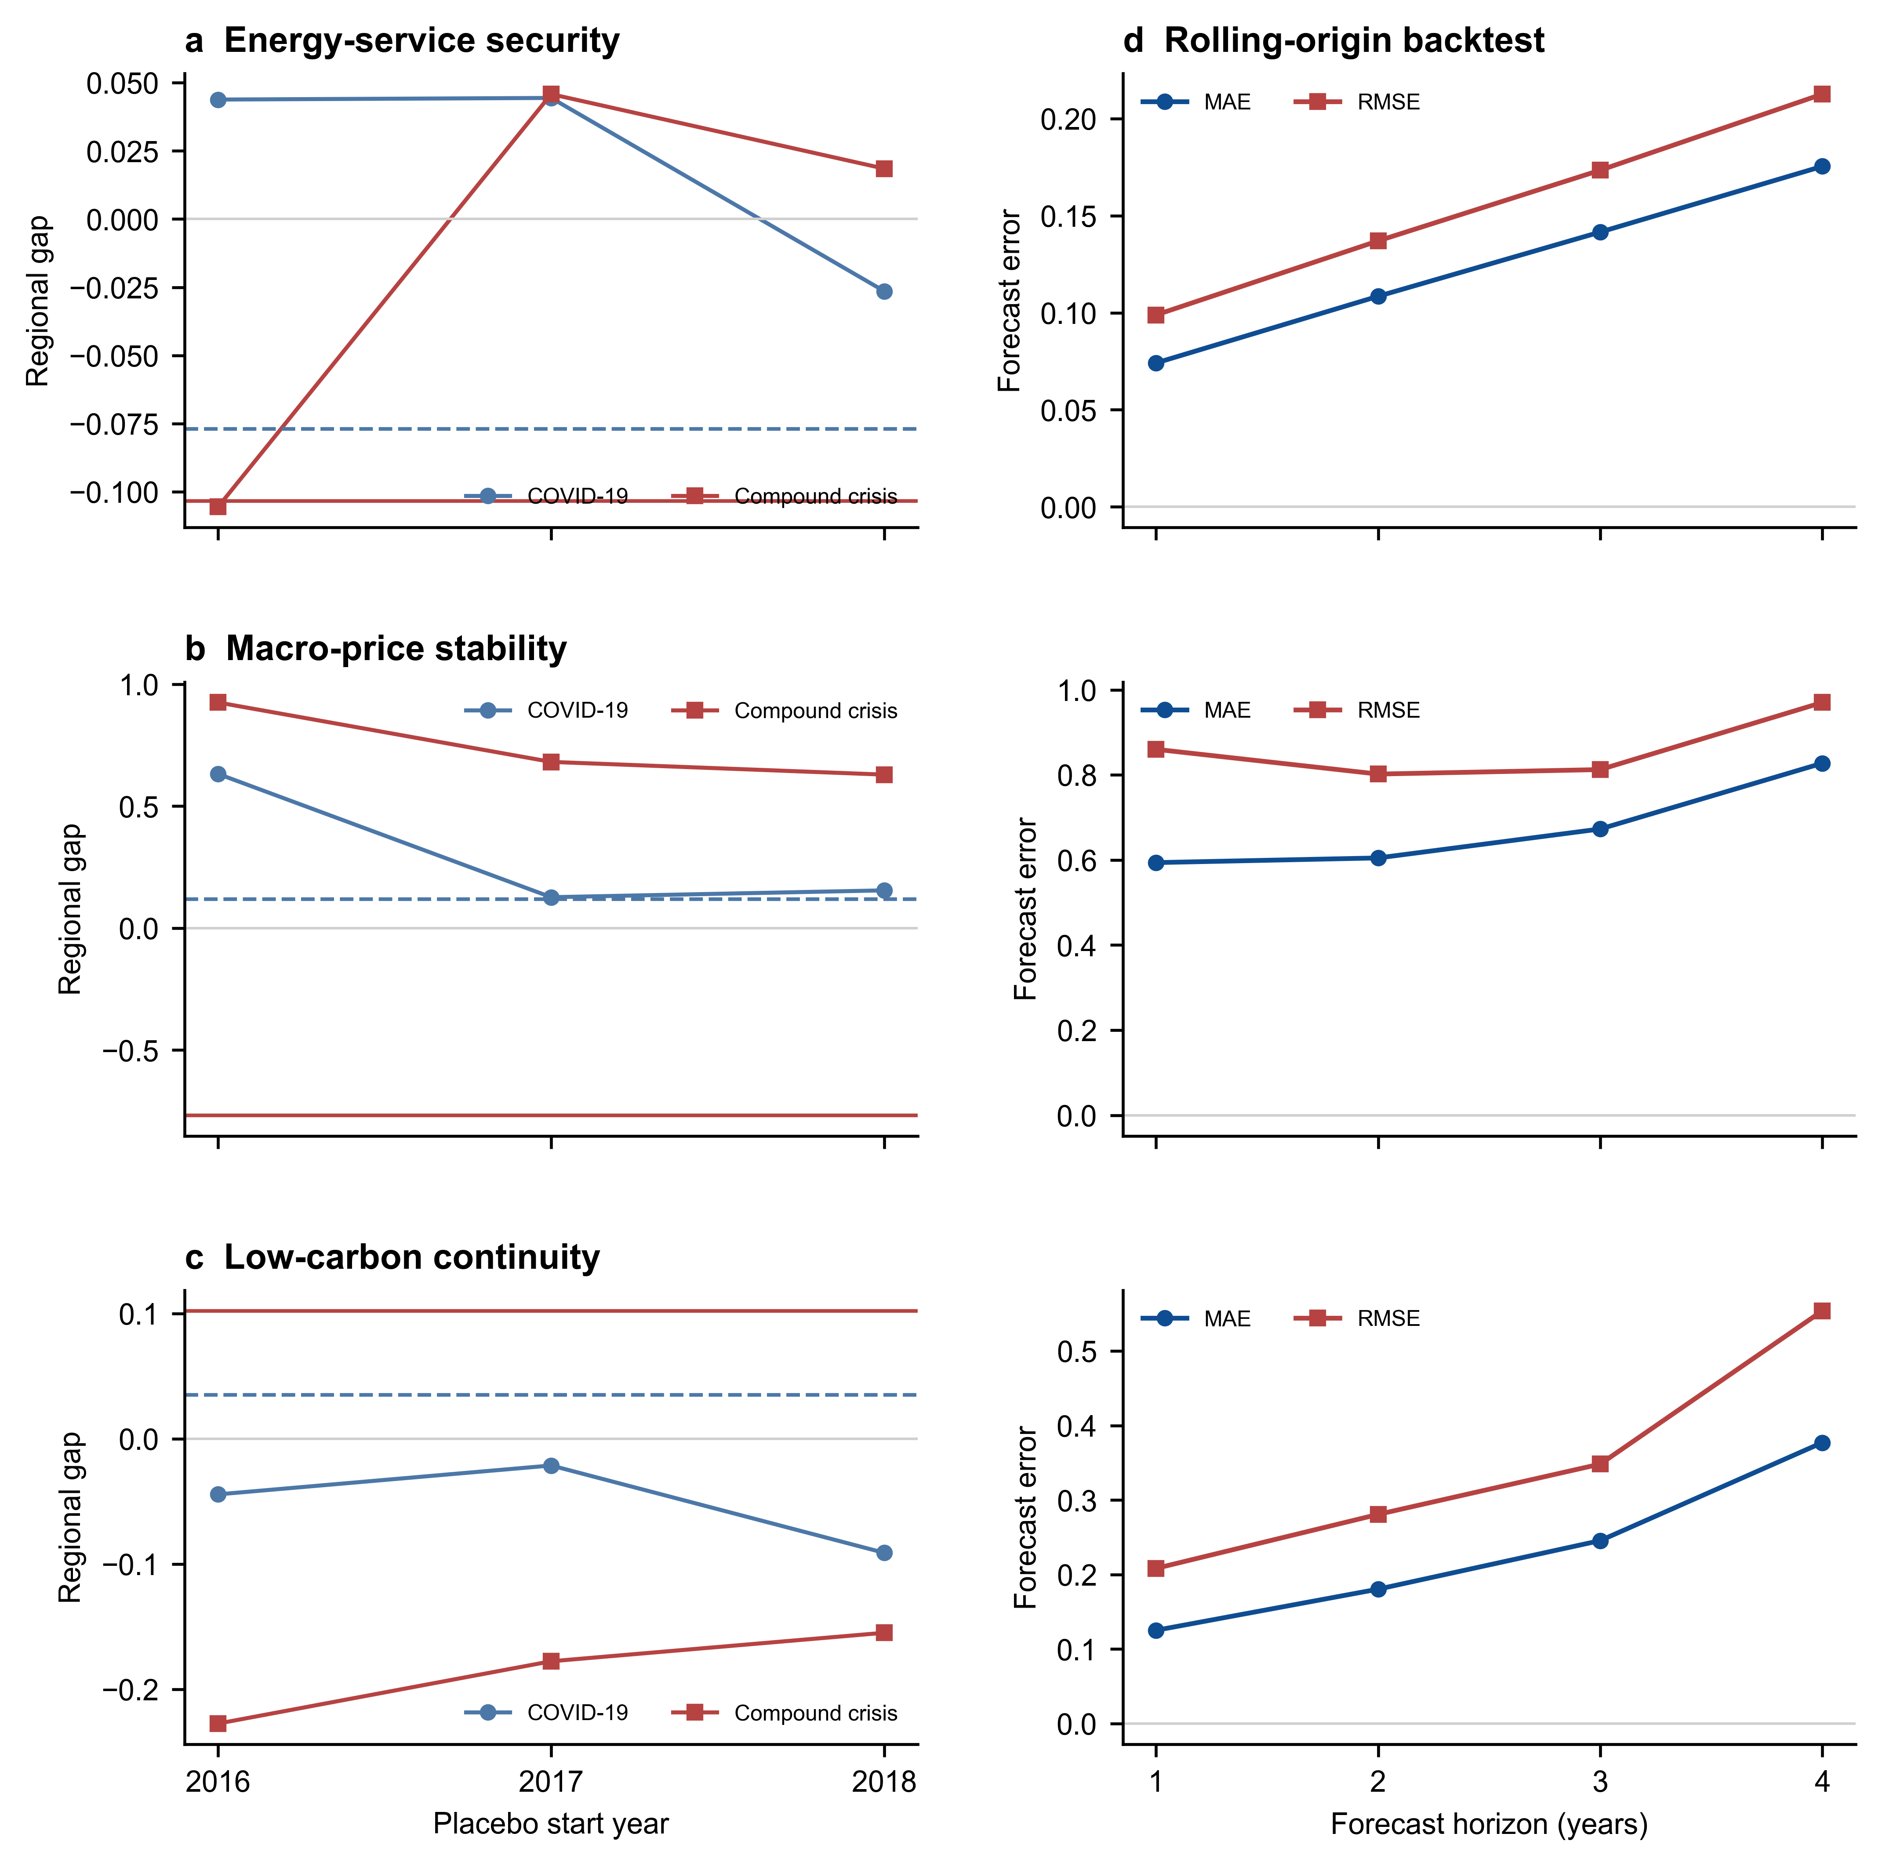
Fig. 4. Horizon-matched placebo gaps and rolling-origin backtest errors across the three dimensions.
Notes: Panel a reports regional placebo windows for energy-service security, macro-price stability, and low-carbon continuity. Panel b reports MAE and RMSE by forecast horizon for all three dimensions. The diagnostics evaluate temporal specificity and forecast uncertainty; they do not supply causal inference.

4.7 Results synthesis
Across the ASEAN-6, consecutive crises shifted the main constraint toward price and service pressure. Low-carbon performance remained above its counterfactual at the regional level, supported by cleaner electricity and renewable-energy indicators, while Malaysia and Thailand fell below their country-specific paths.
Country dispersion, the Vietnam sensitivity, and forecast uncertainty support a function-specific conclusion: selected low-carbon assets continued to advance amid intensifying economy-wide price and service stress, but the regional magnitude is not invariant to country composition. Section 5 examines the mechanisms and policy implications of this configuration.

5. Discussion and policy implications
The results place the two crisis episodes on different margins. Energy-service security and low-carbon continuity stayed within the forecast error of their pre-crisis paths in both stages. Macro-price stability moved by −0.887 standard deviations between them, and the compound-stage shortfall of −0.767 is the only regional estimate whose cross-country interval excludes zero and which exceeds every pre-crisis placebo window in the observed direction. Crisis governance in the ASEAN-6 was therefore tested on prices while supply and decarbonisation held. The implications below follow from that asymmetry.

5.1 A price margin, not a supply or transition margin
The COVID-19 stage produced no measurable regional shortfall in any of the three dimensions. This is consistent with evidence that low-carbon generation held through the pandemic in large systems, and that pandemic-period divergence appeared mainly in investment and recovery spending (Quitzow et al. 2021; Tian et al. 2022; Li et al. 2022). The 2022–2023 stage differs in kind. Economy-wide prices rose across the region while energy costs were mediated by administered channels in all six economies, so the measured gap records general price pressure under a domestic buffer placed in front of imported energy costs. The measure is the headline consumer-price index and carries no direct reading of household energy burdens, which require end-use price data (Guan et al. 2023; Jaeger-Erben et al. 2025).
Country dispersion supports this reading. Singapore recorded −1.816, the largest shortfall in the panel, and imports almost all of its primary energy with no fuel subsidy regime. Indonesia recorded +0.016 while operating an extensive administered-price system and exporting thermal coal. The Philippines (−1.150) and Thailand (−1.117) sit between these poles. The spread of 1.83 standard deviations across six economies facing a common global shock indicates that national price structures shaped the outcome as much as the shock itself (Zakeri et al. 2022; Hussain et al. 2023).
The second half of the finding carries equal weight. Electricity reached consumers and decarbonisation advanced while price pressure peaked. Scaled by the forecast error of its own dimension, the macro-price deviation reaches 0.86 against 0.54 for service security and 0.23 for low-carbon continuity, so the ranking holds once the three dimensions are placed on a common footing. Crisis preparedness in this region can therefore concentrate on price transmission, with supply adequacy and transition continuity treated as conditions that held under two consecutive shocks (Schmitz et al. 2025).

5.2 Legislate price-support triggers, targeting rules, and exit conditions in advance
Price-cushioning measures were documented in five of six economies during 2022–2023 and were absent only in Singapore under the coding rules applied here. The inventory reveals no ordering between the number of years a country deployed cushioning and the size of its price shortfall: Thailand and the Philippines recorded cushioning in both years alongside gaps near −1.1, while Vietnam recorded one year and a gap of −0.194. Presence of an instrument therefore says little about its performance, and the design of the instrument becomes the operative variable (Jaeger-Erben et al. 2025). Governments can replace episodic announcements with support that activates on a published price threshold, targets transfers at verified low-income households, declares its fiscal envelope on activation, and carries a legislated sunset date. Pre-committed rules of this kind shorten the announcement lag, cap open-ended liabilities, and preserve the scarcity signal that fuel prices transmit to consumption and investment (Guan et al. 2023; Horbach and Rammer 2026).

5.3 Protect the dispatch-side levers that carried low-carbon performance
The decomposition assigns the regional low-carbon position to the composition of electricity supply. Electricity carbon intensity contributed +0.049, renewables in final energy +0.039, and the renewable electricity share +0.038, while renewable capacity per capita contributed +0.003. Capacity additions during 2022–2023 tracked the growth rates that pre-crisis expansion already implied, which is consistent with evidence that solar deployment develops its own momentum once established (Nijsse et al. 2023). Crisis-period policy adds little at the capacity margin inside a two-year window, and this qualifies the green-recovery framing applied to the same period elsewhere (D’Orazio 2024; Evro et al. 2025). Instruments acting on dispatch and system operation deserve priority under fiscal stress: grid flexibility investment, curtailment reduction, scheduled coal ramp-down, and cross-border electricity trade all shift the carbon content of delivered power on shorter lead times than new build (Zhong et al. 2025; Kilinc-Ata and Proskuryakova 2024).

5.4 Treat the pre-crisis project pipeline as a crisis instrument
Vietnam recorded a low-carbon gap of +0.851, the largest in the panel, and removing Vietnam reverses the sign of the regional result. Its renewable capacity rose from 268 to 391 watts per capita between 2019 and 2020, delivering commitments made under the 2017–2019 feed-in tariff programme. What an economy builds during a crisis is largely what it financed and permitted before one. Resilience frameworks place preparedness ahead of response for this reason, and the ASEAN evidence gives that sequence an empirical form (Roege et al. 2014; Monie et al. 2025). Depth of the permitted and financed pipeline therefore functions as a preparedness measure. Sustaining it requires financing arrangements that survive fiscal consolidation, including blended-finance vehicles and just-transition instruments designed for the region (Jindal et al. 2024; Fahim et al. 2023).

5.5 Close the remaining electrification gap
Service-side shortfalls concentrated in the two economies that had yet to complete electrification. The Philippines recorded −0.445 and Vietnam −0.232, while Indonesia recorded +0.185 and the economies already at full access recorded gaps between −0.002 and −0.109. The service vulnerability in the ASEAN-6 sits in the final stretch of access and in distribution losses, and not in the reliability of systems that already serve their populations. Access and loss-reduction budgets merit ring-fencing from crisis-period reallocation, since these programmes serve the households with the least capacity to absorb either a price increase or a service interruption (Aleluia et al. 2022; Safrina and Utama 2023).

5.6 Monitor deviations from national trajectories, with uncertainty reported
Level-based baselines reproduce the sign of the main specification in only 50.0 and 66.7 per cent of country-dimension cells, so the choice of benchmark determines the diagnosis at country level. Regional monitoring that reports levels alone will misclassify countries during the next shock. ASEAN energy cooperation already collects the annual series this study uses, and reporting each indicator against a national trajectory, with the forecast error of that trajectory published alongside, would add diagnostic value at low cost (Bai et al. 2023; Hu and Weng 2024). The same reporting convention allows member states to distinguish a crisis effect from the continuation of a pre-existing path, which is the distinction that determines whether an emergency response is warranted (Kim et al. 2025).

5.7 Limitations
Four limits bound these implications. The panel contains six countries, and no regional gap exceeds the forecast error of its own benchmark; the placebo design admits a minimum p-value of 0.250 at the compound-crisis horizon. The policy inventory records the documented presence of an instrument and carries no information on fiscal scale, coverage, duration, targeting quality, or implementation strength, so no association between policy and outcome is estimated. The macro-price dimension rests on the headline consumer-price index, which measures economy-wide price pressure and is not energy-specific; an end-use electricity or fuel price series would be needed to speak to household energy costs. The panel ends in 2023, which places the recovery phase outside the observation window and confines the analysis to the resistance phase of the resilience process (Jasiūnas et al. 2021; Fan et al. 2023).
In summary, the ASEAN-6 met two consecutive shocks with intact supply and continuing decarbonisation, and absorbed the pressure on prices. Pre-committed and targeted price support, dispatch-side decarbonisation levers, a deep project pipeline maintained before a shock arrives, protected electrification budgets, and trajectory-based monitoring form five practical responses to that pattern. Each is grounded in a measured deviation from a national path and bounded by the uncertainty of that measurement. Reading crisis performance against what a country was already on course to achieve gives energy policy in the region a diagnosis it can act on when the next shock arrives.

6. Conclusion
This study measured crisis-period performance in six Southeast Asian economies between 2010 and 2023 as the deviation of an observed outcome from the path each country was already on. Three dimensions were reported separately, and the counterfactual form was matched to each indicator’s data-generating process. The COVID-19 stage produced no measurable regional shortfall: energy-service security recorded −0.077, macro-price stability +0.120, and low-carbon continuity +0.035, each smaller than the forecast error of its own benchmark. The compound crisis of 2022–2023 differed on one margin. Macro-price stability fell to −0.767, the single regional estimate whose cross-country interval excludes zero and which is more negative than every pre-crisis placebo window, while energy-service security (−0.103) and low-carbon continuity (+0.102) stayed near their expected paths. The dominant diagnosed shortfall moved toward prices by 0.887 standard deviations between the two episodes, and scaling each gap by the forecast error of its own dimension preserves that ranking (0.86 for macro-price, 0.54 for service security, 0.23 for low-carbon continuity). Within the low-carbon dimension, the carbon content of electricity contributed +0.049 and renewable capacity +0.003, which places the regional position with the composition of supply and not with capacity additions beyond trend. Price-cushioning measures appeared in five of six economies, and their documented presence carried no ordering with the size of the price shortfall. Two consecutive shocks therefore tested these systems on economy-wide price stability while supply and decarbonisation held, and crisis preparedness in the region can concentrate on price transmission, targeted support, and the depth of the project pipeline maintained before a shock arrives (Zakeri et al. 2022; Guan et al. 2023).
Several limitations bound these conclusions and mark the directions worth pursuing. First, the panel contains six countries observed annually, and no regional gap exceeds the forecast error of its own benchmark; the highest ratio reaches 0.86, and the placebo design admits a minimum p-value of 0.250 at the compound-crisis horizon. Conventional hypothesis testing is unavailable at this sample size, and the estimates are read as bounded diagnostics. Second, the macro-price dimension rests on the headline consumer-price index, which measures economy-wide price pressure and is not energy-specific; an end-use electricity or fuel price series would be needed to speak to household energy costs and would sharpen the dimension carrying the principal finding (Guan et al. 2023; Hussain et al. 2023). Methodologically, each counterfactual is a parametric form estimated on ten pre-crisis observations, so a structural break before 2020 would propagate into the expected path; hierarchical or Bayesian pooling across countries offers one route to borrowing strength without imposing a common trajectory. Additionally, national aggregates conceal sub-national and household heterogeneity, which leaves the distributional incidence of price pressure outside the analysis. From a policy-measurement standpoint, the inventory records the documented presence of an instrument and carries no information on fiscal scale, coverage, duration, or targeting quality; combining budget-execution data with the inventory would allow the design of an instrument to be examined alongside its existence. Finally, the panel ends in 2023, which confines the analysis to the resistance phase and leaves recovery and adaptation unobserved (Monie et al. 2025; Fan et al. 2023). Overall, future research should combine energy-specific price series, longer post-crisis observations, budget-level policy data, and pooled estimation across a wider set of economies to deliver a fuller account of how energy systems in Southeast Asia and comparable regions absorb consecutive shocks (Hu and Weng 2024; Kim et al. 2025).

Declarations
Author contributions Tie Wei: conceptualisation, funding acquisition, supervision. Xiao Ying Lai: methodology, formal analysis, software, data curation, validation, visualisation, writing — original draft, writing — review and editing.
Funding To be completed by the authors.
Competing interests The authors declare no competing interests.
Data availability All indicator series are drawn from public sources listed in Table 2. The corrected country-year panel, the analysis code, the counterfactual specification module, and the full data-revision log are provided as a reproducibility package and are available from the corresponding author on request.

References
Al Irsyad, M. I., Firmansyah, A. I., Hasibuan, V. T. F., et al. (2025). Comparative total cost assessments of electric and conventional vehicles in ASEAN: Commercial vehicles and motorcycle conversion. Energy for Sustainable Development, 85, 101599.
Aleluia, J., Tharakan, P., Chikkatur, A. P., Shrimali, G., & Chen, X. (2022). Accelerating a clean energy transition in Southeast Asia: Role of governments and public policy. Renewable and Sustainable Energy Reviews, 159, 112226.
Aslam, N., Yang, W., Saeed, R., & Ullah, F. (2024). Energy transition as a solution for energy security risk: Empirical evidence from BRI countries. Energy, 290, 130090.
Bai, W., Zhang, L., Lu, S., Ren, J., & Zhou, Z. (2023). Sustainable energy transition in Southeast Asia: Energy status analysis, comprehensive evaluation and influential factor identification. Energy, 284, 128670.
Champeecharoensuk, T., Saisirirat, P., & Chollacoop, N. (2025). Global warming potential and environmental impacts of electric vehicles and batteries in Association of Southeast Asian Nations (ASEAN). Energy for Sustainable Development, 86, 101723.
Crnčec, D., Penca, J., & Lovec, M. (2023). The COVID-19 pandemic and the EU: From a sustainable energy transition to a green transition? Energy Policy, 175, 113453.
D’Orazio, P. (2024). Charting the complexities of a post-COVID energy transition: Emerging research frontiers for a sustainable future. Energy Research & Social Science, 108, 103365.
Ember (2024). Yearly electricity data. Ember.
Evro, S., Omonigho, E. N., Mayon, D., Ekpikie, A., Alamooti, M., & Tomomewo, O. S. (2025). Green recovery or fossil lock-in? Assessing sustainability and energy transition pathways in major economies. Energy Research & Social Science, 127, 104205.
Fahim, K. E., De Silva, L. C., Hussain, F., Shezan, S. A., & Yassin, H. (2023). An evaluation of ASEAN renewable energy path to carbon neutrality. Sustainability, 15(9), 6961.
Fan, W., Lv, W., & Wang, Z. (2023). How to measure and enhance the resilience of energy systems? Sustainable Production and Consumption, 39, 191–202.
Guan, Y., Yan, J., Shan, Y., Zhou, Y., Hang, Y., Li, R., Liu, Y., Liu, B., Nie, Q., Bruckner, B., Feng, K., & Hubacek, K. (2023). Burden of the global energy price crisis on households. Nature Energy, 8, 304–316.
Horbach, J., & Rammer, C. (2026). Energy price shocks and short-term reactions of firms: The case of the German energy crisis in 2022. German Economic Review (advance online publication).
Hu, Y., & Weng, L. (2024). Net-zero energy transition in ASEAN countries: The evolutionary model brings novel perspectives to the cooperative mechanism of climate governance. Journal of Environmental Management, 351, 119999.
Hussain, S. A., Razi, F., Hewage, K., & Sadiq, R. (2023). The perspective of energy poverty and 1st energy crisis of green transition. Energy, 275, 127487.
International Energy Agency (2024). Policies and measures database. IEA.
International Monetary Fund (2021). Policy responses to COVID-19. IMF.
IRENA (2024). Renewable capacity statistics 2024. International Renewable Energy Agency.
Jaeger-Erben, M., Gram-Hanssen, K., Hansen, A. R., Frąckowiak, M., Guilbert, A., Pluciński, P., Sahakian, M., Wethal, U. B., & Wertheim-Heck, S. (2025). Policies for times of disruptions: How households in Europe dealt with the energy crisis in the winter 2022/2023. Energy Policy, 205, 114711.
Jasiūnas, J., Lund, P. D., & Mikkola, J. (2021). Energy system resilience — A review. Renewable and Sustainable Energy Reviews, 150, 111476.
Jindal, A., Shrimali, G., Gangwani, B., & Lall, R. B. (2024). Financing just energy transitions in Southeast Asia: Application of the Just Transition Transaction to Indonesia, Vietnam, and Philippines. Energy for Sustainable Development, 81, 101472.
Kilinc-Ata, N., & Proskuryakova, L. N. (2024). The contribution of energy policies to green energy transition in the Asia-Pacific region. Renewable Energy, 237, 121797.
Kim, H., Lee, Y., Koo, J.-H., & Yeo, M. J. (2025). Changes in future carbon dioxide emissions and contributing factors in Southeast Asia under the shared socioeconomic pathways. Energy for Sustainable Development, 86, 101721.
Li, K., Qi, S., & Shi, X. (2022). The COVID-19 pandemic and energy transitions: Evidence from low-carbon power generation in China. Journal of Cleaner Production, 368, 132994.
Mersch, M., Markides, C. N., & Mac Dowell, N. (2023). The impact of the energy crisis on the UK’s net-zero transition. iScience, 26(5), 106491.
Monie, S. W., Gustafsson, M., Önnered, S., & Guruvita, K. (2025). Renewable and integrated energy system resilience — A review and generic resilience index. Renewable and Sustainable Energy Reviews, 215, 115554.
Nijsse, F. J. M. M., Mercure, J.-F., Ameli, N., Larosa, F., Kothari, S., Rickman, J., Vercoulen, P., & Pollitt, H. (2023). The momentum of the solar energy transition. Nature Communications, 14, 6542.
OECD/JRC (2008). Handbook on constructing composite indicators: Methodology and user guide. OECD Publishing.
Quitzow, R., Bersalli, G., Eicke, L., Jahn, J., Lilliestam, J., Lira, F., Marian, A., Süsser, D., Thapar, S., & Weko, S. (2021). The COVID-19 crisis deepens the gulf between leaders and laggards in the global energy transition. Energy Research & Social Science, 74, 101981.
Roege, P. E., Collier, Z. A., Mancillas, J., McDonagh, J. A., & Linkov, I. (2014). Metrics for energy resilience. Energy Policy, 72, 249–256.
Safrina, R., & Utama, N. A. (2023). ASEAN energy transition pathway toward the 2030 agenda. Environmental Progress & Sustainable Energy, 42(4), e14101.
Schmitz, R., Flachsbarth, F., Plaga, L. S., Braun, M., & Härtel, P. (2025). Energy security and resilience: Revisiting concepts and advancing planning perspectives for transforming integrated energy systems. Energy Policy, 207, 114796.
Tashman, L. J. (2000). Out-of-sample tests of forecasting accuracy: An analysis and review. International Journal of Forecasting, 16(4), 437–450.
Tian, J., Yu, L., Xue, R., Zhuang, S., & Shan, Y. (2022). Global low-carbon energy transition in the post-COVID-19 era. Applied Energy, 307, 118205.
United Nations Statistics Division (2026). SDG indicators database: Indicators 7.2.1 and 7.3.1. United Nations.
World Bank (2026). World Development Indicators. World Bank.
Xu, Y., & Sharma, T. (2022). Explaining expedited energy transition toward renewables by COVID-19 in India. Energy Policy, 165, 112986.
Zakeri, B., Paulavets, K., Barreto-Gomez, L., Echeverri, L. G., Pachauri, S., Boza-Kiss, B., Zimm, C., Rogelj, J., Creutzig, F., Ürge-Vorsatz, D., Victor, D. G., Bazilian, M. D., Fritz, S., Gielen, D., McCollum, D. L., Srivastava, L., Hunt, J. D., & Pouya, S. (2022). Pandemic, war, and global energy transitions. Energies, 15(17), 6114.
Zhang, C., Su, Y., Wang, J., Rezgui, Y., Luo, Z., Wu, Y., Sun, C., & Zhao, T. (2026). A critical review and future perspectives: How to define, assess, improve, and optimize the energy resilience for building energy systems by generalized flexible energy resources? Renewable and Sustainable Energy Reviews, 233, 116814.
Zhang, C., Su, Y., Wang, J., Rezgui, Y., Luo, Z., Wu, Y., Sun, C., & Zhao, T. (2026a). A critical review and future perspectives: How to define, assess, improve, and optimize the energy resilience for building energy systems by generalized flexible energy resources? Renewable and Sustainable Energy Reviews, 233, 116814.
Zhang, S., Sovacool, B. K., & Wei, C. (2026b). Do clean energy transitions enhance global energy security? A comparative analysis of trends and tradeoffs across eight major economies, 1990–2020. Energy Policy, 212, 115164.
Zhao, X., Zhao, J., & Taghizadeh-Hesary, F. (2025). Is energy system resilience improved in the energy transition? Evidence from China. Energy Economics, 146, 108485.
Zhong, S., Yang, L., Papageorgiou, D. J., Su, B., Ng, T. S., & Abubakar, S. (2025). Accelerating ASEAN’s energy transition in the power sector through cross-border transmission and a net-zero 2050 view. iScience, 28, 111547.

