Contents
a. Deliverables 2

Deliverables
- Observation and Data
x= | theoretical result | practical result
10 | 3.963268853 | 3.675
20 | 5.604908563 | 5.575
30 | 6.864583017 | 7.7
40 | 7.926537706 | 7.225
50 | 8.862138568 | 7.7
60 | 9.707986403 | 8.175
70 | 10.48582376 | 10.125
80 | 11.20981713 | 11.35
90 | 11.88980656 | 10.3
100 | 12.53295655 | 11.75
200 | 17.72427714 | 19.15
300 | 21.70771752 | 22.6
400 | 25.06591311 | 24.8
500 | 28.02454282 | 29
600 | 30.69934853 | 27.1
700 | 33.15908624 | 33
800 | 35.44855427 | 33.5
900 | 37.59886966 | 38.475
1000 | 39.63268853 | 41.25
1200 | 43.41543504 | 39.925

x= | theoretical result | practical result
10 | 23.02585093 | 27.85
20 | 59.91464547 | 73.35
30 | 102.0359214 | 112.55
40 | 147.5551782 | 176.45
50 | 195.6011503 | 213.225
60 | 245.6606737 | 270.875
70 | 297.3946669 | 341.775
80 | 350.5621308 | 373.625
90 | 404.9828703 | 452.175
100 | 460.5170186 | 506.075
200 | 1059.663473 | 1166.625
300 | 1711.134742 | 1913.375
400 | 2396.585819 | 2602.8
500 | 3107.304049 | 3498.65
600 | 3838.157793 | 4181.375
700 | 4585.756235 | 4859.375
800 | 5347.689382 | 5882.9
900 | 6122.155287 | 6964.475
1000 | 6907.755279 | 7535.635
1200 | 8508.092203 | 8910.775

As has been shown above, the first table with chart is my test result of average counting before the first collision occurs and the second table with chart is the rest of average counting until all the bin/slots are filled.
- Inference
My inference according to the result I get is the time before the first collision will occur should be close to (3.14*0.5*M)^0.5 and the time before all the slots are filled should be close to M*ln(M).

- Conclusion
In the program, for each value of M, I used a for loop to calculate the average counting of both questions to ensure the accuracy of the results. The average counting is the average of 40 random test results. Also I have tried different value of M from 10 to 1200. The blue line in the pictures represents the theoretical results and the red line in the pictures represents the test result I got from my program. From the pictures, it is apparent that red line is very close to blue line so the result conform with theory.

- Screenshot of Unit test
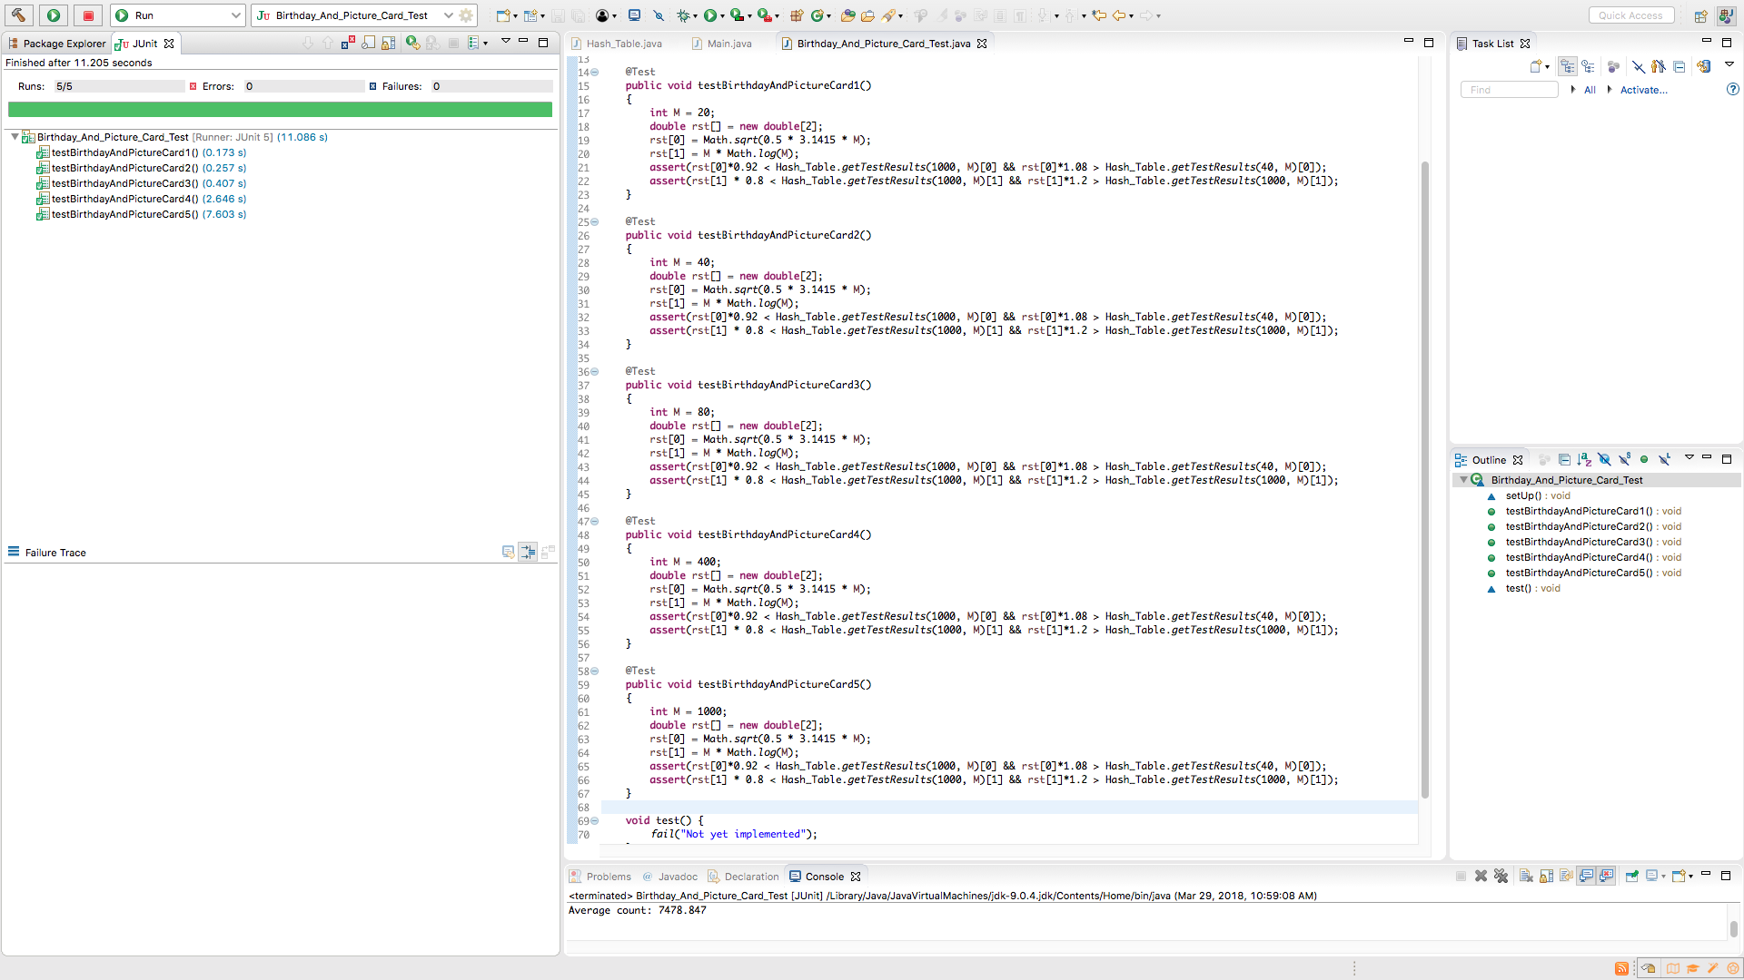
In the unit test, I have tested 5 different value of M with the average of 1000 tests for each M. In the assert method, I set the assertion that the counting for first collision is no more than 8 percent less or more than the theoretical value and for filling all the slots is no more than 20 percent less or more than the theoretical value.

