DA_Assignment4

Jinrong Liu, Fengxi Liu

1. Whisker-plot

> p <- ggplot(titanicFile, aes(factor(SibSp+Parch+1), Survived))

> p + geom_boxplot()

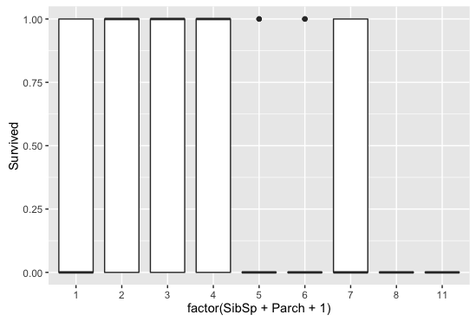

1. Histogram

> ggplot(titanicFile,aes(SibSp))+geom_histogram(binwidth=1)

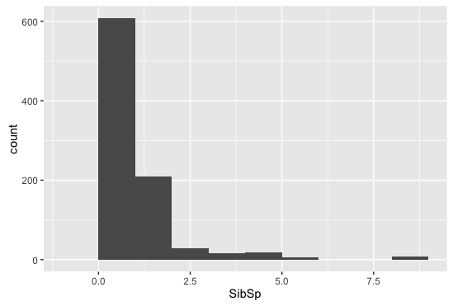

1. Facet grid

> p <- ggplot(data=titanicFile, aes(x=Pclass, fill=factor(Survived)))

> p+geom_bar(position = 'fill')+facet_grid(~Sex)+ggtitle("Pclass and Sex as the Survival Factors")

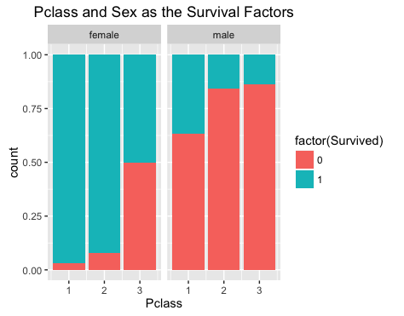

1. Violin

> p_v<-ggplot(titanicFile,aes(factor(Pclass),Survived))

> p_v+geom_violin()

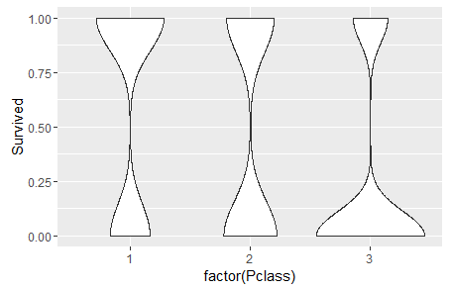

1. Heatmap

> ggplot(data = titanicFile, aes(x=Age, y=Pclass, fill=Survived)) + geom_tile(aes(fill = Survived, width =3))

