Examen Ta’lim – Main Level
Syllabus premier terme (Mai 2026 - Aout 2026)
[Creole]

Point totale: 85

Nom: ______________________________________________________

Branch: ________________________________

A note ki sa papier la li diviser en deux sections.
Section A: Ecrits - 65 marks ………….. Pg.2
Section B: Orale - 20 marks ………… Pg. 16
- Ban candidate pou bizin repone partie ecrits lor sa papier la.
- Enn examinater de la branch pou faire partie Orale, en addition, pou note point de l’examen Orale lor sa papier la.
- Tou questions zot obligatoire.
- Sa questionnaire la ena 16 (seize) pages.

Final Result (Pou examiner selment)

Section A: Ecrits | /65
Section B: Orale | /20
Point totale | /85

Section – A: Examen ecrits

- Ecrire commentaire de sa ban verset de Surah Al Inshiqaq:
[Chaque sub-question li 5 points, Totale: 10 points]

a)
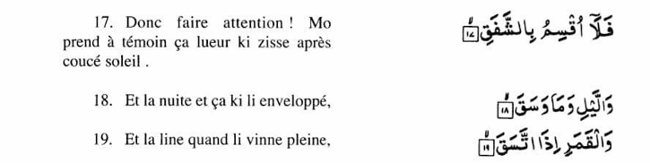

Ecrire ene explication de verset 17, 18 et 19 de Surah Al Inshiqaq cuma inn donner dans Ta’lim Syllabus 25-26.

……………………………………………………………………………………………………………………………………………………………………………
……………………………………………………………………………………………………………………………………………………………………………
……………………………………………………………………………………………………………………………………………………………………………
……………………………………………………………………………………………………………………………………………………………………………
……………………………………………………………………………………………………………………………………………………………………………
……………………………………………………………………………………………………………………………………………………………………………
……………………………………………………………………………………………………………………………………………………………………………
……………………………………………………………………………………………………………………………………………………………………………
……………………………………………………………………………………………………………………………………………………………………………
……………………………………………………………………………………………………………………………………………………………………………

……………………………………………………………………………………………………………………………………………………………………………
……………………………………………………………………………………………………………………………………………………………………………

b)

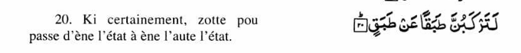

Ecrire ene explication de verset 20 de Surah Al Inshiqaq cuma inn donner dans le Ta’lim Syllabus 25-26.

……………………………………………………………………………………………………………………………………………………………………………
……………………………………………………………………………………………………………………………………………………………………………
……………………………………………………………………………………………………………………………………………………………………………
……………………………………………………………………………………………………………………………………………………………………………
……………………………………………………………………………………………………………………………………………………………………………
……………………………………………………………………………………………………………………………………………………………………………
……………………………………………………………………………………………………………………………………………………………………………
……………………………………………………………………………………………………………………………………………………………………………
……………………………………………………………………………………………………………………………………………………………………………
……………………………………………………………………………………………………………………………………………………………………………
……………………………………………………………………………………………………………………………………………………………………………
……………………………………………………………………………………………………………………………………………………………………………

……………………………………………………………………………………………………………………………………………………………………………
……………………………………………………………………………………………………………………………………………………..……………………

……………………………………………………………………………………………………………………………………………………………………………
……………………………………………………………………………………………………………………………………………………..……………………

- Ecrire signification de sa ban attributes d’ Allah, a coter. [5 points]

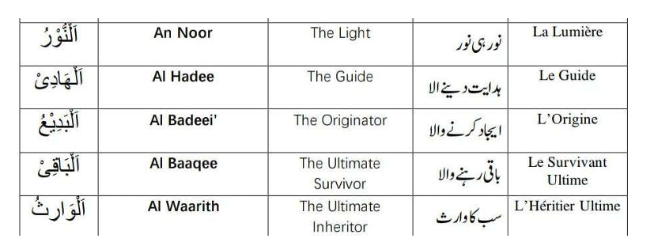

- Attribut d’Allah – Al Quddus (Celi ki Saint)

(a) Ki Khalifatul Masih Al Awwal (ra) ine dire lor Attribut ‘Al Quddus’ dans extrait couma inn donne dans Ta’lim Syllabus 25-26. [2 points]

……………………………………………………………………………………………………………………………………………………………………………
……………………………………………………………………………………………………………………………………………………………………………
……………………………………………………………………………………………………………………………………………………………………………
……………………………………………………………………………………………………………………………………………………………………………
……………………………………………………………………………………………………………………………………………………………………………
……………………………………………………………………………………………………………………………………………………………………………
……………………………………………………………………………………………………………………………………………………………………………
……………………………………………………………………………………………………………………………………………………………………………
……………………………………………………………………………………………………………………………………………………………………………
……………………………………………………………………………………………………………………………………………………………………………
……………………………………………………………………………………………………………………………………………………………………………
……………………………………………………………………………………………………………………………………………………………………………

(b) Ki Khalifatul Masih As Saani (ra) ine dire lor Attribut d’Allah, ‘Al Quddus’ dans extrait couma inn donne dans Ta’lim Syllabus 25-26. [2 points]

……………………………………………………………………………………………………………………………………………………………………………
……………………………………………………………………………………………………………………………………………………………………………
……………………………………………………………………………………………………………………………………………………………………………
……………………………………………………………………………………………………………………………………………………………………………
……………………………………………………………………………………………………………………………………………………………………………
……………………………………………………………………………………………………………………………………………………………………………
……………………………………………………………………………………………………………………………………………………………………………
……………………………………………………………………………………………………………………………………………………………………………
……………………………………………………………………………………………………………………………………………………………………………
……………………………………………………………………………………………………………………………………………………………………………
……………………………………………………………………………………………………………………………………………………………………………
……………………………………………………………………………………………………………………………………………………………………………
……………………………………………………………………………………………………………………………………………………………………………
……………………………………………………………………………………………………………………………………………………………………………

- Namaz-Traduction mot par mot

Ecrire traduction a coter. [11 points]

Sajdah

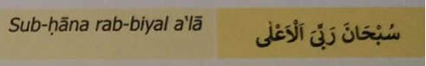

Jilsa

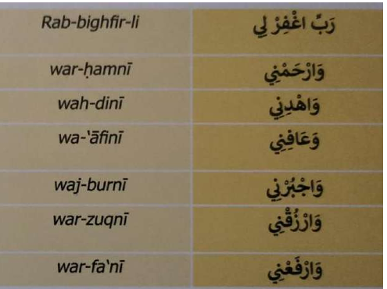

- Hadith

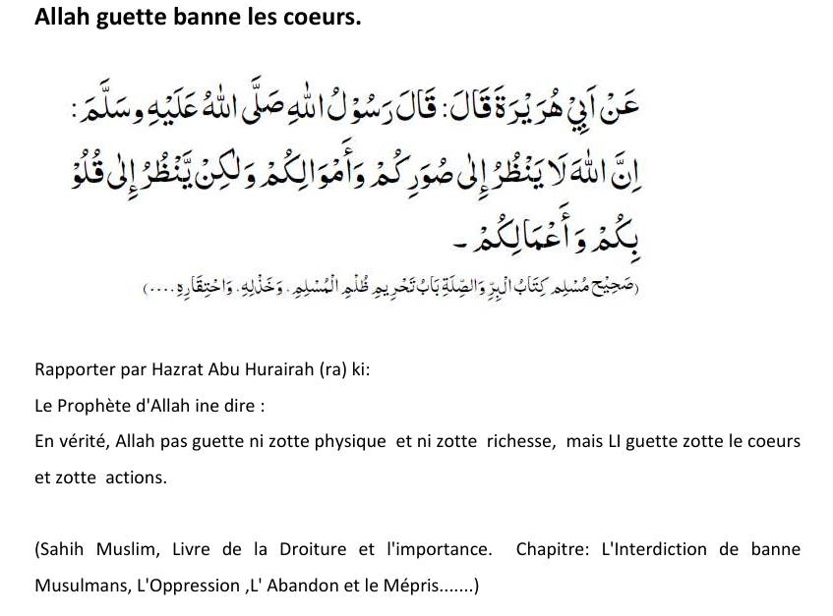

Ecrire ki signification du mot ‘qalb’ finne donner dans sa Hadith la dans explication dans Ta’lim Syllabus 25-26? [5 points]

……………………………………………………………………………………………………………………………………………………………………………
……………………………………………………………………………………………………………………………………………………………………………
……………………………………………………………………………………………………………………………………………………………………………
……………………………………………………………………………………………………………………………………………………………………………
……………………………………………………………………………………………………………………………………………………………………………
……………………………………………………………………………………………………………………………………………………………………………
……………………………………………………………………………………………………………………………………………………………………………
……………………………………………………………………………………………………………………………………………………………………………
……………………………………………………………………………………………………………………………………………………………………………
……………………………………………………………………………………………………………………………………………………………………………
……………………………………………………………………………………………………………………………………………………………………………
……………………………………………………………………………………………………………………………………………………………………………
……………………………………………………………………………………………………………………………………………………………………………
……………………………………………………………………………………………………………………………………………………………………………
……………………………………………………………………………………………………………………………………………………………………………
……………………………………………………………………………………………………………………………………………………………………………
……………………………………………………………………………………………………………………………………………………………………………
……………………………………………………………………………………………………………………………………………………………………………
……………………………………………………………………………………………………………………………………………………………………………
……………………………………………………………………………………………………………………………………………………………………………
……………………………………………………………………………………………………………………………………………………………………………
……………………………………………………………………………………………………………………………………………………………………………
……………………………………………………………………………………………………………………………………………………………………………
……………………………………………………………………………………………………………………………………………………………………………
……………………………………………………………………………………………………………………………………………………………………………
……………………………………………………………………………………………………………………………………………………………………………
……………………………………………………………………………………………………………………………………………………………………………
……………………………………………………………………………………………………………………………………………………………………………

- Ecrire deux points principal ki fine mentionner dans Malfoozat ‘Bon action, li meilleur si faire li en secret’ comme donner dans Ta’lim Syllabus 25-26. [5 points]

……………………………………………………………………………………………………………………………………………………………………………
……………………………………………………………………………………………………………………………………………………………………………
……………………………………………………………………………………………………………………………………………………………………………
……………………………………………………………………………………………………………………………………………………………………………
……………………………………………………………………………………………………………………………………………………………………………
……………………………………………………………………………………………………………………………………………………………………………
……………………………………………………………………………………………………………………………………………………………………………
……………………………………………………………………………………………………………………………………………………………………………
……………………………………………………………………………………………………………………………………………………………………………
……………………………………………………………………………………………………………………………………………………………………………
……………………………………………………………………………………………………………………………………………………………………………
……………………………………………………………………………………………………………………………………………………………………………
……………………………………………………………………………………………………………………………………………………………………………
……………………………………………………………………………………………………………………………………………………………………………
……………………………………………………………………………………………………………………………………………………………………………
……………………………………………………………………………………………………………………………………………………………………………
……………………………………………………………………………………………………………………………………………………………………………
……………………………………………………………………………………………………………………………………………………………………………
……………………………………………………………………………………………………………………………………………………………………………
……………………………………………………………………………………………………………………………………………………………………………

- Nazam: Isaion sey khitab

Ecrire signification de banne mots difficile depi sa Nazam, a coter. [4 points]

Transliteration de  banne mots en Urdu | Signification en Creole
Noor

Ausaaf

Hikmat

Dilruba

- Sa Nazam, Isaion sey khitab ti ecrire par: [1 point] (Tick bon reponse)

- Hadhrat Musleh Maoud (ra)

- Hadhrat Masih Maoud (as)

- Ecrire ene explication bref de Nazam: Isaion sey khitab [2 points]
……………………………………………………………………………………………………………………………………………………………………………
……………………………………………………………………………………………………………………………………………………………………………
……………………………………………………………………………………………………………………………………………………………………………
……………………………………………………………………………………………………………………………………………………………………………
……………………………………………………………………………………………………………………………………………………………………………
……………………………………………………………………………………………………………………………………………………………………………
……………………………………………………………………………………………………………………………………………………………………………
……………………………………………………………………………………………………………………………………………………………………………
……………………………………………………………………………………………………………………………………………………………………………
……………………………………………………………………………………………………………………………………………………………………………
A noter: Question 10, li baser lors le livre, ‘Le Souvenir d’Allah’ ki finne ecrire par Hadhrat Mirza Bashir-ud-Din Mahmood Ahmad, Khalifatul-Masih, As Saani (ra), ki ti prescrire pou self-study.

- D'après Hazrat Musleh Maud (ra), ki faire li important pou banne membres de nous Jama'at pou porte plus boucou l'attention lors Zikr-e-Ilahi ?

Reponne dans 100 à 150 mots.
(Couma finne mentionner dans bannes pages prescrit pou self-study de 2nd term) [10 points]

……………………………………………………………………………………………………………………………………………………………………………
……………………………………………………………………………………………………………………………………………………………………………
……………………………………………………………………………………………………………………………………………………………………………
……………………………………………………………………………………………………………………………………………………………………………
……………………………………………………………………………………………………………………………………………………………………………
……………………………………………………………………………………………………………………………………………………………………………
……………………………………………………………………………………………………………………………………………………………………………
……………………………………………………………………………………………………………………………………………………………………………
……………………………………………………………………………………………………………………………………………………………………………
……………………………………………………………………………………………………………………………………………………………………………
……………………………………………………………………………………………………………………………………………………………………………
……………………………………………………………………………………………………………………………………………………………………………
……………………………………………………………………………………………………………………………………………………………………………
……………………………………………………………………………………………………………………………………………………………………………
……………………………………………………………………………………………………………………………………………………………………………
……………………………………………………………………………………………………………………………………………………………………………
……………………………………………………………………………………………………………………………………………………………………………
……………………………………………………………………………………………………………………………………………………………………………
……………………………………………………………………………………………………………………………………………………………………………
……………………………………………………………………………………………………………………………………………………………………………
……………………………………………………………………………………………………………………………………………………………………………
……………………………………………………………………………………………………………………………………………………………………………
……………………………………………………………………………………………………………………………………………………………………………
……………………………………………………………………………………………………………………………………………………………………………
……………………………………………………………………………………………………………………………………………………………………………
……………………………………………………………………………………………………………………………………………………………………………
……………………………………………………………………………………………………………………………………………………………………………
……………………………………………………………………………………………………………………………………………………………………………
……………………………………………………………………………………………………………………………………………………………………………
……………………………………………………………………………………………………………………………………………………………………………
……………………………………………………………………………………………………………………………………………………………………………
A noter ki Q.11 li base lor bann ti Question et reponse depi le livre, “L'Arche de Noé” pg74-114 (d'apres contenue ki inn prescrit pou l’examen)
Choisir et repond zis quatre question parmi ceki inn donn ou enbas.
Pou chaque question ou pou gagne 2 points. Total: 8 points

- Kifer eski le Messie Promis(as) inn dire ki bann revelation divine li important?
- Donn deux raison kifer Surah Al-Fatihah li consideré couma important.
- Expliké ki pé rode dire par la Certitude.
- Expliké kifer le Messie Promis(as) inn montre nou ki le Saint Quran bizin le premier critère kan pou juge authenticité d'enn Hadith.
- Couma eski le cinq namaz quotidien li beneficier enn croyant?
- Mention deux but de mission du Messie Promis (as).
Ecrire ou response dan l'espace ki Finn donné enbas et dan page apres la.

……………………………………………………………………………………………………………………………………………………………………………
……………………………………………………………………………………………………………………………………………………………………………
……………………………………………………………………………………………………………………………………………………………………………
……………………………………………………………………………………………………………………………………………………………………………
……………………………………………………………………………………………………………………………………………………………………………
……………………………………………………………………………………………………………………………………………………………………………
……………………………………………………………………………………………………………………………………………………………………………
……………………………………………………………………………………………………………………………………………………………………………
……………………………………………………………………………………………………………………………………………………………………………
……………………………………………………………………………………………………………………………………………………………………………
……………………………………………………………………………………………………………………………………………………………………………
……………………………………………………………………………………………………………………………………………………………………………
……………………………………………………………………………………………………………………………………………………………………………
……………………………………………………………………………………………………………………………………………………………………………
……………………………………………………………………………………………………………………………………………………………………………
……………………………………………………………………………………………………………………………………………………………………………
……………………………………………………………………………………………………………………………………………………………………………
……………………………………………………………………………………………………………………………………………………………………………
……………………………………………………………………………………………………………………………………………………………………………
……………………………………………………………………………………………………………………………………………………………………………
……………………………………………………………………………………………………………………………………………………………………………
……………………………………………………………………………………………………………………………………………………………………………
……………………………………………………………………………………………………………………………………………………………………………
……………………………………………………………………………………………………………………………………………………………………………
……………………………………………………………………………………………………………………………………………………………………………
……………………………………………………………………………………………………………………………………………………………………………
……………………………………………………………………………………………………………………………………………………………………………
……………………………………………………………………………………………………………………………………………………………………………
……………………………………………………………………………………………………………………………………………………………………………
……………………………………………………………………………………………………………………………………………………………………………
……………………………………………………………………………………………………………………………………………………………………………
……………………………………………………………………………………………………………………………………………………………………………
……………………………………………………………………………………………………………………………………………………………………………
……………………………………………………………………………………………………………………………………………………………………………
……………………………………………………………………………………………………………………………………………………………………………
……………………………………………………………………………………………………………………………………………………………………………
……………………………………………………………………………………………………………………………………………………………………………
……………………………………………………………………………………………………………………………………………………………………………
……………………………………………………………………………………………………………………………………………………………………………
……………………………………………………………………………………………………………………………………………………………………………
……………………………………………………………………………………………………………………………………………………………………………
……………………………………………………………………………………………………………………………………………………………………………
……………………………………………………………………………………………………………………………………………………………………………
……………………………………………………………………………………………………………………………………………………………………………
……………………………………………………………………………………………………………………………………………………………………………
……………………………………………………………………………………………………………………………………………………………………………
……………………………………………………………………………………………………………………………………………………………………………
……………………………………………………………………………………………………………………………………………………………………………
……………………………………………………………………………………………………………………………………………………………………………
……………………………………………………………………………………………………………………………………………………………………………
……………………………………………………………………………………………………………………………………………………………………………
……………………………………………………………………………………………………………………………………………………………………………
……………………………………………………………………………………………………………………………………………………………………………
……………………………………………………………………………………………………………………………………………………………………………
……………………………………………………………………………………………………………………………………………………………………………
……………………………………………………………………………………………………………………………………………………………………………
……………………………………………………………………………………………………………………………………………………………………………
……………………………………………………………………………………………………………………………………………………………………………
……………………………………………………………………………………………………………………………………………………………………………
……………………………………………………………………………………………………………………………………………………………………………
……………………………………………………………………………………………………………………………………………………………………………
……………………………………………………………………………………………………………………………………………………………………………
……………………………………………………………………………………………………………………………………………………………………………
……………………………………………………………………………………………………………………………………………………………………………
……………………………………………………………………………………………………………………………………………………………………………
……………………………………………………………………………………………………………………………………………………………………………
……………………………………………………………………………………………………………………………………………………………………………
……………………………………………………………………………………………………………………………………………………………………………
……………………………………………………………………………………………………………………………………………………………………………
……………………………………………………………………………………………………………………………………………………………………………

Section B: Examen Orale

- Recite dua ‘Pou gagne la Grace et le pardon’ avec traduction.
Dua: …………………… [3 points]
Traduction: ……………… [2 points]

- Recite dua pou ‘Kan nou truv nouvel lune’ avec traduction.
Dua: …………………… [3 points]
Traduction: ……………… [2 points]

- Recite Qaseedah

Marks: [2 points pou chaque couplet, Totale 10 points]

Couplet 26 - __________ Couplet 29 - __________

Couplet 27 - __________ Couplet 30- ___________

Couplet 28 - __________

Fin de questionnaire

