Ta’lim Examination – Main Level
Second Term Syllabus (May 2026 - August 2026)
[ENGLISH]

Total marks: 85

Name: ______________________________________________________

Branch: ________________________________

Please note that the paper is divided into two sections.
Section A: Written - 55 marks ………….. Pg.2
Section B: Oral - 20 marks ………………… Pg. 16

- The candidate should answer the written part on the sheet.
- An examiner of the branch shall conduct the Oral part, additionally, the marks for the Oral exam will be noted down on the sheet.
- All questions are compulsory.
- This question paper consists of 16 (sixteen) pages.

Final Result (For examiner’s use only)
Section A: Written | /65
Section B: Oral | /20
Total marks | /85

Section – A: Written exam

- Answer the questions related to the commentary of the following verses of Surah Al Inshiqaq:
[Each sub-question carries 5 marks, Total: 10 marks]

a)
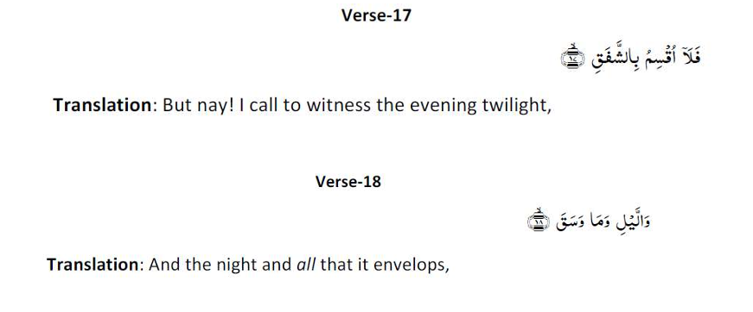
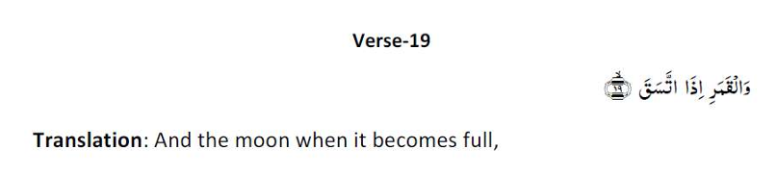
Write the commentary of verses 17, 18 and 19 of Surah Al Inshiqaq as given in the Ta’lim Syllabus 25-26.
……………………………………………………………………………………………………………………………………………………………………………
……………………………………………………………………………………………………………………………………………………………………………
……………………………………………………………………………………………………………………………………………………………………………
……………………………………………………………………………………………………………………………………………………………………………
……………………………………………………………………………………………………………………………………………………………………………
……………………………………………………………………………………………………………………………………………………………………………
……………………………………………………………………………………………………………………………………………………………………………
……………………………………………………………………………………………………………………………………………………………………………
……………………………………………………………………………………………………………………………………………………………………………
……………………………………………………………………………………………………………………………………………………………………………
……………………………………………………………………………………………………………………………………………………………………………
……………………………………………………………………………………………………………………………………………………………………………
……………………………………………………………………………………………………………………………………………………………………………
……………………………………………………………………………………………………………………………………………………………………………
……………………………………………………………………………………………………………………………………………………………………………
……………………………………………………………………………………………………………………………………………………………………………
……………………………………………………………………………………………………………………………………………………………………………

b)
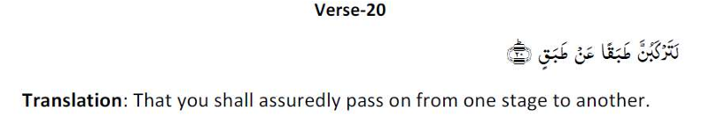

Write the commentary of verse 20 of Surah Al Inshiqaq as given in the Ta’lim Syllabus 25-26.

……………………………………………………………………………………………………………………………………………………………………………
……………………………………………………………………………………………………………………………………………………………………………
……………………………………………………………………………………………………………………………………………………………………………
……………………………………………………………………………………………………………………………………………………………………………
……………………………………………………………………………………………………………………………………………………………………………
……………………………………………………………………………………………………………………………………………………………………………
……………………………………………………………………………………………………………………………………………………………………………
……………………………………………………………………………………………………………………………………………………………………………
……………………………………………………………………………………………………………………………………………………………………………
……………………………………………………………………………………………………………………………………………………………………………
……………………………………………………………………………………………………………………………………………………………………………
……………………………………………………………………………………………………………………………………………………………………………
……………………………………………………………………………………………………………………………………………………………………………
……………………………………………………………………………………………………………………………………………………………………………
……………………………………………………………………………………………………………………………………………………………………………
……………………………………………………………………………………………………………………………………………………………………………
……………………………………………………………………………………………………………………………………………………………………………

- Please write down the meaning of the following attributes of Allah, on the side. [5 marks]

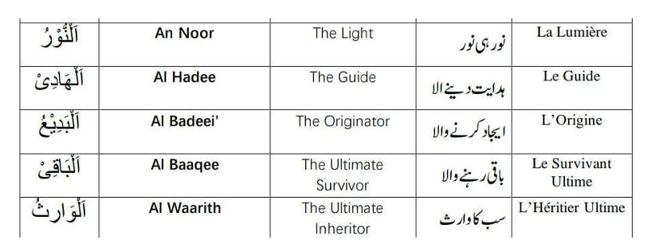

- Attribute of Allah – Al Quddus (The Holy One)

- What did Khalifatul Masih Al Awwal (ra) convey about the attribute of Allah, Al Quddus in the extract given in the Ta’lim Syllabus 25-26? [2 marks]

……………………………………………………………………………………………………………………………………………………………………………

……………………………………………………………………………………………………………………………………………………………………………
……………………………………………………………………………………………………………………………………………………………………………
……………………………………………………………………………………………………………………………………………………………………………
……………………………………………………………………………………………………………………………………………………………………………
……………………………………………………………………………………………………………………………………………………………………………
……………………………………………………………………………………………………………………………………………………………………………
……………………………………………………………………………………………………………………………………………………………………………
……………………………………………………………………………………………………………………………………………………………………………
……………………………………………………………………………………………………………………………………………………………………………
……………………………………………………………………………………………………………………………………………………………………………
……………………………………………………………………………………………………………………………………………………………………………
……………………………………………………………………………………………………………………………………………………………………………
……………………………………………………………………………………………………………………………………………………………………………

(b) What did Khalaifatul Masih As Saani (ra) convey about the attribute of Allah, Al Quddus in the extract given in the Ta’lim Syllabus 25-26? [2 marks]
……………………………………………………………………………………………………………………………………………………………………………
……………………………………………………………………………………………………………………………………………………………………………
……………………………………………………………………………………………………………………………………………………………………………
……………………………………………………………………………………………………………………………………………………………………………
……………………………………………………………………………………………………………………………………………………………………………
……………………………………………………………………………………………………………………………………………………………………………
……………………………………………………………………………………………………………………………………………………………………………
……………………………………………………………………………………………………………………………………………………………………………
……………………………………………………………………………………………………………………………………………………………………………
……………………………………………………………………………………………………………………………………………………………………………
……………………………………………………………………………………………………………………………………………………………………………
……………………………………………………………………………………………………………………………………………………………………………
……………………………………………………………………………………………………………………………………………………………………………
……………………………………………………………………………………………………………………………………………………………………………

- Namaz-Split word translation

Please write the translations on the side. [11 marks]

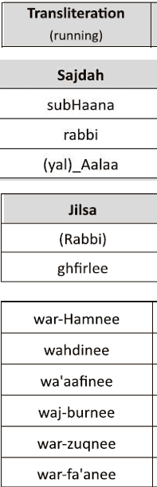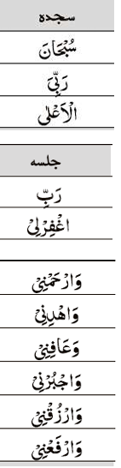

- Referring to the Hadith below, what does the word ‘qalb’ mean? (as given in the explanatory notes in Ta’lim Syllabus 25-26). [5 marks]

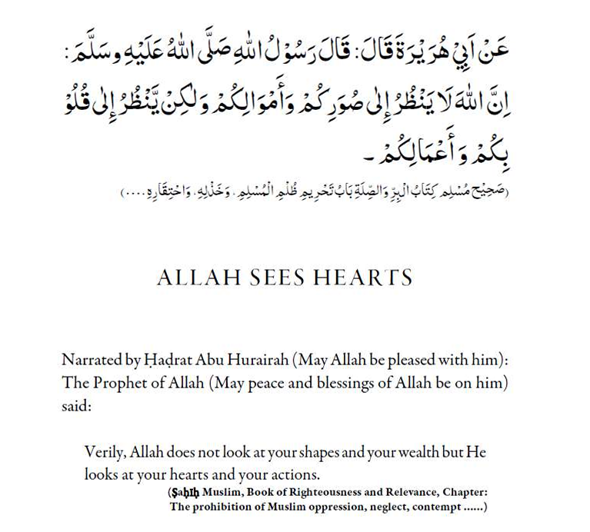

……………………………………………………………………………………………………………………………………………………………………………
……………………………………………………………………………………………………………………………………………………………………………
……………………………………………………………………………………………………………………………………………………………………………
……………………………………………………………………………………………………………………………………………………………………………
……………………………………………………………………………………………………………………………………………………………………………
……………………………………………………………………………………………………………………………………………………………………………
……………………………………………………………………………………………………………………………………………………………………………
……………………………………………………………………………………………………………………………………………………………………………
……………………………………………………………………………………………………………………………………………………………………………
……………………………………………………………………………………………………………………………………………………………………………
……………………………………………………………………………………………………………………………………………………………………………
……………………………………………………………………………………………………………………………………………………………………………
……………………………………………………………………………………………………………………………………………………………………………
……………………………………………………………………………………………………………………………………………………………………………
……………………………………………………………………………………………………………………………………………………………………………
……………………………………………………………………………………………………………………………………………………………………………
……………………………………………………………………………………………………………………………………………………………………………
……………………………………………………………………………………………………………………………………………………………………………
……………………………………………………………………………………………………………………………………………………………………………
……………………………………………………………………………………………………………………………………………………………………………
……………………………………………………………………………………………………………………………………………………………………………
……………………………………………………………………………………………………………………………………………………………………………
……………………………………………………………………………………………………………………………………………………………………………
……………………………………………………………………………………………………………………………………………………………………………

- Write two main points of the Malfuzat on ‘Good deeds are best if concealed’ as given in the Ta’lim Syllabus 25-26. [5 marks]

……………………………………………………………………………………………………………………………………………………………………………
……………………………………………………………………………………………………………………………………………………………………………
……………………………………………………………………………………………………………………………………………………………………………
……………………………………………………………………………………………………………………………………………………………………………
……………………………………………………………………………………………………………………………………………………………………………
……………………………………………………………………………………………………………………………………………………………………………
……………………………………………………………………………………………………………………………………………………………………………
……………………………………………………………………………………………………………………………………………………………………………
……………………………………………………………………………………………………………………………………………………………………………
……………………………………………………………………………………………………………………………………………………………………………
……………………………………………………………………………………………………………………………………………………………………………
……………………………………………………………………………………………………………………………………………………………………………
……………………………………………………………………………………………………………………………………………………………………………
……………………………………………………………………………………………………………………………………………………………………………
……………………………………………………………………………………………………………………………………………………………………………
……………………………………………………………………………………………………………………………………………………………………………
……………………………………………………………………………………………………………………………………………………………………………
……………………………………………………………………………………………………………………………………………………………………………
……………………………………………………………………………………………………………………………………………………………………………
……………………………………………………………………………………………………………………………………………………………………………
……………………………………………………………………………………………………………………………………………………………………………
……………………………………………………………………………………………………………………………………………………………………………
……………………………………………………………………………………………………………………………………………………………………………
……………………………………………………………………………………………………………………………………………………………………………
……………………………………………………………………………………………………………………………………………………………………………
……………………………………………………………………………………………………………………………………………………………………………

- Nazam: Isaion sey khitab
Write the meanings of the difficult words from the Nazam, on the side. [4 marks]
Transliteration of words in Urdu | Meaning in English
Noor

Ausaaf

Hikmat

Dilruba

- The Nazam, Isaion sey Khitab was written by: [1 mark]

(Tick the correct answer)

- Hadhrat Musleh Maoud (ra)

- Hadhrat Masih Maoud (as)

- Write a brief explanation of the Nazam: Isaion sey khitab. [2 marks]

……………………………………………………………………………………………………………………………………………………………………………
……………………………………………………………………………………………………………………………………………………………………………
……………………………………………………………………………………………………………………………………………………………………………
……………………………………………………………………………………………………………………………………………………………………………
……………………………………………………………………………………………………………………………………………………………………………
……………………………………………………………………………………………………………………………………………………………………………
……………………………………………………………………………………………………………………………………………………………………………
……………………………………………………………………………………………………………………………………………………………………………
……………………………………………………………………………………………………………………………………………………………………………
Please note: Question 10 is based on the book, ‘Remembrance of Allah’
written by Hadhrat Mirza Bashir-ud-Din Mahmood Ahmad, Khalifatul-Masih, As Saani (ra),
which is set for self-study.

- ‘According to Hadhrat Musleh Maud (ra), why is it important for people in our Jama'at to focus more on Zikr-e-Ilahi?’ [As mentioned in the pages set for study for second term].
Answer in 100 to 150 words. [10 marks]

……………………………………………………………………………………………………………………………………………………………………………
……………………………………………………………………………………………………………………………………………………………………………
……………………………………………………………………………………………………………………………………………………………………………
……………………………………………………………………………………………………………………………………………………………………………
……………………………………………………………………………………………………………………………………………………………………………
……………………………………………………………………………………………………………………………………………………………………………
……………………………………………………………………………………………………………………………………………………………………………
……………………………………………………………………………………………………………………………………………………………………………
……………………………………………………………………………………………………………………………………………………………………………
……………………………………………………………………………………………………………………………………………………………………………
……………………………………………………………………………………………………………………………………………………………………………
……………………………………………………………………………………………………………………………………………………………………………
……………………………………………………………………………………………………………………………………………………………………………
……………………………………………………………………………………………………………………………………………………………………………
……………………………………………………………………………………………………………………………………………………………………………
……………………………………………………………………………………………………………………………………………………………………………
……………………………………………………………………………………………………………………………………………………………………………
……………………………………………………………………………………………………………………………………………………………………………
……………………………………………………………………………………………………………………………………………………………………………
……………………………………………………………………………………………………………………………………………………………………………
……………………………………………………………………………………………………………………………………………………………………………
……………………………………………………………………………………………………………………………………………………………………………
……………………………………………………………………………………………………………………………………………………………………………
……………………………………………………………………………………………………………………………………………………………………………
……………………………………………………………………………………………………………………………………………………………………………
……………………………………………………………………………………………………………………………………………………………………………
……………………………………………………………………………………………………………………………………………………………………………
……………………………………………………………………………………………………………………………………………………………………………
……………………………………………………………………………………………………………………………………………………………………………
……………………………………………………………………………………………………………………………………………………………………………
……………………………………………………………………………………………………………………………………………………………………………
……………………………………………………………………………………………………………………………………………………………………………
……………………………………………………………………………………………………………………………………………………………………………
……………………………………………………………………………………………………………………………………………………………………………
……………………………………………………………………………………………………………………………………………………………………………
……………………………………………………………………………………………………………………………………………………………………………
……………………………………………………………………………………………………………………………………………………………………………
……………………………………………………………………………………………………………………………………………………………………………
……………………………………………………………………………………………………………………………………………………………………………
……………………………………………………………………………………………………………………………………………………………………………

Please note: Q.11 is based on Short-answer questions on ‘Noah’s Ark’ pg. 74-114 (as per content set for the exam)
Answer any four questions. Each question carries 2 marks. Total: 8 marks

- Why does the Promised Messiah (as) say that divine revelation is important?
- State two reasons why Surah Al-Fatihah is considered important.
- Explain what is meant by ‘Certainty’.
- Explain why the Promised Messiah (as) teaches that the Holy Qur’an should be the first criterion for judging the authenticity of a Hadith.
- How do the five daily prayers benefit a believer?
- Mention two aims of the mission of the Promised Messiah (as).

Answer in the space given below and on the following pages

……………………………………………………………………………………………………………………………………………………………………………
……………………………………………………………………………………………………………………………………………………………………………
……………………………………………………………………………………………………………………………………………………………………………
……………………………………………………………………………………………………………………………………………………………………………
……………………………………………………………………………………………………………………………………………………………………………
……………………………………………………………………………………………………………………………………………………………………………
……………………………………………………………………………………………………………………………………………………………………………
……………………………………………………………………………………………………………………………………………………………………………
……………………………………………………………………………………………………………………………………………………………………………
……………………………………………………………………………………………………………………………………………………………………………
……………………………………………………………………………………………………………………………………………………………………………
……………………………………………………………………………………………………………………………………………………………………………
……………………………………………………………………………………………………………………………………………………………………………
……………………………………………………………………………………………………………………………………………………………………………
……………………………………………………………………………………………………………………………………………………………………………
……………………………………………………………………………………………………………………………………………………………………………
……………………………………………………………………………………………………………………………………………………………………………
……………………………………………………………………………………………………………………………………………………………………………
……………………………………………………………………………………………………………………………………………………………………………
……………………………………………………………………………………………………………………………………………………………………………
……………………………………………………………………………………………………………………………………………………………………………
……………………………………………………………………………………………………………………………………………………………………………
……………………………………………………………………………………………………………………………………………………………………………
……………………………………………………………………………………………………………………………………………………………………………
……………………………………………………………………………………………………………………………………………………………………………
……………………………………………………………………………………………………………………………………………………………………………
……………………………………………………………………………………………………………………………………………………………………………
……………………………………………………………………………………………………………………………………………………………………………
……………………………………………………………………………………………………………………………………………………………………………
……………………………………………………………………………………………………………………………………………………………………………
……………………………………………………………………………………………………………………………………………………………………………
……………………………………………………………………………………………………………………………………………………………………………
……………………………………………………………………………………………………………………………………………………………………………
……………………………………………………………………………………………………………………………………………………………………………
……………………………………………………………………………………………………………………………………………………………………………
……………………………………………………………………………………………………………………………………………………………………………
……………………………………………………………………………………………………………………………………………………………………………
……………………………………………………………………………………………………………………………………………………………………………
……………………………………………………………………………………………………………………………………………………………………………
……………………………………………………………………………………………………………………………………………………………………………
……………………………………………………………………………………………………………………………………………………………………………
……………………………………………………………………………………………………………………………………………………………………………
……………………………………………………………………………………………………………………………………………………………………………
……………………………………………………………………………………………………………………………………………………………………………
……………………………………………………………………………………………………………………………………………………………………………
……………………………………………………………………………………………………………………………………………………………………………
……………………………………………………………………………………………………………………………………………………………………………
……………………………………………………………………………………………………………………………………………………………………………
……………………………………………………………………………………………………………………………………………………………………………
……………………………………………………………………………………………………………………………………………………………………………
……………………………………………………………………………………………………………………………………………………………………………
……………………………………………………………………………………………………………………………………………………………………………
……………………………………………………………………………………………………………………………………………………………………………
……………………………………………………………………………………………………………………………………………………………………………
……………………………………………………………………………………………………………………………………………………………………………
……………………………………………………………………………………………………………………………………………………………………………
……………………………………………………………………………………………………………………………………………………………………………
……………………………………………………………………………………………………………………………………………………………………………

Section-B: Oral exam

- Please recite the ‘Prayer for Mercy and Forgiveness’ with translation.
Dua: …………………… [3 marks]
Translation: ……………… [2 marks]

- Please recite the ‘On observing the new moon’ with translation.
Dua: …………………… [3 marks]
Translation: ……………… [2 marks]

- Recite Qaseedah

Marks: [2 marks for each couplet, Total 10 marks]

Couplet 26 - __________ Couplet 29 - _____________
Couplet 27 - __________ Couplet 30- ___________
Couplet 28 - __________

End of Paper

