Ta’lim Examination – Main Level
First Term Syllabus (December 2025 - April 2026)
[ENGLISH]

Total marks: 75

Name: ______________________________________________________

Branch: ________________________________

Please note that the paper is divided into two sections.
Section A: Written - 55 marks ………….. Pg.2
Section B: Oral - 20 marks ………………… Pg. 11

- The candidate should answer the written part on the sheet.
- An examiner of the branch shall conduct the Oral part, additionally, the marks for the Oral exam will be noted down on the sheet.
- All questions are compulsory.
- This question paper consists of 11 (eleven) pages.

Final Result (For examiner’s use only)
Section A: Written | /55
Section B: Oral | /20
Total marks | /75

Section – A: Written exam

- Answer the questions related to the commentary of the following verses of Surah Al Inshiqaq:
[Each sub-question carries 5 marks, Total: 10 marks]

a)
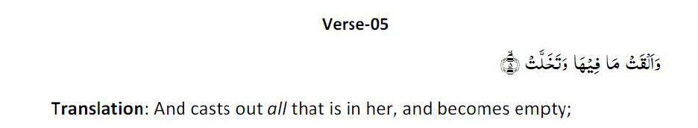
Write at least one meaning of verse 5 of Surah Al Inshiqaq as given in the commentary in the Ta’lim Syllabus 25-26.
……………………………………………………………………………………………………………………………………………………………………………
……………………………………………………………………………………………………………………………………………………………………………
……………………………………………………………………………………………………………………………………………………………………………
……………………………………………………………………………………………………………………………………………………………………………
……………………………………………………………………………………………………………………………………………………………………………
……………………………………………………………………………………………………………………………………………………………………………
……………………………………………………………………………………………………………………………………………………………………………
……………………………………………………………………………………………………………………………………………………………………………
……………………………………………………………………………………………………………………………………………………………………………
……………………………………………………………………………………………………………………………………………………………………………
……………………………………………………………………………………………………………………………………………………………………………
……………………………………………………………………………………………………………………………………………………………………………

b)
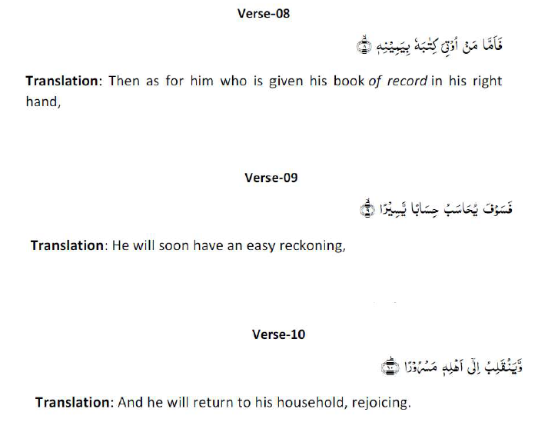
In the commentary of verses 8, 9 and 10 of Surah Al Inshiqaq, as given in the Ta’lim syllabus 25-26, what does the metaphor ‘the right hand’ signify?

……………………………………………………………………………………………………………………………………………………………………………
……………………………………………………………………………………………………………………………………………………………………………
……………………………………………………………………………………………………………………………………………………………………………
……………………………………………………………………………………………………………………………………………………………………………
……………………………………………………………………………………………………………………………………………………………………………
……………………………………………………………………………………………………………………………………………………………………………
……………………………………………………………………………………………………………………………………………………………………………
……………………………………………………………………………………………………………………………………………………………………………
……………………………………………………………………………………………………………………………………………………………………………
……………………………………………………………………………………………………………………………………………………………………………
……………………………………………………………………………………………………………………………………………………………………………
……………………………………………………………………………………………………………………………………………………………………………
……………………………………………………………………………………………………………………………………………………………………………
……………………………………………………………………………………………………………………………………………………………………………

- Please write down the meaning of the following attributes of Allah, on the side. [5 marks]
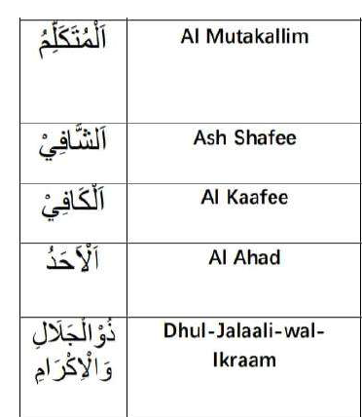

- Attribute of Allah – Al Rahman (The Gracious) [Ta’lim Syllabus 25-26, Pg.17,18]

(a) What did Imam Raghib explain that the word, ‘Rahmat’ connotes? [2 marks]

……………………………………………………………………………………………………………………………………………………………………………
……………………………………………………………………………………………………………………………………………………………………………
……………………………………………………………………………………………………………………………………………………………………………
……………………………………………………………………………………………………………………………………………………………………………
……………………………………………………………………………………………………………………………………………………………………………
……………………………………………………………………………………………………………………………………………………………………………
……………………………………………………………………………………………………………………………………………………………………………
……………………………………………………………………………………………………………………………………………………………………………
……………………………………………………………………………………………………………………………………………………………………………
……………………………………………………………………………………………………………………………………………………………………………
……………………………………………………………………………………………………………………………………………………………………………
……………………………………………………………………………………………………………………………………………………………………………

(b) What did the Promised Messiah (as) say about the attribute of Allah, Al Rahman? [2 marks]
……………………………………………………………………………………………………………………………………………………………………………
……………………………………………………………………………………………………………………………………………………………………………
……………………………………………………………………………………………………………………………………………………………………………
……………………………………………………………………………………………………………………………………………………………………………
……………………………………………………………………………………………………………………………………………………………………………
……………………………………………………………………………………………………………………………………………………………………………
……………………………………………………………………………………………………………………………………………………………………………
……………………………………………………………………………………………………………………………………………………………………………
……………………………………………………………………………………………………………………………………………………………………………
……………………………………………………………………………………………………………………………………………………………………………
……………………………………………………………………………………………………………………………………………………………………………
……………………………………………………………………………………………………………………………………………………………………………
……………………………………………………………………………………………………………………………………………………………………………
……………………………………………………………………………………………………………………………………………………………………………

- Namaz-Split word translation

Please write the translations on the side. [10 marks]

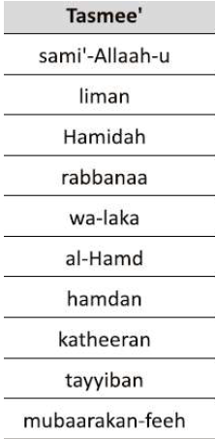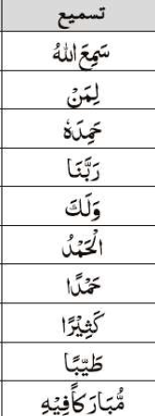

- Referring to the Hadith below, what is the most important aspect of doing good actions? (as given in the explanatory notes in Ta’lim Syllabus 25-26). [5 marks]

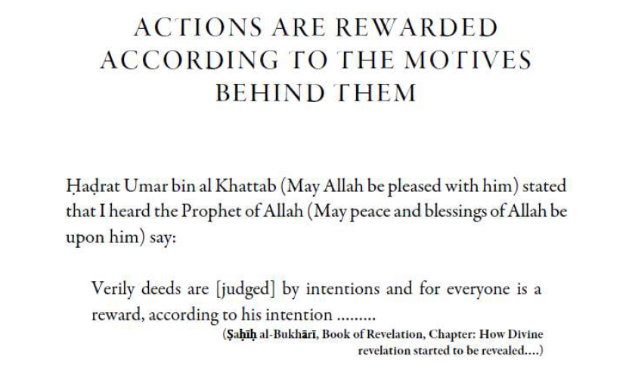

……………………………………………………………………………………………………………………………………………………………………………
……………………………………………………………………………………………………………………………………………………………………………
……………………………………………………………………………………………………………………………………………………………………………
……………………………………………………………………………………………………………………………………………………………………………
……………………………………………………………………………………………………………………………………………………………………………
……………………………………………………………………………………………………………………………………………………………………………
……………………………………………………………………………………………………………………………………………………………………………
……………………………………………………………………………………………………………………………………………………………………………
……………………………………………………………………………………………………………………………………………………………………………
……………………………………………………………………………………………………………………………………………………………………………
……………………………………………………………………………………………………………………………………………………………………………
……………………………………………………………………………………………………………………………………………………………………………
……………………………………………………………………………………………………………………………………………………………………………
……………………………………………………………………………………………………………………………………………………………………………
……………………………………………………………………………………………………………………………………………………………………………

- Write two main points of the Malfuzat on ‘Trials are Necessary’ as given in the Ta’lim Syllabus 25-26.
[4 marks]

……………………………………………………………………………………………………………………………………………………………………………
……………………………………………………………………………………………………………………………………………………………………………
……………………………………………………………………………………………………………………………………………………………………………
……………………………………………………………………………………………………………………………………………………………………………
……………………………………………………………………………………………………………………………………………………………………………
……………………………………………………………………………………………………………………………………………………………………………
……………………………………………………………………………………………………………………………………………………………………………
……………………………………………………………………………………………………………………………………………………………………………
……………………………………………………………………………………………………………………………………………………………………………
……………………………………………………………………………………………………………………………………………………………………………
……………………………………………………………………………………………………………………………………………………………………………
……………………………………………………………………………………………………………………………………………………………………………
……………………………………………………………………………………………………………………………………………………………………………
……………………………………………………………………………………………………………………………………………………………………………
……………………………………………………………………………………………………………………………………………………………………………
……………………………………………………………………………………………………………………………………………………………………………
……………………………………………………………………………………………………………………………………………………………………………

- Nazam: Dawat e Fikr
Write the meanings of the difficult words from the Nazam, on the side. [4 marks]
Transliteration of words in Urdu | Meaning in English
Batil

Rujuh

Zid o tasub

Basdiq

- The Nazam, Dawat e Fikr was written by: [1 mark]

(Tick the correct answer)

- Hadhrat Musleh Maoud (ra)

- Hadhrat Masih Maoud (as)

- Write a brief explanation of the Nazam: Dawat e Fikr. [2 marks]

……………………………………………………………………………………………………………………………………………………………………………
……………………………………………………………………………………………………………………………………………………………………………
……………………………………………………………………………………………………………………………………………………………………………
……………………………………………………………………………………………………………………………………………………………………………
……………………………………………………………………………………………………………………………………………………………………………
……………………………………………………………………………………………………………………………………………………………………………
……………………………………………………………………………………………………………………………………………………………………………
……………………………………………………………………………………………………………………………………………………………………………
……………………………………………………………………………………………………………………………………………………………………………
……………………………………………………………………………………………………………………………………………………………………………

Please note: Question 10 is based on the book, ‘Remembrance of Allah’
written by Hadhrat Mirza Bashir-ud-Din Mahmood Ahmad, Khalifatul-Masih, As Saani (ra),
which is set for self-study.

- ‘What is Zikr e Ilahi (Remembrance of Allah)’? Answer in 100 to 150 words.
(As mentioned in the pages set for study in first term). [10 marks]

……………………………………………………………………………………………………………………………………………………………………………
……………………………………………………………………………………………………………………………………………………………………………
……………………………………………………………………………………………………………………………………………………………………………
……………………………………………………………………………………………………………………………………………………………………………
……………………………………………………………………………………………………………………………………………………………………………
……………………………………………………………………………………………………………………………………………………………………………
……………………………………………………………………………………………………………………………………………………………………………
……………………………………………………………………………………………………………………………………………………………………………
……………………………………………………………………………………………………………………………………………………………………………
……………………………………………………………………………………………………………………………………………………………………………
……………………………………………………………………………………………………………………………………………………………………………
……………………………………………………………………………………………………………………………………………………………………………
……………………………………………………………………………………………………………………………………………………………………………
……………………………………………………………………………………………………………………………………………………………………………
……………………………………………………………………………………………………………………………………………………………………………
……………………………………………………………………………………………………………………………………………………………………………
……………………………………………………………………………………………………………………………………………………………………………
……………………………………………………………………………………………………………………………………………………………………………
……………………………………………………………………………………………………………………………………………………………………………
……………………………………………………………………………………………………………………………………………………………………………
……………………………………………………………………………………………………………………………………………………………………………
……………………………………………………………………………………………………………………………………………………………………………
……………………………………………………………………………………………………………………………………………………………………………
……………………………………………………………………………………………………………………………………………………………………………
……………………………………………………………………………………………………………………………………………………………………………
……………………………………………………………………………………………………………………………………………………………………………
……………………………………………………………………………………………………………………………………………………………………………
……………………………………………………………………………………………………………………………………………………………………………
……………………………………………………………………………………………………………………………………………………………………………
……………………………………………………………………………………………………………………………………………………………………………
……………………………………………………………………………………………………………………………………………………………………………
Section-B: Oral exam

- Please recite the ‘Prayer for Forgiveness of Sins and Transgressions and Prayer for Steadfastness’ with translation.
Dua:…………………… [3 marks]
Translation:……………… [2 marks]

- Please recite the ‘To put on a new dress’ with translation.
Dua:…………………… [3 marks]
Translation:……………… [2 marks]

- Recite Qaseedah

Marks: [2 marks for each couplet, Total 10 marks]

Couplet 21 - __________ Couplet 24 - _____________
Couplet 22 - __________ Couplet 25- ___________
Couplet 23 - __________

End of Paper

