
Examen Ta’lim
Syllabus Premier Term (Decembre 2025 - Avril 2026)
[Beginner Level / Nivo Debutant]
Point Total: 40

Section – A: Examen Ecrits

- Ecrire signification de sa banne attributs d’Allah, a coter. [2 points]

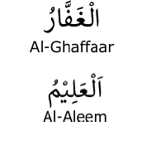
For the answer, refer to pg. 10 of Ta’lim Syllabus 25-26 Beginner Level

- Hadith:

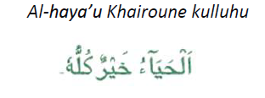
Ecrire traduction de sa Hadith la. [2 points]

For the answer, refer to pg. 10 of Ta’lim Syllabus 25-26 Beginner Level

- D’apres Malfuzat ki ena dans Ta’lim Syllabus, Ki faire Allah plus content Hazrat Muhammad (saw)? [2 points]

For the answer, refer to pg. 10 of Ta’lim Syllabus 25-26 Beginner Level

- Rempli bann tiret avek bann mots ki finn donne enbas: [4 points]

Khulafa Succession Khilafat Successeur

Après Prophétat, institution plis important dans l’Islam, c’est “Khilafat”.

Mot Arabique “Khilafat” signifié “Succession” et le mot “Khalifa” vedir “Successeur”.

Form pluriel du mot “Khalifa”, c’est “Khulafa”.

- Dans le Saint Coran, ki banne types principale de Khulafa finne mentionner. [2 points]

For the answer, refer to pg. 12 of Ta’lim Syllabus 25-26 Beginner Level

- Quand Khilafat e Rashidah ti etabli? [2 points]
For the answer, refer to pg. 12 of Ta’lim Syllabus 25-26 Beginner Level

- Kifere Khilafat e Rashidah pas finne capav continuer? [2 points]
For the answer, refer to pg. 12 of Ta’lim Syllabus 25-26 Beginner Level

- Ecrire quatre Khulafa e Rashideen so nom [4 points]

For the answer, refer to pg. 12 and 13 of Ta’lim Syllabus 25-26 Beginner Level

