Examen Ta’lim – Main Level
Syllabus premier terme (Decembre 2025 - Avril 2026)
[Creole]

Point totale: 75

ANSWER KEY

Section – A: Examen ecrits

- Ecrire commentaire de sa ban verset de Surah Al Inshiqaq:
[Chaque sub-question li 5 points, Totale: 10 points]

a)

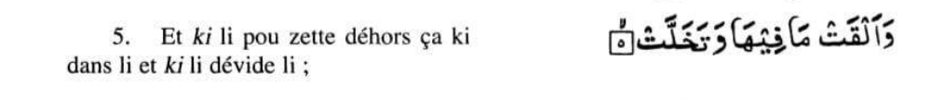
Ecrire au moins ene explication de verset 5 de Surah Al Inshiqaq comme donner dans commentaire de Talim Syllabus 25-26

Refer to Pg. 15 of the Ta’lim Syllabus, Main Level-Creole
b)
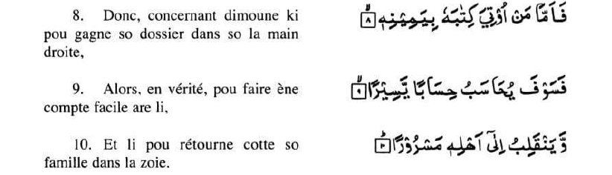

Dans commentaire de versets 8, 9 et 10 de Surah Al Inshiqaq, comme donner dans le Talim Syllabus 25-26, qui explication metaphorique (symbolique) ena de ‘la main droite’

Refer to Pg. 15 of the Ta’lim Syllabus, Main Level-Creole

- Ecrire signification de sa ban attributes d’ Allah, a coter. [5 points]

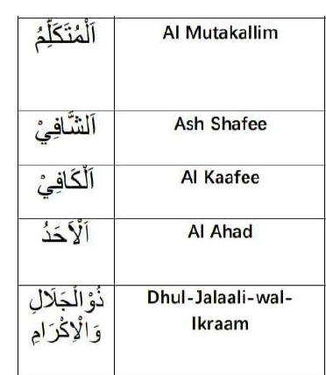

Refer to Pg. 16 of the Ta’lim Syllabus, Main Level-Creole

- Attribut d’Allah – Al Rahman (Le Gracieux) [Ta’lim Syllabus 25-26, Pg.17,18]

(a) Couma Imam Raghib fine explik signification du mot « Rahmat »? [2 points]
Refer to Pg. 17 of the Ta’lim Syllabus, Main Level-Creole

(b) Ki le Messie Promis (as) ine dire lor attribut d’Allah, Al Rahman? [2 points]
Refer to Pg. 17 and 18 of the Ta’lim Syllabus, Main Level-Creole

- Namaz-Traduction mot par mot

Ecrire traduction a coter. [10 points]

Tasmee

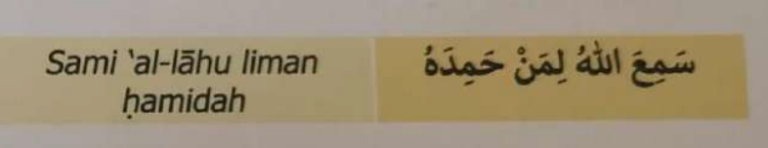
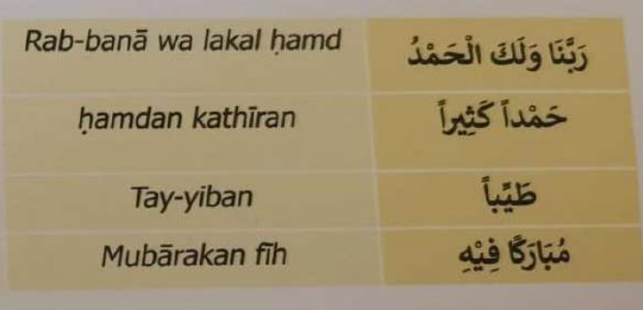
Refer to Pg. 19 of the Ta’lim Syllabus, Main Level-Creole

- Hadith

Banne actions pou recompenser d'apres l'intention ki ena derriere sa.
Hazrat Umar bin Al-Khatab (ra) dire ki :
"Mo ti tende le Saint Prophète (saw) dire: "En verité, pou juge banne actions d'apres
l'intention, et ena ene recompense pou chacun dependant de so l'intention...
[Sahih Al Bukhari, livre de révêlation, chapitre "couma revelation Divine ti commencer."]

D’apres sa Hadith lahaut la, ki l’aspet de banne bons actions plus important ki tout? [5 points]

Refer to Pg. 20 and 21 of the Ta’lim Syllabus, Main Level-Creole

- Ecrire deux points principal ki fine mentionner dans Malfuzat lors ‘Banne épreuves (difficultés) -- zotte necessaire’ comme donner dans Ta’lim Syllabus 25-26. [4 points]
Refer to Pg. 22 and 23 of the Ta’lim Syllabus, Main Level-Creole

- Nazam: Dawat e Fikr

Ecrire signification de banne mots difficile depi sa Nazam, a coter. [4 points]

Transliteration de  banne mots en Urdu | Signification en Creole
Batil

Zid o tasub

Rujuh

Basdiq

Refer to Pg. 27 of the Ta’lim Syllabus, Main Level-Creole

- Sa Nazam, Dawat e Fikr ti ecrire par: [1 point]

Reponse: Hadhrat Masih Maoud (as)

- Ecrire ene explication bref de Nazam, Dawat e Fikr [2 points]
Refer to Pg. 25 of the Ta’lim Syllabus, Main Level-Creole

A noter: Question 10, li baser lors le livre, ‘Le souvenir d’Allah’ ecrit par Hadhrat Mirza Bashir-ud-Din Mahmood Ahmad, Khalifatul-Masih, As Saani (ra), prescrit pou self-study.

- ‘Cest quoi Zikr e Ilahi (Le souvenir d’Allah)’? Reponne dans 100 à 150 mots.
(Couma finne mentionner dans bannes pages prescrit pou self-study de 1st term) [10 points]

Main points of the answer:

- Meaning of Dhikr-e-Ilahi: Dhikr-e-Ilahi means remembering Allah by keeping His attributes in mind, repeatedly mentioning them, affirming them wholeheartedly, and reflecting upon His power and greatness.
- Importance of Dhikr: The Holy Quran describes remembrance of Allah as something of great importance and commands believers to remember Him frequently, especially in the morning and evening.
- Blessings of Dhikr: According to the Holy Prophet (saw), angels surround gatherings where Allah is remembered and Allah’s mercy and blessings descend upon those engaged in Dhikr.
- Dhikr keeps faith alive: Believers are warned not to let wealth, children, or worldly occupations distract them from remembering Allah. A person who remembers Allah is compared to the living, while one who does not is compared to the dead.
- Dhikr encourages righteousness: The Holy Prophet (saw) described remembrance of Allah as exceptionally valuable—even greater than worldly spending and striving in Allah’s cause—because sincere remembrance inspires a person towards righteous deeds.

