

Ta’lim Examination – Main Level
First Term Syllabus (December 2025 - April 2026)
[ENGLISH]

Total marks: 75

ANSWER KEY

Section – A: Written exam

- Answer the questions related to the commentary of the following verses of Surah Al Inshiqaq:
[Each sub-question carries 5 marks, Total: 10 marks]

a)
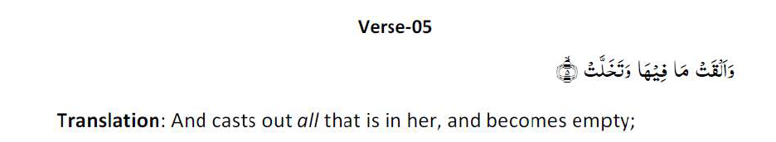
Write at least one meaning of verse 5 of Surah Al Inshiqaq as given in the commentary in the Ta’lim Syllabus 25-26.
For the answer: Refer to Pg.13 of Ta’lim Syllabus 25-26 Main Level-English
b)
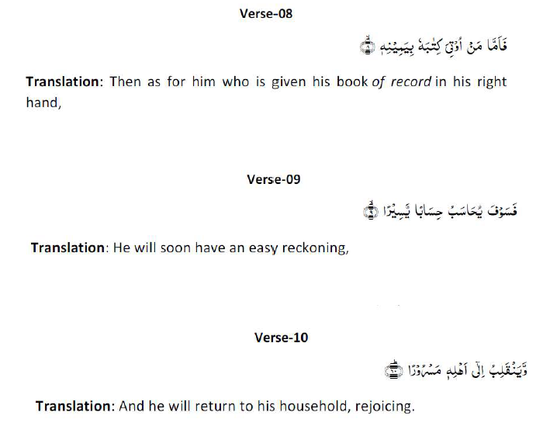
In the commentary of verses 8, 9 and 10 of Surah Al Inshiqaq, as given in the Ta’lim syllabus 25-26, what does the metaphor ‘the right hand’ signify?

For the answer: Refer to Pg.15 of Ta’lim Syllabus 25-26 Main Level-English

- Please write down the meaning of the following attributes of Allah, on the side. [5 marks]
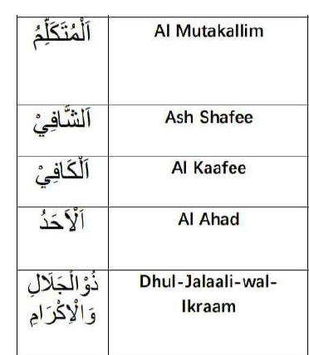
For the answer: Refer to Pg.16 of Ta’lim Syllabus 25-26 Main Level-English

- Attribute of Allah – Al Rahman (The Gracious) [Ta’lim Syllabus 25-26, Pg.17,18]

- What did Imam Raghib explain that the word, ‘Rahmat’ connotes? [2 marks]

For the answer: Refer to Pg.17 of Ta’lim Syllabus 25-26 Main Level-English
(b) What did the Promised Messiah (as) say about the attribute of Allah, Al Rahman? [2 marks]
For the answer: Refer to Pg.13 of Ta’lim Syllabus 25-26 Main Level-English
- Namaz-Split word translation

Please write the translations on the side. [10 marks]

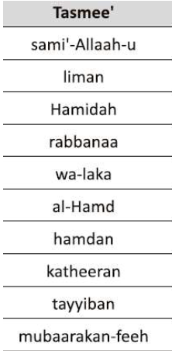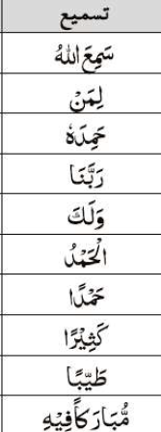
For the answer: Refer to Pg.19 of Ta’lim Syllabus 25-26 Main Level-English

- Referring to the Hadith below, what is the most important aspect of doing good actions? (as given in the explanatory notes in Ta’lim Syllabus 25-26). [5 marks]
For the answer: Refer to Pg.21 and 22 of Ta’lim Syllabus 25-26 Main Level-English

- Write two main points of the Malfuzat on ‘Trials are Necessary’ as given in the Ta’lim Syllabus 25-26.
[4 marks]
For the answer: Refer to Pg.23 of Ta’lim Syllabus 25-26 Main Level-English

- Nazam: Dawat e Fikr
Write the meanings of the difficult words from the Nazam, on the side. [4 marks]
Transliteration of words in Urdu | Meaning in English
Batil

Rujuh

Zid o tasub

Basdiq

For the answer: Refer to Pg.13 of Ta’lim Syllabus 25-26 Main Level-English

- The Nazam, Dawat e Fikr was written by: [1 mark]

- Hadhrat Masih Maoud (as)

- Write a brief explanation of the Nazam: Dawat e Fikr. [2 marks]
For the answer: Refer to Pg.25 of Ta’lim Syllabus 25-26 Main Level-English

Please note: Question 10 is based on the book, ‘Remembrance of Allah’
written by Hadhrat Mirza Bashir-ud-Din Mahmood Ahmad, Khalifatul-Masih, As Saani (ra),
which is set for self-study.

- ‘What is Zikr e Ilahi (Remembrance of Allah)’? Answer in 100 to 150 words.
(As mentioned in the pages set for study in first term). [10 marks]

Main points of the answer:

- Meaning of Dhikr-e-Ilahi: Dhikr-e-Ilahi means remembering Allah by keeping His attributes in mind, repeatedly mentioning them, affirming them wholeheartedly, and reflecting upon His power and greatness.
- Importance of Dhikr: The Holy Quran describes remembrance of Allah as something of great importance and commands believers to remember Him frequently, especially in the morning and evening.
- Blessings of Dhikr: According to the Holy Prophet (saw), angels surround gatherings where Allah is remembered and Allah’s mercy and blessings descend upon those engaged in Dhikr.
- Dhikr keeps faith alive: Believers are warned not to let wealth, children, or worldly occupations distract them from remembering Allah. A person who remembers Allah is compared to the living, while one who does not is compared to the dead.
- Dhikr encourages righteousness: The Holy Prophet (saw) described remembrance of Allah as exceptionally valuable—even greater than worldly spending and striving in Allah’s cause—because sincere remembrance inspires a person towards righteous deeds.

