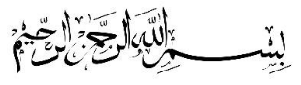

Examen Ta’lim – Main Level
Syllabus premier terme (Mai 2026 - Aout 2026)
[Creole]

Point totale: 85

ANSWER KEY

Section – A: Examen ecrits

- Ecrire commentaire de sa ban verset de Surah Al Inshiqaq:
[Chaque sub-question li 5 points, Totale: 10 points]

a)
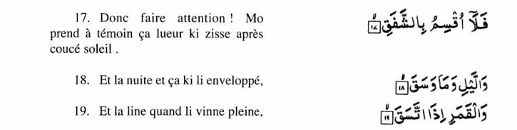

Ecrire ene explication de verset 17, 18 et 19 de Surah Al Inshiqaq cuma inn donner dans Ta’lim Syllabus 25-26.

For the answer, please refer to Pg.33 of Ta’lim Syllabus 25-26 Main level-Creole

b)

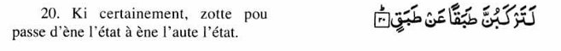

Ecrire ene explication de verset 20 de Surah Al Inshiqaq cuma inn donner dans le Ta’lim Syllabus 25-26.

For the answer, please refer to Pg.33 of Ta’lim Syllabus 25-26 Main level-Creole

- Ecrire signification de sa ban attributes d’ Allah, a coter. [5 points]

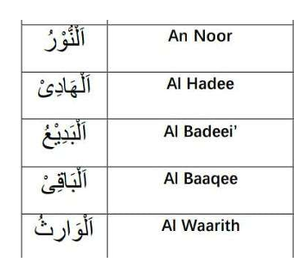

For the answer, please refer to Pg.35 of Ta’lim Syllabus 25-26 Main level-Creole

- Attribut d’Allah – Al Quddus (Celi ki Saint)

(a) Ki Khalifatul Masih Al Awwal (ra) ine dire lor Attribut ‘Al Quddus’ dans extrait couma inn donne dans Ta’lim Syllabus 25-26. [2 points]

For the answer, please refer to Pg.35 and 36 of Ta’lim Syllabus 25-26 Main level-Creole

(b) Ki Khalifatul Masih As Saani (ra) ine dire lor Attribut d’Allah, ‘Al Quddus’ dans extrait couma inn donne dans Ta’lim Syllabus 25-26. [2 points]

For the answer, please refer to Pg.36 of Ta’lim Syllabus 25-26 Main level-Creole

- Namaz-Traduction mot par mot

Ecrire traduction a coter. [11 points]

Sajdah

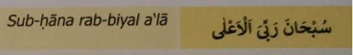

Jilsa

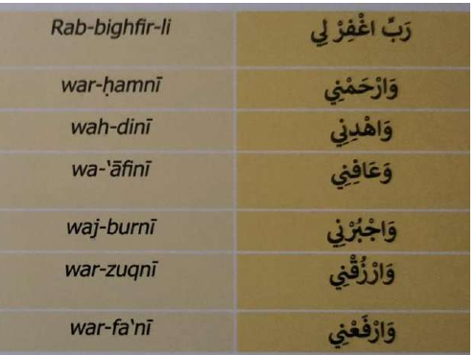

For the answer, please refer to Pg.37 of Ta’lim Syllabus 25-26 Main level-Creole

- Hadith
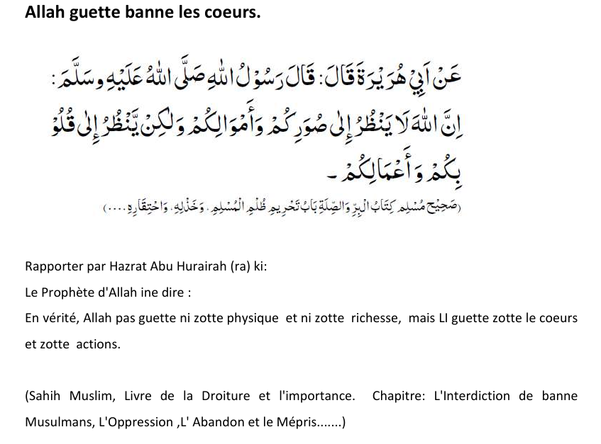

Ecrire ki signification du mot ‘qalb’ finne donner dans sa Hadith la dans explication dans Ta’lim Syllabus 25-26? [5 points]

For the answer, please refer to Pg.38-40 of Ta’lim Syllabus 25-26 Main level-Creole

- Ecrire deux points principal ki fine mentionner dans Malfoozat ‘Bon action, li meilleur si faire li en secret’ comme donner dans Ta’lim Syllabus 25-26. [5 points]

For the answer, please refer to Pg.40 and 41 of Ta’lim Syllabus 25-26 Main level-Creole

- Nazam: Isaion sey khitab

Ecrire signification de banne mots difficile depi sa Nazam, a coter. [4 points]

Transliteration de  banne mots en Urdu | Signification en Creole
Noor

Ausaaf

Hikmat

Dilruba

For the answer, please refer to Pg.46 of Ta’lim Syllabus 25-26 Main level-Creole

- Sa Nazam, Isaion sey khitab ti ecrire par: [1 point]

Hadhrat Masih Maoud (as)

- Ecrire ene explication bref de Nazam: Isaion sey khitab [2 points]

For the answer, please refer to Pg.46 of Ta’lim Syllabus 25-26 Main level-Creole

A noter: Question 10, li baser lors le livre, ‘Le Souvenir d’Allah’ ki finne ecrire par Hadhrat Mirza Bashir-ud-Din Mahmood Ahmad, Khalifatul-Masih, As Saani (ra), ki ti prescrire pou self-study.

- D'après Hazrat Musleh Maud (ra), ki faire li important pou banne membres de nous Jama'at pou porte plus boucou l'attention lors Zikr-e-Ilahi ?

Reponne dans 100 à 150 mots.
(Couma finne mentionner dans bannes pages prescrit pou self-study de 2nd term) [10 points]

Model Answer written by Ayesha Shadiya Khudurun Sahiba, she is a position holder of competition Ta’lim exam 25-26

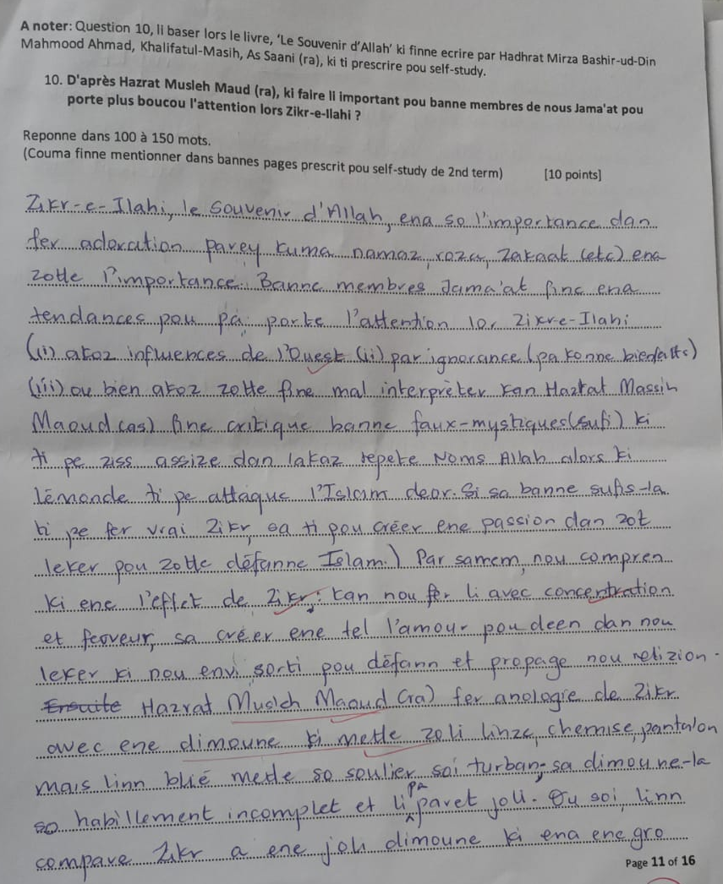

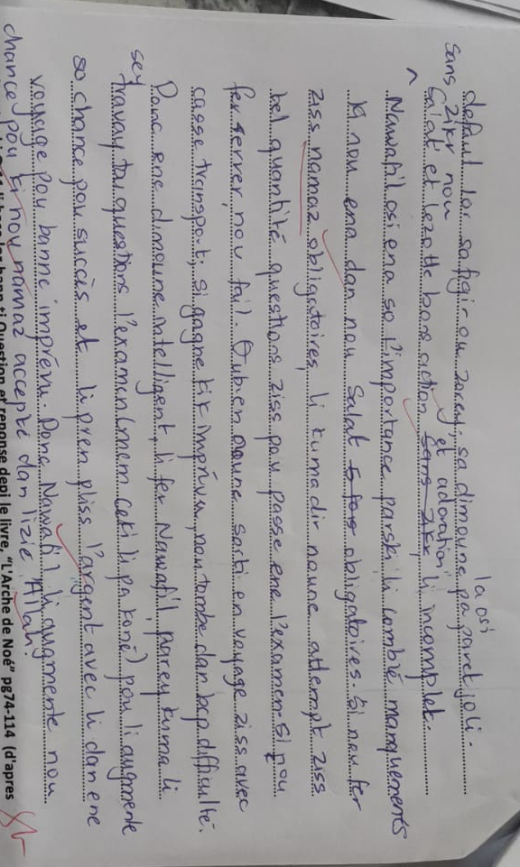

A noter ki Q.11 li base lor bann ti Question et reponse depi le livre, “L'Arche de Noé” pg74-114 (d'apres contenue ki inn prescrit pou l’examen)
Choisir et repond zis quatre question parmi ceki inn donn ou enbas.
Pou chaque question ou pou gagne 2 points. Total: 8 points

- Kifer eski le Messie Promis(as) inn dire ki bann revelation divine li important?
- Donn deux raison kifer Surah Al-Fatihah li consideré couma important.
- Expliké ki pé rode dire par la Certitude.
- Expliké kifer le Messie Promis(as) inn montre nou ki le Saint Quran bizin le premier critère kan pou juge authenticité d'enn Hadith.
- Couma eski le cinq namaz quotidien li beneficier enn croyant?
- Mention deux but de mission du Messie Promis (as).

Main points of the answers:

1.Divine Revelation
- It proves Islam is a living religion.
- Allah still communicates with His chosen servants.
- It strengthens the faith of believers.
- It is evidence of divine support.

2. Surah Al-Fatihah
- It is the summary of the Holy Qur’an.
- It teaches believers how to seek Allah’s guidance.
- It contains essential spiritual teachings.
- It promises blessings for those who follow the straight path.

3. Certainty
- Defines Certainty as complete belief or firm faith in Allah.
- Explains that it develops through prayer, righteousness, obedience, and personal spiritual experience.

4. Hadith
- The Holy Qur’an is the highest and most authoritative source of Islamic guidance.
- No authentic Hadith can contradict the Qur’an.
- Hadith should be accepted only when they are consistent with the Qur’an and the established Sunnah.

5. Five Daily Prayers
- They strengthen and purify the soul.
- They protect believers from spiritual harm and future trials.
- They draw a person closer to Allah.
- They remind believers of Allah throughout the day.

6. Mission of the Promised Messiah (as)
- To revive the true teachings of Islam.
- To correct false beliefs.
- To guide humanity back to Allah.
- To establish peace through prayer, reason, and moral reform.

