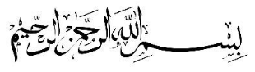

Ta’lim Examination – Main Level
Second Term Syllabus (May 2026 - August 2026)
[ENGLISH]

Total marks: 85

ANSWER KEY

Section – A: Written exam
- Answer the questions related to the commentary of the following verses of Surah Al Inshiqaq:
[Each sub-question carries 5 marks, Total: 10 marks]

a)
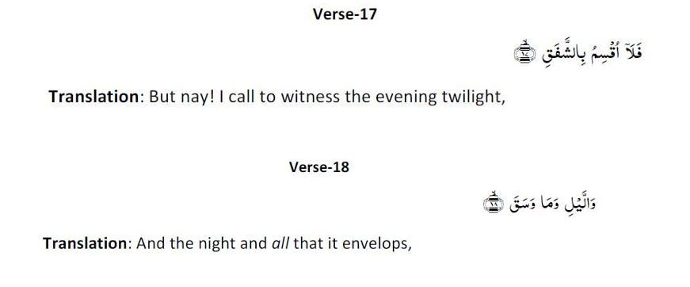
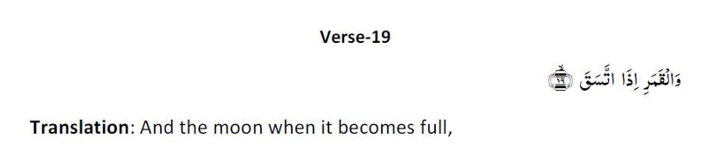
Write the commentary of verses 17, 18 and 19 of Surah Al Inshiqaq as given in the Ta’lim Syllabus 25-26.
For the answer, refer to Pg. 34 of Ta’lim Syllabus 25-26 Main level-Creole.

b)
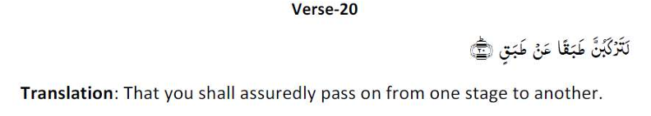
Write the commentary of verse 20 of Surah Al Inshiqaq as given in the Ta’lim Syllabus 25-26.
For the answer, refer to Pg. 34 of Ta’lim Syllabus 25-26 Main level-Creole.

- Please write down the meaning of the following attributes of Allah, on the side. [5 marks]
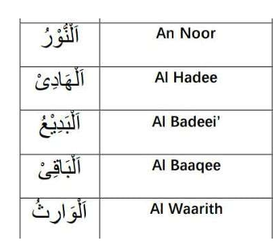
For the answer, refer to Pg. 36 of Ta’lim Syllabus 25-26 Main level-Creole.

- Attribute of Allah – Al Quddus (The Holy One)

- What did Khalifatul Masih Al Awwal (ra) convey about the attribute of Allah, Al Quddus in the extract given in the Ta’lim Syllabus 25-26? [2 marks]

For the answer, refer to Pg. 37 of Ta’lim Syllabus 25-26 Main level-Creole.

(b) What did Khalaifatul Masih As Saani (ra) convey about the attribute of Allah, Al Quddus in the extract given in the Ta’lim Syllabus 25-26? [2 marks]
For the answer, refer to Pg. 38 of Ta’lim Syllabus 25-26 Main level-Creole.

- Namaz-Split word translation

Please write the translations on the side. [11 marks]

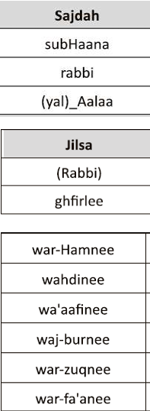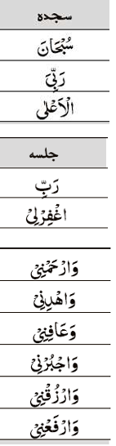
For the answer, refer to Pg. 39 of Ta’lim Syllabus 25-26 Main level-Creole.

- Referring to the Hadith below, what does the word ‘qalb’ mean? (as given in the explanatory notes in Ta’lim Syllabus 25-26). [5 marks]
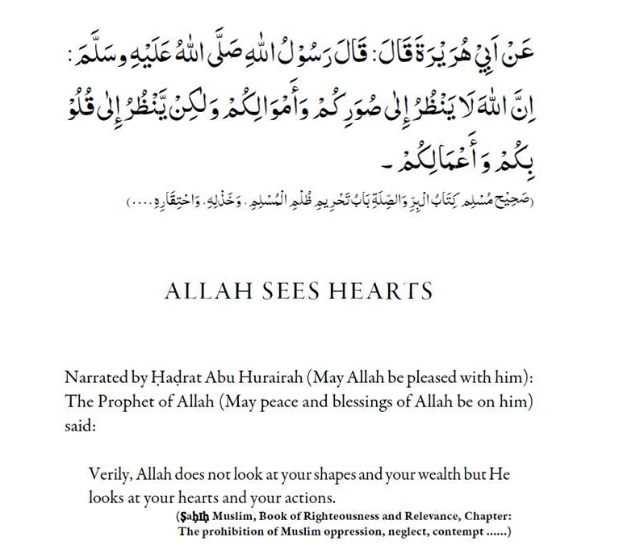
For the answer, refer to Pg. 40 and 41 of Ta’lim Syllabus 25-26 Main level-Creole.

- Write two main points of the Malfuzat on ‘Good deeds are best if concealed’ as given in the Ta’lim Syllabus 25-26. [5 marks]
For the answer, refer to Pg. 42 of Ta’lim Syllabus 25-26 Main level-Creole.

- Nazam: Isaion sey khitab
Write the meanings of the difficult words from the Nazam, on the side. [4 marks]
Transliteration of words in Urdu | Meaning in English
Noor

Ausaaf

Hikmat

Dilruba

For the answer, refer to Pg. 46 of Ta’lim Syllabus 25-26 Main level-Creole.

- The Nazam, Isaion sey Khitab was written by: [1 mark]
Hadhrat Masih Maoud (as)

- Write a brief explanation of the Nazam: Isaion sey khitab. [2 marks]
For the answer, refer to Pg. 44 of Ta’lim Syllabus 25-26 Main level-Creole.

Please note: Question 10 is based on the book, ‘Remembrance of Allah’
written by Hadhrat Mirza Bashir-ud-Din Mahmood Ahmad, Khalifatul-Masih, As Saani (ra),
which is set for self-study.

- ‘According to Hadhrat Musleh Maud (ra), why is it important for people in our Jama'at to focus more on Zikr-e-Ilahi?’ [As mentioned in the pages set for study for second term].
Answer in 100 to 150 words. [10 marks]

Model Answer written by Azra Muslun Sahiba, she is a position holder of competition Ta’lim exam 25-26

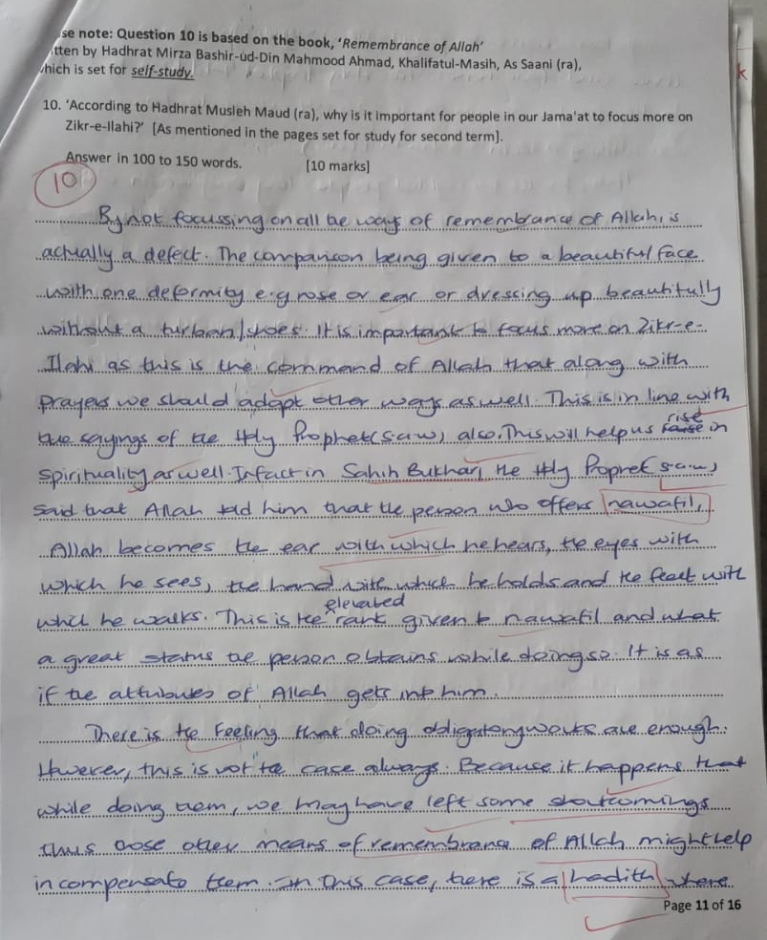

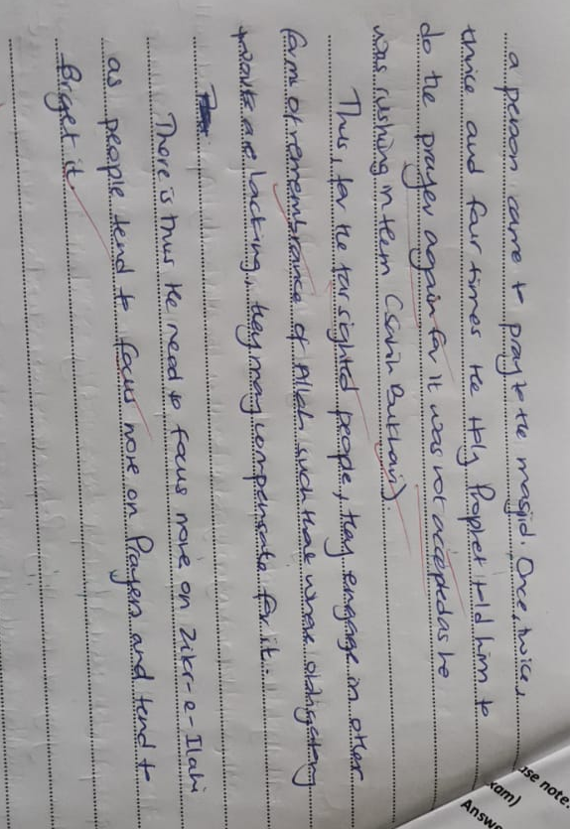

Please note: Q.11 is based on Short-answer questions on ‘Noah’s Ark’ pg. 74-114 (as per content set for the exam)
Answer any four questions. Each question carries 2 marks. Total: 8 marks
1.Why does the Promised Messiah (as) say that divine revelation is important?
2.State two reasons why Surah Al-Fatihah is considered important.
3.Explain what is meant by Certainty.
4.Explain why the Promised Messiah (as) teaches that the Holy Qur’an should be the first criterion for judging the authenticity of a Hadith.
5.How do the five daily prayers benefit a believer?
6.Mention two aims of the mission of the Promised Messiah (as).

Main points of the answers:

1.Divine Revelation
- It proves Islam is a living religion.
- Allah still communicates with His chosen servants.
- It strengthens the faith of believers.
- It is evidence of divine support.

2. Surah Al-Fatihah
- It is the summary of the Holy Qur’an.
- It teaches believers how to seek Allah’s guidance.
- It contains essential spiritual teachings.
- It promises blessings for those who follow the straight path.

3. Certainty
- Defines Certainty as complete belief or firm faith in Allah.
- Explains that it develops through prayer, righteousness, obedience, and personal spiritual experience.

4. Hadith
- The Holy Qur’an is the highest and most authoritative source of Islamic guidance.
- No authentic Hadith can contradict the Qur’an.
- Hadith should be accepted only when they are consistent with the Qur’an and the established Sunnah.

5. Five Daily Prayers
- They strengthen and purify the soul.
- They protect believers from spiritual harm and future trials.
- They draw a person closer to Allah.
- They remind believers of Allah throughout the day.

6. Mission of the Promised Messiah (as)
- To revive the true teachings of Islam.
- To correct false beliefs.
- To guide humanity back to Allah.
- To establish peace through prayer, reason, and moral reform.

