

**Ta’lim Examination**

**First Term Syllabus (January 2025 - April 2025)**

**[ENGLISH]**

**Total marks: 65**

**ANSWER KEY**

**Section – A: Written exam**

1. Write the **commentary** of the following verses of Surah Al Infitar:

[Each sub-question carries 5 marks, Total: 10 marks]

a)



**Refer to pg.9 of English Ta’lim Syllabus 2025**

b)



**Refer to pg.12 of English Ta’lim Syllabus 2025**

1. Please write down the **meaning** of the following attributes of Allah, **on the side**. [3 marks]

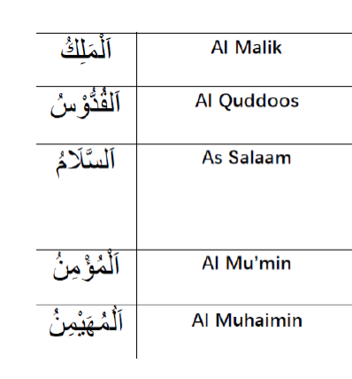

**Refer to pg.15 of English Ta’lim Syllabus 2025**

1. Write/Explain any two points on the attribute, **Al Rabb**, as given in the topic in the Ta’lim Syllabus. [4 marks]

**Refer to pg.16, 17 of English Ta’lim Syllabus 2025**

1. **Namaz-Split word translation**

Please write the translations on the side. [5 marks]



**Refer to pg.18 of English Ta’lim Syllabus 2025**

1. Referring to the **Hadith below**, write about the **Belief in Angels** and **Belief in Books revealed by God** (as given in the explanatory notes in Ta’lim syllabus 2025). [4 marks]

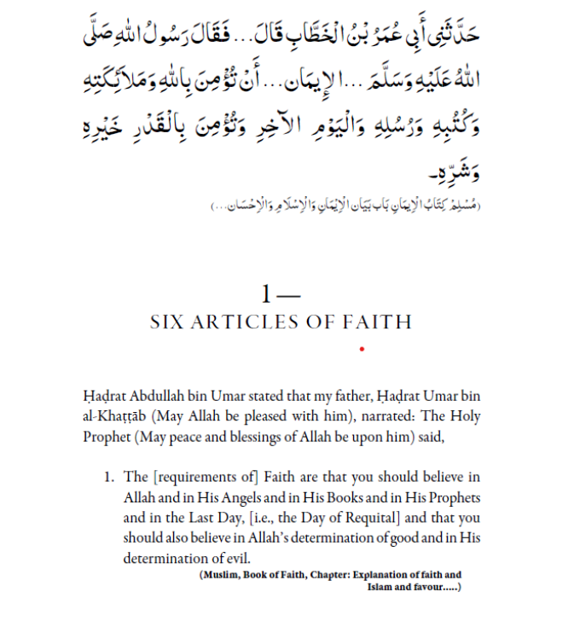

**Refer to pg.20,21 of English Ta’lim Syllabus 2025**

Write any two points on the theme of **Righteousness** as highlighted by **the Promised Messiah (as)** in the **Malfuzat** given in the First term Ta’lim Syllabus 2025. [4 marks]

**Refer to pg.22 of English Ta’lim Syllabus 2025**

1. **Nazam: Nusrat e Ilahi**

Write the meanings of the difficult words from the Nazam, on the side. [3 marks]

|  |  |
| --- | --- |
| **Transliteration of words in Urdu** | **Meaning in English** |
| Nusrat |  |
| Mukhalif |  |
| Aalam |  |

**Refer to pg.25 of English Ta’lim Syllabus 2025**

1. The Nazam, Nusrat e Ilahi was written by: [1 mark]

* **Hadhrat Masih Maoud (as)**

1. Write two ideas as an explanation of the Nazam **or** what the message of the Nazam is about. [2 marks]

**Refer to pg.25 of English Ta’lim Syllabus 2025**

**Please note: Questions 10 and 11 are based on the book, ‘Noah’s Ark’.**

1. Answer the questions below in True or False. Each question carries one mark. Total: 5 marks
2. The book, ‘Noah’s Ark’ is written by Hadhrat Musleh Maoud (ra).

**Answer: False**

1. Another name for the book/exposition, ‘Noah’s Ark’ is ‘An Invitation to Faith’.

**Answer: True**

1. The Promised Messiah (as) asked members of the Jama’at to go and take the vaccine immediately.

**Answer: False**

1. A Hadith mentioned in the book states that there is no disease for which God has not created a remedy.

**Answer: True**

1. Initially, 4,596 copies of the book were printed.

**Answer: False**

1. Short-answer questions on ‘Noah’s Ark’

Answer **any three** of the following questions. Each question carries 3 marks, Total: 9 marks

From the chapter ‘ The Plague Vaccine’ :

**Answers to the Short-Answer Questions on “Noah’s Ark”**

1. What does the Promised Messiah (as) say about the British Government?

- He acknowledges the British Government's justice and religious freedom.

- He appreciates the protection and peace they provide for religious communities.

- He prays for their prosperity and expresses gratitude for the freedom to practice and preach Islam.

2. Who are the ‘true servants’ of the Promised Messiah (as), and what qualities do they display?

- They are sincere followers who wholeheartedly accept his teachings.

- They show unwavering faith, patience, and steadfastness in the face of trials.

- They strive to purify their hearts and actions, embodying righteousness and humility.

3. Two possible reasons for occasional deaths in his community despite the prophecy:

- Some individuals may lack true faith or sincerity.

- Certain members may face trials or divine tests to strengthen their faith.

4. Why does the occasional death not invalidate his prophecy?

- The prophecy was for the protection of the righteous and sincere followers, not everyone in the community.

- Deaths may occur due to natural causes or Divine wisdom, which do not annul the overall fulfillment of the prophecy.

5. Why does the Promised Messiah (as) refer to the example of Abdullah Atham?

- To demonstrate that divine warnings and prophecies can be averted through sincere repentance and turning to Allah.

- Abdullah Atham’s survival after receiving a death prophecy was due to his inward fear and repentance, which aligned with Divine mercy.