

**Ta’lim Examination**

**Second Term Syllabus (May 2025 - August 2025)**

**[ENGLISH]**

**ANSWER KEY**

**Section – A: Written exam**

1. Write the **commentary** of the following verses of Surah At Tariq:

[Each sub-question carries 5 marks, Total: 10 marks]

a)

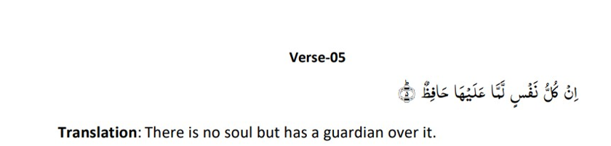

Refer to Pg. 31, 32 of Main level English Ta’lim Syllabus 2025

b)

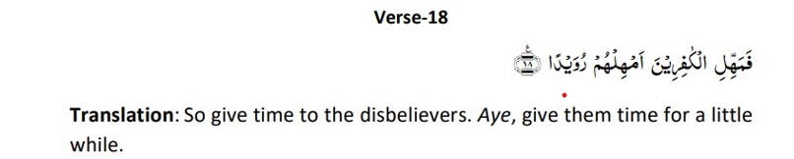

Refer to Pg. 35 of Main level English Ta’lim Syllabus 2025

1. Please write down the **meaning** of the following attributes of Allah, **on the side**. [5 marks]

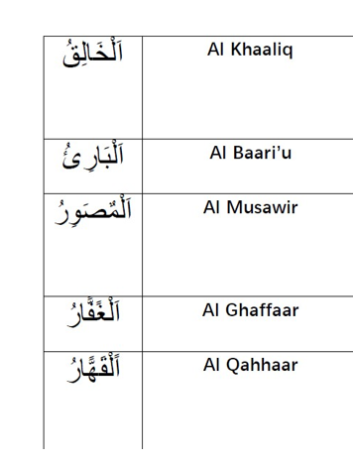

Refer to Pg. 35 of Main level English Ta’lim Syllabus 2025

1. Write about any two points on the attribute, **Al Hadi**, specifically **as explained by the Promised Messiah (as)**, as given in the second term Ta’lim Syllabus 2025. [5 marks]

Refer to Pg. 36, 37 of Main level English Ta’lim Syllabus 2025

1. **Namaz-Split word translation**

Please write the translations on the side. [9 marks]

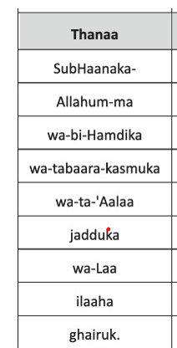

Refer to Pg. 38 of Main level English Ta’lim Syllabus 2025

1. Referring to the **Hadith** below on **the five Pillars of Islam**, write about **Salat** and **Fasting during the month of Ramadhan** (as given in the explanatory notes in Ta’lim Syllabus 2025). [6 marks]

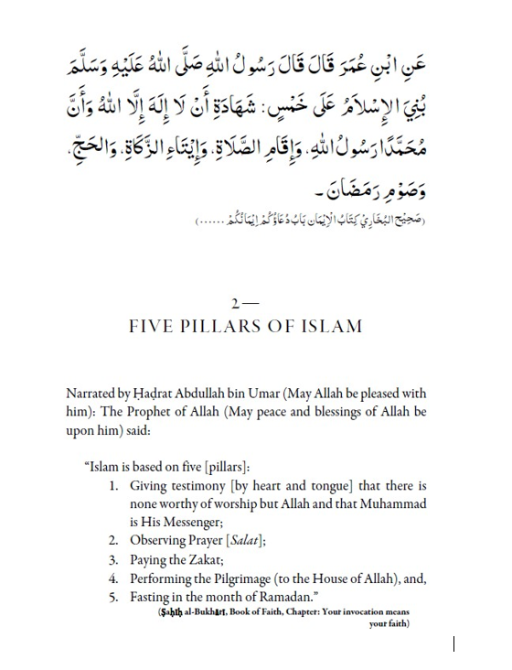

Refer to Pg. 40, 43 and 44 of Main level English Ta’lim Syllabus 2025

1. Write about the **theme of Harmony in one’s words and deeds** as highlighted by **the Promised Messiah (as)** in the **Malfuzat** given in the Second term Ta’lim Syllabus 2025. [5 marks]

Refer to Pg. 45 of Main level English Ta’lim Syllabus 2025

1. **Nazam: Ausaaf e Quran e Majeed**

Write the meanings of the difficult words from the Nazam, on the side. [3 marks]

|  |  |
| --- | --- |
| **Transliteration of words in Urdu** | **Meaning in English** |
| Ausaaf |  |
| Ajla |  |
| Murjha |  |

Refer to Pg. 48 of Main level English Ta’lim Syllabus 2025

1. The Nazam, **Ausaaf e Quran e Majeed** was written by: [1 mark]

* **Hadhrat Masih Maoud (as)**

1. Write a brief explanation of the **Nazam: Ausaaf e Quran e Majeed**. [2 marks]

Refer to Pg. 48 of Main level English Ta’lim Syllabus 2025

1. Short-answer questions on ‘Noah’s Ark’

Answer any 3 (three) of the following questions. Each question carries 3 marks, Total: 9 marks

**From the chapter ‘Our Teachings’:**

**Question (a)**

**Explain the value of the Quran as described by Hazrat Massih Mawood (as). Support your answer with at least three key points from the book.**

* The Quran is the ultimate source of salvation and disregarding its commandments shuts the door to salvation.
* It is the only direct guidance from God, surpassing all other scriptures (e.g., Torah, Gospel).
* The Quran has the power to purify and transform a person within a week if followed sincerely.
* It contains all spiritual and religious needs, fulfilling every requirement for faith and prosperity.
* The Quran’s Holy Spirit manifested magnificently (unlike the Gospel’s "weak" pigeon symbolism), making it superior.
* The Quran grants blessings akin to those given to Prophets, Martyrs, and the Righteous
* Without the Quran, the world would be spiritually "a filthy half-formed lump of flesh."

**Question (b)**

**Give an example from the book that compares Quranic teachings with those of the Gospel, also explain how the teachings of the Quran, from the example chosen, is superior. (3 marks)**

**Suggested examples and explanations**

1. Treatment of Women & Modesty

- Quran:

- Forbids any glance at non-Mahram women (even with pure intent).

- Orders believers to lower their gaze (like "clouded cataract vision").

- Gospel:

- Only forbids lustful glances; permits looking otherwise.

2. Alcohol Consumption

- Quran: Complete ban (considered "Satan’s invention").

- Gospel: Permits drinking as long as one is not intoxicated.

3. Anger & Forgiveness

- Quran:

- Suppress anger and encourage others to show mercy (Surah Al-Balad 90:18).

- Allows measured retribution if it reforms the oppressor (Surah Ash-Shura 42:41).

- Gospel:

- Advocates unconditional forgiveness (e.g., "turn the other cheek").

4. Divorce & Marital Relations

- Quran:

- Permits divorce for non-adulterous but immoral acts (e.g., lustful behavior, idolatry, Surah An-Nur 24:27).

- Gospel:

- Forbids divorce except in cases of adultery.

5. Oaths & Testimony

- Quran:

- Bans meaningless oaths but allows sworn testimony for justice.

- Gospel:

- Total prohibition of oaths ("swear not at all").

6. Resistance to Oppression

- Quran:

- Permits self-defense and proportional justice.

- Gospel:

- Teaches non-resistance ("do not resist an evil person").

7. Love for Enemies

- Quran:

- Oppose actions, not persons; pray for enemies but reject their wrongdoing.

- Gospel:

- Commands to "love your enemies" and bless those who curse you.

8. Prayer & Good Deeds

- Quran:

- Pray publicly or privately based on wisdom (Surah Al-Baqarah 2:275).

- Good deeds should be visible if they inspire others.

- Gospel:

- Pray only in secret; good deeds must be hidden.

9. Concept of God’s Presence

- Quran:

- God’s holiness is proclaimed on earth and heaven (everything glorifies Him).

- Gospel:

- Focuses on God being "in heaven" (e.g., "Our Father in heaven").

10. Cursing & Blessings

- Quran:

- Do not curse unless divine inspiration confirms it (e.g., Prophets never blessed Satan).

- Gospel:

- Instructs to bless those who curse you.

**Question (c)**

**The Promised Messiah (as) says that some people do not belong to his Community. Mention 3 examples.**

Those who are not of the Community

1. Dishonest & Deceitful

- Liars, fraudsters, and those who practice deceit.

2. Materialistic & Worldly

- People obsessed with greed, ignoring the hereafter.

3. Worldly Over Religious

- Those who prioritize worldly matters over faith.

4. Unrepentant Sinners

- Individuals who do not abandon:

- Drunkenness, gambling, lustful gazes.

- Bribery, corruption, misappropriation.

5. Neglectful of Prayer

- Those who skip the five daily prayers.

6. Lacking Humility & Remembrance of God

- People who do not supplicate or remember Allah with humility.

7. Keeping Evil Company

- Those who associate with corrupt influencers.

8. Disrespectful to Parents

- Children who disobey parents (unless against Islam) or neglect serving them.

9. Harsh with Family

- Men who mistreat wives or in-laws; wives who deceive husbands.

10. Unkind to Neighbors

- Those who refuse even small acts of kindness to neighbors.

11. Unforgiving & Grudge-Holders

- People who refuse to pardon offenders.

12. Oath-Breakers (Bai’at Violators)

- Those who break their pledge of allegiance.

13. Deniers of His Messianic Claim

- People who reject him as the Promised Messiah & Mahdi.

14. Disobedient to Righteous Commands

- Those unwilling to follow his guidance in goodness.

15. Allies of Opponents

- Those who associate with/support his detractors.

16. Open Sinners & Their Associates

- Includes:

- Adulterers, drunkards, murderers, thieves.

- Gamblers, corrupt officials (bribe-takers), usurpers.

- Tyrants, liars, forgers, slanderers.

- Even those who sit with such sinners without repentance.

**Question (d)**

**Briefly describe the main differences between human beings and angels as explained by the Promised Messiah (as) in the book?**

Angels:

- They are unable to disobey.

-They are not subject to error or forgetfulness.

- They cannot progress.

- They have no free will.