7COM1079-0901-2025 - Team Research and Development Project

Final report title: Sports vs Other Genres: Investigating Differences in Global Video Game Sales

Group ID: 7COM1079-Group-B-150

Dataset number: DS 157

Prepared by - 24099492 Kanakam Lakshmi
24099202 Kaanushan Sivarajah
24099735 Fajal Baig
24099772 Sujin Kumar Anthati

University of Hertfordshire
Hatfield, 2025
Table of Contents
1.Introduction 3
1.1 Problem Statement and Research Motivation 3
1.2 The Data Set 3
1.3 Research Question 3
1.4 Null Hypothesis and Alternative Hypothesis (H0/H1) 3
2.Background Research 4
2.1 Research Paper 4
2.2 Why RQ is of interest 4
3.Visualisation 5
3.1 Appropriate Graphs for the RQ 5
3.2 Additional information relating to understanding the data 6
3.3 Useful Information for the data understanding 6
4.Analysis 6
4.1 Statistical test used to test the hypotheses and output 6
4.2 The Null Hypothesis is rejected / not rejected based on the p-value 6
5.Evaluation – Group Experience at 7COM1079 7
5.1 What went Well 7
5.2 Points for Improvement 7
5.3 Group’s Time Management 7
5.4 Project Overall Judgement 7
5.5 Comment on the GitHub log Output 7
6.Conclusion 8
6.1 Results Explained 8
6.2 Interpretation of the results 8
6.3 Reason or Implications for future works 8
7.Reference List 9
8.Appendics 9
Appendix A-R code 9
Appendix B – GitHub screenshots 13

1.Introduction

1.1 Problem Statement and Research Motivation
The video game industry has expanded rapidly and global slae have become one of the main ways to judge a game success. Publishers often study sale trends to decide which genres are worth funding and players also form expectations based on genre labels. Some genres seem more visible or talked about, but popularity does not always translate into higher into sale. Because of this it is useful to look at whether certain genres consistently perform better than others. Sports game are a good example as they include well known franchises and release regularly which might give the impression that they sell more than average. This project examines whether sports game achieve different levels of global sales by comparing them with all other genres combined. The aim is to provide a simple data driven comparison that helps clarify how genre relates to sales performance.

1.2 The Data Set
The dataset includes more than sixteen thousand video games records each containing details such as the game title, platform, genre, publisher, release year and sale across major regions. For this study only genre and global sales variable were needed. After cleaning the dataset and removing missing value, the games were divided into two groups: Sports and Others. This follows the lecturer advice to simplify the comparison by focusing on one genre of interest againstt all remaining genres. The grouped data was then used to perform an independent samples t-test.

1.3 Research Question
This study investigates whether sports games differ in their average global sales when compared with all other video game genres combined. The core question guiding the analysis ‘is: Is there a difference in mean global sales between Sports game and all other genres?’ This comparison helps determine whether Sports games hold a meaningful sales advantage or whether their performance is similar to the wider market.

1.4 Null Hypothesis and Alternative Hypothesis (H0/H1)
To address the research question two hypotheses were set up to guide the statistical analysis.

Null Hypothesis (Ho) : There is no difference in the mean global sales between sports games and all other genres

Alternative Hypothesis (H₁): There is a difference in the mean global sales between sports games and all other genres.

These hypotheses make it possible to test whether any observed difference in sale is genuine or simply due to chance. Because the comparison involves two group and the dependent variable is numerical and independent sample t-test is an appropriate method. The test will show whether sports games stand apart from other genres in terms of average global sales.

2.Background Research

2.1 Research Paper

Previous research has shown that genre can influence how players react to games and what they choose to play. This idea is supported by broader industry studies that examine how different genres shape engagement, expectations and overall player appeal [1]. Some studies suggest that certain genres, such as action or shooter titles, tend to create stronger excitement and involvement, and this level of engagement may contribute to higher sales. Other work has explored how games attract players for different reasons, highlighting the importance of themes, visual style, difficulty and underlying mechanics [2]. These studies reinforce the idea that genre is not just a label but a meaningful part of how players interact with games.

More recent research has looked at how genre preferences shift over time, noting that players respond not only to gameplay but also to wider cultural trends, social influences and technological changes. This means that genre popularity is not fixed and can vary depending on what is happening in the industry and in culture more broadly [3].

Although these studies highlight the importance of genre most focus on player psychology or game design rather than directly comparing sales between genres. Many also examine multiple genres simultaneously which can make the findings harder to interpret. This project takes a simpler approach by comparing one genre, Sports, against all others to offer a clearer view of how genre may relate to global sales performance [4] [5].

2.2 Why RQ is of interest

This research question is worth exploring because sports games are often viewed as a dependable category within the video game market. Many well-known sports franchises release new titles every year, which creates an assumption that they consistently sell well. However, popularity or visibility does not always guarantee higher sales, and relying on assumptions can be misleading without examining real data. By comparing Sports games with all other genres combined, this study offers a straightforward way to see whether Sports titles perform differently in terms of global sales. The findings may also highlight whether genre alone influences commercial success or whether other factors, such as marketing budgets, platform availability or release timing, have a stronger impact. This opens the door for future research to investigate those elements in more details.

3.Visualisation

3.1 Appropriate Graphs for the RQ

To address the research, question a boxplot was chosen as the main visualisation because it provides a clear comparison of global sales between Sports games and all other genres. It shows the median, the spread of the data and any extreme values, which helps identify whether one group tends to sell more than the other. A histogram was included as a supporting plot to show the overall distribution of global sales in the dataset. Since global sales vary widely and include many low-selling games, the histogram helps reveal the shape of the data and highlights the presence of a long right tail. Both plots were generated directly in R and follow the required formatting guidelines.
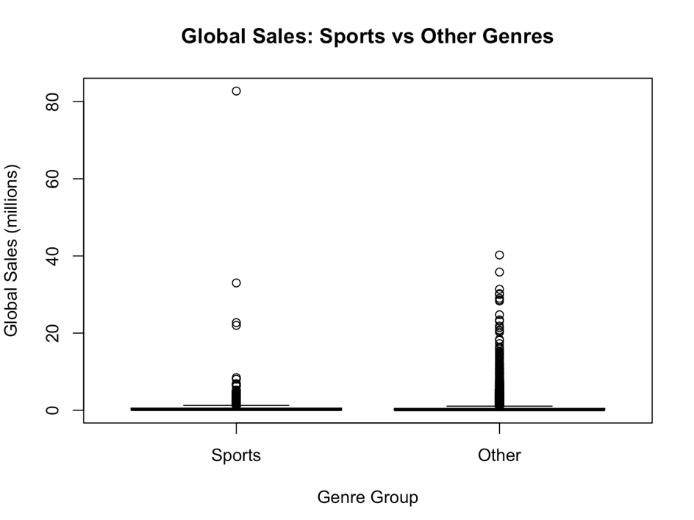
Figure 1 Boxplot

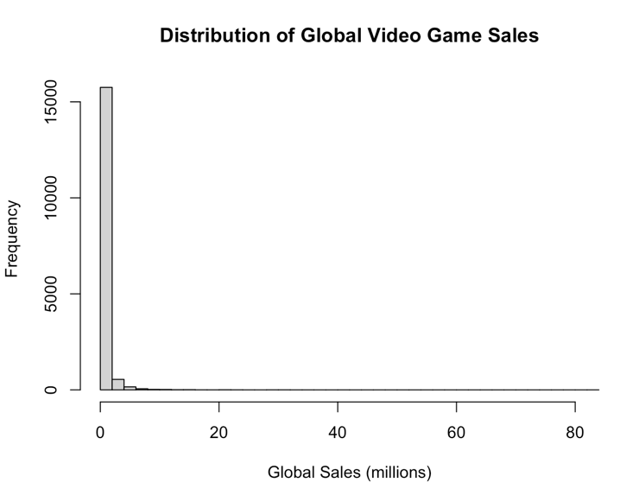
Figure 2 Histogram

3.2 Additional information relating to understanding the data

The boxplot helps compare the two groups by showing their median values and how spread out the sales are within each group. It also makes it easy to spot outliers, which are common in video game sales because a few titles can reach much higher numbers than the rest. The histogram adds context by showing how these values are distributed overall. Most games fall into the lower end of the sales range, with only a small number achieving high global sales. Seeing these patterns helps explain why the average for both group the distribution is small and why affects the interpretation of the results.

3.3 Useful Information for the data understanding

The visualisations show that sports and other genres share very similar patterns in global sales. Both groups include many low-selling games and a few titles that sold extremely well. The medians are close to each other, and the interquartile ranges overlap, which means there is no clear visual sign that one group consistently outperforms the other. The histogram also shows a heavily right-skewed distribution, which is expected in real-world sales data. Taken together, the plots support the statistical results from the t-test. They suggest that genre alone does not create a meaningful difference in average global sales between sports games and rest of the dataset.

4.Analysis

4.1 Statistical test used to test the hypotheses and output

An independent samples t-test was used to compare the mean global sales of sports games with the mean sales of all other genres. This test was appropriate because the research question focuses on the difference between two groups, and the dependent variable, global sales, is numerical. A Welch version of the t-test was chosen since the groups differ in size and may not have equal variances. The test output reported t (2727.7) = 0.78 with a p-value of 0.438.

4.2 The Null Hypothesis is rejected / not rejected based on the p-value

The P-value of 0.438 is well above the common significance level of 0.05. This means there is no statistical evidence to suggest a meaningful difference in mean global sales between Sports games and the Other group. As a result, the null hypothesis is not rejected. Although Sports games show a slightly higher average sales value, the difference is small and not statistically significant. The results indicate that any variation between the two groups is likely due to normal fluctuations within the dataset rather than a real difference in performance.

5.Evaluation – Group Experience at 7COM1079

5.1 What went Well

Our Group worked well together, and everyone contributed to the outcome. We divided the work early which made the project easier to manage. Each member was responsible for a specific part, and we regularly shared update through Teams and WhatsApp. The collaboration helped us stay on track and we supported each other when someone had question about R or the analysis. Overall, the workflow felt smooth respectful and the group communication stayed consistentt throughout.

5.2 Points for Improvement
Although we completed the work on time, we realised we could have organised our schedule more effectively. Some tasks were left until late in the process and a clearer timeline might have helped reduce pressure near the deadline. It would also have been useful to hold more regular short meeting instead of relying mostly on chat message. Improving our documentation on git hub could also help future projects especially when multiple people are editing file.

5.3 Group’s Time Management
We managed our time reasonably well, meeting on Teams and WhatsApp when needed. However, some section of the project took longer than expected. With a more structured plan we cloud have spread the workload more evenly. Even so the group stayed committed and made steady progress towards the deadline.

5.4 Project Overall Judgement
The project achieved its main goal and produced clear results. Our analysis answered the research question, and the group worked together effectively. The process helped us gain more confidence with R and statistical testing. Overall, the project felt successful and gave us a practical understanding of working with real data.

5.5 Comment on the GitHub log Output
The GitHub log Shown in Appendix records each key stage of the project, from loading the dataset to running the analysis and creating the plots. The commits are clear and focused, and they provide a transparent record of how the script was developed and refined over time.

Some Commits
- Commit Message: Create Sports vs Others
Brief explanation: This commit added the code that creates the two-category variable used throughout the project. It grouped Sports games separately from all other genres and prepared the dataset for visualisation and analysis. This step was essential because it defined the independent variable used in both the plots and the t-test.

- Commit Message: Summary statistics for Sports vs Other
Brief explanation: This commit introduced the summary statistics table, including counts, means and standard deviations for both Sports and Other groups. These numbers helped us understand the basic differences between the two groups before running the statistical tests. The summary also supported the interpretation of the t-test results.

- Commit Message: Independent samples t-test Sports vs Other
Brief explanation: This commit added the code that performs the independent samples t-test comparing global sales of Sports games with all other genres. It also includes the output needed for interpreting the hypothesis test. This was a key step in the analysis because it provided the main statistical result used to answer the research question.

6.Conclusion

6.1 Results Explained
The results show that sports game do not differ in a meaningful way from all other genres in terms of average global sales. Although the mean for sports titles is slightly higher the difference is very small and not statistically significant. The t-test produced a statistic of t=0.7764 with a p-value of 0.4376 which is well above the 0.05 threshold. This indicates that any difference between the groups is likely due to random variation in the dataset rather than areal performance gap.

6.2 Interpretation of the results
The analysis shows that sports game does not perform better or worse than other genres in terms of global sale. Since the p-value from the t-test is far above 0.05, there is no evidence that genre alone explains differences in sale. This suggests that other factors such as marketing strategies, brand recognition, platform availability or release timing may be more influential. Overall, the results imply that sale performance is shaped by multiple elements rather than the sports genre standing out on its own.

6.3 Reason or Implications for future works
This study uses one dataset and simplified two group comparison, which may hide meaningful variation within genres. Future work could analyse more genres separately or include variables such as platform release year or regional sale. Previous research also shows that player motivations and market trends influence sale, suggesting that genre is only one part of a larger picture.

7.Reference List

[1] | M. a. Hennig-Thurau, “Value creation in the video game industry: Industry economics, consumer benefits, and research opportunities.,” Journal of Interactive Marketing, no. 27, p. 141–157, 2013.
[2] | C. a. R. L.Nacke, “BrainHex: A neurobiological gamer typology survey.,” Entertainment Computing, no. 2, pp. 55-62, 2011.
[3] | C. J. a. R. M.Birk, “Fostering intrinsic motivation through avatar identification in digital games,” Proceedings of the 2016 CHI Conference on Human Factors in Computing Systems, p. 2982–2995, 2016.
[4] | N. a. S. D.Williams, “Who plays, how much, and why? Debunking the stereotypical gamer profile’,” Journal of Computer-Mediated Communication, no. 13(4), p. 993–1018, 2008.
[5] | J. a. L.Keronen, “Why do people play games? A meta-analysis,” International Journal of Information Management, vol. 37(3), p. 125–141, 2017.

8.Appendics

Appendix A-R code

# Analysis.R
# Full pipeline for "Sports vs Other" analysis using video_games_sales
# Save this file as Analysis.R and run in RStudio (set working directory first)

# 1. Load dataset
View(video_games_sales)

#2.Clean the data and keep the needed variables
video_games_sales <- video_games_sales[, c("genre", "global_sales")]
video_games_sales <- na.omit(video_games_sales)

#3.Create Sports vs Other groups
video_games_sales$genre_group <- ifelse(video_games_sales$genre == "Sports",
"Sports",
"Other")

video_games_sales$genre_group <- factor(video_games_sales$genre_group,
levels = c("Sports", "Other"))

#4.Summary statistics for Sports vs Other
group_counts <- table(video_games_sales$genre_group)
group_means <- tapply(video_games_sales$global_sales,
video_games_sales$genre_group,
mean)
group_sds <- tapply(video_games_sales$global_sales,
video_games_sales$genre_group,
sd)

summary_stats <- data.frame(
genre_group = names(group_counts),
count = as.numeric(group_counts),
mean = as.numeric(group_means),
sd = as.numeric(group_sds)
)

print(summary_stats)

#5.Normality Test for Sports

sports_only <- subset(video_games_sales, genre_group == "Sports")$global_sales
other_only <- subset(video_games_sales, genre_group == "Other")$global_sales

shapiro_sports <- shapiro.test(if(length(sports_only) > 5000) sample(sports_only, 5000) else sports_only)
shapiro_other <- shapiro.test(if(length(other_only) > 5000) sample(other_only, 5000) else other_only)

# print results
print("Shapiro-Wilk test for Sports (possibly sampled):")
print(shapiro_sports)
print("Shapiro-Wilk test for Other (possibly sampled):")
print(shapiro_other)

#6.Independent samples t-test Sports vs Other
t_test_result <- t.test(global_sales ~ genre_group,
data = video_games_sales,
var.equal = FALSE) # Welch t-test

print(t_test_result)

#7.Boxplot
boxplot(global_sales ~ genre_group,
data = video_games_sales,
main = "Global Sales: Sports vs Other Genres",
xlab = "Genre Group",
ylab = "Global Sales (millions)")

#Save the Boxplots as image
png("boxplot_genre_group.png", width = 800, height = 600)

boxplot(global_sales ~ genre_group,
data = video_games_sales,
main = "Global Sales: Sports vs Other Genres",
xlab = "Genre Group",
ylab = "Global Sales (millions)")

dev.off()

#8.Histogram
hist(video_games_sales$global_sales,
breaks = 30,
main = "Distribution of Global Video Game Sales",
xlab = "Global Sales (millions)")

#Save the Histogram as image
png("hist_global_sales.png", width = 800, height = 600)

hist(video_games_sales$global_sales,
breaks = 30,
main = "Distribution of Global Video Game Sales",
xlab = "Global Sales (millions)")

dev.off()

#9.Scatterplot: category vs sales (jittered for clarity)

video_games_sales$genre_numeric <- as.numeric(video_games_sales$genre_group)

png("scatterplot_genre_sales.png", width = 900, height = 700)
# add jitter to x so points don't overlap exactly
plot(jitter(video_games_sales$genre_numeric, amount = 0.15),
video_games_sales$global_sales,
main = "Scatterplot of Global Sales: Sports vs Other (jittered)",
xlab = "Genre Group (1 = Sports, 2 = Other)",
ylab = "Global Sales (millions)",
pch = 16,
cex = 0.6,
col = ifelse(video_games_sales$genre_group == "Sports", "blue", "red"),
xaxt = "n")
axis(1, at = c(1,2), labels = c("Sports", "Other"))
dev.off()

# 10. Export cleaned dataset used for analysis (optional)

write.csv(video_games_sales, "video_games_sales_cleaned.csv", row.names = FALSE)

# 11. Write a short results summary to a text file

sink("results_summary.txt")
cat("Summary of analysis: Sports vs Other (global_sales)\n\n")
cat("Summary statistics (saved to summary_stats_by_genre_group.csv):\n")
print(summary_stats)
cat("\nShapiro-Wilk test results (note: large samples may yield significant p-values):\n")
print(shapiro_sports)
print(shapiro_other)
cat("\nVariance tests:\n")
print(bartlett_res)
if (!is.null(levene_res)) { print(levene_res) } else { cat("Levene's test not run (package 'car' not installed)\n") }
cat("\nWelch t-test result (saved to t_test_result.txt):\n")
print(t_test_result)
cat("\nInterpretation: If p-value > 0.05, we fail to reject the null hypothesis; there is no evidence of a difference in mean global sales between Sports and Other.\n")
sink()

Appendix B – GitHub screenshots
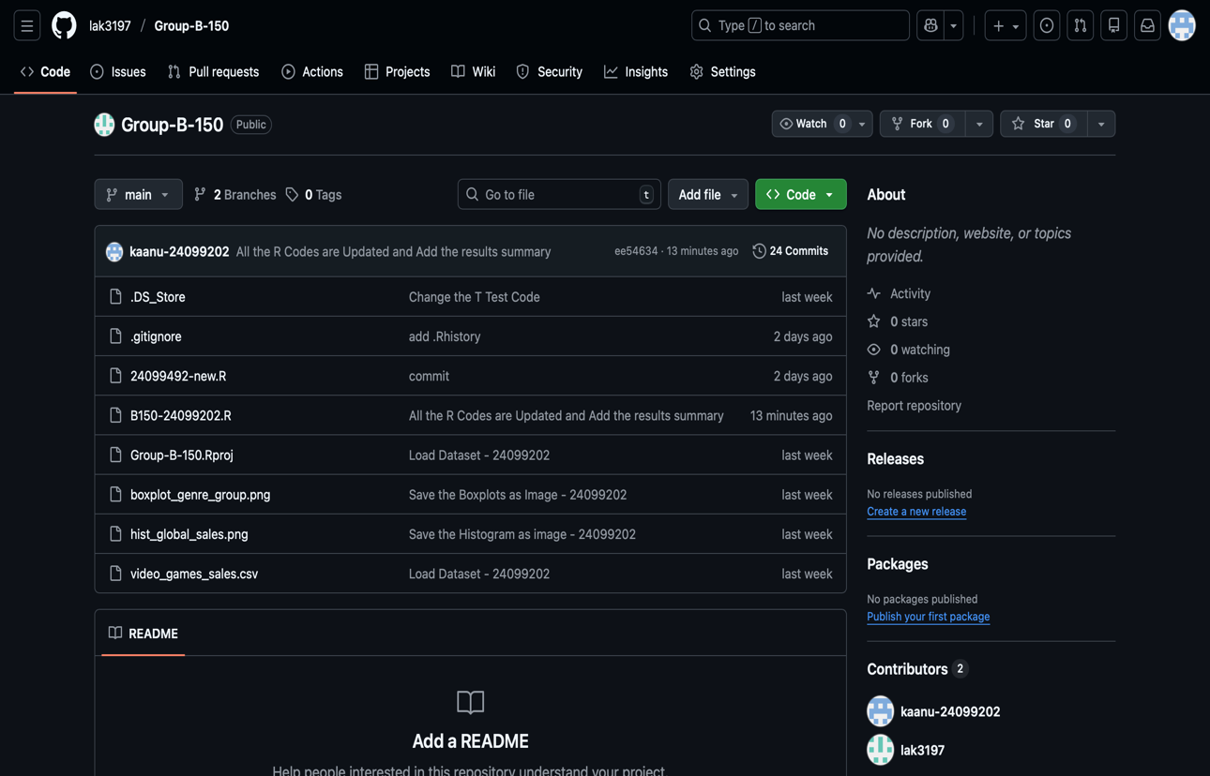
Figure 3 Repository Structure

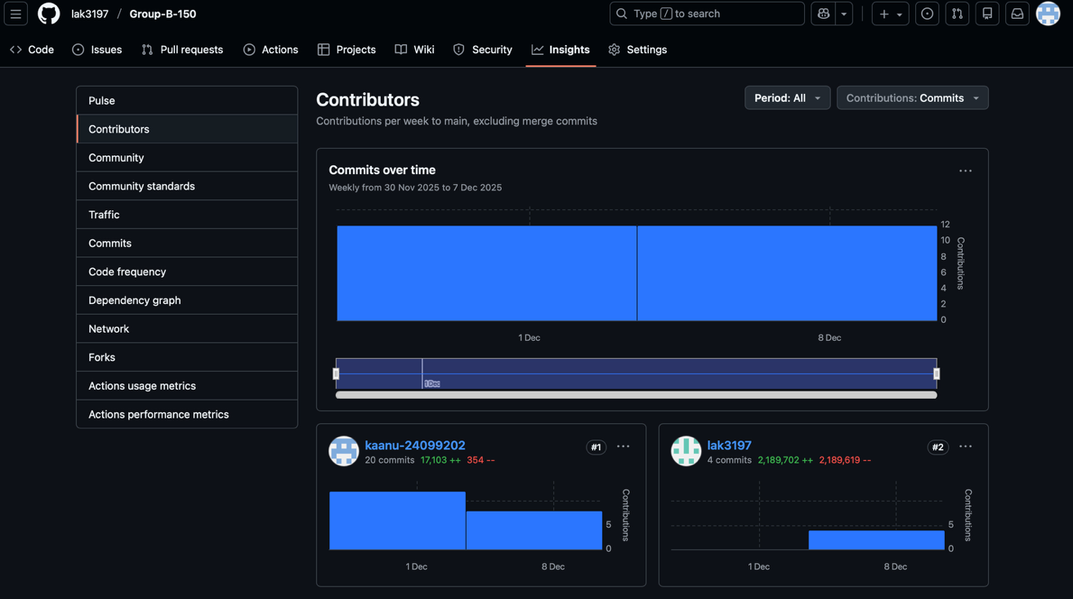
Figure 4 Contributors

