**UVA Football Recruiting Summary**

Logan King

The following is a summary of UVA football recruiting classes dating back to 2002. The data was scraped from 247sports.com and only includes data for recruits that were ranked when coming out of high school. All code for scraping and graphs were produced in R. All information was used in a presentation given to the UVA Football Recruiting Department.

**Background Geographic Information**

The first image displays a US map that is color coded according to which Power Five conference has member schools in that given state. Some states have multiple colors, as there are multiple conferences represented in those states.

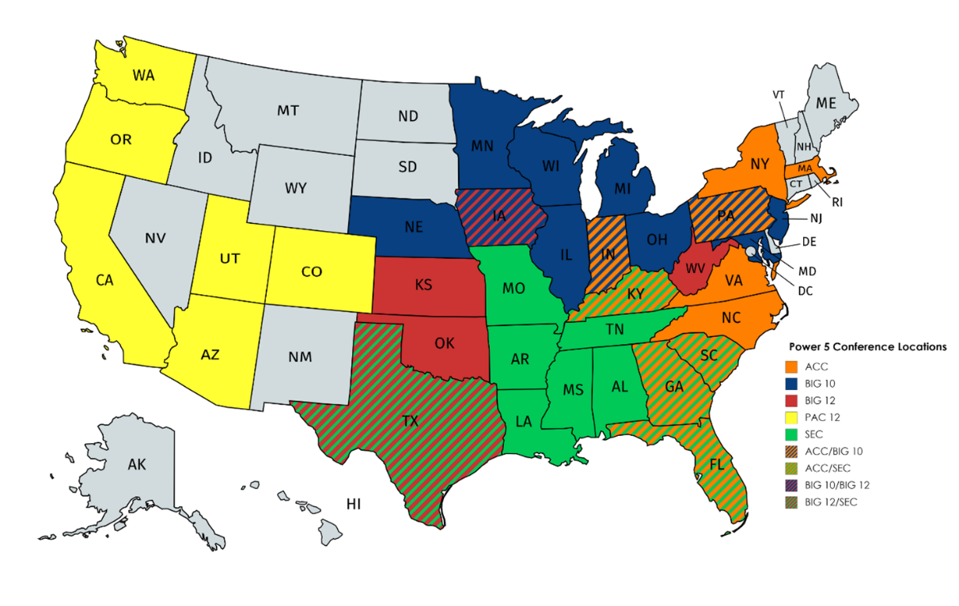

The second image displaysstates considered to be part of the UVA recruiting footprint. States colored orange are considered to be in the primary footprint, while states in blue are considered to be in the secondary footprint. A state’s footprint status is determined by several factors, including distance from the university and airline accessibility to Charlottesville.

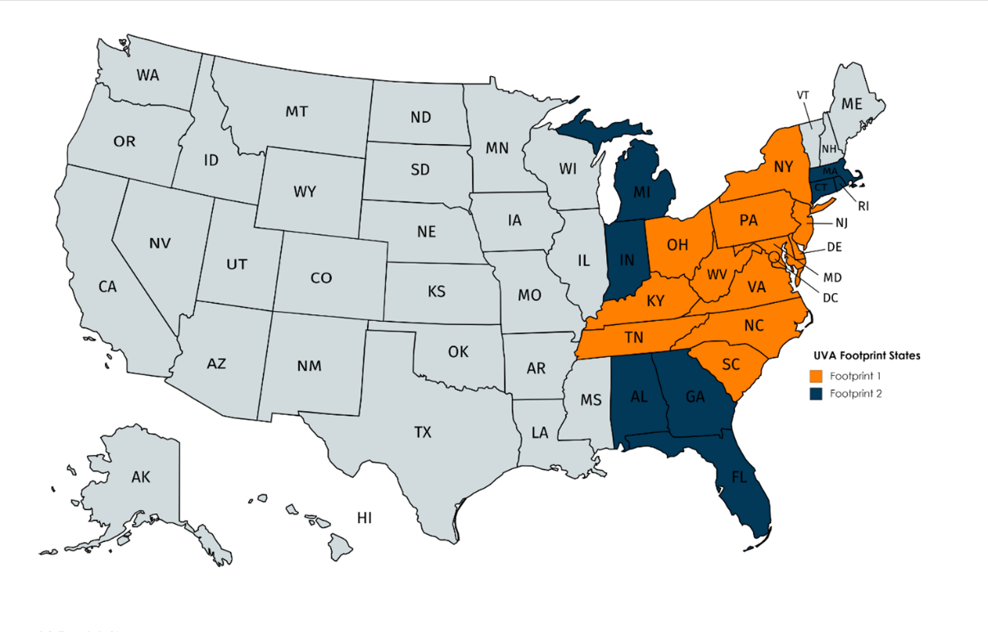

**Recruiting Data Visualization**

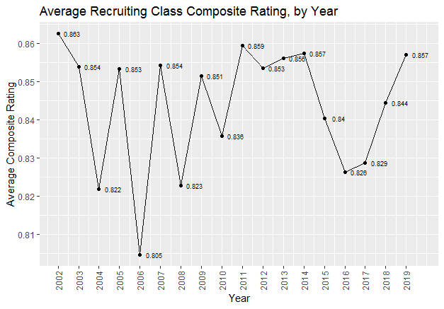

The above graph displays the average 247 composite rating of UVA recruiting classes dating back to the year 2002. Composite ratings are aggregate ratings for recruits based on ratings from multiple football recruiting services. Since Coach Mendenhall’s arrival in 2016, there has been a sharp increase in the average composite rating of UVA recruiting classes.

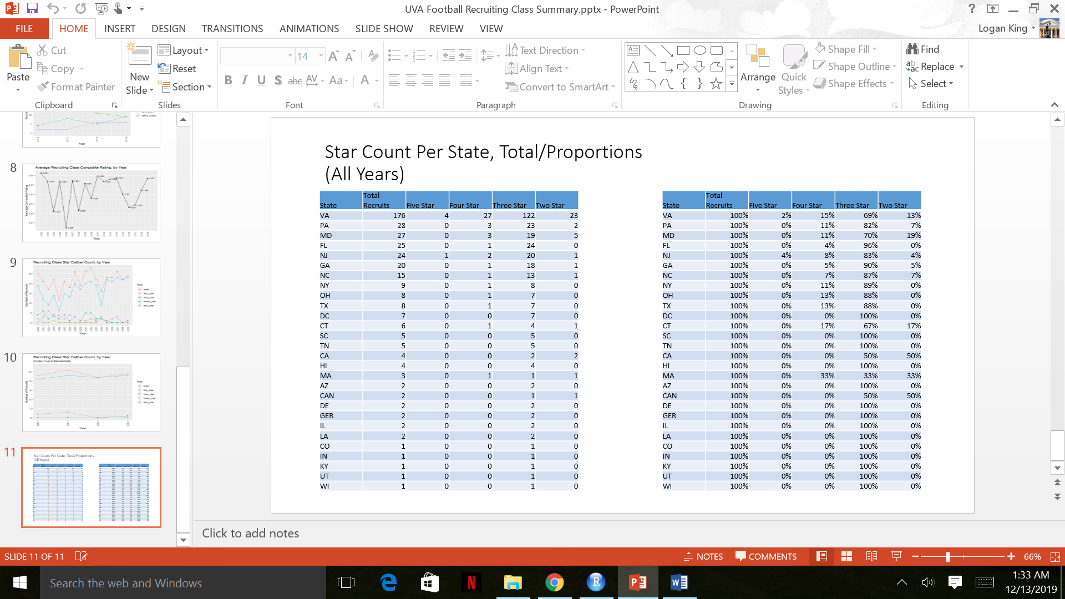

The above charts show a breakdown by state of the total number of recruits and total recruits by star ranking. One chart displays total numbers while the other displays the values as proportions. With the exception of Texas, every 4 star or better recruit has come from a primary or secondary footprint state.

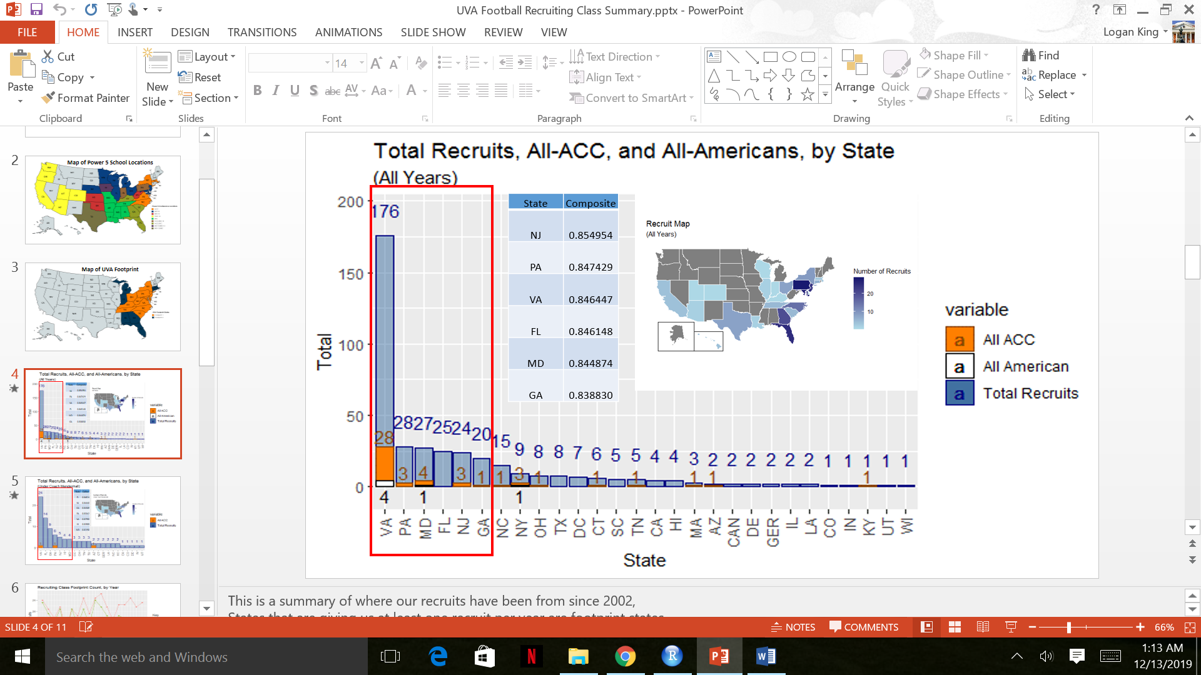

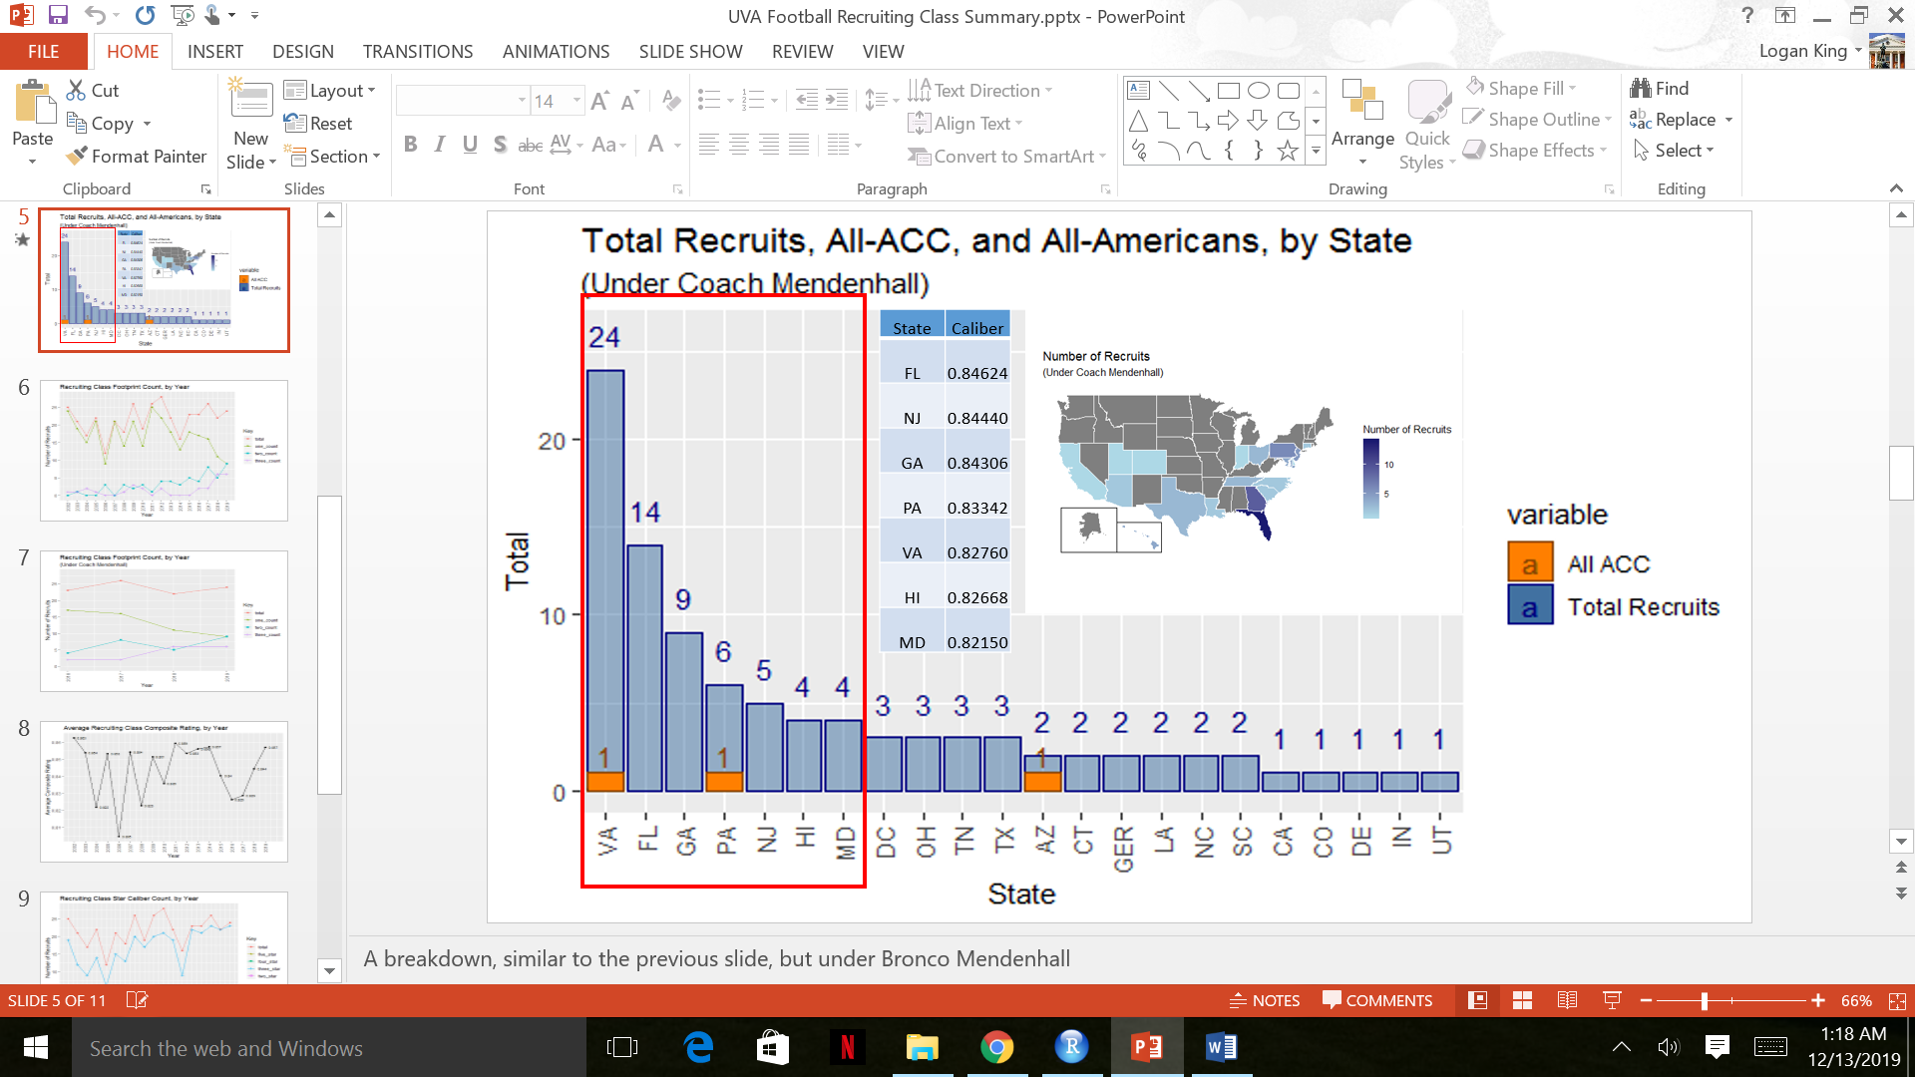

The above graphs display the total recruits from each state for UVA. One graph includes data fro 2002-2019, while the other includes data from Coach Mendenhall’s tenure, 2016-2019. These recruit counts also include the number of recruits who received All-ACC or All-American honors. The highlighted bars include ‘pipeline’ states, those with at least 1 recruit per year. The included charts display the average recruit composite rating for the pipeline states for the given time period. The heat maps give a geographical visualization of the states that recruits come from.

Under Coach Mendenhall, there has been a movement of recruits from outside of the footprint states. Hawaii is now a pipeline state and multiple recruits have come from Louisiana and Germany. Though this could be attributed to the increased accessibility of high school talent in recent years, this trend may point to a need to redefine the idea of which areas are considered priorities and in the recruiting footprint.

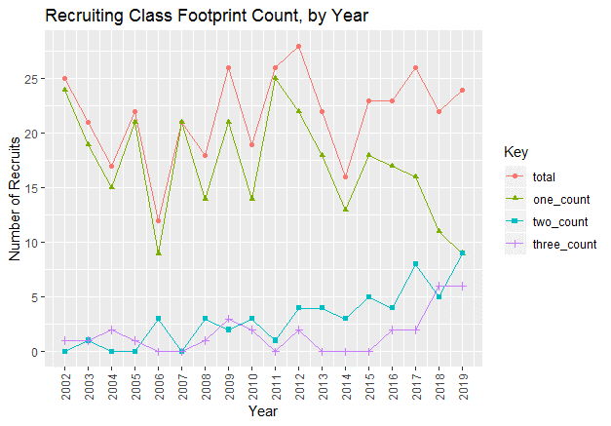

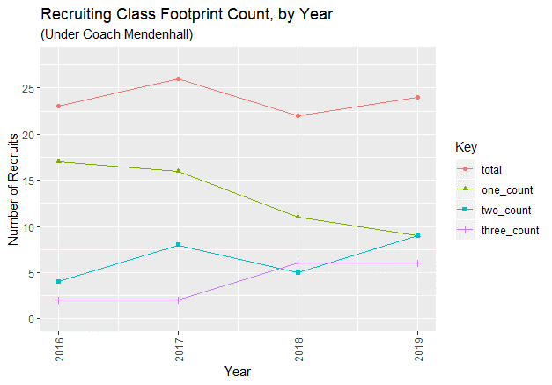

The above graphs display counts for the total number of recruits along with the total number of recruits from each footprint designation for both the 2002-2019 period and subset to the Mendenhall period (2016-2019). Primary footprint, secondary footprint, and outside of footprint are represented by one_count, two_count, and three_count, respectively.

There has been a shift to a larger proportion of the recruiting classes being outside of the primary footprint under Coach Mendenhall. This is in conjuncture with the rise in average composite rating of the recruiting classes under Mendenhall, as seen earlier.

**Conclusion and Recommendations**

Since the arrival of Coach Mendenhall, there has been a surge in the caliber of recruiting class ratings. This increase in caliber has coincided with an increase in the proportion of the recruiting class outside of the primary recruiting footprint. Winning the in-state recruiting battle is a primary goal for recruiting, but given the success seen outside of the primary footprint, re-defining our footprint areas and designating more resources outside of the current primary footprint may bring about positive returns.

Further research into the cause of the shift away from the primary footprint will be useful in contextualizing this data and help to better inform a decision on where recruiting resources should be allocated. An important question that needs to be answered is: what is the reason for the sudden shift away from the primary footprint? Is this shift due to the more national nature of present day recruiting? Is the shift due to connections built by Coach Mendenhall in his tenure at BYU? Is UVA forced to rely on recruits outside of the primary footprint due to major programs stealing away top talent in our backyard? While this list is not exhaustive, answers to these questions will help to better inform the decision of recruiting resource allocation. However, current findings point to promising results from widening our recruiting focus to new areas.