**1. OVERVIEW**

Artistic After Effects is a command-line visual effects application.

Most traditional 3D modelling programs attempt to create photorealistic images. But what if a user wants their model to have an artistic touch to it? What if they want their model to look as though it were an artwork, rather than computer-generated? Artistic After Effects is designed for those 3D modelers. However, it can be applied to any image, such as a traditional painting or photograph.

Artistic After Effects provides users with eight different filters: Noir, Sepia, Vintage, Recolor, Remap, Pixelate, Pencil and Dots. Recolor, Remap, Pixelate, Pencil and Dots are implemented using K-Means Clustering, Depth First Search and Chessboard Overlay.

**2. USAGE**

You must activate the virtual environment. It will have all the required packages:

Python, Wand, PIL. And it will set your Python Path correctly. Do the following:

CD into the AfterEffects folder. Then run: . ./sandbox/bin/activate

[ Note: The Python Path will be set based on your working directory. Therefore, it is important that you are in the AfterEffects folder before activation. ]

**3. FILTER USAGE:**

To use a filter: python3 filter.py {filter} {image path} {other commands}

**A. NOIR**

filter.py noir {image path}

**B. SEPIA**

filter.py sepia {image path}

**C. VINTAGE**

filter.py vintage {image path}

**D.RECOLOR**

filter.py noir {image path} {2+ hex codes}

**E. REMAP**

filter.py noir {map image path} {front image path} {back image path}

**F. PIXELATE**

filter.py pixelate {image path} {optional square size}

**G. PENCIL**

filter.py pencil {image path} {optional square size}

**F. DOTS**

filter.py dots {image path} {optional square size}**4. FILTER EXAMPLES**

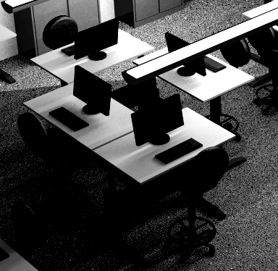**A. NOIR**

Noir filter emulating black-and-white films.

Turns the image greyscale. Then cranks the levels to increase the contrast. Moves the white point to 0.3 and the black point to 0.7.

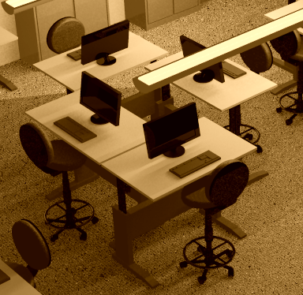**B. SEPIA**

Sepia filter emulating early tinted photography.

Increases sepia tone with a threshold of 0.8.

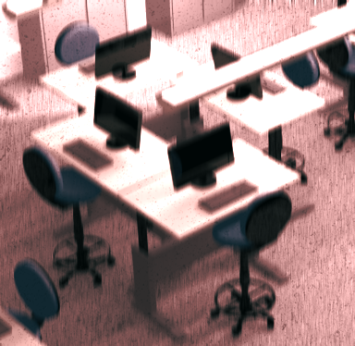**C. VINTAGE**

Vintage filter emulating 70s, 80s photography.

Motion-blurs the image with a random angle of -90, -45, 0, 45 or 90. Composites a grain texture onto the image. Composites a faded sepia version of the image on top of the original with a blend mode.

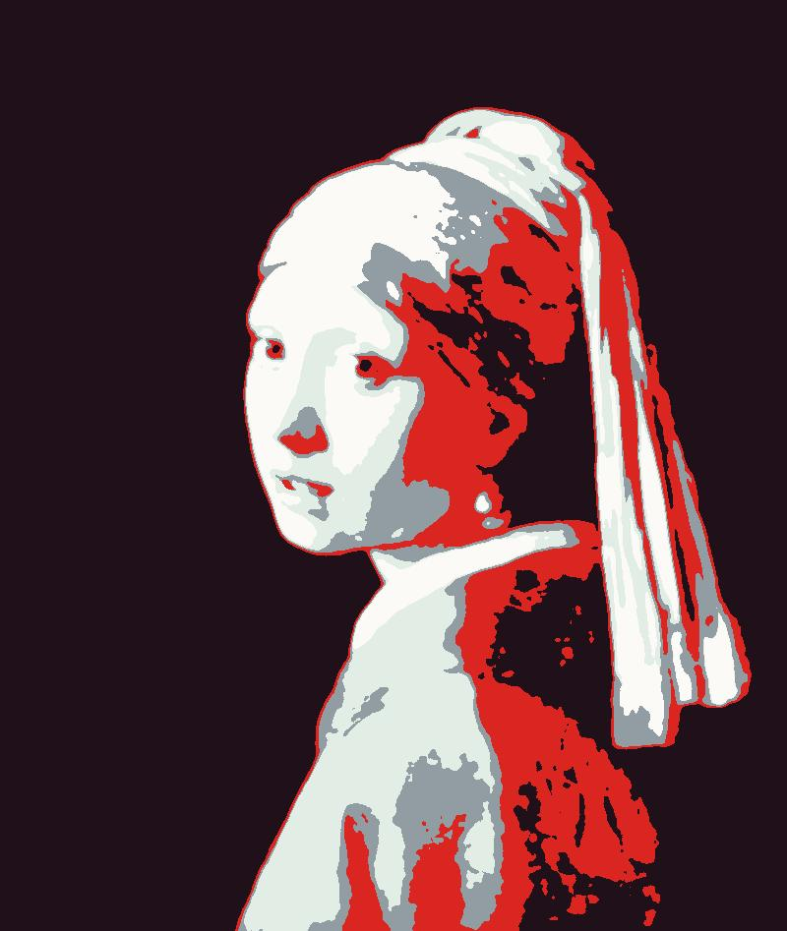**D. RECOLOR**

Recolor filter reduces colors and then recolors them with user input for striking effect.

One example is the Obama "Change" image from 2008. Takes 2 or more hex code commands from user.

Blurs the image to smooth out the edges. Clusters the image colors based on the number of image filters. Sorts the clustered colors from light-to-dark. Sorts the input colors from light-to-dark. Replaces the clustered colors with their corresponding input colors.

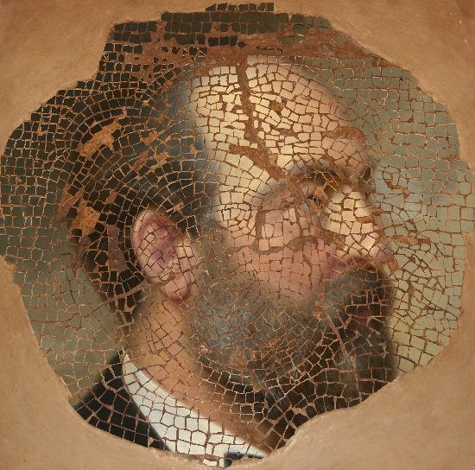**E. REMAP**

Remaps based on map. White parts become back image; everything else becomes front image.

Resizes front and back image based on map size. For every pixel, a depth-first search is performed to find neighboring pixels with the same color. If the color is white, the new image will be the back image at those pixels. If the color is not white, the new image will be the front image at those pixels.

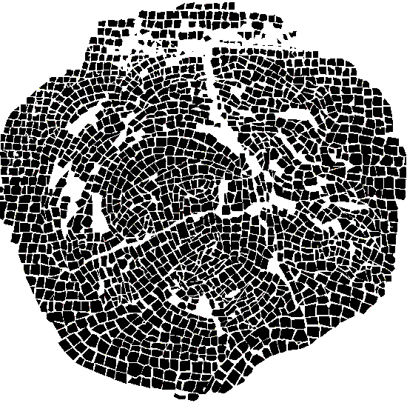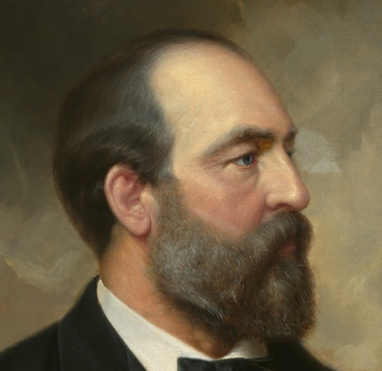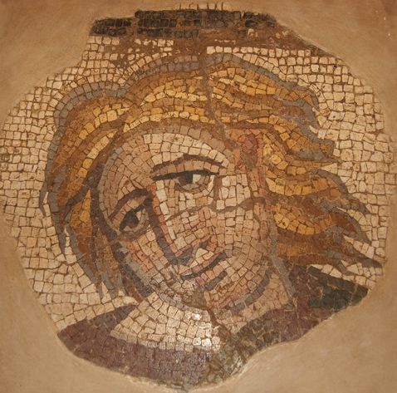

**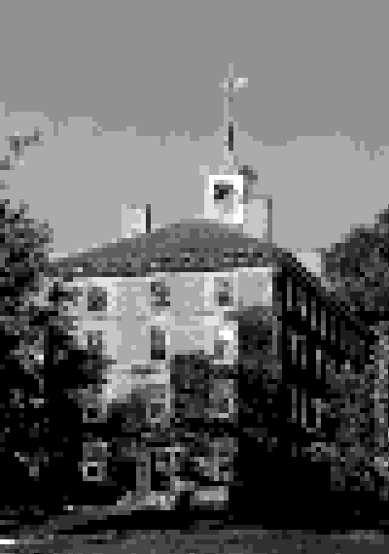  
F. PIXELATE**

Pixelates image.

Enhances the contrast. Creates a chessboard with one square for every 5x5 pixel square of the image. Performs a depth-first search on every square. Then clusters that square, extracting the value. Replaces the clustered square with a corresponding value on a simple 1-10 value scale.

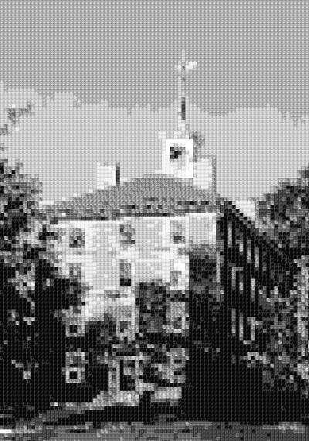**G. PENCIL**

Replaces value squares with pencil marking to emulate a pencil value drawing.

Same as pixelate. Replaces every clustered square with a pencil value marking.

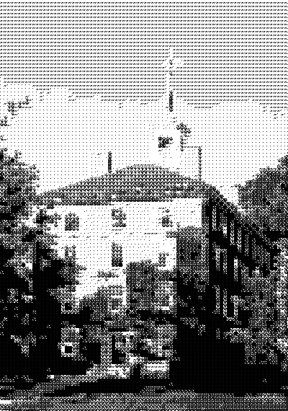**H. DOTS**

Replaces values square with stippling emulating the stippled hatching of the Wall Street Journal Portraits.

Same as pixelate. Replaces every clustered square with a stippled value marking.

**5 ALGORITHMS**

**A. K-MEANS CLUSTERING** 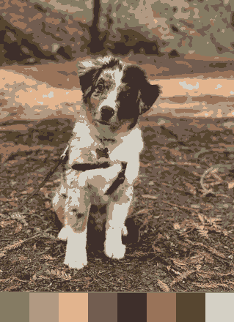

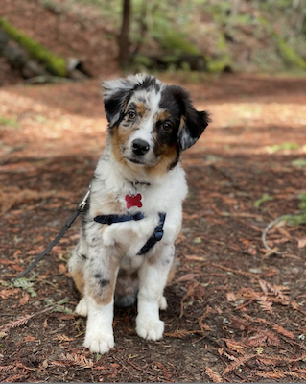The basis for the K-Means Clustering algorithm is reused from the Spring 2021 CS134 Lab 7 assignment.

"The K-Means algorithm seeks to take a collection of at least "k" data "values", and assign each value to one of "k" different clusters. The assignment is based on minimizing the distance between a particular value and the "label" associated with its destination cluster." - Duane Bailey & Molly Q. Feldman

After Effects uses K-Means Clustering to cluster the RGB values in an image into a reduced palette. In Recolor, we use it to simplify the image colors before replacing them. In Pixelate, Pencil and Dots, we cluster every value square to 1 color, such that we can replace it with the appropriate value.

**B. DEPTH-FIRST SEARCH** 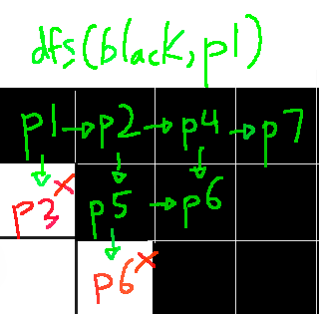

The Depth-First Search is for neighboring pixels with same color. The algorithm takes a color and a pixel. The two neighbors of the pixel are the one directly to the right and directly to the bottom. If the pixel is the same color, then it will add it to the return list, add that pixel to the list of visited pixels and recursively perform the search on that pixel. Any pixel that is in the list of visited pixels will be skipped.

After Effects uses Depth-First Search to distinguish between white and non-white values. In Remap, we use it to find the locations of the front and image.

In Pixelate, Pencil and Dots, we use it find the pixels of each square in the chessboard.

**C. CHESSBOARD OVERLAY**

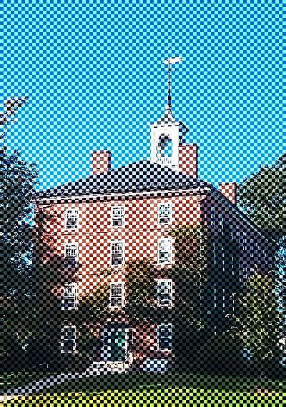The default size for each chess square is 5.

The image is cropped, such that both its width and height are divisible by the square size. Then we divide the width and height of the image by the square size. Then for the divided height and width, we make every odd pixel of the chessboard white. Then we resize the chessboard back, multiplying the width and height by the square size.

In Pixelate, Pencil and Dots, we use the chessboard as a guide to isolate the pixels in the squares. Then we cluster the values in each square. Finally, we replace it with the corresponding value marking.