Fixed rate account
The fixed rate account Type is another general purpose account type, it could be used for any fixed rate products (e.g. Deposits, simple Loans, money market deals, and Bonds)
It’s mainly like the following
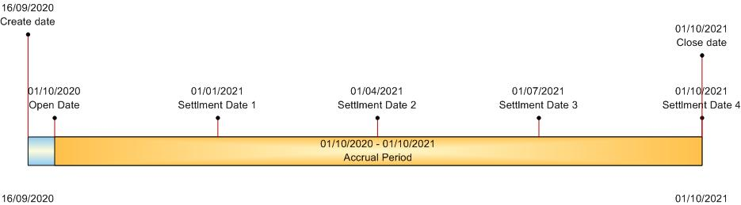

This account got the following attributes
Attribute | Description
account type | SIMPLELOAN
account class | An object of type Account Class  which should contains  - Creation date accounting structure  - Open date accounting structure  - Accrual accounting structure  - Settlement accounting structure  - Closure accounting structure
account number | A serial number generated by the system
description | description for the account
creation date | The creation date of the account, it could be less than or equal the open date, however at that date, nothing really occurs other than marking a new account that will be opened on the open date
open date | On which the system will actually begin accrual of the account, also the system should execute the open date accounting structure which is based on the account class
closure date | On which the system will mark the account as closed
rate percentage | A rate that once the account is opened, can’t be changed, the system will calculate the accrual amount based on this rate.
accrual basis | The basis on which the accrued amount will be calculated, it’s based on Organization fiscal year and many other parameters
principle amount | The principle amount on which the system calculates the accrued amount based on

Currency | Account currency
list of settlement dates | during the lifetime of the account, there could some sort of dates , on which the settlement accounting structure will be executed, it could be bills dates for loan, coupons for bonds, profit distribution for deposit  if not supplied , the closure date shall be considered as the only settlement date

